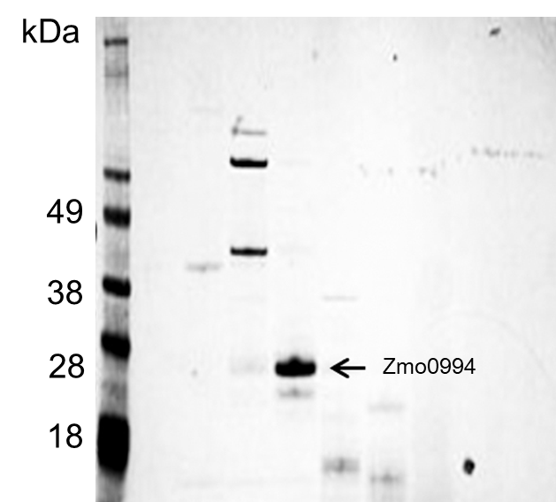

Figure S1 SDS-PAGE analysis of extracellular proteins produced by Zymomonas mobilis.

