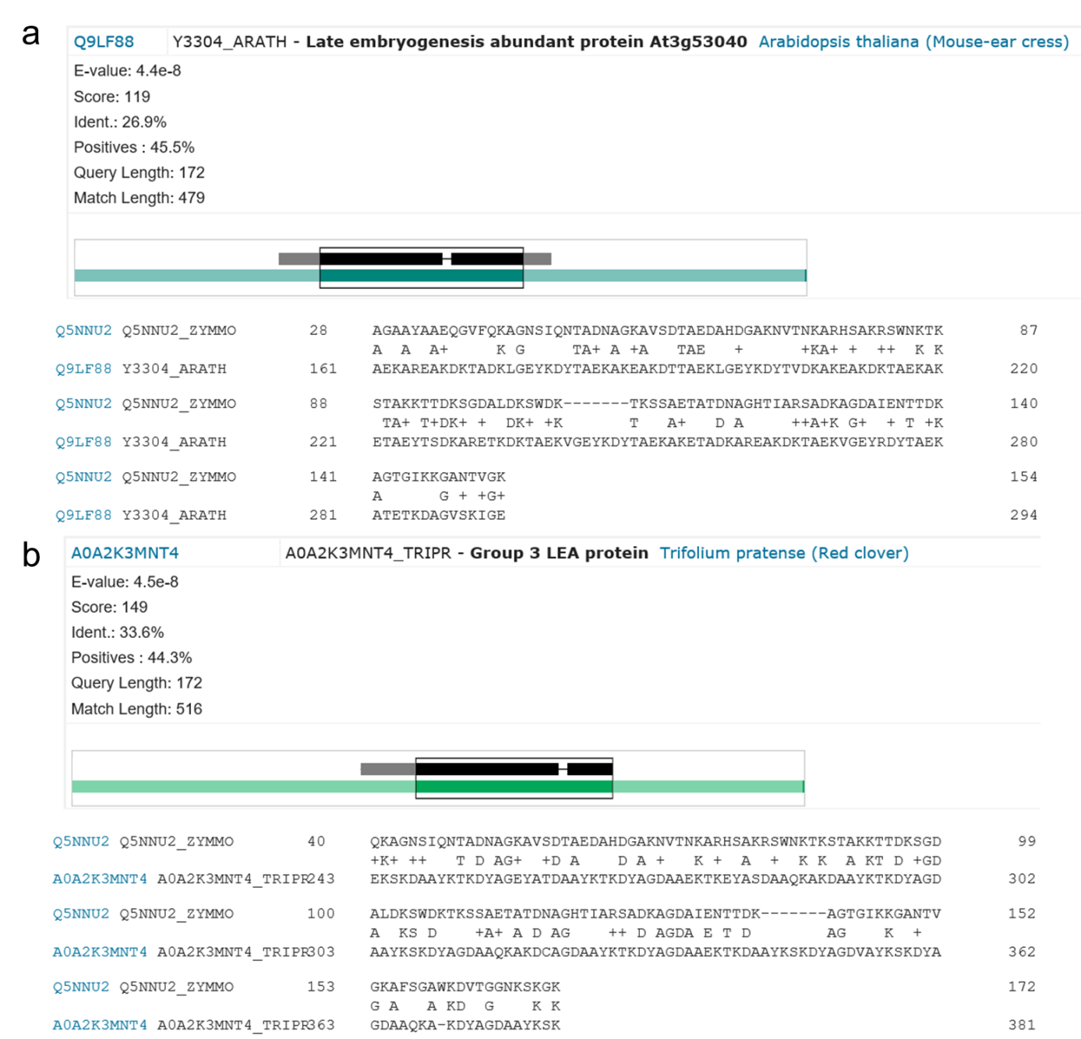

Figure S3 Blast results of Zmo0994 (UniProt accession number: Q5NNU2) against (a) Q9LF88, LEA protein from Arabidopsis thaliana and (b) A0A2K3MNT4, Group 3 LEA protein from Trifolium pretense.

