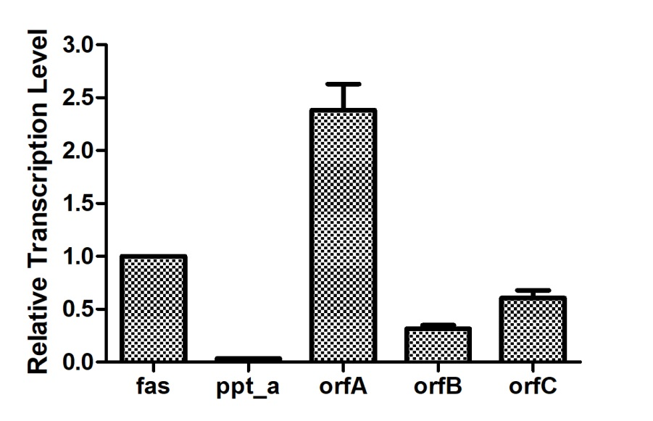
Fig.S6. The relative transcription levels of the fatty acid synthesis genes in transformant containing empty plasmid. fas gene was used as the contrast.

