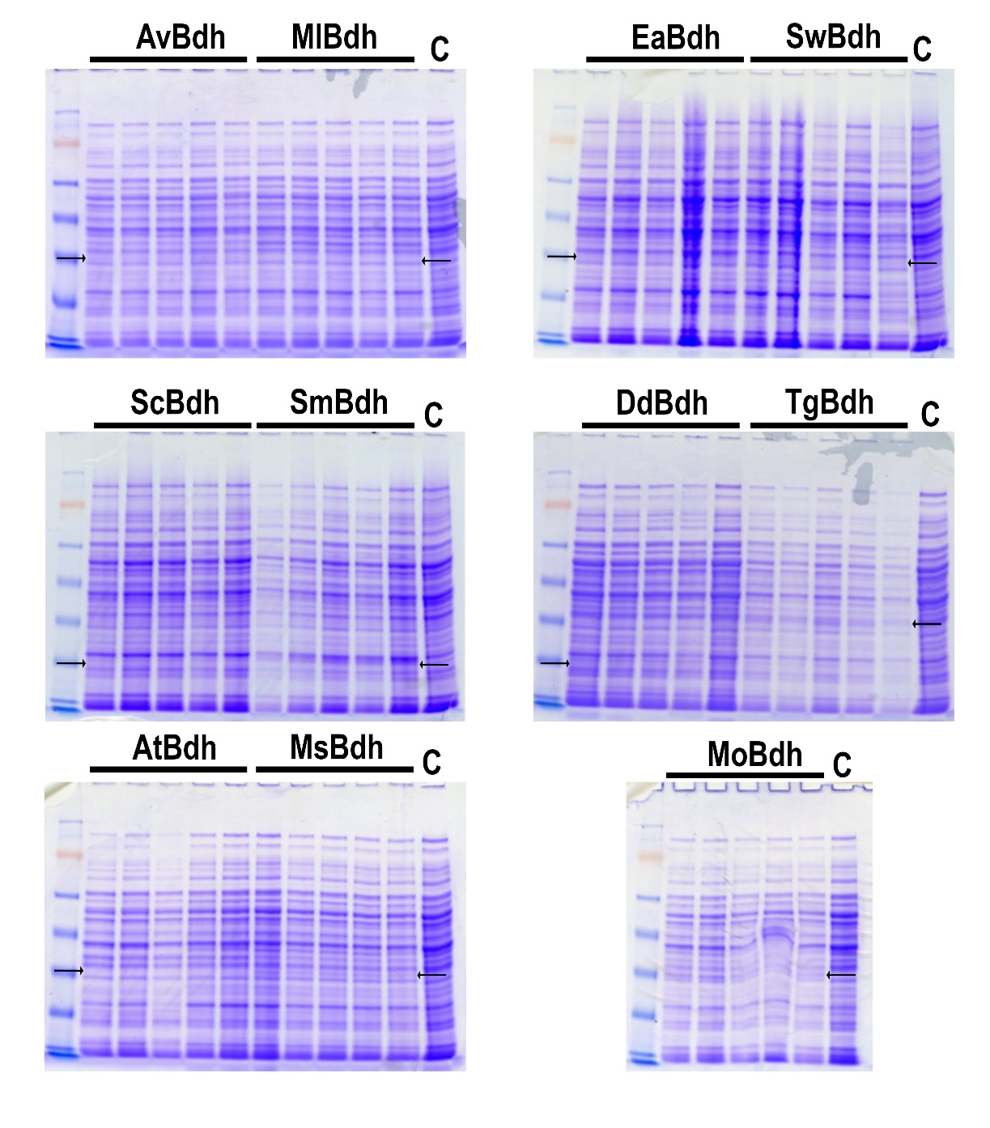
Additional file 3. Detection of heterologous Bdh proteins from Z. mobilis transformants using total protein staining. Five independent transformant colonies were selected for protein extraction. µg total protein was separated on 4-12% SDS PAGE gel followed by Coomassie staining. Arrows represent the expected molecular weight of the individual Bdh proteins. Two Bdh protein sets are shown in each PAGE gel. Each protein set is represented by 5 lanes as indicated by the black bars. Bdh protein names are shown above the black bars. Av, Azotobacter vinelandii; Ml, Micrococcus luteus; Ea, Erwinia amylovora; Sw, Staphylococcus warneri; Sc, Streptomyces coelicolor; Sm, Serratia marcescens; Dd, Dickeya dadantii; Tg, Thermococcus gammatolerans; At, Agrobacterium tumefaciens; Ms, Mycobacterium Smegmatis; Mo, Myroides odoratimimus; C, Z. mobilis control strain.

