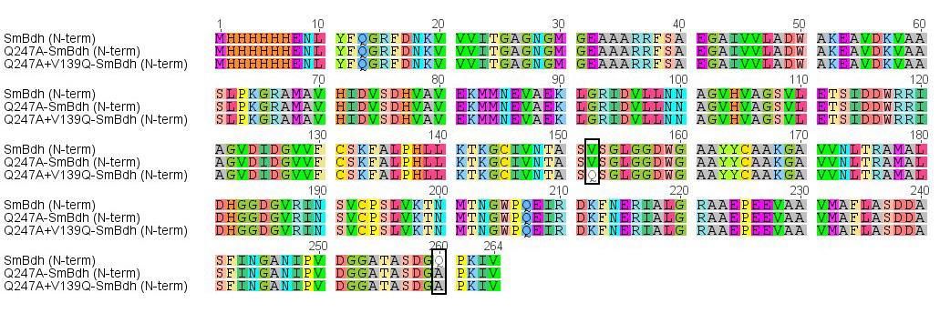

Additional file 5: Multiple alignment of N-terminal histidine tagged SmBdh sequences representing the sites of amino acid changes. Three different version of SmBdh are shown. Boxes indicate the amino acids that were replaced in the other mutants. SmBdh (N-term), wild-type; Q247A-SmBdh (N-term) and Q247A+V139Q-SmBdh (N-term), two different variants of SmBdh.

