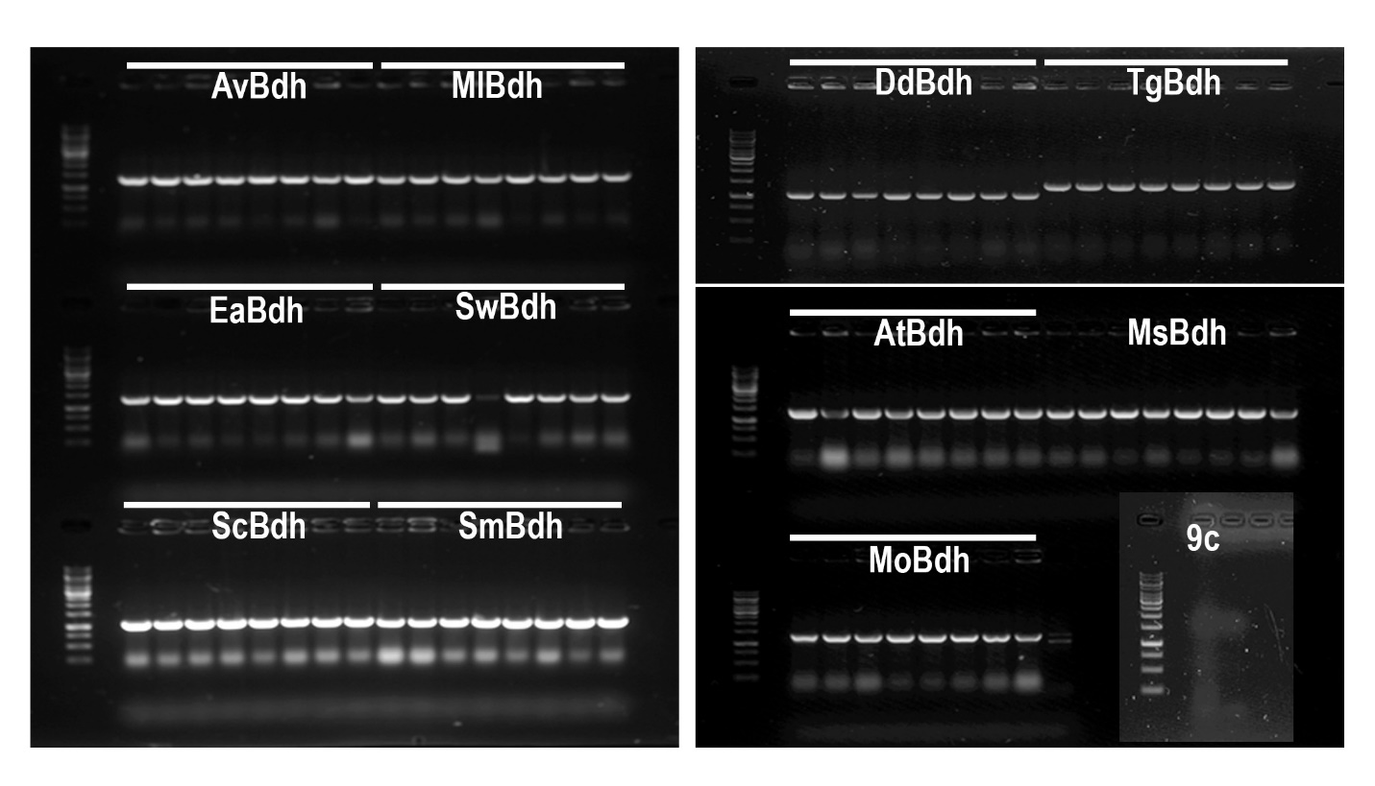

Additional file 1. PCR analysis of Z. mobilis tranformants containing the different Bdh genes. Eleven Bdh genes were transformed into Z. mobilis strain 9C and plated on RMG medium containing spectinomycin. Eight independent colonies were selected for colony PCR analysis using gene specific primers. Five microliters of the PCR products were run on 1% agarose gel and visualized using FluoChem Gel analyzer. White bar represents sets of 8 lanes for each Bdh gene. Av, Azotobacter vinelandii; Ml, Micrococcus luteus; Ea, Erwinia amylovora; Sw, Staphylococcus warneri; Sc, Streptomyces coelicolor; Sm, Serratia marcescens; Dd, Dickeya dadantii; At, Tg, Thermococcus gammatolerans; Agrobacterium tumefaciens; Ms, Mycobacterium Smegmatis; Mo, Myroides odoratimimus; 9c, Z. mobilis control strain.

