Type of contribution: Supplementary
Number of figures: 8
Number of tables: 6
Title
Lignin Intermediates Lead to Phenyl Acid Formation and Microbial Community Shifts in Meso- and Thermophilic Batch Reactors
Authors:
Eva Maria Prem^{1*}, Mira Mutschlechner¹, Blaz Stres^{2,3,4}, Paul Illmer¹, and Andreas Otto Wagner¹

Affiliation:
¹Department of Microbiology, Universität Innsbruck, Technikerstr. 25d, 6020 Innsbruck, Austria
²Department of Animal Science, Biotechnical Faculty, University of Ljubljana, Jamnikarjeva 101, SI-1000 Ljubljana, Slovenia
³Institute of Sanitary Engineering, Faculty of Civil and Geodetic Engineering, University of Ljubljana, Jamova 2, SI-1000 Ljubljana, Slovenia
⁴Department of Automation, Biocybernetics and Robotics, Jozef Štefan Institute, Jamova 39, SI-1000 Ljubljana, Slovenia

*Corresponding author:
Eva Maria Prem, Department of Microbiology, Universität Innsbruck, Technikerstraße 25d, 6020 Innsbruck, Austria, Tel.: 0043 512 507 51346, email: eva.prem@uibk.ac.at

- Supplementary Results

Table S1: pH values and concentrations of propionate, i-butyrate, and butyrate of mesophilic control samples as well as of mesophilic samples fed with the respective lignin intermediate (gallic, syringic, vanillic, ferulic, or coumaric acid) under low, medium, and high overload conditions on day 0, 7, 14, and 28 . VFA results are shown in mM; mean values are presented with the respective standard deviations (SD).
Day | Source | Load | pH |  | Propionate |  | i-Butyrate |  | Butyrate |  | Day | Source | Load | pH |  | Propionate |  | i-Butyrate |  | Butyrate
Day | Source | Load | mean | SD | mean | SD | mean | SD | mean | SD | Day | Source | Load | mean | SD | mean | SD | mean | SD | mean | SD
0 | control | control | 7.00 | 0.00 | 0.20 | 0.34 | 0.38 | 0.03 | 0.00 | 0.00 | 14 | control | control | 7.00 | 0.00 | 2.66 | 0.88 | 0.34 | 0.14 | 1.33 | 0.19
0 | gallic acid | low | 7.00 | 0.00 | 0.65 | 0.04 | 0.53 | 0.02 | 0.00 | 0.00 | 14 | gallic acid | low | 7.00 | 0.00 | 2.12 | 0.46 | 0.42 | 0.32 | 1.40 | 0.26
0 | gallic acid | medium | 7.00 | 0.00 | 0.48 | 0.17 | 1.21 | 0.72 | 0.00 | 0.00 | 14 | gallic acid | medium | 6.50 | 0.00 | 1.51 | 0.47 | 0.26 | 0.03 | 1.96 | 0.30
0 | gallic acid | high | 7.00 | 0.00 | 1.26 | 0.48 | 0.00 | 0.00 | 0.00 | 0.00 | 14 | gallic acid | high | 5.50 | 0.00 | 8.28 | 3.51 | 0.00 | 0.00 | 0.00 | 0.00
0 | syringic acid | low | 7.00 | 0.00 | 0.38 | 0.17 | 0.38 | 0.15 | 0.00 | 0.00 | 14 | syringic acid | low | 7.00 | 0.00 | 3.12 | 0.63 | 0.29 | 0.09 | 1.45 | 0.16
0 | syringic acid | medium | 7.00 | 0.00 | 0.64 | 0.02 | 0.49 | 0.05 | 0.00 | 0.00 | 14 | syringic acid | medium | 7.00 | 0.00 | 3.03 | 0.89 | 0.22 | 0.05 | 4.86 | 0.15
0 | syringic acid | high | 7.00 | 0.00 | 0.59 | 0.25 | 0.30 | 0.02 | 0.00 | 0.00 | 14 | syringic acid | high | 5.00 | 0.00 | 2.46 | 1.22 | 4.64 | 0.11 | 0.87 | 0.29
0 | vanillic acid | low | 7.00 | 0.00 | 0.62 | 0.04 | 0.47 | 0.03 | 0.00 | 0.00 | 14 | vanillic acid | low | 7.00 | 0.00 | 2.82 | 0.62 | 0.26 | 0.05 | 1.46 | 0.06
0 | vanillic acid | medium | 7.00 | 0.00 | 0.59 | 0.05 | 0.35 | 0.02 | 0.00 | 0.00 | 14 | vanillic acid | medium | 7.00 | 0.00 | 1.16 | 0.11 | 0.59 | 0.59 | 3.41 | 0.16
0 | vanillic acid | high | 7.00 | 0.00 | 0.68 | 0.03 | 0.29 | 0.09 | 0.00 | 0.00 | 14 | vanillic acid | high | 5.00 | 0.00 | 0.46 | 0.02 | 4.59 | 0.44 | 0.47 | 0.21
0 | ferulic acid | low | 7.00 | 0.00 | 0.64 | 0.03 | 0.47 | 0.01 | 0.00 | 0.00 | 14 | ferulic acid | low | 7.00 | 0.00 | 2.57 | 0.51 | 0.64 | 0.22 | 1.53 | 0.14
0 | ferulic acid | medium | 7.00 | 0.00 | 0.75 | 0.07 | 0.38 | 0.03 | 0.00 | 0.00 | 14 | ferulic acid | medium | 6.50 | 0.00 | 3.24 | 0.15 | 0.75 | 0.69 | 1.57 | 0.37
0 | ferulic acid | high | 7.00 | 0.00 | 0.83 | 0.01 | 0.24 | 0.02 | 0.00 | 0.00 | 14 | ferulic acid | high | 5.50 | 0.00 | 0.32 | 0.36 | 4.46 | 0.26 | 0.00 | 0.00
0 | coumaric acid | low | 7.00 | 0.00 | 0.72 | 0.06 | 0.41 | 0.04 | 0.00 | 0.00 | 14 | coumaric acid | low | 7.00 | 0.00 | 4.48 | 1.64 | 0.76 | 0.31 | 1.40 | 0.05
0 | coumaric acid | medium | 7.00 | 0.00 | 0.69 | 0.01 | 0.42 | 0.01 | 0.00 | 0.00 | 14 | coumaric acid | medium | 7.00 | 0.00 | 2.98 | 0.33 | 0.37 | 0.04 | 4.06 | 0.59
0 | coumaric acid | high | 7.00 | 0.00 | 0.68 | 0.02 | 0.25 | 0.02 | 0.00 | 0.00 | 14 | coumaric acid | high | 5.00 | 0.00 | 0.49 | 0.29 | 4.57 | 0.17 | 9.99 | 0.59
7 | control | control | 7.50 | 0.00 | 1.43 | 0.16 | 0.09 | 0.02 | 0.30 | 0.07 | 28 | control | control | 7.50 | 0.00 | 3.12 | 0.85 | 0.11 | 0.12 | 0.00 | 0.00
7 | gallic acid | low | 7.00 | 0.00 | 1.63 | 0.04 | 0.10 | 0.01 | 0.35 | 0.03 | 28 | gallic acid | low | 7.00 | 0.00 | 1.91 | 0.91 | 0.10 | 0.17 | 0.15 | 0.25
7 | gallic acid | medium | 6.00 | 0.00 | 1.44 | 0.05 | 0.11 | 0.01 | 0.59 | 0.05 | 28 | gallic acid | medium | 7.00 | 0.00 | 0.36 | 0.08 | 0.00 | 0.00 | 1.60 | 0.82
7 | gallic acid | high | 5.50 | 0.00 | 2.32 | 0.32 | 8.93 | 2.57 | 8.68 | 5.25 | 28 | gallic acid | high | 5.50 | 0.00 | 2.16 | 0.45 | 0.00 | 0.00 | 0.00 | 0.00
7 | syringic acid | low | 7.00 | 0.00 | 1.36 | 0.23 | 0.11 | 0.00 | 0.48 | 0.08 | 28 | syringic acid | low | 7.00 | 0.00 | 2.65 | 1.30 | 0.16 | 0.14 | 0.00 | 0.00
7 | syringic acid | medium | 6.50 | 0.00 | 1.56 | 0.12 | 0.10 | 0.02 | 4.28 | 0.03 | 28 | syringic acid | medium | 7.00 | 0.00 | 0.76 | 0.11 | 0.00 | 0.00 | 4.17 | 0.14
7 | syringic acid | high | 5.00 | 0.00 | 0.61 | 0.04 | 1.91 | 1.51 | 0.00 | 0.00 | 28 | syringic acid | high | 5.00 | 0.00 | 0.68 | 0.45 | 4.08 | 0.89 | 0.44 | 0.39
7 | vanillic acid | low | 7.00 | 0.00 | 1.72 | 0.03 | 0.11 | 0.01 | 0.37 | 0.03 | 28 | vanillic acid | low | 7.00 | 0.00 | 2.47 | 0.67 | 0.05 | 0.09 | 0.00 | 0.00
7 | vanillic acid | medium | 7.00 | 0.00 | 1.16 | 0.15 | 0.02 | 0.03 | 2.13 | 0.06 | 28 | vanillic acid | medium | 7.00 | 0.00 | 3.08 | 0.32 | 0.00 | 0.00 | 2.02 | 0.23
7 | vanillic acid | high | 5.00 | 0.00 | 0.63 | 0.01 | 0.63 | 0.11 | 0.00 | 0.00 | 28 | vanillic acid | high | 5.00 | 0.00 | 0.49 | 0.03 | 4.56 | 0.48 | 0.15 | 0.13
7 | ferulic acid | low | 7.00 | 0.00 | 1.14 | 0.20 | 0.60 | 0.13 | 0.34 | 0.05 | 28 | ferulic acid | low | 7.00 | 0.00 | 4.33 | 0.42 | 0.23 | 0.40 | 0.00 | 0.00
7 | ferulic acid | medium | 6.50 | 0.00 | 2.13 | 1.32 | 1.90 | 0.34 | 0.63 | 0.24 | 28 | ferulic acid | medium | 7.00 | 0.00 | 6.71 | 4.65 | 2.15 | 0.35 | 0.70 | 0.33
7 | ferulic acid | high | 5.50 | 0.00 | 1.09 | 0.03 | 0.71 | 0.09 | 0.00 | 0.00 | 28 | ferulic acid | high | 5.50 | 0.00 | 0.34 | 0.30 | 4.53 | 0.58 | 0.00 | 0.00
7 | coumaric acid | low | 7.00 | 0.00 | 1.64 | 0.16 | 0.08 | 0.02 | 0.53 | 0.15 | 28 | coumaric acid | low | 7.50 | 0.00 | 2.79 | 0.90 | 0.43 | 0.17 | 0.84 | 0.17
7 | coumaric acid | medium | 7.00 | 0.00 | 0.85 | 0.01 | 0.12 | 0.03 | 1.95 | 0.24 | 28 | coumaric acid | medium | 6.50 | 0.00 | 2.36 | 0.32 | 0.21 | 0.04 | 2.39 | 0.22
7 | coumaric acid | high | 5.00 | 0.00 | 0.59 | 0.02 | 0.48 | 0.01 | 2.18 | 0.54 | 28 | coumaric acid | high | 5.00 | 0.00 | 0.49 | 0.02 | 4.26 | 0.08 | 8.32 | 0.27

Table S2: Concentrations of phenylacetate (PAA), phenylpropionate (PPA), and phenylbutyrate (PBA, sum) of mesophilic control samples as well as of mesophilic samples fed with the respective lignin intermediate (gallic, syringic, vanillic, ferulic, or coumaric acid) under low, medium, and high overload conditions on day 0, 7, 14, and 28 . “PBA sum” represents the sum of the 2-PBA, 3-PBA, and 4-PBA concentrations of each variation. Results are shown in mM. Mean values are presented with the respective standard deviations (SD).
Day | Source | Load | PAA |  | PPA |  | PBA (sum) |  | Day | Source | Load | PAA |  | PPA |  | PBA (sum)
Day | Source | Load | mean | SD | mean | SD | mean | SD | Day | Source | Load | mean | SD | mean | SD | mean | SD
0 | control | control | 0.00 | 0.00 | 0.00 | 0.00 | 0.00 | 0.00 | 14 | control | control | 0.20 | 0.01 | 0.09 | 0.02 | 0.04 | 0.05
0 | gallic acid | low | 0.00 | 0.00 | 0.00 | 0.00 | 0.00 | 0.00 | 14 | gallic acid | low | 0.21 | 0.02 | 0.09 | 0.02 | 0.03 | 0.05
0 | gallic acid | medium | 0.00 | 0.00 | 0.00 | 0.00 | 0.00 | 0.00 | 14 | gallic acid | medium | 0.22 | 0.03 | 0.08 | 0.01 | 0.00 | 0.00
0 | gallic acid | high | 0.00 | 0.00 | 0.00 | 0.00 | 0.00 | 0.00 | 14 | gallic acid | high | 1.76 | 0.21 | 0.01 | 0.01 | 0.00 | 0.00
0 | syringic acid | low | 0.00 | 0.00 | 0.00 | 0.00 | 0.00 | 0.00 | 14 | syringic acid | low | 0.22 | 0.02 | 0.07 | 0.02 | 0.01 | 0.00
0 | syringic acid | medium | 0.00 | 0.00 | 0.00 | 0.00 | 0.00 | 0.01 | 14 | syringic acid | medium | 0.25 | 0.03 | 0.07 | 0.01 | 0.00 | 0.00
0 | syringic acid | high | 0.00 | 0.00 | 0.00 | 0.00 | 0.06 | 0.00 | 14 | syringic acid | high | 0.21 | 0.01 | 0.01 | 0.02 | 0.11 | 0.09
0 | vanillic acid | low | 0.00 | 0.00 | 0.00 | 0.00 | 0.00 | 0.00 | 14 | vanillic acid | low | 0.02 | 0.00 | 0.09 | 0.00 | 0.00 | 0.00
0 | vanillic acid | medium | 0.00 | 0.00 | 0.00 | 0.00 | 0.00 | 0.00 | 14 | vanillic acid | medium | 0.02 | 0.00 | 0.09 | 0.01 | 0.00 | 0.00
0 | vanillic acid | high | 0.00 | 0.00 | 0.00 | 0.00 | 0.00 | 0.00 | 14 | vanillic acid | high | 0.02 | 0.00 | 0.32 | 0.56 | 5.01 | 1.77
0 | ferulic acid | low | 0.00 | 0.00 | 0.00 | 0.00 | 0.63 | 0.00 | 14 | ferulic acid | low | 0.03 | 0.01 | 0.48 | 0.02 | 0.00 | 0.00
0 | ferulic acid | medium | 0.00 | 0.00 | 0.00 | 0.00 | 0.01 | 0.00 | 14 | ferulic acid | medium | 0.04 | 0.02 | 0.31 | 0.08 | 0.00 | 0.00
0 | ferulic acid | high | 0.00 | 0.00 | 0.00 | 0.00 | 0.00 | 0.00 | 14 | ferulic acid | high | 0.00 | 0.00 | 0.00 | 0.00 | 0.17 | 0.01
0 | coumaric acid | low | 0.00 | 0.00 | 0.00 | 0.00 | 0.05 | 0.00 | 14 | coumaric acid | low | 0.22 | 0.19 | 0.54 | 0.06 | 0.00 | 0.00
0 | coumaric acid | medium | 0.18 | 0.01 | 0.00 | 0.00 | 0.16 | 0.00 | 14 | coumaric acid | medium | 1.82 | 0.11 | 5.44 | 0.09 | 0.24 | 0.06
0 | coumaric acid | high | 0.42 | 0.05 | 0.00 | 0.00 | 0.15 | 0.00 | 14 | coumaric acid | high | 14.6 | 1.69 | 0.32 | 0.04 | 0.27 | 0.03
7 | control | control | 0.01 | 0.01 | 0.00 | 0.00 | 0.00 | 0.00 | 28 | control | control | 0.21 | 0.01 | 0.03 | 0.03 | 0.06 | 0.06
7 | gallic acid | low | 0.00 | 0.00 | 0.00 | 0.00 | 0.00 | 0.00 | 28 | gallic acid | low | 0.23 | 0.01 | 0.05 | 0.01 | 0.05 | 0.06
7 | gallic acid | medium | 0.00 | 0.01 | 0.00 | 0.00 | 0.00 | 0.00 | 28 | gallic acid | medium | 0.26 | 0.02 | 0.08 | 0.01 | 0.00 | 0.00
7 | gallic acid | high | 0.36 | 0.62 | 0.00 | 0.00 | 0.00 | 0.00 | 28 | gallic acid | high | 0.52 | 0.49 | 0.01 | 0.02 | 0.01 | 0.01
7 | syringic acid | low | 0.01 | 0.01 | 0.00 | 0.00 | 0.00 | 0.00 | 28 | syringic acid | low | 0.25 | 0.01 | 0.01 | 0.02 | 0.33 | 0.26
7 | syringic acid | medium | 0.00 | 0.00 | 0.00 | 0.00 | 0.00 | 0.00 | 28 | syringic acid | medium | 0.26 | 0.02 | 0.06 | 0.01 | 0.03 | 0.03
7 | syringic acid | high | 0.00 | 0.00 | 0.00 | 0.00 | 0.06 | 0.00 | 28 | syringic acid | high | 0.23 | 0.01 | 0.01 | 0.02 | 0.06 | 0.00
7 | vanillic acid | low | 0.00 | 0.00 | 0.00 | 0.00 | 0.00 | 0.00 | 28 | vanillic acid | low | 0.26 | 0.02 | 0.00 | 0.01 | 0.45 | 0.13
7 | vanillic acid | medium | 0.00 | 0.00 | 0.00 | 0.00 | 0.00 | 0.00 | 28 | vanillic acid | medium | 0.23 | 0.01 | 0.08 | 0.00 | 0.00 | 0.01
7 | vanillic acid | high | 0.00 | 0.00 | 0.00 | 0.00 | 2.30 | 2.17 | 28 | vanillic acid | high | 0.16 | 0.14 | 1.54 | 0.02 | 3.31 | 1.99
7 | ferulic acid | low | 0.02 | 0.02 | 0.00 | 0.00 | 0.00 | 0.00 | 28 | ferulic acid | low | 0.28 | 0.01 | 0.00 | 0.00 | 1.82 | 0.04
7 | ferulic acid | medium | 0.58 | 0.48 | 0.00 | 0.00 | 0.02 | 0.03 | 28 | ferulic acid | medium | 1.13 | 0.68 | 0.80 | 0.15 | 0.13 | 0.12
7 | ferulic acid | high | 0.00 | 0.00 | 0.00 | 0.00 | 0.15 | 0.01 | 28 | ferulic acid | high | 0.00 | 0.00 | 0.00 | 0.00 | 0.19 | 0.02
7 | coumaric acid | low | 0.00 | 0.00 | 0.00 | 0.00 | 0.00 | 0.00 | 28 | coumaric acid | low | 0.34 | 0.01 | 0.83 | 0.18 | 0.01 | 0.02
7 | coumaric acid | medium | 0.18 | 0.01 | 0.62 | 0.53 | 0.19 | 0.08 | 28 | coumaric acid | medium | 0.86 | 0.15 | 7.22 | 0.11 | 0.57 | 0.39
7 | coumaric acid | high | 1.20 | 1.14 | 0.00 | 0.00 | 0.25 | 0.03 | 28 | coumaric acid | high | 17.9 | 0.66 | 0.87 | 0.58 | 0.28 | 0.04

Table S3: Concentrations of benzoate, hydroxybenzoate, and hydroxy-PAA of mesophilic control samples as well as of mesophilic samples fed with the respective lignin intermediate (gallic, syringic, vanillic, ferulic, or coumaric acid) under low, medium, and high overload conditions on day 0, 7, 14, and 28 . Results are shown mM. Mean values are presented with the respective standard deviations (SD).
Day | Source | Load | Benzoate |  | Hydroxy-benzoate |  | Hydroxy-PAA |  | Day | Source | Load | Benzoate |  | Hydroxy-benzoate |  | Hydroxy-PAA
Day | Source | Load | mean | SD | mean | SD | mean | SD | Day | Source | Load | mean | SD | mean | SD | mean | SD
0 | control | control | 0.00 | 0.00 | 0.00 | 0.00 | 0.00 | 0.00 | 14 | control | control | 0.00 | 0.00 | 0.00 | 0.00 | 0.00 | 0.00
0 | gallic acid | low | 0.00 | 0.00 | 0.00 | 0.00 | 0.00 | 0.00 | 14 | gallic acid | low | 0.00 | 0.00 | 0.00 | 0.00 | 0.00 | 0.00
0 | gallic acid | medium | 0.00 | 0.00 | 0.00 | 0.00 | 0.00 | 0.00 | 14 | gallic acid | medium | 0.00 | 0.00 | 0.00 | 0.00 | 0.00 | 0.00
0 | gallic acid | high | 0.00 | 0.00 | 0.00 | 0.00 | 0.00 | 0.00 | 14 | gallic acid | high | 0.00 | 0.00 | 0.00 | 0.00 | 0.03 | 0.00
0 | syringic acid | low | 0.00 | 0.00 | 0.00 | 0.00 | 0.00 | 0.00 | 14 | syringic acid | low | 0.00 | 0.00 | 0.00 | 0.00 | 0.00 | 0.00
0 | syringic acid | medium | 0.00 | 0.00 | 0.00 | 0.00 | 0.00 | 0.00 | 14 | syringic acid | medium | 0.00 | 0.00 | 0.00 | 0.00 | 0.00 | 0.00
0 | syringic acid | high | 0.00 | 0.00 | 0.00 | 0.00 | 0.02 | 0.03 | 14 | syringic acid | high | 0.00 | 0.00 | 0.17 | 0.01 | 0.00 | 0.00
0 | vanillic acid | low | 0.00 | 0.00 | 0.00 | 0.00 | 0.00 | 0.00 | 14 | vanillic acid | low | 0.00 | 0.00 | 0.05 | 0.01 | 0.11 | 0.00
0 | vanillic acid | medium | 0.00 | 0.00 | 0.00 | 0.00 | 0.00 | 0.00 | 14 | vanillic acid | medium | 0.00 | 0.00 | 0.03 | 0.01 | 1.66 | 0.11
0 | vanillic acid | high | 0.00 | 0.00 | 0.00 | 0.00 | 0.00 | 0.00 | 14 | vanillic acid | high | 0.00 | 0.00 | 0.08 | 0.01 | 0.00 | 0.00
0 | ferulic acid | low | 0.00 | 0.00 | 0.00 | 0.00 | 0.00 | 0.00 | 14 | ferulic acid | low | 0.00 | 0.00 | 0.01 | 0.00 | 0.00 | 0.00
0 | ferulic acid | medium | 0.00 | 0.00 | 0.00 | 0.00 | 0.00 | 0.00 | 14 | ferulic acid | medium | 0.01 | 0.01 | 0.00 | 0.00 | 0.05 | 0.06
0 | ferulic acid | high | 0.00 | 0.00 | 0.00 | 0.00 | 0.00 | 0.01 | 14 | ferulic acid | high | 0.00 | 0.00 | 0.43 | 0.38 | 0.05 | 0.03
0 | coumaric acid | low | 0.00 | 0.00 | 0.00 | 0.00 | 0.00 | 0.00 | 14 | coumaric acid | low | 0.00 | 0.00 | 0.00 | 0.00 | 0.00 | 0.00
0 | coumaric acid | medium | 0.00 | 0.00 | 0.00 | 0.00 | 0.00 | 0.00 | 14 | coumaric acid | medium | 0.00 | 0.00 | 0.00 | 0.00 | 0.00 | 0.00
0 | coumaric acid | high | 0.00 | 0.00 | 0.00 | 0.00 | 0.00 | 0.00 | 14 | coumaric acid | high | 0.00 | 0.00 | 0.00 | 0.00 | 0.00 | 0.00
7 | control | control | 0.00 | 0.00 | 0.00 | 0.00 | 0.00 | 0.00 | 28 | control | control | 0.00 | 0.00 | 0.00 | 0.00 | 0.00 | 0.00
7 | gallic acid | low | 0.00 | 0.00 | 0.00 | 0.00 | 0.00 | 0.00 | 28 | gallic acid | low | 0.00 | 0.00 | 0.00 | 0.00 | 0.00 | 0.00
7 | gallic acid | medium | 0.00 | 0.00 | 0.00 | 0.00 | 0.00 | 0.00 | 28 | gallic acid | medium | 0.00 | 0.00 | 0.00 | 0.00 | 0.00 | 0.00
7 | gallic acid | high | 0.00 | 0.00 | 0.00 | 0.00 | 0.42 | 0.04 | 28 | gallic acid | high | 0.00 | 0.00 | 0.00 | 0.00 | 0.00 | 0.00
7 | syringic acid | low | 0.00 | 0.00 | 0.00 | 0.00 | 0.00 | 0.00 | 28 | syringic acid | low | 0.00 | 0.00 | 0.00 | 0.00 | 0.00 | 0.00
7 | syringic acid | medium | 0.00 | 0.00 | 0.00 | 0.00 | 0.00 | 0.00 | 28 | syringic acid | medium | 0.00 | 0.00 | 0.00 | 0.00 | 0.00 | 0.00
7 | syringic acid | high | 0.00 | 0.00 | 0.17 | 0.00 | 0.00 | 0.00 | 28 | syringic acid | high | 0.00 | 0.00 | 0.22 | 0.02 | 0.00 | 0.00
7 | vanillic acid | low | 0.00 | 0.00 | 0.00 | 0.00 | 0.21 | 0.01 | 28 | vanillic acid | low | 0.00 | 0.00 | 0.00 | 0.00 | 0.00 | 0.00
7 | vanillic acid | medium | 0.00 | 0.00 | 0.00 | 0.00 | 2.15 | 0.04 | 28 | vanillic acid | medium | 0.00 | 0.00 | 1.25 | 0.29 | 1.65 | 0.16
7 | vanillic acid | high | 0.00 | 0.00 | 0.07 | 0.01 | 0.00 | 0.00 | 28 | vanillic acid | high | 0.00 | 0.00 | 0.07 | 0.02 | 0.00 | 0.00
7 | ferulic acid | low | 0.00 | 0.00 | 0.00 | 0.00 | 0.10 | 0.01 | 28 | ferulic acid | low | 0.00 | 0.00 | 0.00 | 0.00 | 0.00 | 0.00
7 | ferulic acid | medium | 0.08 | 0.03 | 0.29 | 0.29 | 0.76 | 0.21 | 28 | ferulic acid | medium | 0.00 | 0.00 | 0.00 | 0.00 | 0.05 | 0.05
7 | ferulic acid | high | 0.00 | 0.00 | 0.00 | 0.00 | 0.01 | 0.01 | 28 | ferulic acid | high | 0.00 | 0.00 | 0.00 | 0.00 | 0.04 | 0.01
7 | coumaric acid | low | 0.00 | 0.00 | 0.00 | 0.00 | 0.00 | 0.00 | 28 | coumaric acid | low | 0.00 | 0.00 | 0.00 | 0.00 | 0.00 | 0.00
7 | coumaric acid | medium | 0.00 | 0.00 | 0.00 | 0.00 | 0.00 | 0.00 | 28 | coumaric acid | medium | 0.00 | 0.00 | 0.00 | 0.00 | 0.00 | 0.00
7 | coumaric acid | high | 0.00 | 0.00 | 0.00 | 0.00 | 0.00 | 0.00 | 28 | coumaric acid | high | 0.00 | 0.00 | 0.00 | 0.00 | 0.00 | 0.00

Table S4: pH values and concentrations of propionate, i-butyrate, and butyrate of thermophilic control samples as well as of thermophilic samples fed with the respective lignin intermediate (gallic, syringic, vanillic, ferulic, or coumaric acid) under low, medium, and high overload conditions on day 0, 7, 14, and 28 . VFA results are shown in mM; mean values are presented with the respective standard deviations (SD).
Day | Source | Load | pH |  | Propionate |  | i-Butyrate |  | Butyrate |  | Day | Source | Load | pH |  | Propionate |  | i-Butyrate |  | Butyrate
Day | Source | Load | mean | SD | mean | SD | mean | SD | mean | SD | Day | Source | Load | mean | SD | mean | SD | mean | SD | mean | SD
0 | control | control | 7.00 | 0.00 | 0.00 | 0.00 | 0.00 | 0.00 | 1.68 | 0.00 | 14 | control | control | 7.50 | 0.00 | 2.67 | 0.88 | 1.34 | 0.19 | 0.13 | 0.02
0 | gallic acid | low | 7.00 | 0.00 | 0.00 | 0.00 | 0.00 | 0.00 | 1.82 | 0.02 | 14 | gallic acid | low | 7.00 | 0.00 | 2.13 | 0.47 | 1.40 | 0.26 | 0.28 | 0.05
0 | gallic acid | medium | 7.00 | 0.00 | 0.00 | 0.00 | 0.00 | 0.00 | 1.97 | 0.02 | 14 | gallic acid | medium | 6.00 | 0.00 | 1.52 | 0.47 | 1.97 | 0.30 | 0.39 | 0.06
0 | gallic acid | high | 7.00 | 0.00 | 0.00 | 0.00 | 0.00 | 0.00 | 2.02 | 0.10 | 14 | gallic acid | high | 5.00 | 0.00 | 2.00 | 0.15 | 0.00 | 0.00 | 0.97 | 0.15
0 | syringic acid | low | 7.00 | 0.00 | 0.00 | 0.00 | 0.00 | 0.00 | 1.82 | 0.02 | 14 | syringic acid | low | 7.00 | 0.00 | 3.13 | 0.64 | 1.45 | 0.16 | 0.14 | 0.02
0 | syringic acid | medium | 7.00 | 0.00 | 0.00 | 0.00 | 0.00 | 0.00 | 2.00 | 0.01 | 14 | syringic acid | medium | 6.50 | 0.00 | 3.05 | 0.89 | 0.49 | 0.01 | 4.88 | 0.15
0 | syringic acid | high | 7.00 | 0.00 | 1.63 | 0.05 | 0.00 | 0.00 | 2.47 | 0.02 | 14 | syringic acid | high | 5.00 | 0.00 | 2.47 | 1.22 | 0.87 | 0.29 | 0.09 | 0.03
0 | vanillic acid | low | 7.00 | 0.00 | 0.00 | 0.00 | 0.00 | 0.00 | 1.49 | 0.01 | 14 | vanillic acid | low | 7.00 | 0.00 | 2.87 | 0.64 | 1.45 | 0.07 | 0.15 | 0.01
0 | vanillic acid | medium | 7.00 | 0.00 | 0.00 | 0.00 | 0.00 | 0.00 | 1.62 | 0.01 | 14 | vanillic acid | medium | 7.00 | 0.00 | 1.18 | 0.11 | 3.40 | 0.17 | 3.41 | 0.16
0 | vanillic acid | high | 7.00 | 0.00 | 2.12 | 0.03 | 0.00 | 0.00 | 2.38 | 0.02 | 14 | vanillic acid | high | 5.00 | 0.00 | 0.46 | 0.03 | 0.47 | 0.21 | 0.05 | 0.02
0 | ferulic acid | low | 7.00 | 0.00 | 0.00 | 0.00 | 0.00 | 0.00 | 1.61 | 0.01 | 14 | ferulic acid | low | 7.00 | 0.00 | 2.61 | 0.52 | 1.52 | 0.14 | 0.15 | 0.01
0 | ferulic acid | medium | 7.00 | 0.00 | 0.00 | 0.00 | 0.00 | 0.00 | 1.90 | 0.03 | 14 | ferulic acid | medium | 6.50 | 0.00 | 3.28 | 0.16 | 1.56 | 0.37 | 0.16 | 0.04
0 | ferulic acid | high | 7.00 | 0.00 | 0.00 | 0.00 | 0.00 | 0.00 | 2.26 | 0.02 | 14 | ferulic acid | high | 5.00 | 0.00 | 0.32 | 0.36 | 0.00 | 0.00 | 0.00 | 0.00
0 | coumaric acid | low | 7.00 | 0.00 | 0.00 | 0.00 | 0.00 | 0.00 | 1.41 | 0.01 | 14 | coumaric acid | low | 7.00 | 0.00 | 4.48 | 1.64 | 1.40 | 0.05 | 0.84 | 0.03
0 | coumaric acid | medium | 7.00 | 0.00 | 0.00 | 0.00 | 0.00 | 0.00 | 1.40 | 0.00 | 14 | coumaric acid | medium | 7.00 | 0.00 | 2.98 | 0.33 | 4.06 | 0.59 | 2.44 | 0.35
0 | coumaric acid | high | 7.00 | 0.00 | 2.15 | 0.04 | 0.00 | 0.00 | 1.70 | 0.01 | 14 | coumaric acid | high | 5.00 | 0.00 | 0.49 | 0.29 | 9.99 | 0.59 | 5.99 | 0.36
7 | control | control | 7.50 | 0.00 | 1.64 | 0.10 | 0.00 | 0.00 | 0.26 | 0.04 | 28 | control | control | 7.50 | 0.00 | 3.16 | 0.86 | 0.10 | 0.11 | 0.00 | 0.00
7 | gallic acid | low | 7.00 | 0.00 | 1.80 | 0.05 | 0.00 | 0.00 | 0.59 | 0.08 | 28 | gallic acid | low | 7.00 | 0.00 | 1.94 | 0.92 | 0.09 | 0.16 | 0.14 | 0.25
7 | gallic acid | medium | 6.00 | 0.00 | 1.63 | 0.02 | 0.00 | 0.00 | 1.05 | 0.04 | 28 | gallic acid | medium | 6.00 | 0.00 | 0.37 | 0.08 | 0.00 | 0.00 | 1.57 | 0.80
7 | gallic acid | high | 5.00 | 0.00 | 0.00 | 0.00 | 0.00 | 0.00 | 0.88 | 0.07 | 28 | gallic acid | high | 5.00 | 0.00 | 34.2 | 2.01 | 1.78 | 3.09 | 1.45 | 0.41
7 | syringic acid | low | 7.00 | 0.00 | 1.45 | 0.18 | 0.00 | 0.00 | 0.42 | 0.07 | 28 | syringic acid | low | 7.00 | 0.00 | 2.69 | 1.32 | 0.15 | 0.13 | 0.00 | 0.00
7 | syringic acid | medium | 6.50 | 0.00 | 1.69 | 0.16 | 0.00 | 0.00 | 4.28 | 0.14 | 28 | syringic acid | medium | 6.50 | 0.00 | 0.77 | 0.11 | 0.00 | 0.00 | 4.09 | 0.14
7 | syringic acid | high | 5.00 | 0.00 | 0.49 | 0.06 | 0.00 | 0.00 | 0.00 | 0.00 | 28 | syringic acid | high | 5.00 | 0.00 | 0.78 | 0.44 | 3.80 | 0.83 | 0.44 | 0.38
7 | vanillic acid | low | 7.00 | 0.00 | 1.78 | 0.06 | 0.00 | 0.00 | 0.28 | 0.03 | 28 | vanillic acid | low | 7.00 | 0.00 | 2.27 | 0.62 | 0.04 | 0.08 | 0.00 | 0.00
7 | vanillic acid | medium | 7.00 | 0.00 | 2.29 | 0.13 | 0.15 | 0.01 | 1.83 | 0.02 | 28 | vanillic acid | medium | 7.00 | 0.00 | 8.36 | 0.29 | 0.00 | 0.00 | 1.77 | 0.20
7 | vanillic acid | high | 5.00 | 0.00 | 0.58 | 0.03 | 0.00 | 0.00 | 0.00 | 0.00 | 28 | vanillic acid | high | 5.00 | 0.00 | 0.45 | 0.03 | 3.86 | 0.40 | 0.13 | 0.11
7 | ferulic acid | low | 7.00 | 0.00 | 4.32 | 0.50 | 0.00 | 0.00 | 0.15 | 0.04 | 28 | ferulic acid | low | 7.00 | 0.00 | 3.98 | 0.39 | 0.20 | 0.34 | 0.00 | 0.00
7 | ferulic acid | medium | 6.50 | 0.00 | 7.27 | 3.36 | 0.22 | 0.03 | 0.22 | 0.39 | 28 | ferulic acid | medium | 6.50 | 0.00 | 6.17 | 4.28 | 1.82 | 0.30 | 0.62 | 0.29
7 | ferulic acid | high | 5.00 | 0.00 | 0.85 | 0.09 | 0.00 | 0.00 | 0.00 | 0.00 | 28 | ferulic acid | high | 5.00 | 0.00 | 0.33 | 0.29 | 4.15 | 0.32 | 0.00 | 0.00
7 | coumaric acid | low | 7.00 | 0.00 | 1.86 | 0.15 | 0.08 | 0.07 | 0.36 | 0.10 | 28 | coumaric acid | low | 7.00 | 0.00 | 2.91 | 0.94 | 0.41 | 0.16 | 0.81 | 0.16
7 | coumaric acid | medium | 7.00 | 0.00 | 0.91 | 0.06 | 0.25 | 0.02 | 1.61 | 0.32 | 28 | coumaric acid | medium | 7.00 | 0.00 | 2.46 | 0.33 | 0.20 | 0.04 | 2.31 | 0.21
7 | coumaric acid | high | 5.00 | 0.00 | 0.47 | 0.03 | 0.00 | 0.00 | 1.91 | 0.25 | 28 | coumaric acid | high | 5.00 | 0.00 | 0.51 | 0.02 | 4.07 | 0.07 | 8.03 | 0.27

Table S5: Concentrations of phenylacetate (PAA), phenylpropionate (PPA), and phenylbutyrate (PBA, sum) of thermophilic control samples as well as of thermophilic samples fed with the respective lignin intermediate (gallic, syringic, vanillic, ferulic, or coumaric acid) under low, medium, and high overload conditions on day 0, 7, 14, and 28 . “PBA sum” represents the sum of the 2-PBA, 3-PBA, and 4-PBA concentrations of each variation. Results are shown in mM. Mean values are presented with the respective standard deviations (SD).
Day | Source | Load | PAA |  | PPA |  | PBA (sum) |  | Day | Source | Load | PAA |  | PPA |  | PBA (sum)
Day | Source | Load | mean | SD | mean | SD | mean | SD | Day | Source | Load | mean | SD | mean | SD | mean | SD
0 | control | control | 0.22 | 0.00 | 0.10 | 0.01 | 0.02 | 0.00 | 14 | control | control | 0.20 | 0.01 | 0.09 | 0.02 | 0.10 | 0.03
0 | gallic acid | low | 0.26 | 0.00 | 0.09 | 0.00 | 0.03 | 0.00 | 14 | gallic acid | low | 0.21 | 0.02 | 0.09 | 0.02 | 0.09 | 0.02
0 | gallic acid | medium | 0.29 | 0.00 | 0.07 | 0.00 | 0.02 | 0.00 | 14 | gallic acid | medium | 0.22 | 0.02 | 0.08 | 0.01 | 0.08 | 0.01
0 | gallic acid | high | 0.49 | 0.09 | 0.00 | 0.01 | 0.04 | 0.00 | 14 | gallic acid | high | 3.53 | 0.42 | 0.01 | 0.01 | 0.01 | 0.01
0 | syringic acid | low | 0.27 | 0.00 | 0.11 | 0.00 | 0.02 | 0.00 | 14 | syringic acid | low | 0.23 | 0.01 | 0.07 | 0.02 | 0.07 | 0.02
0 | syringic acid | medium | 0.40 | 0.00 | 0.14 | 0.00 | 0.01 | 0.01 | 14 | syringic acid | medium | 0.26 | 0.04 | 0.07 | 0.01 | 0.07 | 0.01
0 | syringic acid | high | 0.28 | 0.00 | 0.27 | 0.00 | 0.01 | 0.00 | 14 | syringic acid | high | 0.21 | 0.01 | 0.01 | 0.02 | 0.07 | 0.03
0 | vanillic acid | low | 0.28 | 0.01 | 0.00 | 0.00 | 0.00 | 0.00 | 14 | vanillic acid | low | 0.26 | 0.01 | 0.10 | 0.01 | 0.10 | 0.01
0 | vanillic acid | medium | 0.28 | 0.00 | 0.00 | 0.00 | 0.00 | 0.00 | 14 | vanillic acid | medium | 0.27 | 0.01 | 0.10 | 0.01 | 0.10 | 0.01
0 | vanillic acid | high | 0.89 | 0.00 | 0.00 | 0.00 | 0.00 | 0.00 | 14 | vanillic acid | high | 0.23 | 0.00 | 0.00 | 0.00 | 0.00 | 0.00
0 | ferulic acid | low | 0.22 | 0.00 | 0.24 | 0.00 | 0.01 | 0.01 | 14 | ferulic acid | low | 0.31 | 0.01 | 0.52 | 0.02 | 0.52 | 0.02
0 | ferulic acid | medium | 0.27 | 0.01 | 0.00 | 0.00 | 0.03 | 0.00 | 14 | ferulic acid | medium | 0.73 | 0.26 | 0.21 | 0.15 | 0.34 | 0.13
0 | ferulic acid | high | 0.23 | 0.00 | 0.00 | 0.00 | 0.14 | 0.00 | 14 | ferulic acid | high | 0.14 | 0.08 | 0.00 | 0.00 | 0.03 | 0.01
0 | coumaric acid | low | 0.45 | 0.00 | 0.09 | 0.00 | 0.00 | 0.00 | 14 | coumaric acid | low | 0.34 | 0.02 | 0.54 | 0.07 | 0.55 | 0.05
0 | coumaric acid | medium | 0.53 | 0.01 | 0.12 | 0.00 | 0.20 | 0.00 | 14 | coumaric acid | medium | 0.83 | 0.12 | 5.45 | 0.09 | 1.45 | 0.08
0 | coumaric acid | high | 0.89 | 0.00 | 0.00 | 0.00 | 0.04 | 0.02 | 14 | coumaric acid | high | 14.93 | 1.72 | 3.21 | 0.38 | 0.44 | 0.02
7 | control | control | 0.02 | 0.02 | 0.01 | 0.02 | 0.00 | 0.00 | 28 | control | control | 0.21 | 0.01 | 0.03 | 0.02 | 0.03 | 0.01
7 | gallic acid | low | 0.00 | 0.01 | 0.00 | 0.00 | 0.00 | 0.00 | 28 | gallic acid | low | 0.23 | 0.01 | 0.05 | 0.01 | 0.05 | 0.06
7 | gallic acid | medium | 0.00 | 0.00 | 0.00 | 0.00 | 0.00 | 0.00 | 28 | gallic acid | medium | 0.26 | 0.02 | 0.07 | 0.00 | 0.00 | 0.01
7 | gallic acid | high | 0.20 | 0.19 | 0.00 | 0.00 | 0.00 | 0.00 | 28 | gallic acid | high | 0.91 | 0.31 | 0.01 | 0.01 | 0.01 | 0.01
7 | syringic acid | low | 0.37 | 0.63 | 0.00 | 0.00 | 0.00 | 0.00 | 28 | syringic acid | low | 0.25 | 0.01 | 0.01 | 0.02 | 0.31 | 0.24
7 | syringic acid | medium | 0.00 | 0.00 | 0.01 | 0.01 | 0.00 | 0.01 | 28 | syringic acid | medium | 0.26 | 0.03 | 0.06 | 0.02 | 0.00 | 0.01
7 | syringic acid | high | 0.00 | 0.00 | 0.00 | 0.00 | 0.07 | 0.00 | 28 | syringic acid | high | 0.33 | 0.01 | 0.21 | 0.07 | 0.24 | 0.02
7 | vanillic acid | low | 0.03 | 0.01 | 0.00 | 0.00 | 0.00 | 0.00 | 28 | vanillic acid | low | 0.26 | 0.02 | 0.00 | 0.01 | 0.41 | 0.12
7 | vanillic acid | medium | 0.00 | 0.00 | 0.03 | 0.02 | 0.00 | 0.00 | 28 | vanillic acid | medium | 0.23 | 0.01 | 0.08 | 0.00 | 0.00 | 0.01
7 | vanillic acid | high | 0.00 | 0.00 | 0.17 | 0.03 | 0.00 | 0.00 | 28 | vanillic acid | high | 0.71 | 0.02 | 1.43 | 0.02 | 0.00 | 0.00
7 | ferulic acid | low | 0.15 | 0.12 | 0.08 | 0.05 | 0.00 | 0.01 | 28 | ferulic acid | low | 0.28 | 0.01 | 0.00 | 0.00 | 1.69 | 0.03
7 | ferulic acid | medium | 4.61 | 4.22 | 0.19 | 0.06 | 0.07 | 0.04 | 28 | ferulic acid | medium | 1.12 | 0.68 | 0.75 | 0.14 | 0.00 | 0.00
7 | ferulic acid | high | 0.00 | 0.00 | 0.00 | 0.00 | 0.10 | 0.07 | 28 | ferulic acid | high | 18.4 | 0.70 | 0.00 | 0.00 | 0.00 | 0.00
7 | coumaric acid | low | 2.48 | 0.07 | 0.88 | 0.07 | 0.05 | 0.04 | 28 | coumaric acid | low | 0.34 | 0.00 | 0.78 | 0.17 | 0.09 | 0.04
7 | coumaric acid | medium | 2.09 | 0.15 | 1.85 | 0.15 | 0.15 | 0.13 | 28 | coumaric acid | medium | 0.87 | 0.15 | 6.78 | 0.10 | 1.08 | 0.12
7 | coumaric acid | high | 5.28 | 0.23 | 3.47 | 0.96 | 1.22 | 0.09 | 28 | coumaric acid | high | 18.0 | 0.66 | 1.90 | 0.30 | 0.54 | 0.10

Table S6: Concentrations of benzoate, hydroxybenzoate, and hydroxy-PAA of thermophilic control samples as well as of thermophilic samples fed with the respective lignin intermediate (gallic, syringic, vanillic, ferulic, or coumaric acid) under low, medium, and high overload conditions on day 0, 7, 14, and 28 . Results are shown in mM. Mean values are presented with the respective standard deviations (SD).
Day | Source | Load | Benzoate |  | Hydroxy-benzoate |  | Hydroxy-PAA |  | Day | Source | Load | Benzoate |  | Hydroxy-benzoate |  | Hydroxy-PAA
Day | Source | Load | mean | SD | mean | SD | mean | SD | Day | Source | Load | mean | SD | mean | SD | mean | SD
0 | control | control | 0.00 | 0.00 | 0.00 | 0.00 | 0.00 | 0.00 | 14 | control | control | 0.00 | 0.00 | 0.01 | 0.01 | 0.01 | 0.01
0 | gallic acid | low | 0.00 | 0.00 | 0.00 | 0.00 | 0.00 | 0.00 | 14 | gallic acid | low | 0.00 | 0.00 | 0.01 | 0.01 | 0.00 | 0.00
0 | gallic acid | medium | 0.00 | 0.00 | 0.00 | 0.00 | 0.00 | 0.00 | 14 | gallic acid | medium | 0.00 | 0.00 | 0.00 | 0.00 | 0.13 | 0.04
0 | gallic acid | high | 0.00 | 0.00 | 0.00 | 0.00 | 0.00 | 0.00 | 14 | gallic acid | high | 0.00 | 0.00 | 0.06 | 0.05 | 0.00 | 0.00
0 | syringic acid | low | 0.00 | 0.00 | 0.00 | 0.00 | 0.00 | 0.00 | 14 | syringic acid | low | 0.00 | 0.00 | 0.03 | 0.05 | 0.00 | 0.00
0 | syringic acid | medium | 0.00 | 0.00 | 0.02 | 0.00 | 0.00 | 0.00 | 14 | syringic acid | medium | 0.00 | 0.00 | 0.00 | 0.00 | 0.00 | 0.00
0 | syringic acid | high | 0.00 | 0.00 | 0.07 | 0.00 | 0.00 | 0.00 | 14 | syringic acid | high | 0.00 | 0.00 | 0.00 | 0.00 | 0.01 | 0.02
0 | vanillic acid | low | 0.00 | 0.00 | 0.00 | 0.00 | 0.00 | 0.00 | 14 | vanillic acid | low | 0.00 | 0.00 | 0.04 | 0.04 | 0.06 | 0.05
0 | vanillic acid | medium | 0.00 | 0.00 | 0.00 | 0.00 | 0.00 | 0.00 | 14 | vanillic acid | medium | 0.00 | 0.00 | 0.00 | 0.00 | 2.06 | 0.18
0 | vanillic acid | high | 0.00 | 0.00 | 0.00 | 0.00 | 0.00 | 0.00 | 14 | vanillic acid | high | 0.00 | 0.00 | 0.10 | 0.02 | 0.00 | 0.00
0 | ferulic acid | low | 0.00 | 0.00 | 0.00 | 0.00 | 0.00 | 0.00 | 14 | ferulic acid | low | 0.00 | 0.00 | 0.00 | 0.00 | 0.00 | 0.00
0 | ferulic acid | medium | 0.00 | 0.00 | 0.00 | 0.00 | 0.00 | 0.00 | 14 | ferulic acid | medium | 0.00 | 0.00 | 0.00 | 0.00 | 0.15 | 0.01
0 | ferulic acid | high | 0.00 | 0.00 | 0.00 | 0.00 | 0.00 | 0.00 | 14 | ferulic acid | high | 0.00 | 0.00 | 0.00 | 0.00 | 0.02 | 0.02
0 | coumaric acid | low | 0.00 | 0.00 | 0.00 | 0.00 | 0.00 | 0.00 | 14 | coumaric acid | low | 0.00 | 0.00 | 0.00 | 0.00 | 0.00 | 0.00
0 | coumaric acid | medium | 0.00 | 0.00 | 0.00 | 0.00 | 0.00 | 0.00 | 14 | coumaric acid | medium | 0.00 | 0.00 | 0.00 | 0.00 | 0.00 | 0.00
0 | coumaric acid | high | 0.00 | 0.00 | 0.00 | 0.00 | 0.00 | 0.00 | 14 | coumaric acid | high | 0.00 | 0.00 | 0.00 | 0.00 | 0.00 | 0.00
7 | control | control | 0.00 | 0.00 | 0.00 | 0.00 | 0.00 | 0.00 | 28 | control | control | 0.00 | 0.00 | 0.00 | 0.00 | 0.00 | 0.00
7 | gallic acid | low | 0.00 | 0.00 | 0.00 | 0.00 | 0.00 | 0.00 | 28 | gallic acid | low | 0.01 | 0.00 | 0.00 | 0.00 | 0.00 | 0.00
7 | gallic acid | medium | 0.00 | 0.00 | 0.00 | 0.00 | 0.00 | 0.00 | 28 | gallic acid | medium | 0.01 | 0.00 | 0.00 | 0.00 | 0.17 | 0.05
7 | gallic acid | high | 0.00 | 0.00 | 0.00 | 0.00 | 0.00 | 0.00 | 28 | gallic acid | high | 0.00 | 0.00 | 0.10 | 0.00 | 0.00 | 0.00
7 | syringic acid | low | 0.00 | 0.00 | 0.00 | 0.00 | 0.00 | 0.00 | 28 | syringic acid | low | 0.00 | 0.00 | 0.00 | 0.00 | 0.00 | 0.00
7 | syringic acid | medium | 0.00 | 0.00 | 0.00 | 0.00 | 0.00 | 0.00 | 28 | syringic acid | medium | 0.01 | 0.00 | 0.00 | 0.00 | 0.00 | 0.00
7 | syringic acid | high | 0.00 | 0.00 | 0.18 | 0.00 | 0.18 | 0.00 | 28 | syringic acid | high | 0.00 | 0.00 | 0.00 | 0.00 | 0.00 | 0.00
7 | vanillic acid | low | 0.00 | 0.00 | 0.00 | 0.00 | 0.00 | 0.00 | 28 | vanillic acid | low | 0.00 | 0.00 | 0.00 | 0.00 | 0.00 | 0.00
7 | vanillic acid | medium | 0.00 | 0.00 | 0.00 | 0.00 | 0.00 | 0.00 | 28 | vanillic acid | medium | 0.01 | 0.00 | 0.00 | 0.00 | 0.00 | 0.00
7 | vanillic acid | high | 0.00 | 0.00 | 0.07 | 0.01 | 0.07 | 0.01 | 28 | vanillic acid | high | 0.00 | 0.00 | 0.00 | 0.00 | 0.00 | 0.00
7 | ferulic acid | low | 0.00 | 0.00 | 0.00 | 0.00 | 0.00 | 0.00 | 28 | ferulic acid | low | 0.00 | 0.00 | 0.00 | 0.00 | 0.00 | 0.00
7 | ferulic acid | medium | 0.00 | 0.00 | 0.34 | 0.37 | 0.34 | 0.37 | 28 | ferulic acid | medium | 0.11 | 0.02 | 0.00 | 0.00 | 0.16 | 0.04
7 | ferulic acid | high | 0.00 | 0.00 | 0.00 | 0.00 | 0.00 | 0.00 | 28 | ferulic acid | high | 0.00 | 0.00 | 0.00 | 0.00 | 0.01 | 0.00
7 | coumaric acid | low | 0.00 | 0.00 | 0.00 | 0.00 | 0.00 | 0.00 | 28 | coumaric acid | low | 0.11 | 0.02 | 0.00 | 0.00 | 0.00 | 0.00
7 | coumaric acid | medium | 0.00 | 0.00 | 0.02 | 0.02 | 0.02 | 0.02 | 28 | coumaric acid | medium | 0.00 | 0.00 | 0.00 | 0.00 | 0.00 | 0.00
7 | coumaric acid | high | 0.00 | 0.00 | 0.02 | 0.01 | 0.02 | 0.01 | 28 | coumaric acid | high | 0.00 | 0.00 | 0.00 | 0.00 | 0.01 | 0.00

Figure S1a: Mean sequence proportions [%] of mesophilic genera of all control and gallic (left), syringic (middle), and vanillic acid (right) samples (White’s non-parametric t-test, p<0.05, B-H adjusted, effect size >1).
Figure S1b: Mean sequence proportions [%] of mesophilic genera of all control and ferulic acid (left) and of all control and coumaric acid (right) samples (White’s non-parametric t-test, p<0.05, B-H adjusted, effect size >1).
Figure S2a: Interactive visualisation of mesophilic taxa of the control as well of the gallic-, syringic-, vanillic-, ferulic-, and coumaric acid samples at low (LCL), medium (MCL), and high (HCL) overload conditions on day 0 (control) and on day 14 (all samples). The link was generated via the internet browser Mozilla Firefox™.
Figure S2b: Interactive visualisation of mesophilic taxa of the control as well of the gallic-, syringic-, vanillic-, ferulic-, and coumaric acid samples at low (LCL), medium (MCL), and high (HCL) overload conditions on day 0 (control) and on day 28 (all samples). The link was generated via the internet browser Mozilla Firefox™.
Figure S3: The Kyoto Encyclopedia of Genes and Genomes (KEGG) orthology counts of general pathways and of pathways relevant for anaerobic degradation of aromatic compounds of all mesophilic samples of day 28. Kruskal-Wallis (KW-H) analyses are included. The markers represent the medians, the boxes show the upper to lower quartiles of each median.
Figure S4a: Mean sequence proportions [%] of thermophilic genera of all control and gallic (left), syringic (middle), and vanillic acid (right) samples (White’s non-parametric t-test, p<0.05, B-H adjusted, effect size >1).
Figure S4b: Mean sequence proportions [%] of thermophilic genera of all control and ferulic acid (left) and of all control and coumaric acid (right) samples (White’s non-parametric t-test, p<0.05, B-H adjusted, effect size >1).
Figure S5a: Interactive visualisation of thermophilic taxa of the control as well of the gallic-, syringic-, vanillic-, ferulic-, and coumaric acid samples at low (LCL), medium (MCL), and high (HCL) overload conditions on day 0 (control) and on day 14 (all samples). The link was generated via the internet browser Mozilla Firefox™.
Figure S5b: Interactive visualisation of thermophilic taxa of the control as well of the gallic-, syringic-, vanillic-, ferulic-, and coumaric acid samples at low (LCL), medium (MCL), and high (HCL) overload conditions on day 0 (control) and on day 28 (all samples). The link was generated via the internet browser Mozilla Firefox™.
Figure S6: The Kyoto Encyclopedia of Genes and Genomes (KEGG) orthology counts of general pathways and of pathways relevant for anaerobic degradation of aromatic compounds of all thermophilic samples of 28. Kruskal-Wallis (KW-H) analyses are included. The markers represent the medians, the boxes show the upper to lower quartiles of each median.
Figure S7: Shannon diversity index for meso- and thermophilic samples fed with gallic (1st column), syringic (2nd column), vanillic (3rd column), ferulic (4th column), and coumaric acid (5th column).
Figure S8a: Neighbour joining clustering with KEGG enzyme results of thermophilic samples on day 28. The Bray-Curtis similarity index was applied.
Figure S8b: Heatmap (blue to red) using KEGG orthology counts of the most abundant and most differently expressed enzymes (orthology count sum ≥ 10,000 and standard deviation ≥ 500) of thermophilic controls and HCL samples of day 28. Bottom, horizontal: expressed enzymes labelled after the KEGG orthology database.
Figure S8c: KEGG orthology counts per samples of the enzyme subunits K00282 (glycin dehydrogenase (gcvP) subunit 1) and K00283 (gcvP subunit 2) as well of K01990 (ABC-2 type transport system ATP-binding protein) of thermophilic controls and HCL samples of day 28. Marker points and boxes show medians and lower - upper quartiles (25% - 75%), respectively
Figure S1a

Figure S1b
Figure S2a

Figure S2b


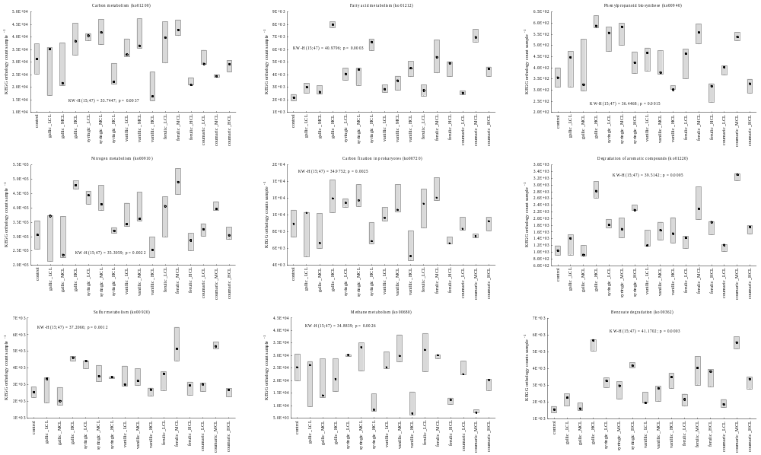
Figure S3

Figure S4a

Figure S4b
Figure S5a
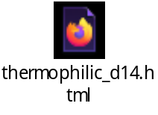

Figure S5b
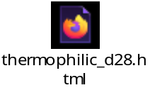
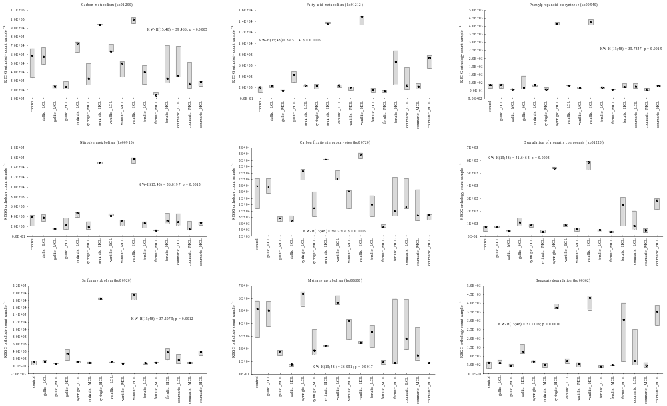
Figure S6

Figure S7
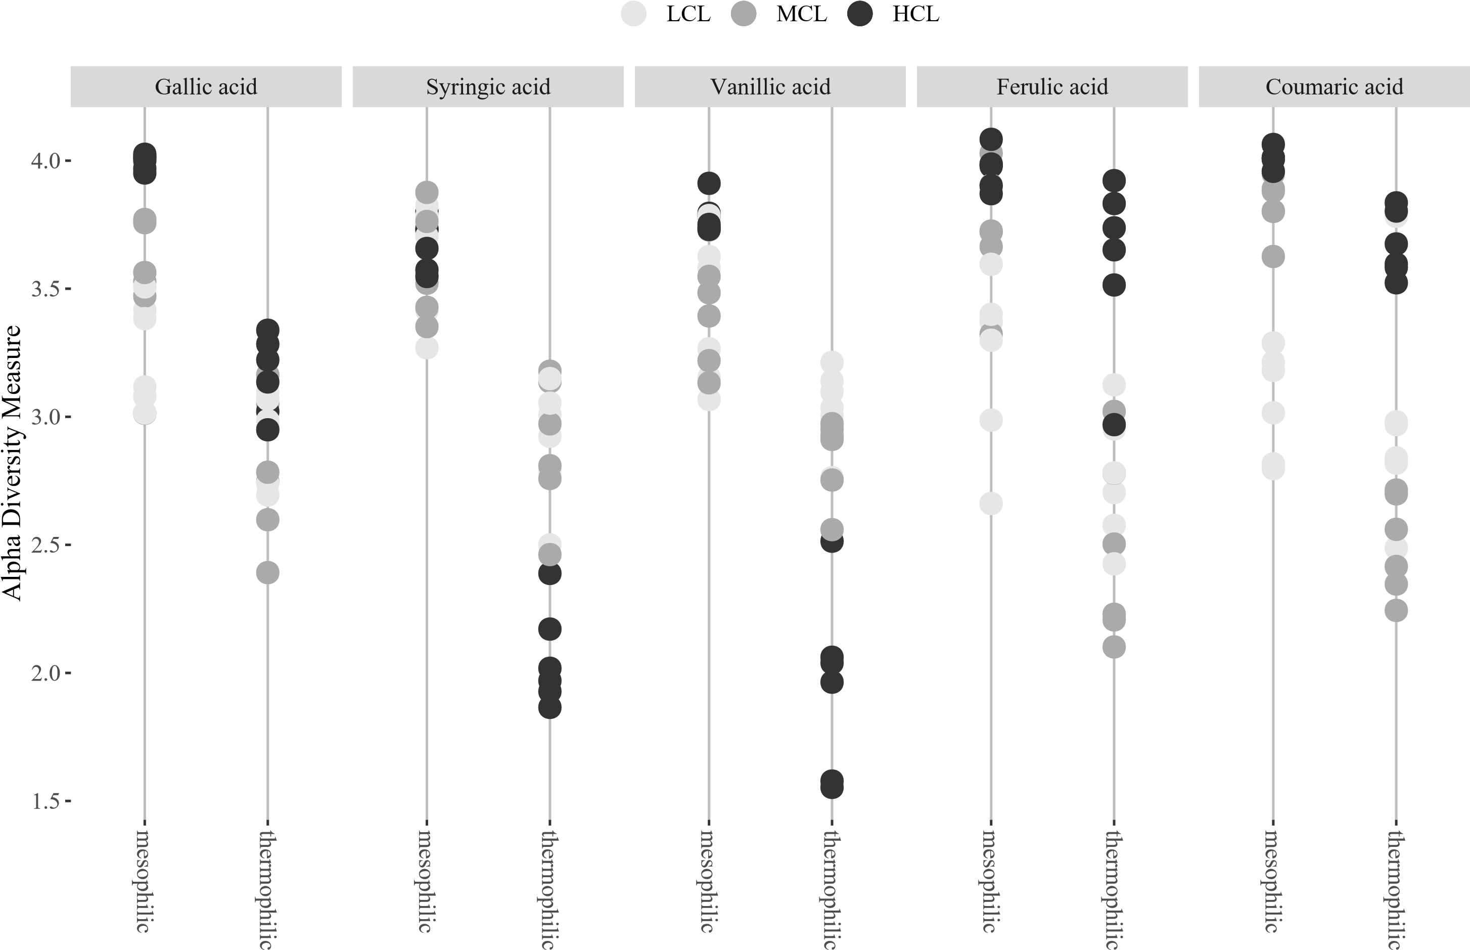
Figure S8a
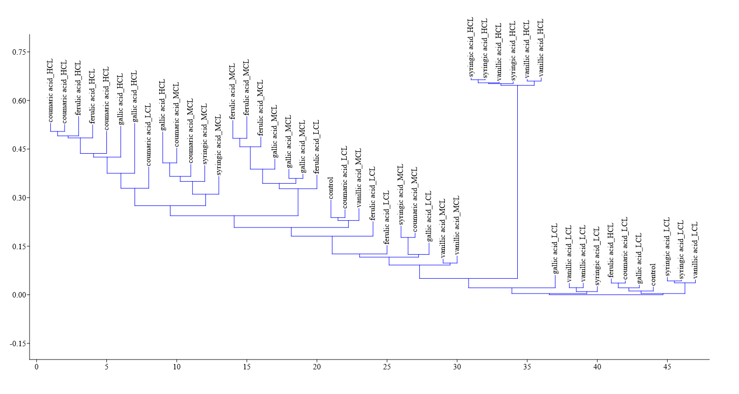
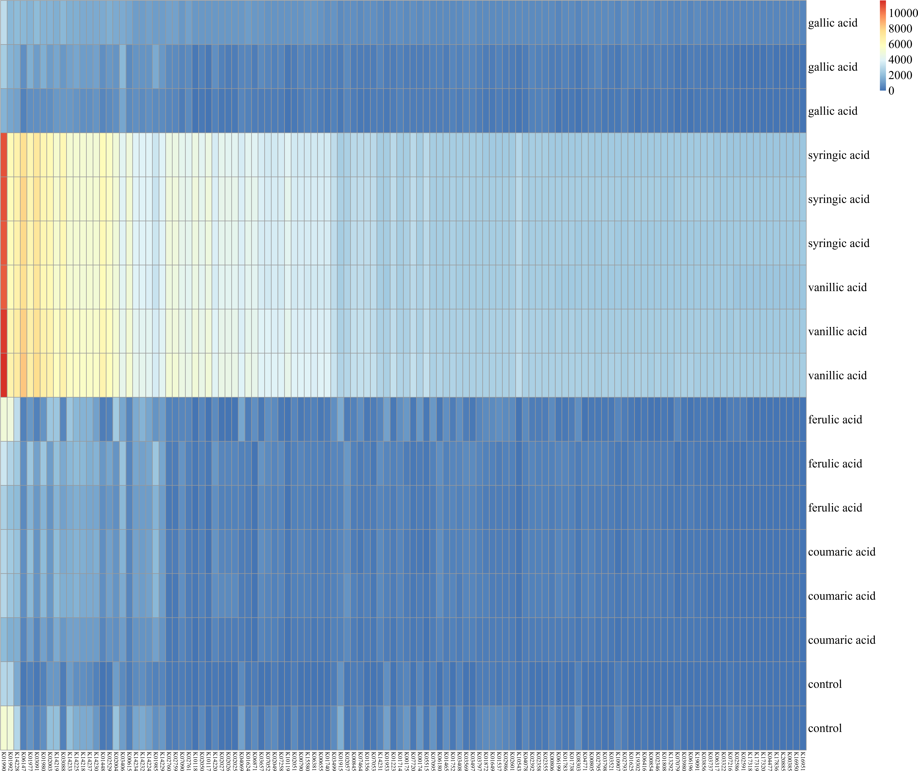
Figure S8b

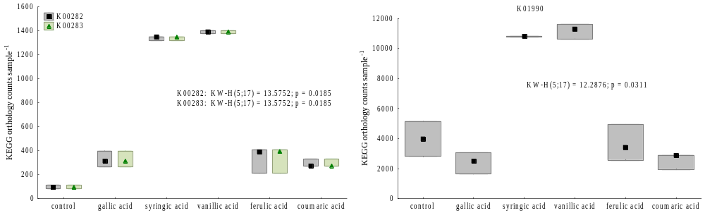
Figure S8c

- Supplementary Discussion
Text S1: KEGG analyses showed that K01990 (ABC-2 type transport system ATP-binding protein) was highly expressed in thermophilic syringic and vanillic HCL samples (Fig. S8b and S8c). The high orthology counts for K01990 (as well as for K00282 and K00283) can be explained by the fact that i) the protein was pre-dominantly associated with Thermoanaerobacterium thermosaccharolyticum and ii) by the dominance of Thermoanaerobacterium spp. in syringic and vanillic HCL samples (Fig. S5). In general, ATP- binding cassette (ABC) transporters are multi-subunit membrane pumps needed to energise the vectorial transfer of various substrates through membranes via ATP binding and hydrolysation [1]. While Thermoanaerobacterium spp. was primarily associated with K01990 in syringic and vanillic HCL samples, the hydrogenotrophic methanogens Methanoculleus bourgensis and M. sp. MAB 1 were responsible for high K01990 expressions in all other samples. This are interesting first insights in the substrate transport mechanisms of anaerobic microbial consortia; however, deeper knowledge is still pending, especially when considering the role of substrate transfer during syntrophic co-operations in anaerobic (methanogenic) systems [2].
- References
1. Rice AJ, Park A, Pinkett HW. Diversity in ABC transporters: Type I, II and III importers. Crit Rev Biochem Mol Biol. 2014;49:426–37. doi:10.3109/10409238.2014.953626.
2. Westerholm M, Moestedt J, Schnürer A. Biogas production through syntrophic acetate oxidation and deliberate operating strategies for improved digester performance. Applied Energy. 2016;179:124–35. doi:10.1016/j.apenergy.2016.06.061.

