HPLC to verify protein purity
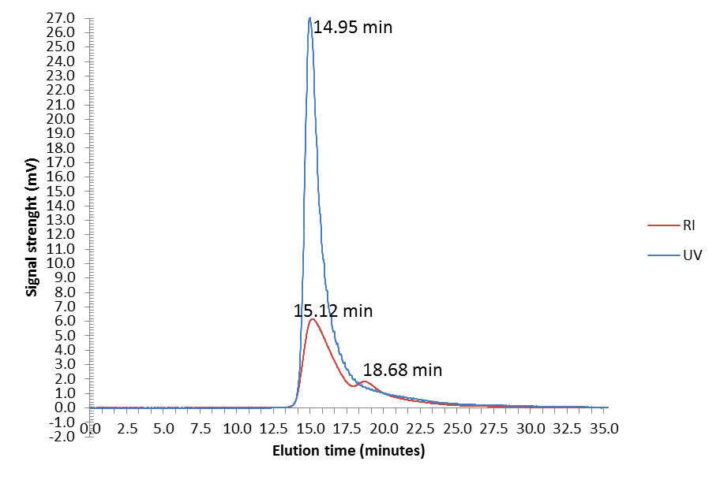
Additional figure 2. TrCBHI HPSEC graph.
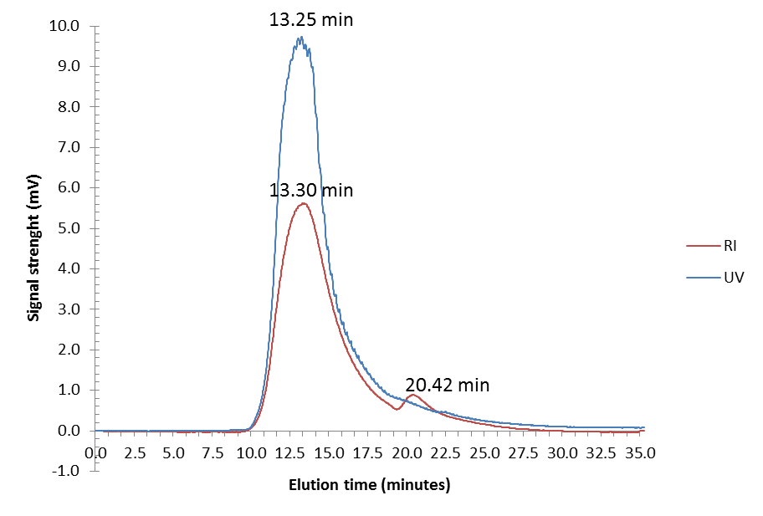
Additional figure 3. ScCBHI Peak 1 HPSEC graph.

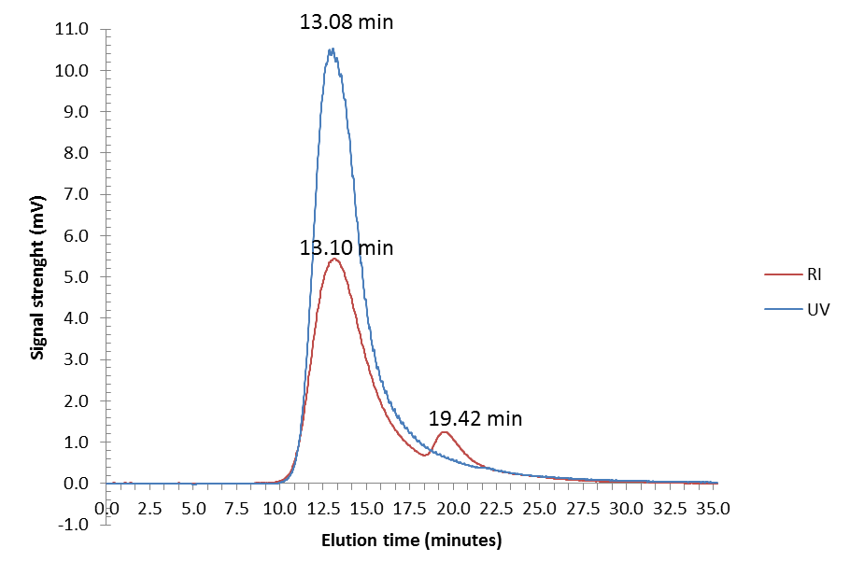
Additional figure 4. ScCBHI Peak 2A HPSEC graph.

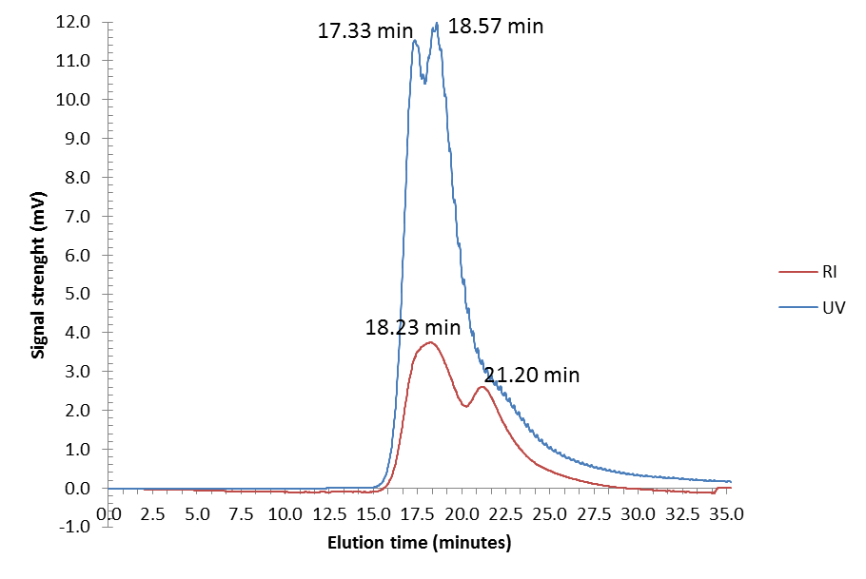
Additional figure 5. ScCBHI Peak 2B HPSEC graph.

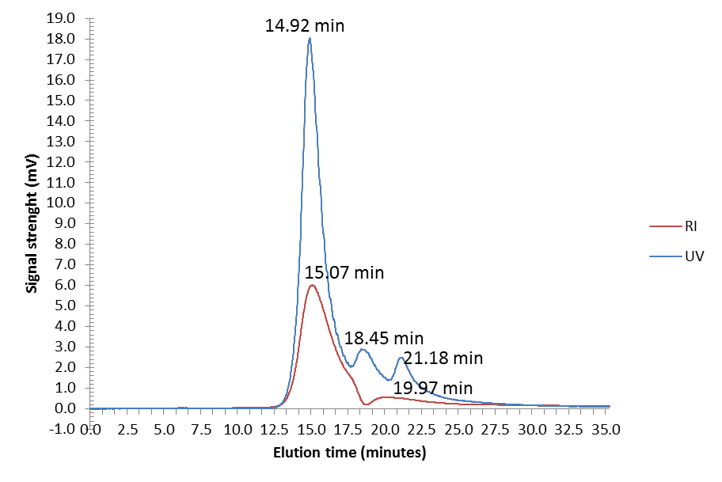
Additional figure 6. YlCBHI HPLC graph.

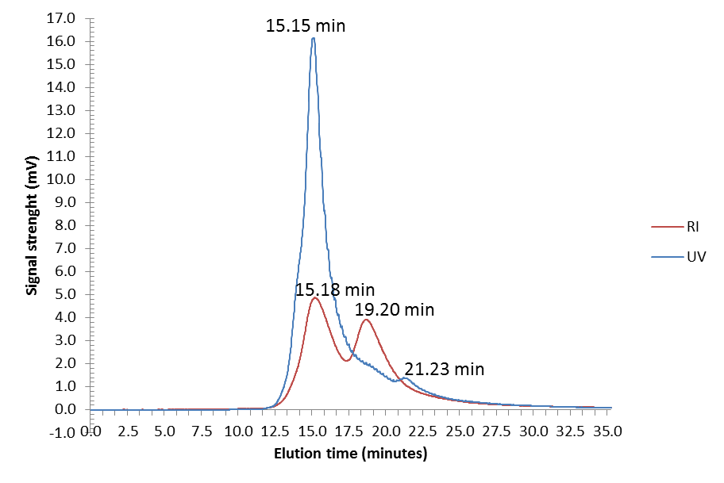
Additional figure 7. LsCBHI HPSEC graph.

