Additional file 2 Figure S2
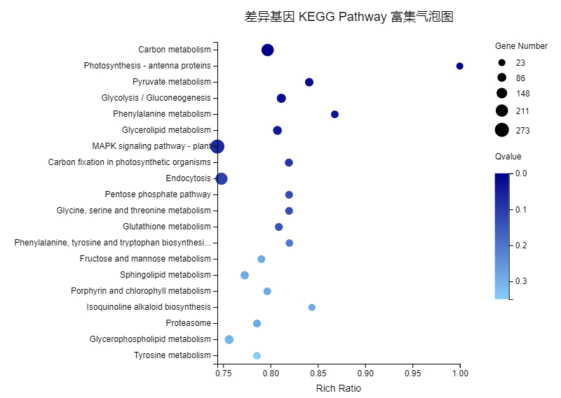
Figure S2 Pathway functional enrichment of DEGs
X axis represents enrichment factor. Y axis represents pathway name. The color indicates the q-value (high: white, low: blue), a lower q-value indicates more significant enrichment. Point size indicates DEG number. Rich Factor refers to the value of enrichment factor, which is the quotient of foreground value (the number of DEGs) and background value (total gene amount). The larger the value, the more significant enrichment.

