Additional file 5 Sup. Figure 3

A
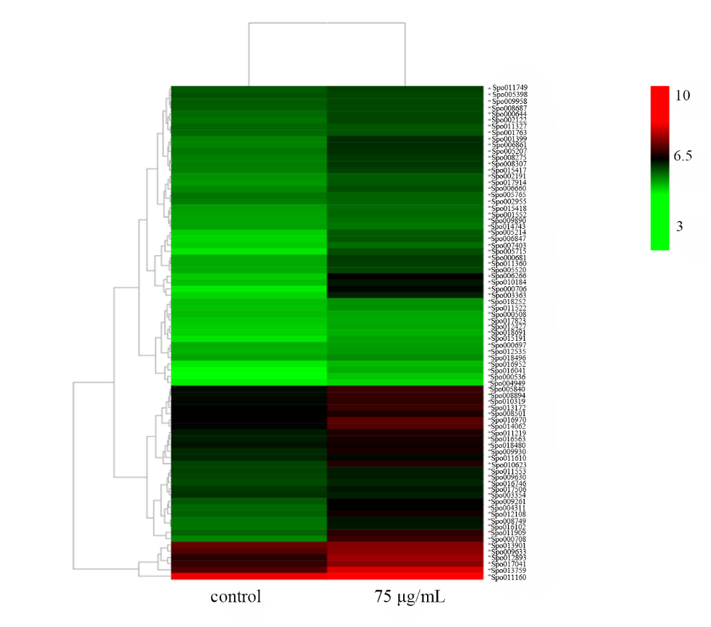
B
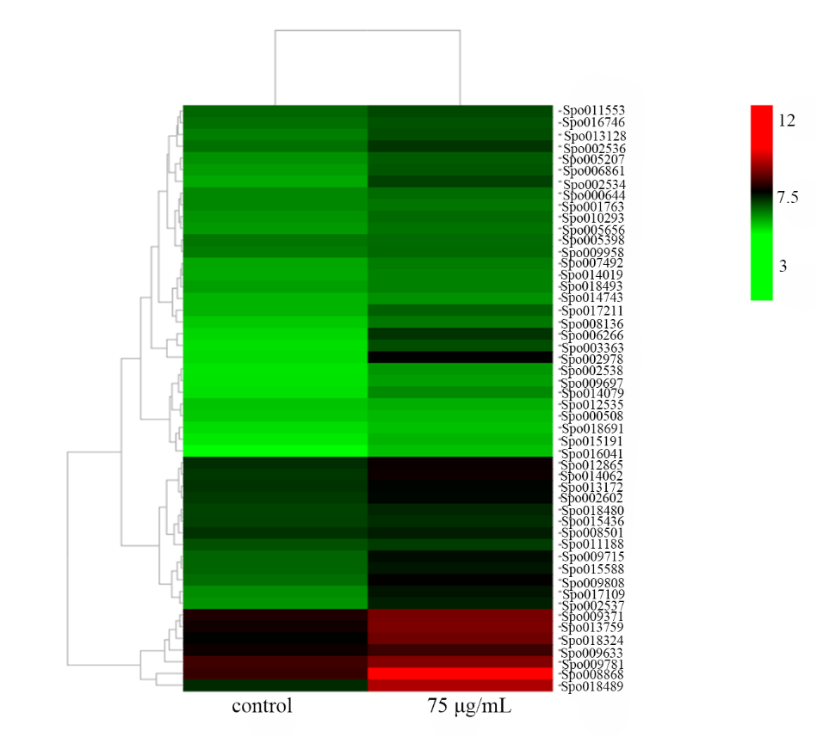
C
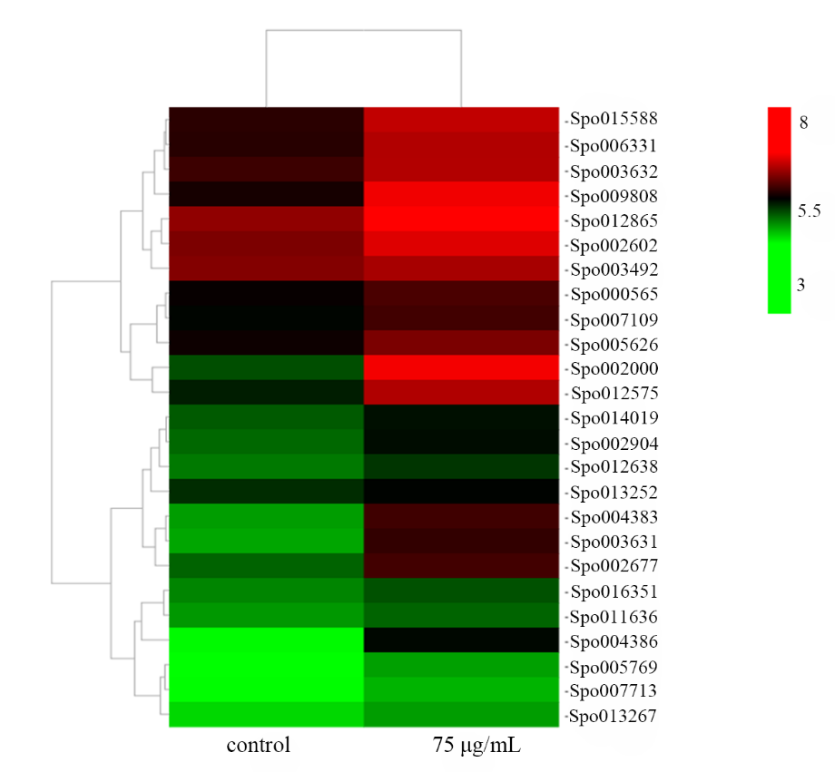
D
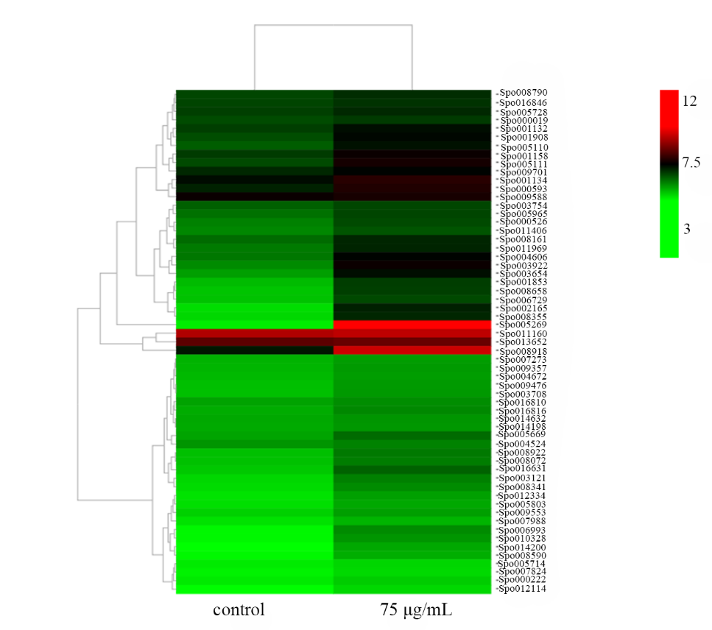
E
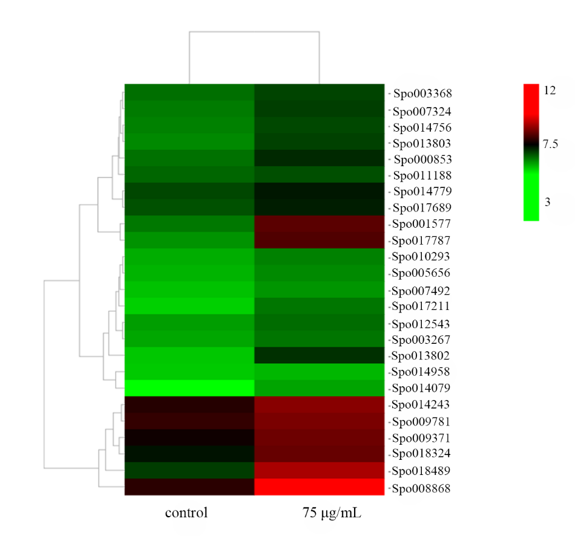
Fig.3 Main pathway expression heatmap of DEGs classified by KEGG
A. Carbon metabolism; B. Glycolysis gluconeogenesis; C. Glycerolipid metabolism; D. MAPK; E. Carbon fixation. Information of these genes in the heatmap was list in the Additional file 10-14, respectively.

