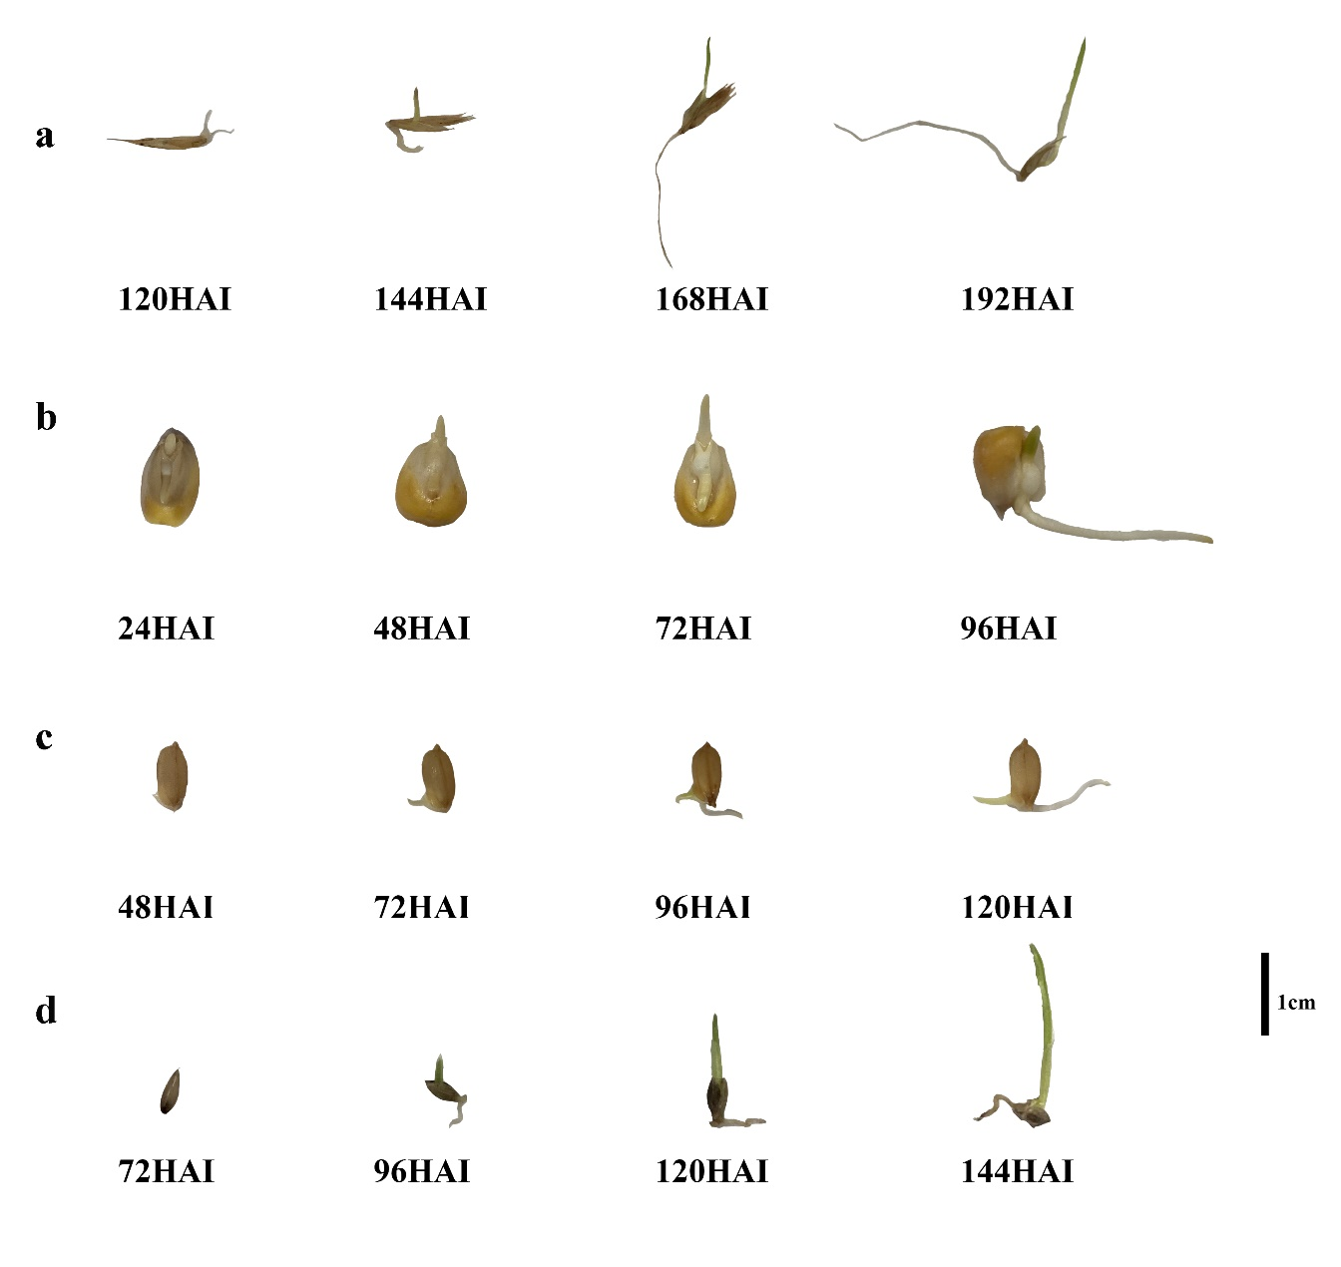
Figure S1 Morphological changes of four other plants seeds from dry seed to seedling. a. Orchardgrass b. Maize c. Rice d. Switchgrass. Note: Due to the different germination time of the four kinds of plants and limited space, we only provide photos from the emergence of the germ to the next three days
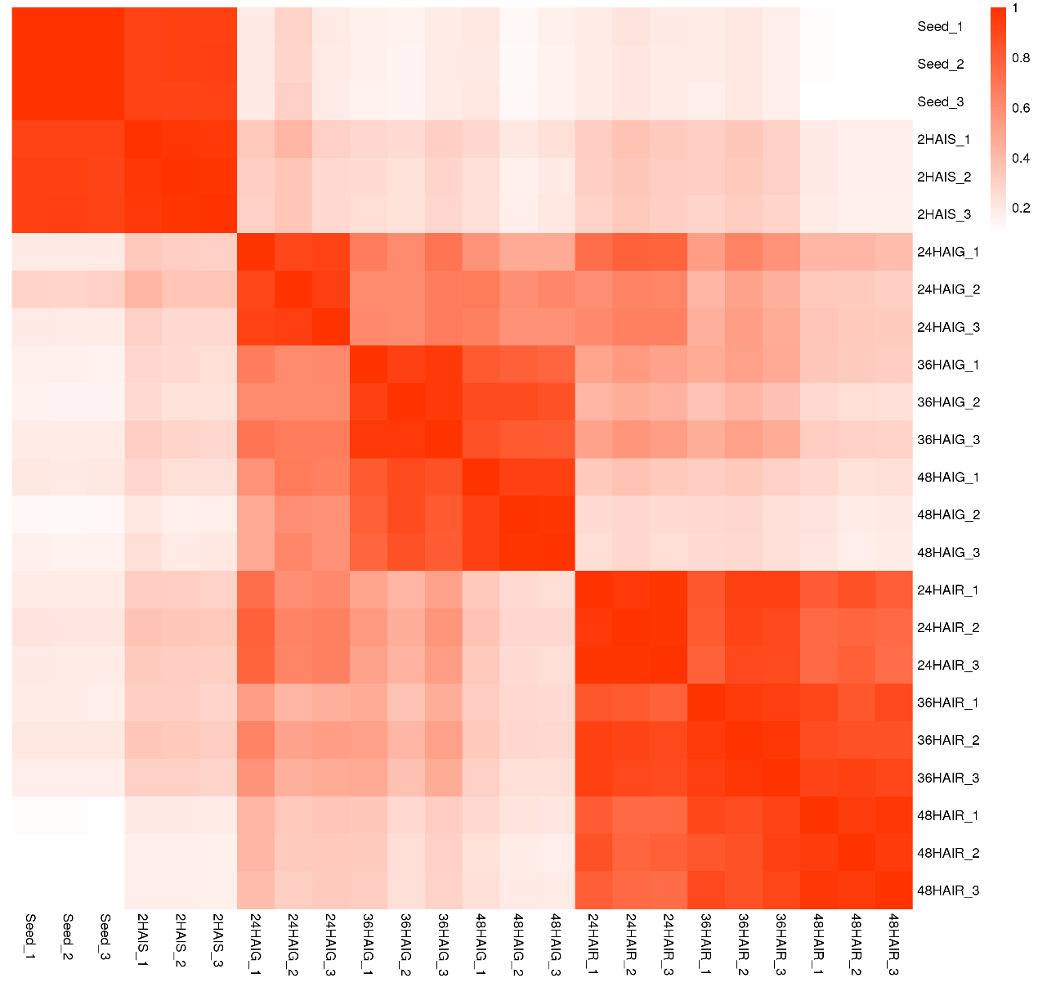
Figure S2 Correlation between different samples

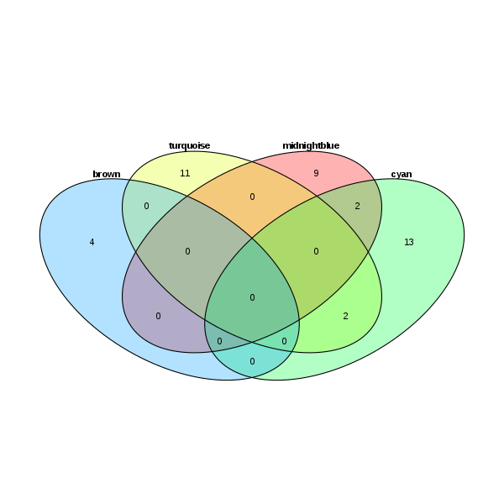
Figure S3 Number of pathways shared among the four modules “brown”, “turquoise”, “midnightblue” and “cyan”

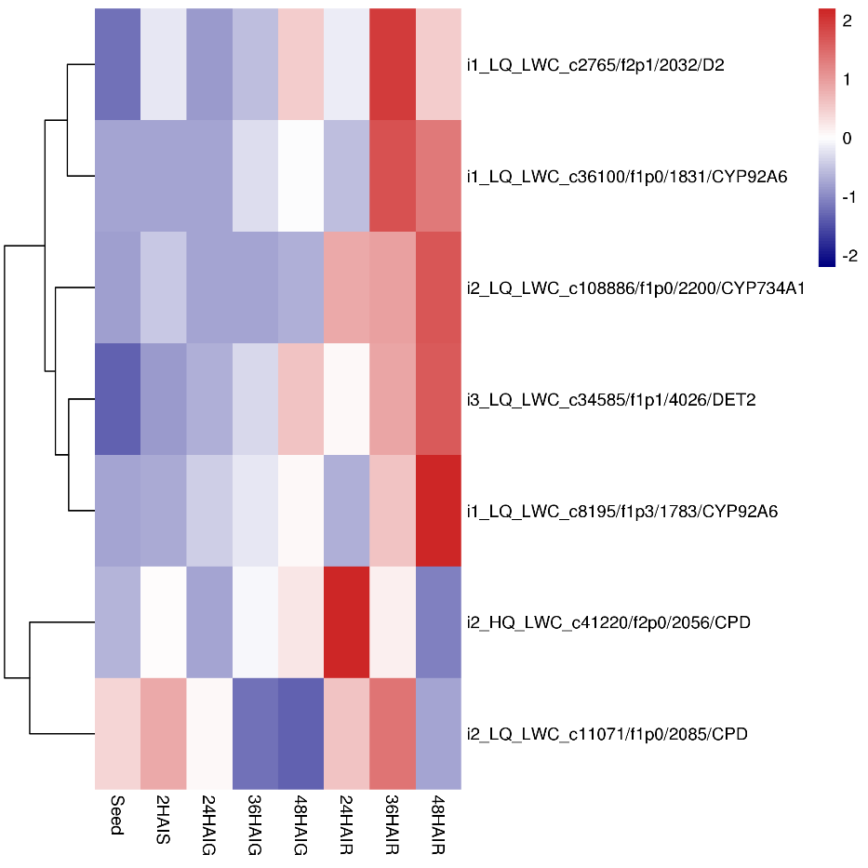

Figure S4 Heat map of genes expression related to brassinosteroid biosynthesis. The expression data are the TPM values of the samples, red color indicates upregulated expression, and blue indicates downregulated expression

