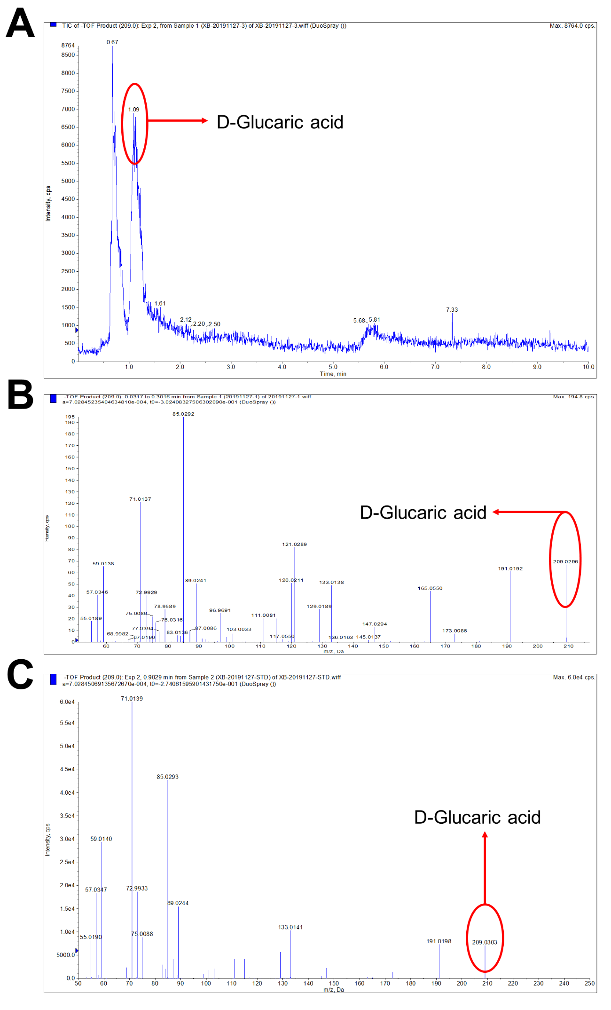
Fig. S1. Results of liquid chromatography–mass spectrometry (LC-MS) analysis. (A) LC and (B) MS graphs of the fermentation broth of S. cerevisiae LGA-1 after 7 d of fed-batch fermentation in YPD medium supplemented with 10 g/L glucose and 10.8 g/L myo-inositol. (C) MS graph of the standard of D-glucaric acid.

