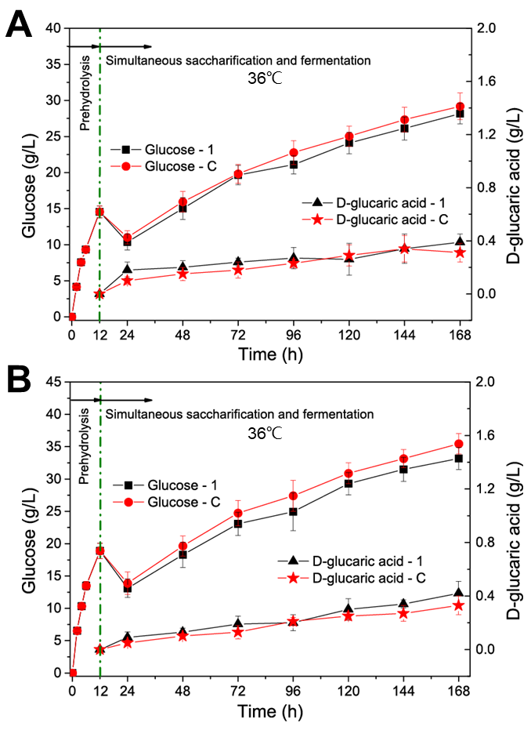
Fig. S3. Simultaneous saccharification and fermentation of (A) Avicel and (B) SECS at 36°C from 12 to 168 h after enzymatic pre-hydrolysis at 50°C for 12 h. LGA-1 and LGA-C are the engineered S. cerevisiae strains capable of producing D-glucaric acid. The data shown here are average values of at least three biological replicates, and the error bars represent standard deviations.

