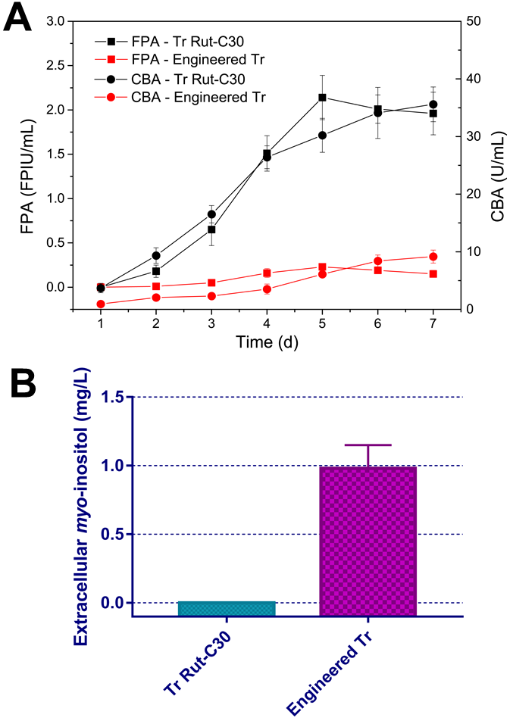
Fig. S7. (A) FPAs and CBAs during fermentation on 15 g/L Avicel by T. reesei Rut-C30 and the engineered T. reesei for myo-inositol production. (B) Concentrations of myo-inositol after 5 d of fermentation. The data shown here are average values of at least three biological replicates, and the error bars represent standard deviations.

