Additional file 1.
Homologous sequences of transcription-elongation factor-alpha and beta-tubulin genes used for identifying the strain as T. terrestris LPH172.

Method

First, homologues of these genes from ascomycetous filamentous fungi were looked up in GenBank (KM655459.1 and M38265.1), then blasted with the T. terrestris NRRL 8126 coding sequences to find the matching homologues in T. terrestris (Thite2|2111611 and Thite2|2149383). Lastly, the homologues from NRRL 8126 were blasted with the T. terrestris LPH172, giving the results described in the article.

The TEF1 homologue in T. terrestris LPH172:
>THTET00000002213 gene=THTEG00000002213 name=tef seq_id=unitig_0|quiver type=cds
ATGGGCAAGGAAGACAAGACCCACATCAACGTGGTCGTCATCGGCCACGTCGACTCTGGC
AAGTCCACGACGACTGGTCACTTGATCTACAAGTGCGGTGGTATCGACTCCCGTACCATC
GAGAAGTTCGAGAAGGAAGCTGCCCAGCTCGGCAAGGGCTCCTTCAAGTATGCGTGGGTT
CTCGACAAGCTCAAGGCTGAGCGTGAGCGTGGTATCACCATCGATATCGCCCTCTGGAAG
TTCGAGACCCCCAAGTACATGGTCACTGTCATCGATGCCCCCGGCCATCGTGACTTCATC
AAGAACATGATCACTGGTACTTCCCAGGCCGACTGCGCTATTCTCATCATTGCCGCCGGT
ACTGGTGAGTTCGAGGCTGGTATCTCCAAGGATGGCCAGACTCGTGAGCACGCTCTGCTT
GCCTACACCCTGGGTGTCAAGCAGCTCATCGTCGCCATCAACAAGATGGACACGACCAAC
TGGTCCGAGGCTCGGTTCAACGAGATCATCAAGGAGACCTCGAACTTCATCAAGAAGGTC
GGCTACAACCCCAAGTCGGTCGCCTTCGTCCCCATCTCCGGCTTCCACGGCGACAACATG
CTGGAGCCCTCCGCCAACGCTCCCTGGTACAAGGGCTGGGAGAAGGAGGTCAAGAACGGC
AAGGTCACCGGCAAGACCCTCCTTGAGGCCATTGACGCCATCGAGCCCCCCAAGCGCCCC
ACCGACAAGCCCCTCCGCCTTCCTCTGCAGGATGTGTACAAGATCGGCGGTATCGGCACT
GTCCCTGTCGGCCGTATTGAGACCGGTATCCTGAAGCCCGGCATGGTTGTTACCTTCGCC
CCTTCGAACGTCACCACTGAAGTCAAGTCCGTCGAGATGCACCACGAGTCGCTCGCTGAG
GGTGTTCCGGGCGACAACGTCGGCTTCAACGTGAAGAACGTTTCCGTCAAGGAAATCCGC
CGCGGCAACGTTGCCGGCGACTCCAAGAACGACCCTCCTGCTGGCGCCGCTTCCTTCGAG
GCCCAGGTCATCATTCTCAACCACCCCGGTCAGGTCGGCGCTGGCTATGCCCCCGTCCTC
GACTGCCACACCGCGCACATTGCCTGCAAGTTCGCTGAGCTCCTCCAGAAGATCGACCGC
CGCACTGGTAAGGCCGTCGAGGACAACCCCAAGTTCATCAAGTCTGGCGATGCCGCCATC
GTCAAGATGATTCCCTCGAAGCCCATGTGCGTGGAGGCTTTCACCGAGTACCCTCCCCTT
GGTCGTTTCGCCGTCCGCGACATGCGTCAAACCGTCGCCGTCGGTGTCATCAAGAAGGTT
GAGAAGGCTGCTGCCGGTGCCGGCAAGGTCACCAAGTCCGCTGTCAAGGCCTCCAAGAAA
TAA

The beta-tubulin homologue in T. terrestris LPH172:
>THTET00000009462 gene=THTEG00000009462 name=tub-2 seq_id=unitig_90|quiver type=cds
ATGCGTGAGATCGTTCACCTCCAGACCGGCCAATGCGGTAACCAAATTGGTGCCGCTTTT
TGGCAGACCATCTCGGGCGAGCACGGCCTTGACAGCAATGGCGTGTACAATGGCACCTCC
GAGCTCCAGCTCGAGCGCATGAACGTCTACTTCAACGAGGCCTCCGGCAACAAGTATGTC
CCTCGTGCCGTCCTCGTCGACCTGGAGCCCGGCACCATGGATGCCGTCCGCGCTGGACCC
TTCGGCCAGCTCTTCCGCCCTGACAACTTCGTCTTCGGCCAGTCCGGTGCTGGCAACAAC
TGGGCCAAGGGTCACTACACCGAGGGTGCCGAGCTCGTGGACCAGGTCCTCGATGTCGTC
CGTCGCGAGGCCGAGGGCTGCGACTGCCTCCAGGGCTTCCAGATCACCCACTCGCTCGGT
GGTGGTACCGGTGCCGGTATGGGTACCCTCCTGATCTCCAAGATCCGCGAGGAGTTCCCC
GACCGCATGATGGCCACCTTCTCGGTCGTGCCCTCGCCCAAGGTCTCCGACACGGTCGTC
GAGCCTTACAACGCCACTCTCTCGGTGCACCAGCTGGTCGAAAACTCGGACGAGACCTTC
TGCATTGACAACGAGGCCCTCTACGACATCTGCATGCGCACCCTGAAGCTGTCGAACCCC
TCGTACGGTGACCTCAACTACCTGGTCTCGGCCGTCATGTCGGGCGTCACCGTCTCGCTG
CGCTTCCCCGGCCAGCTCAACTCGGACCTTCGCAAGCTGGCCGTCAACATGGTTCCTTTC
CCGCGTCTCCACTTCTTCATGGTTGGCTTCGCGCCTCTGACCAGCCGTGGCGCCCACTCG
TTCCGCGCCGTCTCCGTTCCTGAGTTGACCCAGCAGATGTTCGACCCCAAGAACATGATG
GCTGCGTCCGACTTCCGCAATGGTCGCTACCTCACCTGCTCTGCCATCTTCCGTGGCAAG
GTCTCCATGAAGGAGGTTGAGGACCAGATGCGCAACGTCCAGAACAAGAACTCGTCCTAC
TTTGTCGAGTGGATCCCGAACAACGTCCAAACGGCGCTGTGCTCGATCCCGCCGCGCGGT
CTCAAGATGTCGTCGACCTTCGTCGGCAACTCGACGGCCATCCAGGAGCTGTTCAAGCGT
GTTGGCGAGCAGTTCACGGCCATGTTCCGCCGCAAGGCCTTCTTGCACTGGTACACTGGC
GAAGGCATGGACGAGATGGAGTTCACCGAGGCCGAGTCCAACATGAACGATCTCGTCTCG
GAGTACCAGCAGTACCAGGATGCTGGCGTCGACGAGGACGAGGAGGGTTATGAGGAGGAG
GTTCCTGTCGAGCAGGAGGAGTAA

Phylogenetic analysis
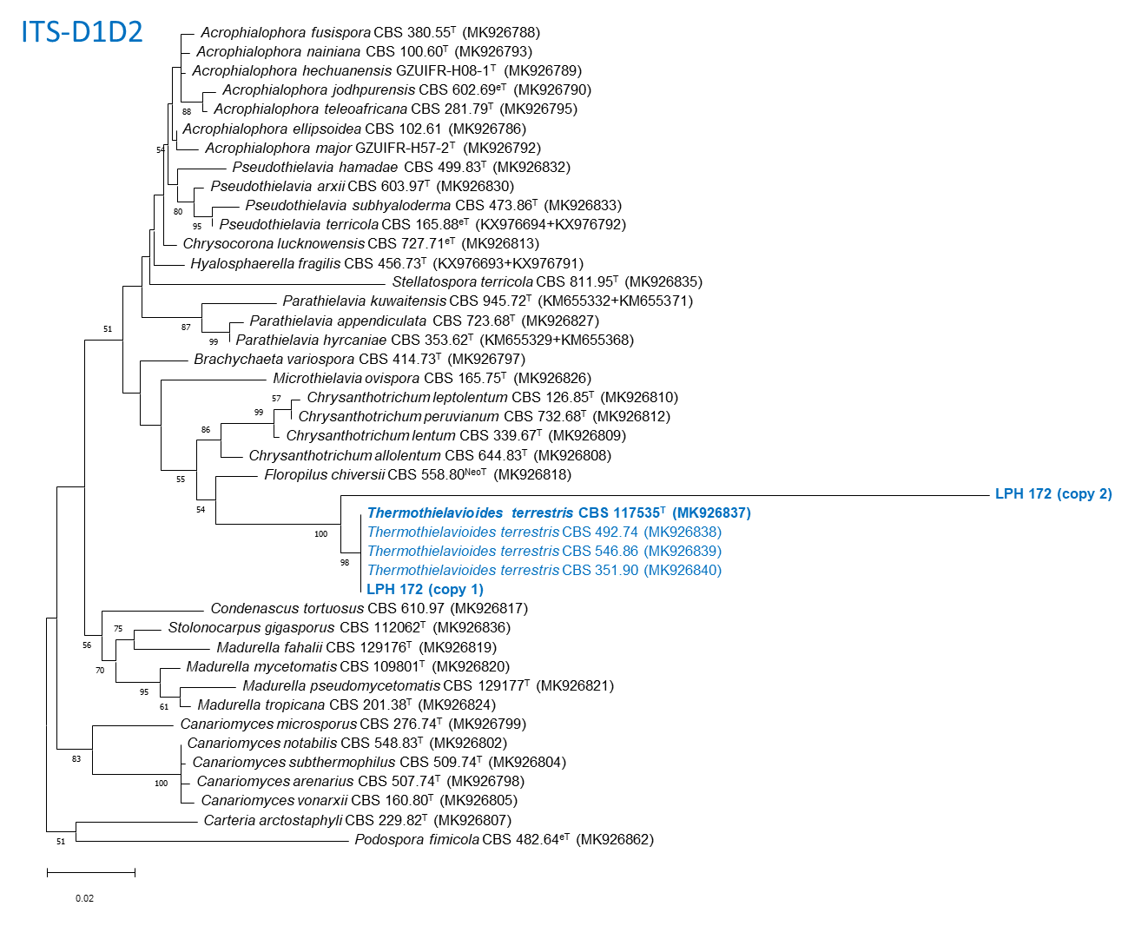

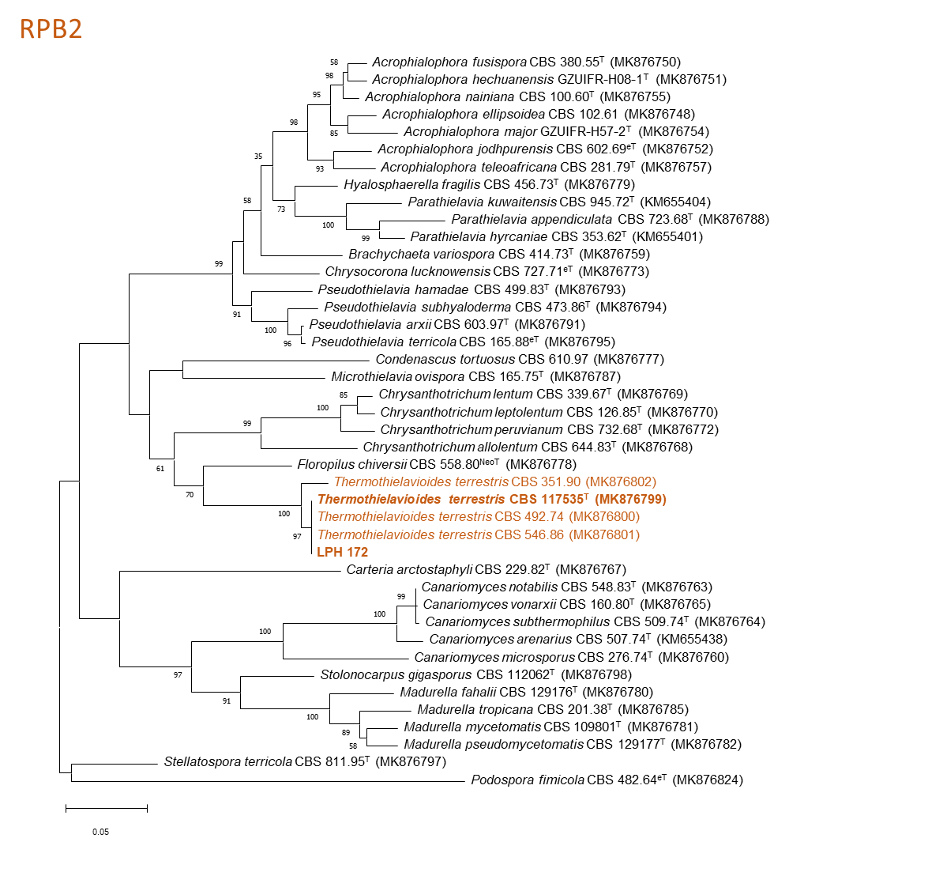

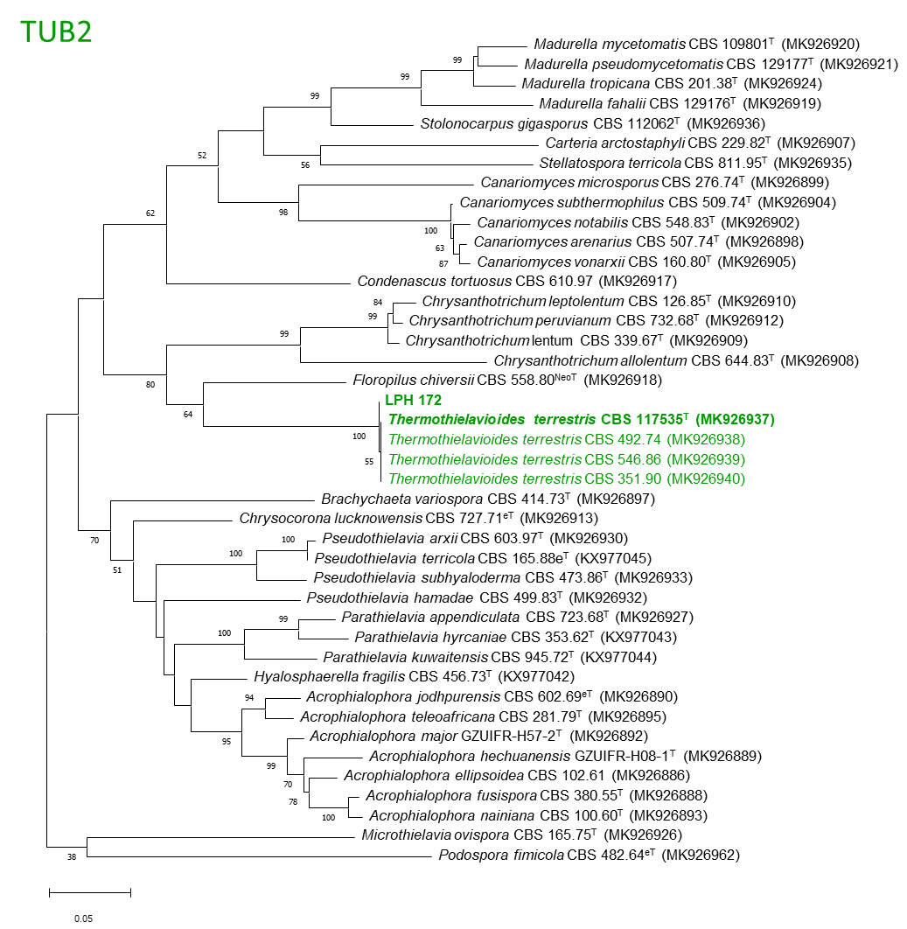
Fig S1. Maximum Likelihood trees depicting the relationship between LPH 172 and related taxa of Chaetomiaceae. The trees were constructed based on the ITS-D1D2 (internal transcribed spacer and the D1D2 domains of the 28S nrDNA), RPB2 (a part of the DNA-directed RNA polymerase II second largest subunit gene), and TUB2 (the β-tubulin gene) sequences using Maximum Likelihood method and Tamura-Nei model [1]. Bootstrap values of >50 %, obtained from 1000 replications, are shown. All positions with less than 95% site coverage were eliminated. GenBank accession numbers of the sequences are given in parentheses. Evolutionary analyses were conducted in MEGA X [2].
Note: LPH 172 sequences were extracted from the genome of the strain. There are two types of ITS-D1D2 sequences detected (“copy 1” and “copy 2”). Transcriptome analysis indicated that “copy 2” was most likely a pseudogene as it was not transcribed (while “copy 1” did). ITS-D1D2 (copy 1) and RPB2 sequences of LPH 172 were identical with the ones of CBS 117535T, the type strain of Thermothielavioides terrestris. There was single difference in the TUB2 sequence between two strains. Thus, LPH 172 could be reliably placed under Thermothielavioides terrestris.

1. Tamura K. and Nei M. (1993). Estimation of the number of nucleotide substitutions in the control region of mitochondrial DNA in humans and chimpanzees. Molecular Biology and Evolution 10:512-526.
2. Kumar S., Stecher G., Li M., Knyaz C., and Tamura K. (2018). MEGA X: Molecular Evolutionary Genetics Analysis across computing platforms. Molecular Biology and Evolution 35:1547-1549.

