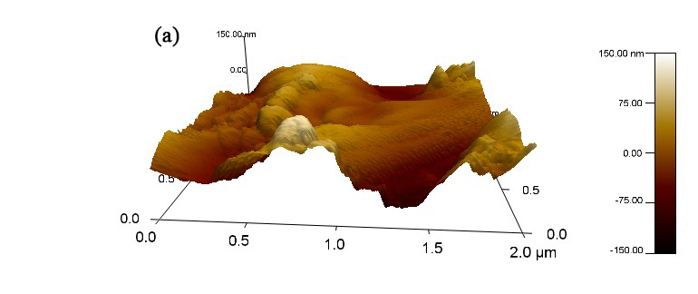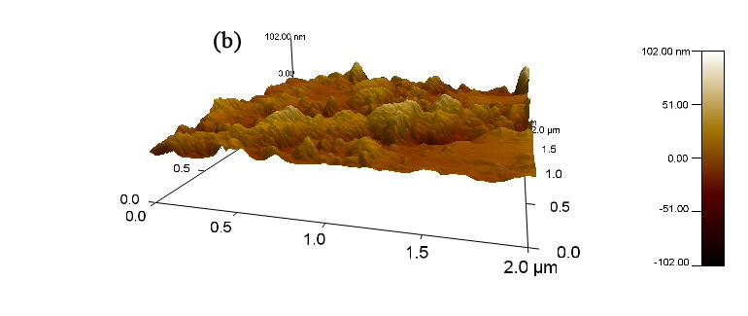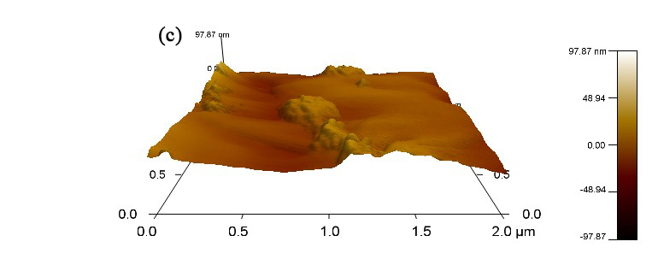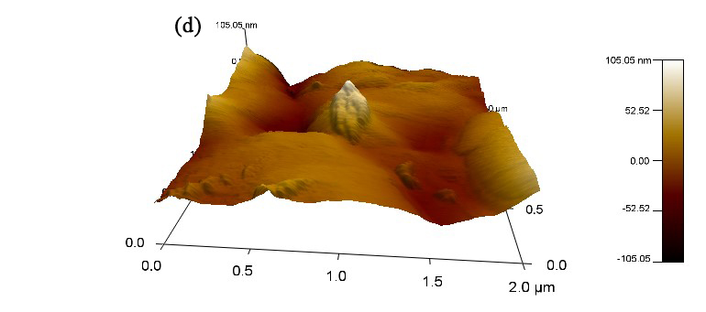
Fig. S1 The 3D AFM images of pretreated bamboo residues (a), DAP-BR (b), Dio-BR (c), Eth-BR and (d), THF-BR

