Glutamine Involvement in Nitrogen Regulation of Cellulase Production in Fungi

Ai-Ping Pang,¹ Funing Zhang,¹ Xin Hu,¹ Yongsheng Luo,¹ Haiyan Wang,¹ Samran Durrani,¹ Fu-Gen Wu,¹ Bingzhi Li,² Zhihua Zhou,³ Zuhong Lu,^{1*} Fengming Lin,^{1*}

¹State Key Laboratory of Bioelectronics, School of Biological Science and Medical Engineering, Southeast University, Nanjing, China
²Key Laboratory of Systems Bioengineering (Ministry of Education), School of Chemical Engineering and Technology, Tianjin University, Tianjin, China
³Key Laboratory of Synthetic Biology, Institute of Plant Physiology and Ecology, Shanghai Institutes for Biological Sciences, Chinese Academy of Sciences, Shanghai, China

*Correspondence: linfengming@seu.edu.cn; zhlu@seu.edu.cn

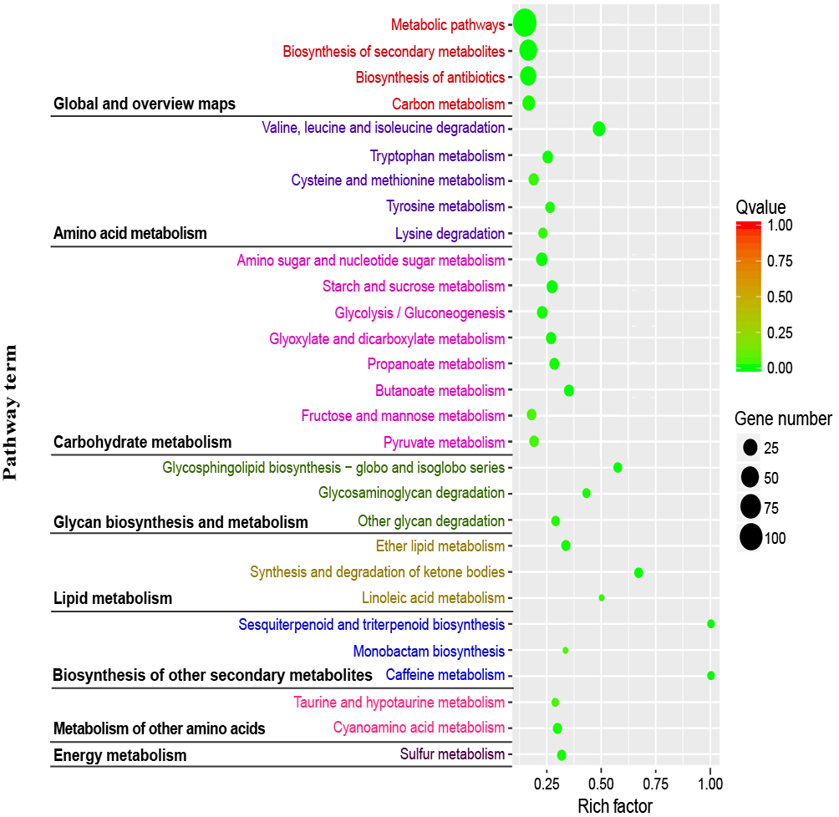
Figure S1 Kyoto Encyclopedia of Genes and Genomes (KEGG) enrichment analysis of DEGs. The y axis represents the name of the most enriched pathways.

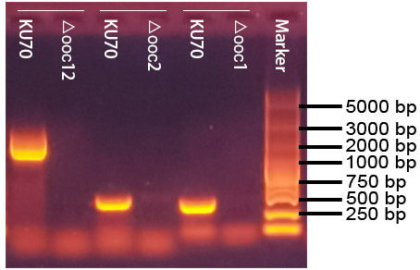
Figure S2 PCR confirmation of recombinant T. reesei strains △ooc1, △ooc2, and △ooc12. T. reesei KU70 was used as the negative control.

