Supplementary Information
Lingling Sun^{1,2}, Bo Wu¹, Zengqin Zhang^{1,2}, Jing Yan¹, Panting Liu^{1,2}, Chao Song^{1,2}, Samina Shabbir^{1,2}, QiliZhu¹, Shihui Yang³, Nan Peng⁴, Mingxiong He^{1,5*}, Furong Tan^{1*}
¹ Key Laboratory of Development and Application of Rural Renewable Energy, Ministry of Agriculture and Rural Affairs, Biogas Institute of Ministry of Agriculture and Rural Affairs, Chengdu 610041, China
² Graduate School of Chinese Academy of Agricultural Sciences, Beijing 100081, China
³ Hubei Collaborative Innovation Center for Green Transformation of Bio-resources, Environmental Microbial Technology Center of Hubei Province, Hubei Key Laboratory of Industrial Biotechnology, College of Life Sciences, Hubei University, Wuhan 430062, China
⁴ State Key Laboratory of Agricultural Microbiology, College of Life Science and Technology, Huazhong Agricultural University, Wuhan 430070, China
⁵ Chengdu National Agricultural Science and Technology Center, Chengdu 610221, China
Correspondence:
Mingxiong He: hemingxiong@caas.cn
Furong Tan: tanfurong@caas.cn
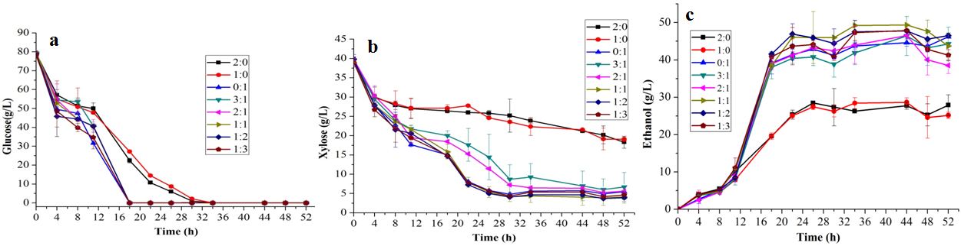
Fig. S1 Fermentation profiles of consortia consisting of S. stipitis CICC1960 and Z. mobilis 8b in 80G40XRM with “low amount” inoculums of fermentations. a Glucose assimilation profiles. b Xylose assimilation profiles. c Ethanol production profiles. Data are mean ± standard error from four replicates

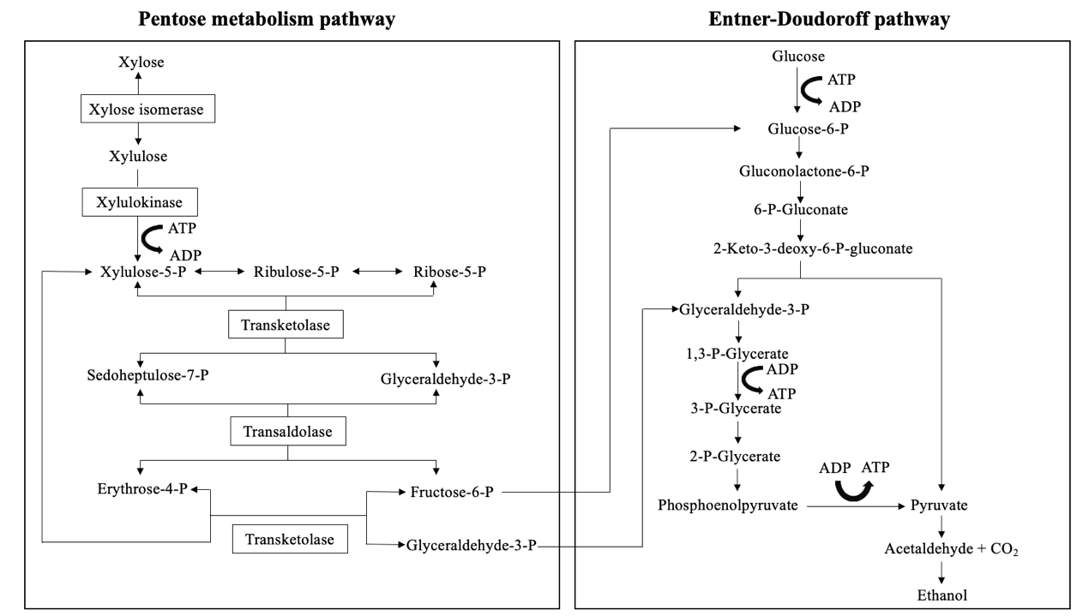
Fig. S2 Pentose metabolism and Entner-Doudoroff pathways in engineered Z. mobilis(1)

Table S1 Fermentation profiles of consortia consisting of S. stipitis CICC1960 and Z. mobilis 8b in 80G40XRM
ª S. stipitis CICC1960 : Z. mobilis 8b | Glucose consumption (g/L) | Xylose consumption (g/L) | Ethanol
ª S. stipitis CICC1960 : Z. mobilis 8b | Glucose consumption (g/L) | Xylose consumption (g/L) | Titer  (g/L) | Yield  (g/g) | Productivity (g/L/h)
1:0 | 76.29 ± 2.50 | 12.71 ± 0.81 | 38.56 ± 0.29 | 0.43 ± 0.01 | 4.28 ± 0.03
0:1 | 76.29 ± 2.50 | 34.81 ± 0.55 | 53.71 ± 2.03 | 0.48 ± 0.02 | 5.10 ± 0.17
3:1 | 76.29 ± 2.50 | 21.93 ± 1.03 | 49.22 ± 0.49 | 0.50 ± 0.01 | 4.20 ± 0.08
2:1 | 76.29 ± 2.50 | 28.23 ± 0.54 | 52.70 ± 0.75 | 0.50 ± 0.00 | 4.47 ± 0.10
1:1 | 76.29 ± 2.50 | 36.60 ± 0.48** | 55.76 ± 1.11 | 0.49 ± 0.01 | 4.86 ± 0.16
1:2 | 76.29 ± 2.50 | 37.06 ± 0.17** | 54.84 ± 2.18 | 0.48 ± 0.02 | 5.02 ± 0.04
1:3 | 76.29 ± 2.50 | 36.73 ± 0.48** | 57.21 ± 1.73 | 0.50 ± 0.01 | 4.99 ± 0.09
Data are mean ± standard error from four replicates. A significant difference was determined using a one-way ANOVA followed by the T-test. Asterisks indicate that this group data was significantly higher than that in Z.mobilis 8b mono-fermentation (none, P > 0.05; **, P < 0.01)
ªS. stipitis CICC1960 : Z. mobilis 8b represent the initial inoculum proportion between the two species

Table S2 Fermentation profiles of Z. mobilis 8b, Z. mobilis FR1, and Z. mobilis FR2 in 80G40XRM
Strain | Glucose consumed (g/L) | Xylose consumed (g/L) | Ethanol
Strain | Glucose consumed (g/L) | Xylose consumed (g/L) | Titer (g/L) | Yield (g/g) | Productivity (g/L/h)
Z. mobilis 8b | 72.95 ± 0.73 | 31.38 ± 0.42 | 49.75 ± 0.16 | 0.48 ± 0.00 | 4.84 ± 0.01
Z. mobilis FR1 | 72.95 ± 0.73 | 30.99 ± 0.33 | 47.94 ± 1.56 | 0.46 ± 0.01 | 4.87 ± 0.00
Z. mobilis FR2 | 72.95 ± 0.73 | 36.20 ± 0.33** | 53.14 ± 1.06 | 0.49 ± 0.01 | 5.08 ± 0.00**
Data are mean ± standard error from four replicates. A significant difference was determined using a one-way ANOVA followed by the T-test, if P > 0.05 in the test of homogeneity of variances. Otherwise, significant difference was determined by a nonparametric test (Kruskal-Wallis H). Asterisks indicate that the group data was significantly higher than that in Z. mobilis 8b fermentation (none, P > 0.05; **, P < 0.01)

Table S3 Strains, plasmids, and sgRNAs used in this study
Strain, plasmid or sgRNA | Characteristic |  | Source
Strain
Z. mobilis 8b | Having exogenous xylose-metabolic pathway | Kindly given by Shihui Yang, Hubei University (2)
Z. mobilis FR1 | Derived from Z. mobilis 8b; ZMO0256::P_{pdc}-talB-tktA |  | This study
Z. mobilis FR2 | Derived from Z. mobilis FR1; ZMO0689::P_{pdc}-xylA-xylB |  | This study
S. stipitis CICC1960 |  |  | China Center of Industrial Culture Collection
E. coli trans110 |  |  | TransGen Biotech
Plasmid
Pmini | addA |  | Kindly given by Nan Peng, Huazhong Agricultural University (3)
Pmini-P_{pdc}-talB-tktA | Derived from Pmini; carrying sgRNA (ZMO0256), ZMO0256up500, P_{pdc}-talB-tktA and ZMO0256down500 |  | This study
Pmini-P_{pdc}-xylA-xylB | Derived from Pmini; carrying sgRNA (ZMO0689), ZMO0689up540, P_{pdc}-xylA-xylB and ZMO0689down500 |  | This study
Table S3 (continued)
sgRNA
sgRNA (ZMO0256) | AGATACAGAAGATTTTCTGGTACCGTTCACTGCCGCACAGGCAGCTTAGAAAGACATGGGAATGAAACAGAAAATCAGCAATTTGTTCACTGCCGCACAGGCAGCTTAGAAAGGATCCTCGAACGCGCCGAATAAG | This study
sgRNA (ZMO0689) | AGATACAGAAGATTTTCTGGTACCGTTCACTGCCGCACAGGCAGCTTAGAAAAATGCTGTTTCAGCAACGGATGACAACGCTTCGTTCACTGCCGCACAGGCAGCTTAGAAAGGATCCTCGAACGCGCCGAATAAG | This study

Table S4 Primers used in this study
Primers | Sequence (5’ to 3’)
sgRNA-F | CCATTGTAGATACAGAAGATTTTCTGGTACCG
sgRNA-R | ACCTGAATTACTTATTCGGCGCGTTCGA
Pmini-F | GCCGAATAAGTAATTCAGGTTTTTTTATAAAGACCTG
Pmini-R | CCAGAAAATCTTCTGTATCTACAATGGCTAATTTTATTATTAGAATG
130bp-F | ATTTACGATTGCTCGTCCTAAATAAATAAG
130bp-R | CACTTCACTGACACCCTCATCAGTGCCAAC
Pmini-backbone-F | ACTAGTAGCGGCCGCTGCAG
Pmini-backbone-R | GTCGACACTTGCAGCTTGATATAGCCGGTA
ZMO0256up500-F | TATATCAAGCTGCAAGTGTCGACTTTGATGACGATTGTG
ZMO0256up500-R | AAGGAACGGGACACCTTGAATATATCGACCTTTTATTTTC
ZMO0256down500-F | GTTGATGCAAAGAGGCCCTGCCTTTACG
ZMO0256down500-R | CTGCAGCGGCCGCTACTAGTCTAAGAAAGTATCTTTTCCGT
talB-F | TTTGAATATATGGAGTAAGCAATGACGGACAAATTGACCTCCCT
tktA-R | CAGGGCCTCTTTGCATCAACTTACAGCAGTTCTTTTGC
P_{pdc}-F | TTCAAGGTGTCCCGTTCCTT
Table S4 (continued)
P_{pdc}-R | TGCTTACTCCATATATTCAAAACACTATGTCT
ZMO0256-checkF | TACCACGAAAGGCGGCGTTATTCC
ZMO0256-checkR | GCGAAAAGCTGCGGCAAGCGATC
ZMO0689up540-F | GCTATATCAAGCTGCAAGTGTCGACGTCTTTGCGTCCAGAAAAGACAGCA
ZMO0689up540-R | GAAAAAGGAACGGGACACCTTGAAAATCCTTGTTTCTTTCTTAACTAACC
ZMO0689down500-F | TATCCGTGCTTTCAAAGCCGGCAAGCATGT
ZMO0689down500-R | CTGCAGCGGCCGCTACTAGTGCACCGAGAAACGTGAA
xylA-F | TTTGAATATATGGAGTAAGCAATGCAAGCCTATTTTGACCAGCTCGA
xylB-R | CCGGCTTTGAAAGCACGGATATTACGCCATTAATGGCAGAA
ZMO0689-checkF | ATCAATGGATCTCCGAAGAGGCTT
ZMO0689-checkR | CATCATCGACTGGTTAGCATGGC
ZMO0366-F | GACGTCATTCCGAGGCTAGTAA
ZMO0366-R | AAGGCAGCAACGGATACACC
HGT1-F | ATGTGTGCTTCGTGGATGGT
HGT1-R | GTGCTATTCCGCCCACAAAA
HGT2-F | CCAGGCTCAGACATCCAAGG
HGT2-R | GCACCGACCATCCAGAAGAA
MIG1-F | AGAACTCACACCGGCGAAAA
MIG1-R | CCAGTGATCTGACCGTTGCT
MIG2-F | ATGCTGTTGCCGTCTCGTAA
MIG2-R | ATCCTCGCTGGAATTGGTGG
QUP2-F | GGGATCTGTTCCGTGCTCTC
QUP2-R | CATGGCTTGAGCTGCCTTTC
RGT2-F | GGTCCTCTTTGTTGGGCTGT
RGT2-R | GGCAATACCCCAGTTCCACA
SNF3-F2 | GTTGGTAGAGCGATCTCGGG
SNF3-R2 | AAACGACGGAACCTCTGACC
ZMO0293-F | GACGTCATTCCGAGGCTAGCAA
ZMO0293-R | AAGGCAGCAACGGATACCCC
XUT4-F | GCCAGGAGAGCAAGTGTCAT
XUT4-R | ATGGTGGTACTGGCGAAAGG
XUT5-F | GCAATCAGCAGCCCAAAACA
XUT5-R | TGTCTGGAGGGGCTAGTTCA
XUT7-F | TTTCTGGGGTGGGTGTAGGA
XUT7-R | AGGCTTCTCCCTTGCATCAC
16s-F | TCAACTATAGACCAGTAAGT
16s-R | AGAACATAGAAGAGGTAAGT
tdh2-F | AAGGCTTGATGACTACTGTTCA
tdh2-R | CTTCATAGCAGCACAGATTTCC
References
1. Zhang M, Eddy C, Deanda K, Finkelstein M, Picataggio S. Metabolic engineering of a pentose metabolism pathway in ethanologenic Zymomonas mobilis. Science. 1995;267(5195):240-3.
2. Yang S, Vera JM, Grass J, Savvakis G, Moskvin OV, Yang Y, et al. Complete genome sequence and the expression pattern of plasmids of the model ethanologen Zymomonas mobilis ZM4 and its xylose-utilizing derivatives 8b and 2032. Biotechnol Biofuels. 2018;11:125.
3. Wang X, Wu B, Sui X, Zhang Z, Liu T, Li Y, et al. CRISPR-mediated host genomic DNA damage is efficiently repaired through microhomology-mediated end joining in Zymomonas mobilis. J Genet Genomics. 2021.

