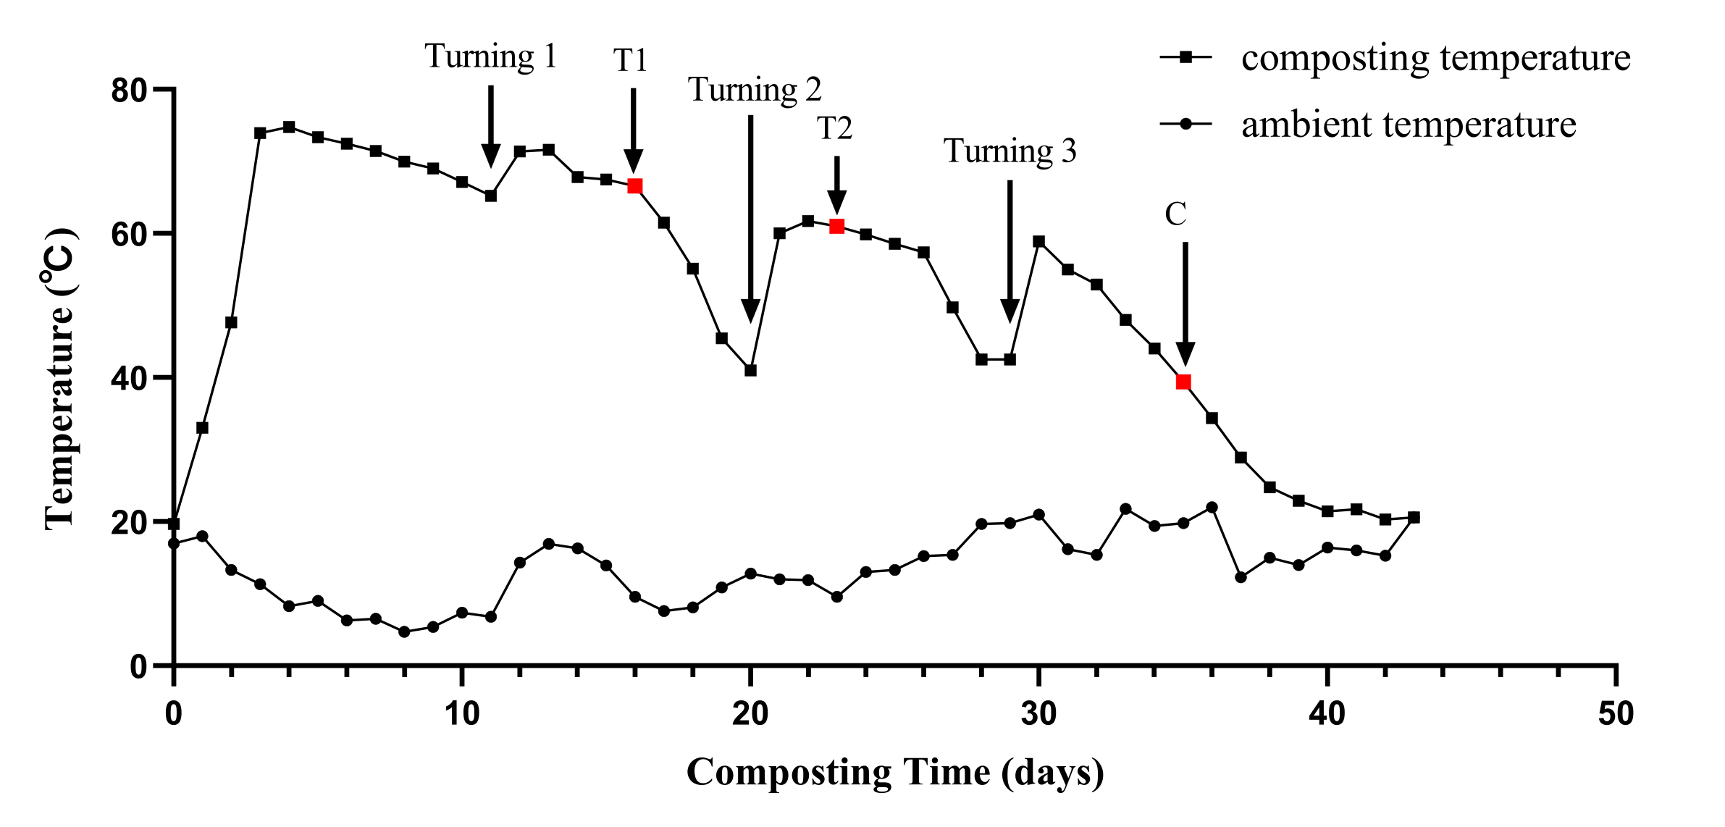
Fig. S1 Changes in temperature of the aerobic composting pile.

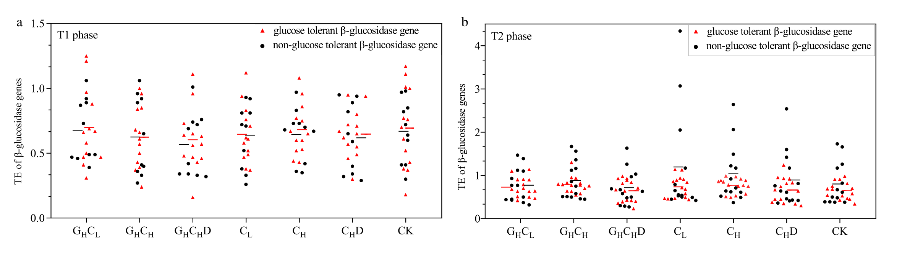
Fig. S2 Transcription efficiency of individual β-glucosidase genes in a) T1 and b) T2 phase of compost using qPCR method. The red line represents the average transcription efficiency of glucose tolerant β-glucosidase genes. The black line represents the average transcription efficiency of non-glucose tolerant β-glucosidase genes.

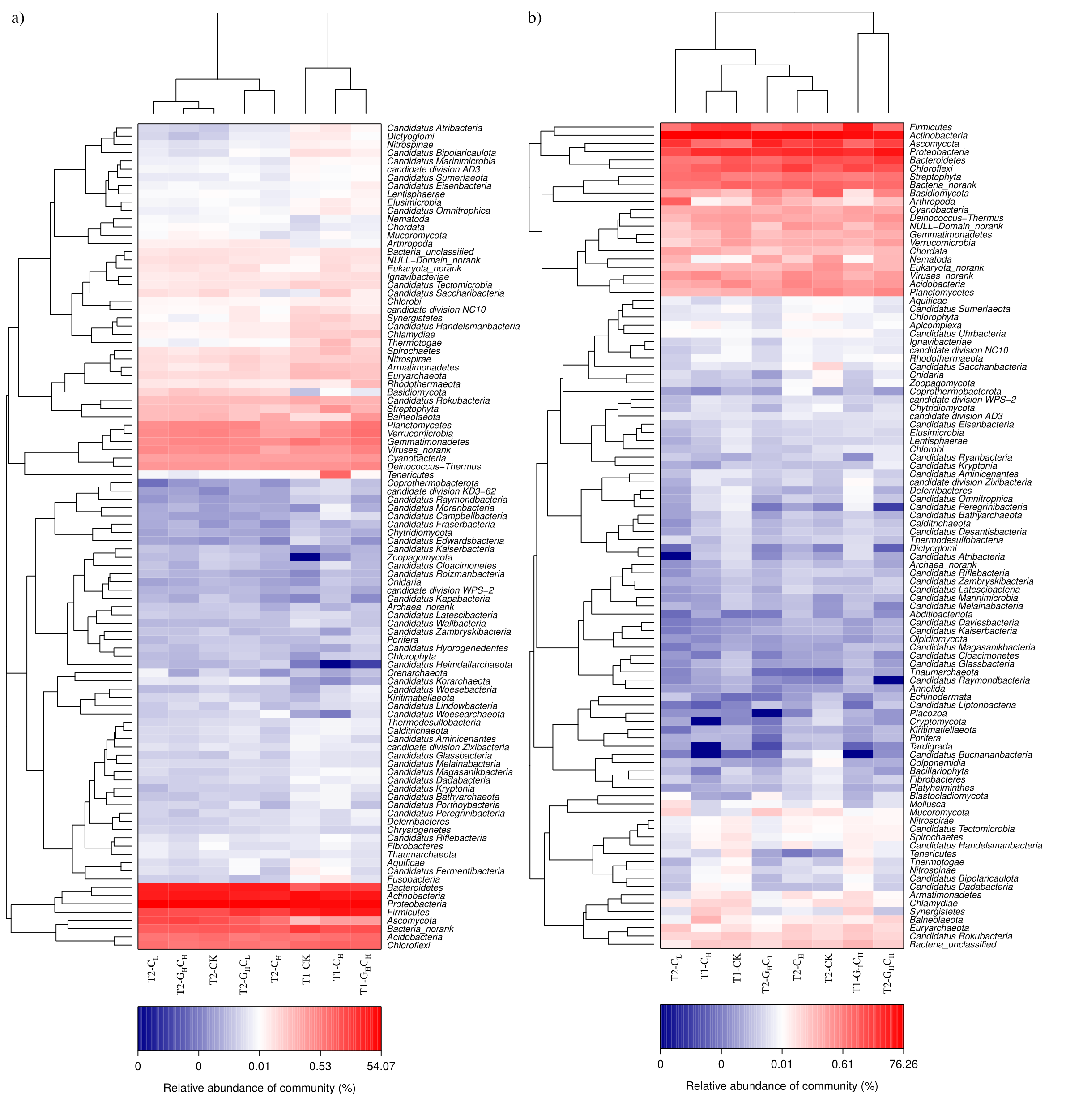
Fig. S3 Different treatments and different phases of composting samples microbial community at phylum level Heatmap in a) metagenome and b) metatranscriptome.

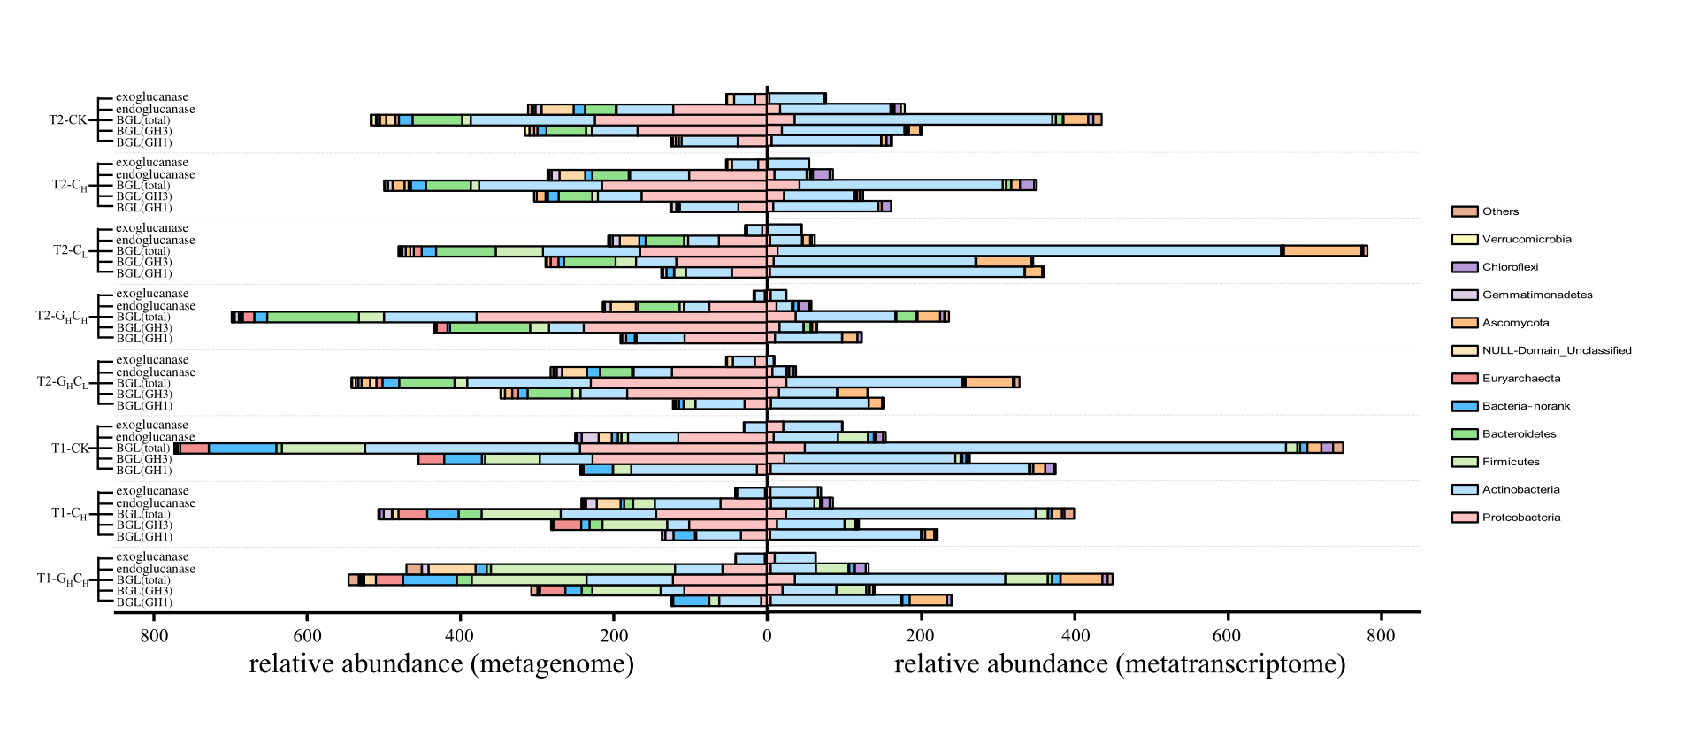
Fig. S4 Abundant and expression of key enzymes genes in cellulose degradation during composting. X-axis indicates the share of read in the total metagenome and metatranscriptome in TPM (Transcripts Per Million).

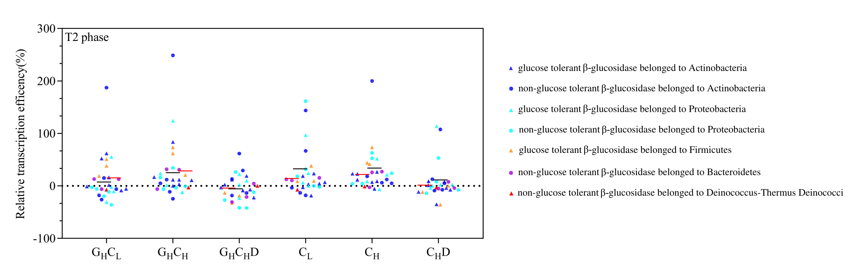
Fig. S5 Relative transcription efficiency and phylogenetic analysis of β-glucosidase genes of treatments in T2 phase of compost using qPCR method. The red line represents the average transcription efficiency of glucose tolerant β-glucosidase genes. The black line represents the average transcription efficiency of non-glucose tolerant β-glucosidase genes.

