Table S1. Primers used in this study
Primer | Sequence 5'-3' | Usage
OriF1 | tttccataggctccgcccccctga | Amplification of Ampr-ori  Amplification of Ampr-ori
AmprR1 | ttctttgtttgaaaaattagcgct | Amplification of Ampr-ori  Amplification of Ampr-ori
Pcbh1F1 | ctaatttttcaaacaaagaatcaacctttggcgtttccctgatt | Amplification of cbh1 promoter
Pcbh1R1 | ttaattaatacgtagtcgacgatgcgcagtccgcggttgactat | Amplification of cbh1 promoter
Txyr1F | gtcgactacgtattaattaacatatgggaggccactcaatcgtatga | Amplification of xyr1 terminator
Txyr1R | gggggcggagcctatggaaaacagccatgctcatcgtgcactt | Amplification of xyr1 terminator
Xyr1F | gactgcgcatcgtcgactacgtaatgttgtccaatcctctccgtcgc | Amplification of xyr1
Ppdc1F1 | ctaatttttcaaacaaagaacgatgaaagccttgcaactgtgg | Amplification of pdc1 promoter
Ppdc1R1 | ttaattaatacgtagtcgacgattgtgctgtagctgcgctgct | Amplification of pdc1 promoter
Tpdc1F1 | gtcgactacgtattaattaacatatgcccggcatgaagtctgacc | Amplification of pdc1 terminator
Tpdc1R1 | gggggcggagcctatggaaatcttaggagcggaatctgacatt | Amplification of pdc1 terminator
Ace3F1 | agctacagcacaatcgtcgactacgtaatgctgcgctactcccccgtctta | Amplification of ace3
Ace3R1 | tcagacttcatgccgggcatatgttagccaacaacggtagtggacgt | Amplification of ace3
APAF1 | tacggttatccacagaatcagggg | Amplification of Ampr-ori-Ampr-pyr4
APAR1 | ggatccgccaagcgcgcaattaac | Amplification of Ampr-ori-Ampr-pyr4
Pgpd1pF1 | ggttaattgcgcgcttggcggatccctgcgcttcccacgcacagtacg | Amplification of gpd1 promoter
Pgpd1pR1 | catatgttaattaatacgtagtcgactttgtatctgcgaattgagcttgc | Amplification of gpd1 promoter
Peno1TF1 | gtcgactacgtattaattaacatatgatggccacgagagacaactacct | Amplification of eno1 terminator
Peno1TR1 | gattctgtggataaccgtagaattcttctgtgtactctgtactttgac | Amplification of eno1 terminator
26163F | tcgcagatacaaagtcgactacgtacatgcctgcctcgagtgtcaacg | Amplification of 26163
26163R | tcgtggccatcatatgttaattaagttgtctcgtgttggaaatcttgg | Amplification of 26163
66966F | tcgcagatacaaagtcgactacgtaatggccaagaaggcgcgtcaaag | Amplification of 66966
66966R | tcgtggccatcatatgttaattaagctaggcgccgttgacgactccaa | Amplification of 66966
122523F | tcgcagatacaaagtcgactacgtaatggtagcacatagtctaccctct | Amplification of 122523
122523R | tcgtggccatcatatgttaattaagtcatatcggcaccatgtcgacgt | Amplification of 122523
80621F | tcgcagatacaaagtcgactacgtaatggctctcaacctcacctcgtc | Amplification of 80621
80621R | tcgtggccatcatatgttaattaagttagctgctctccacctgcttcag | Amplification of 80621
PcDNA1pF1 | ggttaattgcgcgcttggcggatcccccgtaggacaagatcctgtcg | Amplification of cDNA1 promoter
PcDNA1pR1 | catatgttaattaatacgtagtcgacgttgagagaagttgttggattg | Amplification of cDNA1 promoter
PcDNA1tF1 | gtcgactacgtattaattaacatatgaagatcagactcttgtcgaggc | Amplification of cDNA1 terminator
PcDNA1tR1 | gattctgtggataaccgtagaattcaaaaagacttgctatctacatcg | Amplification of cDNA1 terminator
80291F | acttctctcaacgtcgactacgtaatgggccggcaaccgagacaacg | Amplification of 80291
80291R | agtctgatcttcatatgttaattaagttatataaacggggcatcaatac | Amplification of 80291
64608F | acttctctcaacgtcgactacgtaagtgtcctaccaccccctccacg | Amplification of 64608
64608R | agtctgatcttcatatgttaattaagtcacgcagttgctgcctgaacgc | Amplification of 64608
53567F | acttctctcaacgtcgactacgtaatggctcccatcaccaaagagacc | Amplification of 53567
53567R | agtctgatcttcatatgttaattaagtcatttcatcgtcaccagctcct | Amplification of 53567
75769F | acttctctcaacgtcgactacgtaatggaccacacccagccgtaagt | Amplification of 75769
75769R | agtctgatcttcatatgttaattaagttacaacttggtgggagcggcag | Amplification of 75769
72685F | acttctctcaacgtcgactacgtaatgtctggccctgtgtaagtcggc | Amplification of 72685
72685R | agtctgatcttcatatgttaattaagttatgcctggtacgttgaggcgga | Amplification of 72685
Pxpp1pF1 | ggttaattgcgcgcttggcggatccgtatcgtggtgtccagactatattg | Amplification of xpp1 promoter
Pxpp1pR1 | catatgttaattaatacgtagtcgactgctgtatgggtaggttgaagg | Amplification of xpp1 promoter
Pxpp1tF1 | gtcgactacgtattaattaacatatgagagagagagagagaggccagtgg | Amplification of xpp1 terminator
Pxpp1tR1 | gattctgtggataaccgtagaattctcggggggaagaagattagaggag | Amplification of xpp1 terminator
123668F | acccatacagcagtcgactacgtaatgcctctcgttgtcgtcccagc | Amplification of 123668
123668R | tctctctctctcatatgttaattaagttaattgagcagcggctcgcgaa | Amplification of 123668
27600F | acccatacagcagtcgactacgtacgcccggcagcccgcggcaccgcc | Amplification of 27600
27600R | tctctctctctcatatgttaattaaggagctctcgctccagggttgatc | Amplification of 27600
74765F | acccatacagcagtcgactacgtaatgacttctgaagccccctctca | Amplification of 74765
74765R | tctctctctctcatatgttaattaagctactcgccctcttcgcctccca | Amplification of 74765
57940F | acccatacagcagtcgactacgtaatgtgctcgtcttacctctttcac | Amplification of 57940
57940R | tctctctctctcatatgttaattaagtcagatgacctcctctcgctcgt | Amplification of 57940
PpkipF1 | ggttaattgcgcgcttggcggatcccgtggcagcacgagataacggtg | Amplification of pki promoter to construct the pPpki-Tcbh2 intermediate plasmid
PpkipR1 | catatgttaattaatacgtagtcgacggttaagagggttcttccggcttc | Amplification of pki promoter to construct the pPpki-Tcbh2 intermediate plasmid
PpkitF1 | gtcgactacgtattaattaacatatgatgcatggctttcgtgaccgggc | Amplification of pki terminator to construct the pPpki-Tcbh2 intermediate plasmid
PpkitR1 | gattctgtggataaccgtagaattctggtttccacgtgcacttacatgt | Amplification of pki terminator to construct the pPpki-Tcbh2 intermediate plasmid
73903F | accctcttaaccgtcgactacgtaatgcccaagacacagcccaatct | Amplification of 73903
73903R | aagccatgcatcatatgttaattaagttacaagtatgccctccgagggaa | Amplification of 73903
52055F | accctcttaaccgtcgactacgtaatggccgcccgcaacatggccac | Amplification of 52055
52055R | aagccatgcatcatatgttaattaagttattgcttcagcgtggccttca | Amplification of 52055
Xpp1PF2 | gtcgactacgtattaattaacatatgtgctgtatgggtaggttgaaggaa | Amplification of xpp1 promoter to construct the cDNA1P-xpp1P intermediate plasmid
Xpp1PR2 | gattctgtggataaccgtagaattcgtatcgtggtgtccagactatat | Amplification of xpp1 promoter to construct the cDNA1P-xpp1P intermediate plasmid
Cre1iF1 | acttctctcaacgtcgactacgtaatgcaacgagcacagtctgccgtg | Amplification of cre1 RNAi fragment
Cre1iR1 | cccatacagcacatatgttaattaagaggcatgacaaaggacgagtagga | Amplification of cre1 RNAi fragment
Ace1iF1 | acttctctcaacgtcgactacgtagtcccggaaccgactgcgaacatg | Amplification of ace1 RNAi fragment
Ace1iR1 | cccatacagcacatatgttaattaagagagtcggcggcgccagccttgtc | Amplification of ace1 RNAi fragment
Yps1iF1 | acttctctcaacgtcgactacgtagatacctttgacgaggtcggccaa | Amplification of yps1 RNAi fragment
Yps1iR1 | cccatacagcacatatgttaattaagatcctcgcttgtggagagcgtgtc | Amplification of yps1 RNAi fragment
Ptef1pF1 | ggttaattgcgcgcttggcggatcctcgaatgtgactgcacacaccaca | Amplification of tef1 promoter to construct the Ptef1-Ppki intermediate plasmid
Ptef1pR1 | catatgttaattaatacgtagtcgactttgacggtttgtgtgatgtagcg | Amplification of tef1 promoter to construct the Ptef1-Ppki intermediate plasmid
PpkipF2 | gtcgactacgtattaattaacatatgggttaagagggttcttccggcttc | Amplification of pki promoter to construct the Ptef1-Ppki intermediate plasmid
PpkipR2 | gattctgtggataaccgtagaattccgtggcagcacgagataacggtga | Amplification of pki promoter to construct the Ptef1-Ppki intermediate plasmid
Ymr1iF1 | caaaccgtcaaagtcgactacgtaatcatcgaacatgtccaggccatc | Amplification of ymr1 RNAi fragment
Ymr1iR1 | accctcttaacccatatgttaattaagctggggtcatagatgttccagcc | Amplification of ymr1 RNAi fragment
Och1-2iF1 | caaaccgtcaaagtcgactacgtaaccctgatcggccagagaggaggc | Amplification of och1-2 RNAi fragment
Och1-2iR1 | accctcttaacccatatgttaattaagagttcatcacctcgaagctctccg | Amplification of och1-2 RNAi fragment
Pep4iF1 | caaaccgtcaaagtcgactacgtatcgttcaaggttgtcctcgacacg | Amplification of pep4 RNAi fragment
Pep4iR1 | accctcttaacccatatgttaattaagtactcaatcttgccctcgtagtga | Amplification of pep4 RNAi fragment
doa10iF1 | caaaccgtcaaagtcgactacgtaaacatcgagactcgacccgacac | Amplification of doa10 RNAi fragment
doa10iR1 | accctcttaacccatatgttaattaagggacccggtagccaggccctcgtc | Amplification of doa10 RNAi fragment
Ppdc1pF2 | ggttaattgcgcgcttggcggatcccgatgaaagccttgcaactgtggt | Amplification of pdc1 promoter to construct the Ppdc1-Peno1 intermediate plasmid
Ppdc1pR2 | catatgttaattaatacgtagtcgacgattgtgctgtagctgcgctgct | Amplification of pdc1 promoter to construct the Ppdc1-Peno1intermediate plasmid
Peno1pF2 | gtcgactacgtattaattaacatatgtttgaagctatttcaggtggctgg | Amplification of eno1 promoter to construct the Ppdc1-Peno1 intermediate plasmid
Peno1pR2 | gattctgtggataaccgtagaattcttctcaaataccgcagaggcgac | Amplification of peno1 promoter to construct the Ppdc1-Peno1intermediate plasmid
Sed1iF1 | gcacaatcgtcgactacgtattaattaacatgaagttcaccgtcgctgtcgct | Amplification of sed1 RNAi fragment
Sed1iR1 | cctgaaatagcttcaaacatatggccagtggggacggcgggaggagc | Amplification of sed1RNAi fragment
Ych1iF1 | gcacaatcgtcgactacgtattaattaactgactattgcgtcgctcaagaga | Amplification of ych1 RNAi fragment
Ych1iR1 | cctgaaatagcttcaaacatatgctccaaatctccctccgaaacc | Amplification of ych1 RNAi fragment
Der1iF1 | gcacaatcgtcgactacgtattaattaacatggcagagctttccacggatgcg | Amplification of der1 RNAi fragment
Der1iR1 | cctgaaatagcttcaaacatatgcgaagtgcaggggtaatctccctc | Amplification of der1 RNAi fragment
YPcbh1F | caagaacaatagccgataaagat | Verification of chromosomal integration of xyr1
Yxyr1R | agagccctggcgctgctttggc | Verification of chromosomal integration of xyr1
Yace3F | tcctgattatgttgtctggatgctg | Verification of chromosomal integration of ace3
YPdc1TR | cctctcatgcgacgtgcaagatta | Verification of chromosomal integration of ace3
YEno1TR | cacgcagcggtgtctgtcaagcta | Verification of the joint sequence of 26163 /66966 /122523 and Eno1T
Y26163F | gtttctgtatcaagcagccatgata | Verification of chromosomal integration of 26163
Y66966F | gcaatgaccagctgcttcacccaa | Verification of chromosomal integration of 66966
Y122523F | agttcaaccagtcggcgccttcag | Verification of chromosomal integration of 122523
YcDNA1TR | gtcaactgcacaatttgcgtgtaa | Verification of chromosomal integration of of 80291/64608
Y80291F | gagttgtccatccagattctcaga | Verification of chromosomal integration of 80291
Y64608F | agaacggacaccaacacctcggc | Verification of chromosomal integration of 64608
YXpp1TR | cccatacaaacaattaaatcaatcc | Verification of the joint sequence of 123668/27600/74765 and Xpp1T
Y123668F | actgacccggaccatcaaagacgc | Verification of chromosomal integration of 123668
Y27600F | ccatcatcgacatcatgggagcatg | Verification of chromosomal integration of 27600
Y74765F | cctcagcacagtgaagatgaagat | Verification of chromosomal integration of 74765
YcDNA1PF | ataatgcttgggttggaagcgattc | Verification of chromosomal integration of cre1
Yxpp1PR | actctaagacggcagtcggagcat | Verification of chromosomal integration of ace1
actF | tgagagcggtggtatccacg | RT-qPCR for actin
actR | ggtaccaccagacatgacaatgttg | RT-qPCR for actin
qcbh1F | gctgccggtgcggcttgaac | RT-qPCR for cbh1
qcbh1R | ctggccattgatgaacttcagatcgc | RT-qPCR for cbh1
qcbh2F | atcgcaacatttggaaggttcag | RT-qPCR for cbh2
qcbh2R | ctggccattgatgaacttcagatcgc | RT-qPCR for cbh2
qegl1F | gactacacggaggagctcgac | RT-qPCR for egl1
qegl1R | ttgcgagtagtagtcgttgctata | RT-qPCR for egl1
qegl2F | gtaccacagatggcacttgc | RT-qPCR for egl2
qegl2R | agagacaggcacccctgaac | RT-qPCR for egl2
qxyr1F | agcgccagggctctcttatt | RT-qPCR for xyr1
qxyr1R | gcatccaaggccgaattct | RT-qPCR for xyr1
qace3F | tcgtttccttcctcggcact | RT-qPCR for ace3
qace3R | gtgaatcctggttgcgatgg | RT-qPCR for ace3
q66966F | agcagtggcgccctggtgct | RT-qPCR for 66966
q66966R | gccaaggctcactctctgatca | RT-qPCR for 66966
q27600F | gcgccacgtgcattcagtcc | RT-qPCR for 27600
q27600R | tcgtccgggtgcgatggcggc | RT-qPCR for 27600
q74765F | atgacttctgaagccccctctca | RT-qPCR for 74765
q74765R | gatgcggttgagcccatgaga | RT-qPCR for 74765
q26163F | ggagaatgtagaatacgactctg | RT-qPCR for 26163
q26163R | ggctatcaagatgatgtcgat | RT-qPCR for 26163
q64608F | agtgtcctaccaccccctccacg | RT-qPCR for 64608
q64608R | acatatgttccctctcccacca | RT-qPCR for 64608
qder1F | gctggaaacatggttctgggag | RT-qPCR for der1
qder1R | agtcgccagtactgtgacttga | RT-qPCR for der1
qYCH1F | gcgggatgtcgactacataggc | RT-qPCR for ych1
qYCH1R | gctgctggctcagcgcgcagtgg | RT-qPCR for ych1
qsed1F | gctacacctgcggtgctgct | RT-qPCR for sed1
qsed1R | accaccagtgctggcgggagg | RT-qPCR for sed1
qYMR1F | aagccaagaagatcatcgaaca | RT-qPCR for ymr1
qYMR1R | aggcgtcgactcttggccgtct | RT-qPCR for ymr1
qOCH1-2F | gcagattgtgctgcccaagg | RT-qPCR for och1-2
qOCH1-2R | ccgatcagggtgtactgccagtc | RT-qPCR for och1-2
qpep4F | agcagcagctggagggttcgag | RT-qPCR for pep4
qpep4R | cattcatgaagttggtgacgg | RT-qPCR for pep4
qdoa10F | ggtgtcttgtacttcatccga | RT-qPCR for doa10
qdoa10R | cacaagtgctccataaacgaatg | RT-qPCR for doa10
qyps1F | attcggaagcttcaaccctgat | RT-qPCR for yps1
qyps1R | ccatggtgagattcttgacggt | RT-qPCR for yps1
q80621F | ctcttcacgggacttgccgccc | RT-qPCR for 80621
q80621R | ttgcgcagaacggcgtgtccgta | RT-qPCR for 80621
q75759F | cttcggcctgtaccgaaacca | RT-qPCR for 75759
q75759R | gaactcctggagctgctgctca | RT-qPCR for 75759
q535675F | caatgttggatgcgtccccaa | RT-qPCR for 53567
q53567R | atgtacgcgtcgcgcttggtct | RT-qPCR for 53567
q52055F | cctcaagcagatgtggctctct | RT-qPCR for 52055
q52055R | aaaggcgtggcggccgatgat | RT-qPCR for 52055
q73903F | atgcccaagacacagcccaatc | RT-qPCR for 73903
q73903R | ccgcccgagacggccaccttga | RT-qPCR for 73903
q57940F | attgccgtccagtactggcgca | RT-qPCR for 57940
q57940R | gatcctccttctggttgaggt | RT-qPCR for 57940
q72685F | cttgctgtcatgggacaga | RT-qPCR for 72685
q72685R | cgacaatagacttgcccttggc | RT-qPCR for 72685

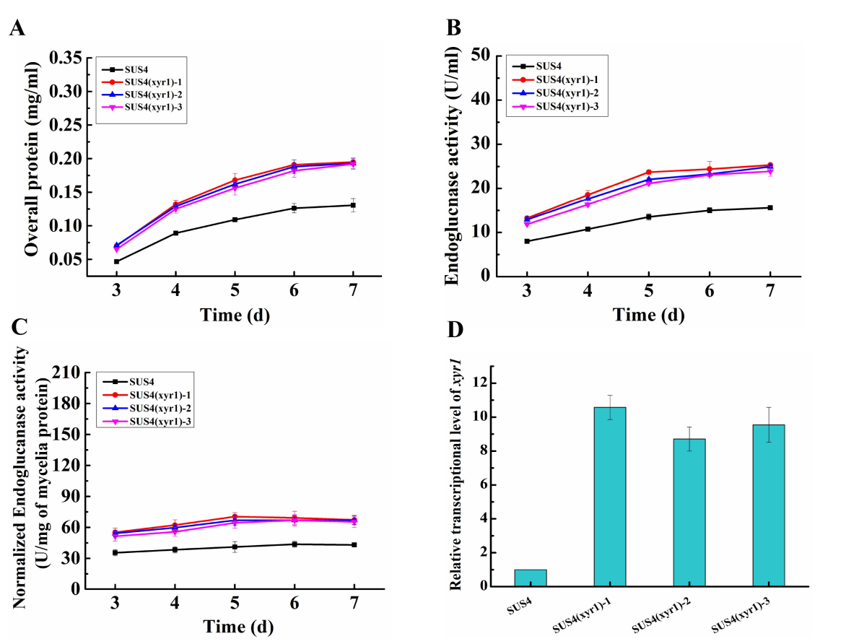

Figure S1. Effect of overexpressing xyr1 on cellulase production in SUS4. A. Extracellular overall protein concentration; B. Endoglucanase activity; C. Normalized endoglucanase activity against mycelial biomass. D. The transcriptional level of xyr1 at 24 h post cellulose induction.

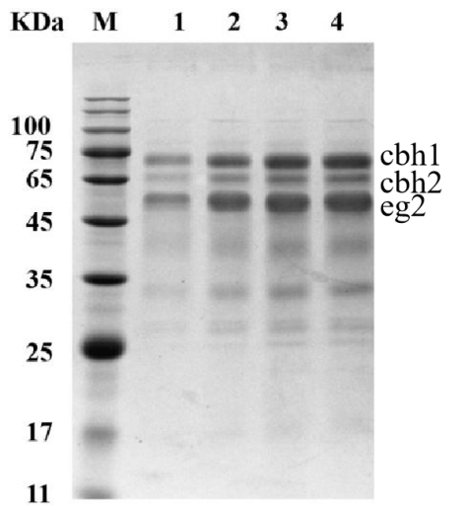
Figure S2. SDS-PAGE analysis of the fermentation broth of SUS4 and its mutant strains. M: protein molecular mass marker; lane 1: the parent strain SUS4; lane 2: strain 1-2; lane 3: strain 2-3; lane 4: strain 3-8. Ten μl of the fermentation supernatant for each representative transformant, which was collected on day 5 post cellulase induction, were used for SDS-PAGE analysis.
.

