Table S1 The DNA oligos used in this study
Primer | Sequence (5’-3’) | Purpose
SC2-F | GTCGTCAATAACATTTGGCAGGTCTA | Verifying and sequencing of strain SC2
SC2-R | TGCGGCAAGAGCGGTTAGAGCGAGT | Verifying and sequencing of strain SC2
P₂₅₄₃₀-F | CTAGTCTAGAGCTGTTCTCCGTCATTTCTAC | Cloning promoter P₂₅₄₃₀
P₂₅₄₃₀-R | CGCGGATCCCAGTCGTTACACCTCCTTTC | Cloning promoter P₂₅₄₃₀
P₁₅₂₄₀-F | CTAGTCTAGATAGTATGAAGAGGCTTGTAACA | Cloning promoter P₁₅₂₄₀
P₁₅₂₄₀-R | CGCGGATCCGTAAATCCCTCCAAATTGTTTG | Cloning promoter P₁₅₂₄₀
P₂₂₉₅₅-F | CTAGTCTAGAGGATTAACTTCCTACTTTCCATC | Cloning promoter P₂₂₉₅₅
P₂₂₉₅₅-R | CGCGGATCCAGGGCACGCCTCCTTTG | Cloning promoter P₂₂₉₅₅
P₁₃₃₈₅-F | CTAGTCTAGATTCGGAGTAGCACAACCTGAT | Cloning promoter P₁₃₃₈₅
P₁₃₃₈₅-R | CGCGGATCCCCTCGTAATCTCCTTTCTCTG | Cloning promoter P₁₃₃₈₅
P₀₄₄₂₀-F | CTAGTCTAGAGTTCATCCCTCCACATCG | Cloning original promoter P₀₄₄₂₀
P₀₄₄₂₀-R | CGCGGATCCTCAAATCACTCCTCTTTCTTAATC | Cloning original promoter P₀₄₄₂₀
P₀₅₃₉₀-F | CTAGTCTAGATCTTGACTATTTGGAGATCATC | Cloning promoter P₀₅₃₉₀
P₀₅₃₉₀-R | CGCGGATCCCTGAAAGGGAACCGGAAATG | Cloning promoter P₀₅₃₉₀
P₀₉₁₁₅-F | GCTCTAGAATAGTAACAATTCGAAACTCCGG | Cloning promoter P₀₉₁₁₅
P₀₉₁₁₅-R | ACGCGTCGACGTTGCTGCCTCCTCTCCCAAAC | Cloning promoter P₀₉₁₁₅
P₂₂₄₄₅-F | CTAGTCTAGATTCCGAAGAGCATTGCTGAAG | Cloning promoter P₂₂₄₄₅
P₂₂₄₄₅-R | CGCGGATCCTTGAACAATTCCTCCTCAATAAC | Cloning promoter P₂₂₄₄₅
P₂₁₅₁₀-F | CTAGTCTAGAAAGAACGCGATGACTGGTGGG | Cloning promoter P₂₁₅₁₀
P₂₁₅₁₀-R | CGCGGATCCTATACAGACCCCCTTATTGCCGC | Cloning promoter P₂₁₅₁₀
P₂₃₀₃₀-F | CTAGTCTAGATGCGCAAGATGATAAATAAAAACAAC | Cloning promoter P₂₃₀₃₀
P₂₃₀₃₀-R | CGCGGATCCTTTAAATTTCCTCCCTGAAGGTAAATG | Cloning promoter P₂₃₀₃₀
P₁₀₁₂₅-F | CTAGTCTAGAACATAAGACAGGCGCTGTGTTATACTG | Cloning promoter P₁₀₁₂₅
P₁₀₁₂₅-R | CGCGGATCCCCTGTTCACCTCCTTCATTATAATCGC | Cloning promoter P₁₀₁₂₅
P₂₂₃₄₀-F | CTAGTCTAGAGCATCATCCGTAAAGAAGGTAAAGC | Cloning promoter P₂₂₃₄₀
P₂₂₃₄₀-R | CGCGGATCCCTCAAGTTTTCACTCCCTTCAG | Cloning promoter P₂₂₃₄₀
P₁₅₅₆₅-F | CTAGTCTAGAAGAATATTCCTTAGGGAATGTTCTC | Cloning promoter P₁₅₅₆₅
P₁₅₅₆₅-R | CGCGGATCCTACCCATTGCTTTCTCCAATGC | Cloning promoter P₁₅₅₆₅
P₀₀₁₆₀-F | CTAGTCTAGACAAATGTGCCTGGGTATATCTGAAC | Cloning promoter P₀₀₁₆₀
P₀₀₁₆₀-R | CGCGGATCCTGCCTAACGACCACCTCTTTCCT | Cloning promoter P₀₀₁₆₀
P₂₅₄₃₀-F | GCTCTAGAACGGTTGTGCCTCCTTAGATAATG | Cloning promoter P₂₅₄₃₀
P₂₅₄₃₀-R | CGCGGATCCTCTTTACACCTCCTTATGGACATAAGG | Cloning promoter P₂₅₄₃₀
P₂₂₄₅₀-F | CTAGTCTAGATGCGGGATTGAAGTGGGAGC | Cloning promoter P₂₂₄₅₀
P₂₂₄₅₀-R | CGCGGATCCGTTGGTTGCCACCCCCTTCC | Cloning promoter P₂₂₄₅₀
P₁₆₈₉₅-F | CTAGTCTAGATGACAGGTATTTCGGACTCGC | Cloning promoter P₁₆₈₉₅
P₁₆₈₉₅-R | CGCGGATCCCAGTTTTCCCTCCCTCCGA | Cloning promoter P₁₆₈₉₅
P₂₂₃₇₀-F | CTAGTCTAGAACATCAAACGTGGTGGTAAGG | Cloning promoter P₂₂₃₇₀
P₂₂₃₇₀-R | CGCGGATCCTGCTTCACCACCCAATTCTTC | Cloning promoter P₂₂₃₇₀
P₀₀₉₇₀-F | CTAGTCTAGATTCTGACTGTTGGCGACAAACAAC | Cloning promoter P₀₀₉₇₀
P₀₀₉₇₀-R | CGCGGATCCCTCCATATTCCTCCGCACCCT | Cloning promoter P₀₀₉₇₀
P₁₉₃₅₅-F | CTAG TCTAGAGACTCTCGTGTAGAACGTGCG | Cloning promoter P₁₉₃₅₅
P₁₉₃₅₅-R | CGC GGATCCTTGCTTGCACCTCCTTATGTC | Cloning promoter P₁₉₃₅₅
P₂₂₄₂₅-F | CTAGTCTAGATCATCGTATTGGACGCTCTTAC | Cloning promoter P₂₂₄₂₅
P₂₂₄₂₅-R | CGCGGATCCTACGCGAGCACCTCCTCTACCT | Cloning promoter P₂₂₄₂₅
P_{spo0A}-F | CTAGTCTAGAGGAATAACTCAGAATTGCAAG | Cloning promoter P_{spo0A}
P_{Spo0A}-R | CGCGGATCCTGTACTTCCTCCTTATTGAGTG | Cloning promoter P_{spo0A}
P₀₄₄₂₀-InF-F | GCCCAAGCTTCTAGAGTTCATCCCTCCACATCGTT | Cloning promoter P₀₄₄₂₀ without BamH I
P₀₄₄₂₀₋InF-R | TTCTCCTTTACTCATTCAAATCACTCCTCTTTCTTA | Cloning promoter P₀₄₄₂₀ without BamH I
p300-fx-F | ATGAGTAAAGGAGAAGAACTTTTC | Linearizing pHY300PLK by PCR
p300-fx-R | TCTAGAAGCTTGGGCAAAGCGT | Linearizing pHY300PLK by PCR
04-BN20-F | GCCCAAGCTTCTAGAGTTCATCCCTCCACATCGT | Cloning promoter P₀₄₄₂₀ by adding Nhe I
04-BN20-R | TTTACTCATGCTAGCGGATCCTCAAATCACTCCTCT | Cloning promoter P₀₄₄₂₀ by adding Nhe I
fx300-04BN20-F | GCTAGCATGAGTAAAGGAGAAGAAC | Linearizing pHY300PLK
fx300-04BN20-R | TCTAGAAGCTTGGGCAAAGCCG | Linearizing pHY300PLK
04-4-amy-F | GTGATTTGAGGATCCATGAAAAGGAACCATACGATGATGC | Amplifing α-amylase gene
04-4-amy-R | CGGCATTATCTCATATCAAGCACTCGCGGTATCC | Amplifing α-amylase gene
fx300-04-4-amy-F | TATGAGATAATGCCGACTGTACT | Linearizing pHY300PLK and amplifing α-amylase gene
fx300-04-4-amy-R | GGATCCTCAAATCACTCCTCT | Linearizing pHY300PLK and amplifing α-amylase gene
fx300-04-6-amy-R | GGATCCTCAAATCACCTCCT | Linearizing pHY300PLK and amplifing α-amylase gene
04-8-amy-F | GAGGAGTGAGGATCCATGAAAAGGAACCATACGATGATGC | Linearizing pHY300PLK and amplifing α-amylase gene
fx300-04-8-amy-R | GGATCCTCACTCCTCTTTCTT | Linearizing pHY300PLK and amplifing α-amylase gene
04-9-amy-F | AAAGAGGAGGGATCCATGAAAAGGAACCATACGATGATGC | Linearizing pHY300PLK and amplifing α-amylase gene
fx300-04-9-amy-R | GGATCCCTCCTCTTTCTTAATCT | Linearizing pHY300PLK and amplifing α-amylase gene
Amy-R | TAGAGTATCCACCAGCCATTTG | Verifying the α-amylase gene
GAP-F | GCTCTAGACGAATCGTTCGGCTATTA | Cloning promoter P_{gap} for expressing gene iaam
GAP-R | AGGTGAAGCTGACATGGATCCTGAATAGTTCCTCCTAGATTTCG | Cloning promoter P_{gap} for expressing gene iaam
04420-F | GCTCTAGAGTTCATCCCTCCACATC | Cloning promoter P₀₄₄₂₀ for expressing gene iaam
04420-R | AGGTGAAGCTGACATGGATCCTCAAATCACTCCTCTTTC | Cloning promoter P₀₄₄₂₀ for expressing gene iaam
GFP-R | CTCGCAAAGCATTGAACACC | Sequencing of gfp sequence
GAP-IAM-F | CGAAATCTAGGAGGAACTATTCAGGATCCATGTCAGCTTCACCT | Cloning gene iaam and expressed by promoter P_{gap}
GAP-IAM-R | TGATCACCACGCCGAAACAAGCGC | Cloning gene iaam and expressed by promoter P_{gap}
04420-IAM-F | GAAAGAGGAGTGATTTGAGGATCCATGTCAGCTTCACCT | Cloning gene iaam and expressed by promoter P₀₄₄₂₀
04420-IAM-R | TGATCACCACGCCGAAACAAGCGC | Cloning gene iaam and expressed by promoter P₀₄₄₂₀
GAP-F1 | CGTCTAGACGAATCGTTCGGCTATTA | Cloning promoter P_{gap} to express IPyA pathway genes
GAP-R1 | GTCTCTTGATTCAGGTAAAGTCATTGAATAGTTCCTCCTAGATTTCG | Cloning promoter P_{gap} to express IPyA pathway genes
aro8-F | CGAAATCTAGGAGGAACTATTCAATGACTTTACCTGAATCAAGAGAC | Cloning gene aro8
aro8-R | CAATTGTAACAGGTGCCATCTATTTGGAAATACCAAATTCTTCG | Cloning gene aro8
kdc-F | CGAAGAATTTGGTATTTCCAAATAGATGGCACCTGTTACAATTG | Cloning gene kdc
kdC-R | CTGGATAAGCCTGGAGGCCTGACTATTTTTTATTTCTTTTAAGTGC | Cloning gene kdc
aldH-F | GCACTTAAAAGAAATAAAAAATAGTCAGGCCTCCAGGCTTATCCAG | Cloning gene aldH
aldH-R | AGTACAGTCGGCATTATCTCATAATGAATTTTCATCATCTGGC | Cloning gene aldH
04420-F2 | GCCCAAGCTTCTAGAGTTCATCCCTCCACATCGTT | Cloning promoter P₀₄₄₂₀ to express IPyA pathway genes
04420-R2 | TTCAGGTAAAGTCATTCAAATCACTCCTCTTTCTTAATCT | Cloning promoter P₀₄₄₂₀ to express IPyA pathway genes
04420-F3 | CGTCTAGA GTTCATCCCTCCACATC | Cloning promoter P₀₄₄₂₀ to express IPyA pathway genes
04420-R3 | CGGACTTTATCCGTCATCATTCAAATCACTCCTCTTTC | Cloning promoter P₀₄₄₂₀ to express IPyA pathway genes
04420-R4 | GGAATTTGTGCACTCATTCAAATCACTCCTCTTTC | Cloning promoter P₀₄₄₂₀ to express IPyA pathway genes
04420-R5 | CTGGATTTATACTCATTCAAATCACTCCTCTTTC | Cloning promoter P₀₄₄₂₀ to express IPyA pathway genes
patA-F | GAGTGATTTGAATGGAGCATTTGCTTAAC | Cloning gene patA
patA-R | GTGCACTCATTTGATATGCCTCCTTAACTCCTAACAATTCCCC | Cloning gene patA
ilvB3-F | GGCATATCAAATGAGTGCACAAATTCCTG | Cloning gene ilvB3
ilvB3-R | GATTTATACTCATTTGATATGCCTCCTTACTCGTCCCCCATCAGC | Cloning gene ilvB3
fusE-F | GGCATATCAAATGAGTATAAATCCAGAAC | Cloning gene fusE
fusE-R | GGAATTCTCATACCAAACTCCTCTTTTC | Cloning gene fusE
pHY300PLK-F | GTCAGATTTCGTGATGCTTGTC | Verifying and sequencing the plasmid pHY300PLK
pHY300PLK-R | GGATCAACTTTGGGAGAGAGTTC | Verifying and sequencing the plasmid pHY300PLK
04420An-F | CGTCTAGAGTTCATCCCTCCACATC | Cloning promoter P₀₄₄₂₀ for the amplification of IPyA pathway (JP6)
04420An-R | CGGACTTTATCCGTCATCATTCAAATCACTCCTCTTTC
An-Ipdc--F | GAAAGAGGAGTGATTTGAATGATGACGGATAAAGTCCG | Cloning gene ELJP6_14505
AnR-R | GCAGTATGGGGTTCGCATTTGATATGCCTCCTTTACGCCGGGCGAACG | Cloning gene ELJP6_14505
IpdcR-F | CGTTCGCCCGGCGTAAAGGAGGCATATCAAATGCGAACCCCATACTGC | Cloning gene ipdC
IPDCR-R | GGGAGGATTGTTTGTCATTTGATATGCCTCCTTCAGGCGTTATTACGCGC | Cloning gene ipdC
QR-F | GCGCGTAATAACGCCTGAAGGAGGCATATCAAATGACAAACAATCCTCCC | Cloning gene ELJP6_00725
Q-R | CGGGATCCTTAGAACAGCCCCAGTGG | Cloning gene ELJP6_00725
aro8-F1 | TCTTGAAGCCTTACTTGAGT | Identification of gene aro8 expression at transcription level
aro8-R1 | GCATCAGATTGTGGTAGATAC
kdC-F2 | ATTCTCTGTTCGTGATTTCG | Identification of gene kdC expression at transcription level
kdC-R2 | ATCTTGGCTTATAGTCCTCTT | Identification of gene kdC expression at transcription level
aldH-F3 | CGGTCCATAGCTTTATTCGGCCTGTTCTTCTGATGTG | Identification of gene aldH expression at transcription level
aldH-R3 | GCCTGTTCTTCTGATGTG
gatA-F | TAGCGAAATACGGATTGGA | Identification of gene gatA expression at transcription level
gatA-R | ATACGAATTAGCATAGGTTCAC
patA-F | TGAGGGAGCCTTCTATCT | Identification of gene patA expression at transcription level
patA-R | CTGTCCGTAAGCGTAAGA
alaT-F | CTGGCGTATTGGATATACTTG | Identification of gene alaT expression at transcription level
alaT-R | GATTATAGGCTTCTACCATTCG
ilvB3-F | AATCGTAATCATCAACAACCA | Identification of gene ilvB3 expression at transcription level
ilvB3-R | CGTGCTTCTTCCTTATTCG
fusE-F | TGGATCAGAACTTGGAGATTA | Identification of gene fusE expression at transcription level
fusE-R | TTCGTAGAACATCAGTCAGA
sdr2-F | AACATACAGCCGTAGAGG | Identification of gene sdr2 expression at transcription level
sdr2-R | TGATGACTTCATTGACAACTC
PPSC2_05390-F | GTTCTTCAAACACAAGTCATTC | Identification of gene PPSC2_05390 expression at transcription level
PPSC2_05390-R | TTTGGAGGGATAACCAGATAA
niT2-F | ATGTATGTCATCGCTTGTAAC | Identification of gene niT2 expression at transcription level
niT2-R | GAACCAAGGCTGATTCAAT
ELJP6_14505-F | ATGATGACGGATAAAGTCCG | Identification of gene ELJP6_14505 expression at transcription level
ELJP6_14505-R | CGAAATAGTAGGTCAGCGC
ipdc-F | ATGCGAACCCCATACTGC | Identification of gene ipdC expression at transcription level
ipdc-R | GCTCATCGCCAGTTTGTTC
ELJP6_00725-F | CAATCCTCCCTCATCGCG | Identification of gene ELJP6_00725 expression at transcription level
ELJP6_00725-R | GAAGGTCGCCAATGACTTC

Table S2 Enrichment results of metabolic pathways
Pathway | Count | Pathway ID | KEGG Names
Positive ion mode
Tryptophan metabolism | 17 | map00380 | Alpha-ketoadipicacid; Indole-3-acetamide; N-formylkynurenine; Indole-3-pyrubate; 5-hydroxyindoleacetate; Serotonin; 8-methoxykynurenicacid; L-tryptophan; Indole; Tryptamine; Kynurenicacid; Questiomycina; N-[(5-hydroxy-1h-indol-3-y) acetyl]glycine; 5-methoxy-3-indoleaceate; Indole-3-acetic acid; Indole-3-ethanol; Indole-3-acetaldehyde
Metabolic pathways | 41 | map01100 | Spermidine; L-serineo-phosphate; N-acetyl-d-mannosamine; Pyridoxal; O-succinyl-l-homoserine; VanillylacidSuccinicacid; N-acetyl-l-asparticacid; D-pantothenicacid; Alpha-ketoadipicacid; 3-phosphonooxypyruvicd; Pyroglutamate; L-allo-threonine; N-acetyl-l-glutamate; N-formylkynurenine; 3-methoxytyramine; Indole-3-pyrubate; 5-hydroxyindoleacetate; Serotonin; L-tryptophan;Indole; (e)-p-coumaricacid; Tryptamine; Kynurenicacid; 1,2-dihydroxy-3-keto-5-methylthiopentene; Naphthalene; Levodopa; Flavinmononucleotide; Biotin; Atrazine; Estriol; Trans-cinnamate; TOLuene; Indole-3-aceticacid; Dopamine; Indole-3-acetaldehyde; Methyl(2r,3s)-3-hydroxy-8-methyl-8-azabicyclo[3.2.1]octane-2-carboxylate; 2-amino-1,3,4-octadecanetriol; S-adenosylmethionine
Tyrosine metabolism | 8 | map00350 | 4-hydroxyphenylaceticacid; Tyramine; DopamineAdenylthiomethylpentose；Succinic acid; Vanillyl 3-methoxytyramine; (e)-p-coumaricacid; Levodopa; mandelic acid;
Microbial metabolism in diverse environments | 22 | map01120 | L-serineo-phosphate; Pyridoxal; Alpha-ketoglutaric acid; Succinic acid; Alpha-ketoadipic acid; 3-phosphonooxypyruvic acid; Glutaric acid; Cis-acetylacrylicacid; Aniline; 1-methoxypyrene; 6-hydroxypseudooxynicotine; Pyrene; Naphthalene; Acetophenone; Benzaldehyde; Atrazine; S-formylglutathione; 4-hydroxyphenylacetic acid; Trans-cinnamate; Benzene; TOLuene; 2,4-diamino TOL
Glycine, serine and threonine metabolism | 4 | map00260 | - serine o-phosphate; 3-phosphonooxypyruvic acid; Llo-al-threonine; L-tryptophan
Phenylalanine  metabolism | 6 | map00360 | - Succinic acid; (e)-p-coumaric acid; 4-hydroxyphenylaceticacid; Trans-cinnamate; Hippuric; N-acetyl-l-phenylalanine
Methane metabolism | 5 | map00680 | L-serine o-phosphate; Alpha-ketoadipic acid; 3-phosphonooxypyruvic acid; S-formylglutathione; Tyramine
Biosynthesis  amino acids | 8 | map01230 | L-serineo-phosphate; O-succinyl-l-homoserine; Alpha-ketoglutaric acid; Alpha-ketoadipic acid; 3-phosphonooxypyruvic acid; N-acetyl-l-glutamate; L-tryptophan; S-adenosylmethionine
Degradation of aromatic compounds | 9 | map01220 | Succinic acid; (e)-p-coumaric acid; Naphthalene; Acetophenone; Benzaldehyde; 4-hydroxyphenylaceticacid; Trans-cinnamate; Benzene; TOLuene
Lysine degradation | 4 | map00310 | Alpha-ketoglutaric acid; Succinic acid; Alpha-ketoadipic acid; Glutaric acid
Oxidative phosphorylation | 3 | map00190 | Phosphoric acid; Succinic acid; Flavin mononucleotide
Alanine, aspartate and glutamate metabolism | 3 | map00250 | Alpha-ketoglutaric acid; Succinic acid; N-acetyl-l-aspartic acid
Cysteine and methioninemetabolism | 4 | map00270 | L-serineo-phosphate; O-succinyl-l-homoserine; 1,2-dihydroxy-3-keto-5-methylthiopentene; S-adenosylmethionine
Citrate cycle | 2 | map00020 | Alpha-ketoglutaric acid; Succinic acid
Arginine biosynthesis | 2 | map00220 | Alpha-ketoglutaric acid; N-acetyl-l-glutamate
beta-Alaninemetabolim | 2 | map00410 | Arginine biosynthesis Spermidine; D-pantothenic acid
Biosynthesis of secondary metabolites | 22 | map01110 | O-succinyl-l-homoserine; Alpha-ketoglutaric acid; Succinic acid; D-pantothenic acid; N-acetyl-l-glutamate; Acetone cyanohydrin; (-)-physostigmine; L-tryptophan; Indole; Tryptamine; Levodopa; Flavin mononucleotide; 2-oxindole; Cinnamyl alcohol; Trans-cinnamate; Tyramine; Dopamine; Methyl(2r,3s)-3-hydroxy-8-methyl-8-azabicyclo[3.2.1]octane-2-carboxylate; 7-hydroxycoumarine; Sparteine; S-adenosylmethionine
Carbon metabolism | 4 | map01200 | L-serine o-phosphate; Alpha-ketoglutaric acid; Succinic acid; 3-phosphonooxypyruvic acid
Negative ion mode
Tryptophan metabolism | 11 | map00380 | N-formylkynurenine; 8-methoxykynurenic acid; Tryptamine; L-tryptophan; N-[(5-hydroxy-1h-indol-3-yl)acetyl]glycine;Kynurenic acid; Indole-3-acetamide; 2-amino-3-methoxybenzoic acid; 5-hydroxyindole-3-acetic acid; Indole-3-acetic acid; Indole-3-pyruvic acid
Biosynthesis  of amino acids | 5 | map01230 | L-2-succinylamino-6-oxoheptanedioic acid; Citrate; L-serineo-phosphate; L-tryptophan; Phenylpyruvic acid
Oxidative phosphorylation | 2 | map00190 | Pyrophosphoric acid; Phosphoric acid
Tyrosine metabolism | 3 | map00350 | Vanillyl mandelic acid; L-dopa; Homovanillic acid
ABC transporters | 3 | map02100 | Sulfuric acid; Sucrose; Phosphoric acid
Quorum sensing | 2 | map02024 | Sulfuric acid; Phosphoric acid
Glycine, serine and threonine metabolism | 2 | map00260 | L-serine o-phosphate; L-tryptophan
Aminoacyl-tRNA biosynthesis | 2 | map00970 | L-serine o-phosphate; L-tryptophan
Two-component system | 2 | map00220 | Citrate; Phosphoric acid
Phenylalanine, tyrosine and tryptophan biosynthesis | 2 | map00400 | L-tryptophan; Phenylpyruvic acid
Cysteine and methionine metabolism | 2 | map00270 | Sulfuric acid; L-serine o-phosphate
2-Oxocarboxylic acid metabolism | 2 | map01210 | Citrate;L-tryptophan; Phenylpyruvic acid
Phenylalanine metabolism | 2 | map00360 | Phenylpyruvic acid; N-acetyl-l-phenylalanine
Purine metabolism | 2 | map00230 | Sulfuric acid; 33517
Metabolic pathways | 19 | map01100 | L-2-succinylamino-6-oxoheptanedioicacid; Sulfuricacid; Citrate; Sucrose; Phosphoricacid; L-gulonolactone; L-serine o-phosphate; 33517; Vanillyl mandelicacid; L-dopa; N-formylkynurenine; Tryptamine; L-tryptophan; Kynurenicacid; Phenylpyruvic acid; 5-hydroxyindole-3-aceticacid; Indole-3-acetic acid; Indole-3-pyruvic acid; Homovanillic acid
Supplemental Table S3 The predicted characteristics of selected promoters
Promoter | Controlling gene | Gene function | -10 region | -35 region | RBS region
P₂₃₁₄₅ | PPSC2_23145 | copper amine oxidase N-terminal | CATAAT | ATGACT | AGGAGG
P₁₅₂₄₀ | PPSC2_15240 / PPSC2_15235 / PPSC2_15245 | formate C-acetyltransferase / pyruvate formate lyase-activating protein / bifunctional acetaldehyde-CoA / alcohol dehydrogenase | TATCAT | TTTATG | GGAGGG
P₂₂₉₅₅ | PPSC2_22955 | ribosome-associated translation inhibitor RaiA | TGTAAT | TTGCAG | AGGAGG
P₁₃₃₈₅ | PPSC2_13385 | hypothetical protein | TATTTT | TTTACG | AGGAGA
P₀₄₄₂₀ | PPSC2_04420 | DoxX family membrane protein | TAGAAT | TTGATT | GAGGAG
P₀₅₃₉₀ | PPSC2_05390 | NHLP leader peptide family natural product precursor | TATAAT | TTGCAA | GGAGGA
P₀₉₁₁₅ | PPSC2_09115 | hypothetical protein | TATAAT | TTGCAT | AGGAGG
P₂₂₄₄₅ | PPSC2_22445 | elongation factor Tu | AAAAAT | TTTCCA | AGGAGG
P₂₁₅₁₀ | PPSC2_21510 / PPSC2_21515 | cytochrome ubiquinol oxidase subunit IV / cytochrome ubiquinol oxidase subunit III | TATGAT | TTGTAT | AAGGGG
P₂₃₀₃₀ | PPSC2_23030 | Flagellin | TAAAAT | CGGAAA | GGAGGA
P₁₀₁₂₅ | PPSC2_10125 | 30S ribosomal protein S1530S | TAGCTT | TTGTGT | AGGAGG
P₂₂₃₄₀ | PPSC2_22340 / PPSC2_22335 | 50S ribosomal protein L1550S L15 / preprotein translocase subunit SecY | TCTACT | TTACCG | AGGGAG
P₁₅₅₆₅ | PPSC2_15565 | HPr family phosphocarrier protein HPr | TATCAT | TGGATG | GGAGAA
P₀₀₁₆₀ | PPSC2_00160 | Veg protein | TATAAT | TTGACA | AAGAGG
P₂₅₄₃₀ | PPSC2_25430 | single-stranded DNA-binding protein | TAAAAT | ATGCAA | AGGAGG
P₂₂₄₅₀ | PPSC2_22450 | elongation factor G | TATTCT | TTTTTG | GGGTGG
P₁₆₈₉₅ | PPSC2_16895 | GatB / YqeY domain-containing protein | TATAAT | TTGACA | AGGGAG
P₂₂₃₇₀ | PPSC2_22370 | type Z 30S ribosomal protein S14 | TAAGAT | TTGCAG | GGGTGG
P₀₀₉₇₀ | PPSC2_00970 | phosphopyruvate hydratase | TAAATT | TTGATC | GGAGGA
P₁₉₃₅₅ | PPSC2_19355 | ribosomal-processing cysteine protease Prp | TATAAT | TTGAAT | AGGAGG
P₂₂₄₂₅ | PPSC2_22425 | 50S ribosomal protein L23 | TAATAT | ATGACA | AGGAGG
P_{spo0A} | PPSC2_15030 | sporulation transcription factor spo0A | AAAAAT | TTGAAT | AGGAGG

Table S4 The sequence characteristics of original P₀₄₄₂₀ and its modified derivatives
Promoter | Promoter Length | -35 Box | Spacer | -10 Box |  | Putative RBS
 |  |  |  | sequence | Distance from start codon | Sequence | Distance from start codon
P₀₄₄₂₀ | 262 | TTGATT | 14 | TAGAAT | 170 | GAGGAG | 14
P₀₄₄₂₀₋₁ | 233 | TTGATT | 14 | TAGAAT | 170 | GAGGAG | 14
P₀₄₄₂₀₋₂ | 205 | TTGATT | 14 | TAGAAT | 170 | GAGGAG | 14
P₀₄₄₂₀₋₃ | 259 | TTGACA | 14 | TATAAT | 170 | GAGGAG | 14
P₀₄₄₂₀₋₄ | 266 | TTGATT | 18 | TAGAAT | 170 | GAGGAG | 14
P₀₄₄₂₀₋₅ | 127 | TTGATT | 14 | TAGAAT | 35 | GAGGAG | 14
P₀₄₄₂₀₋₆ | 264 | TTGATT | 14 | TAGAAT | 172 | TAAGGAGG | 14
P₀₄₄₂₀₋₇ | 262 | TTGATT | 14 | TAGAAT | 170 | GAGGAG | 14
P₀₄₄₂₀₋₈ | 257 | TTGATT | 14 | TAGAAT | 165 | GAGGAG | 9
P₀₄₄₂₀₋₉ | 254 | TTGATT | 14 | TAGAAT | 162 | GAGGAG | 6
P_{n-04420} | 256 | TTGATT | 14 | TAGAAT | 164 | GAGGAG | 8

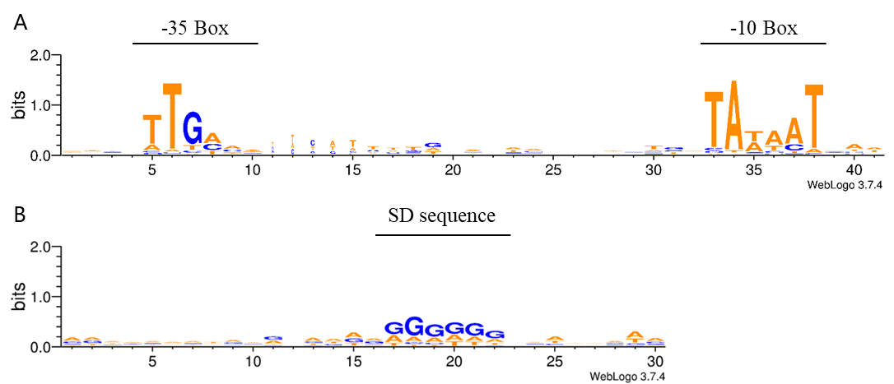

Figure S1 Schematic representation of conserved bases (-10, -35, and SD regions) in the promoter sequences of 77 high transcription level genes.

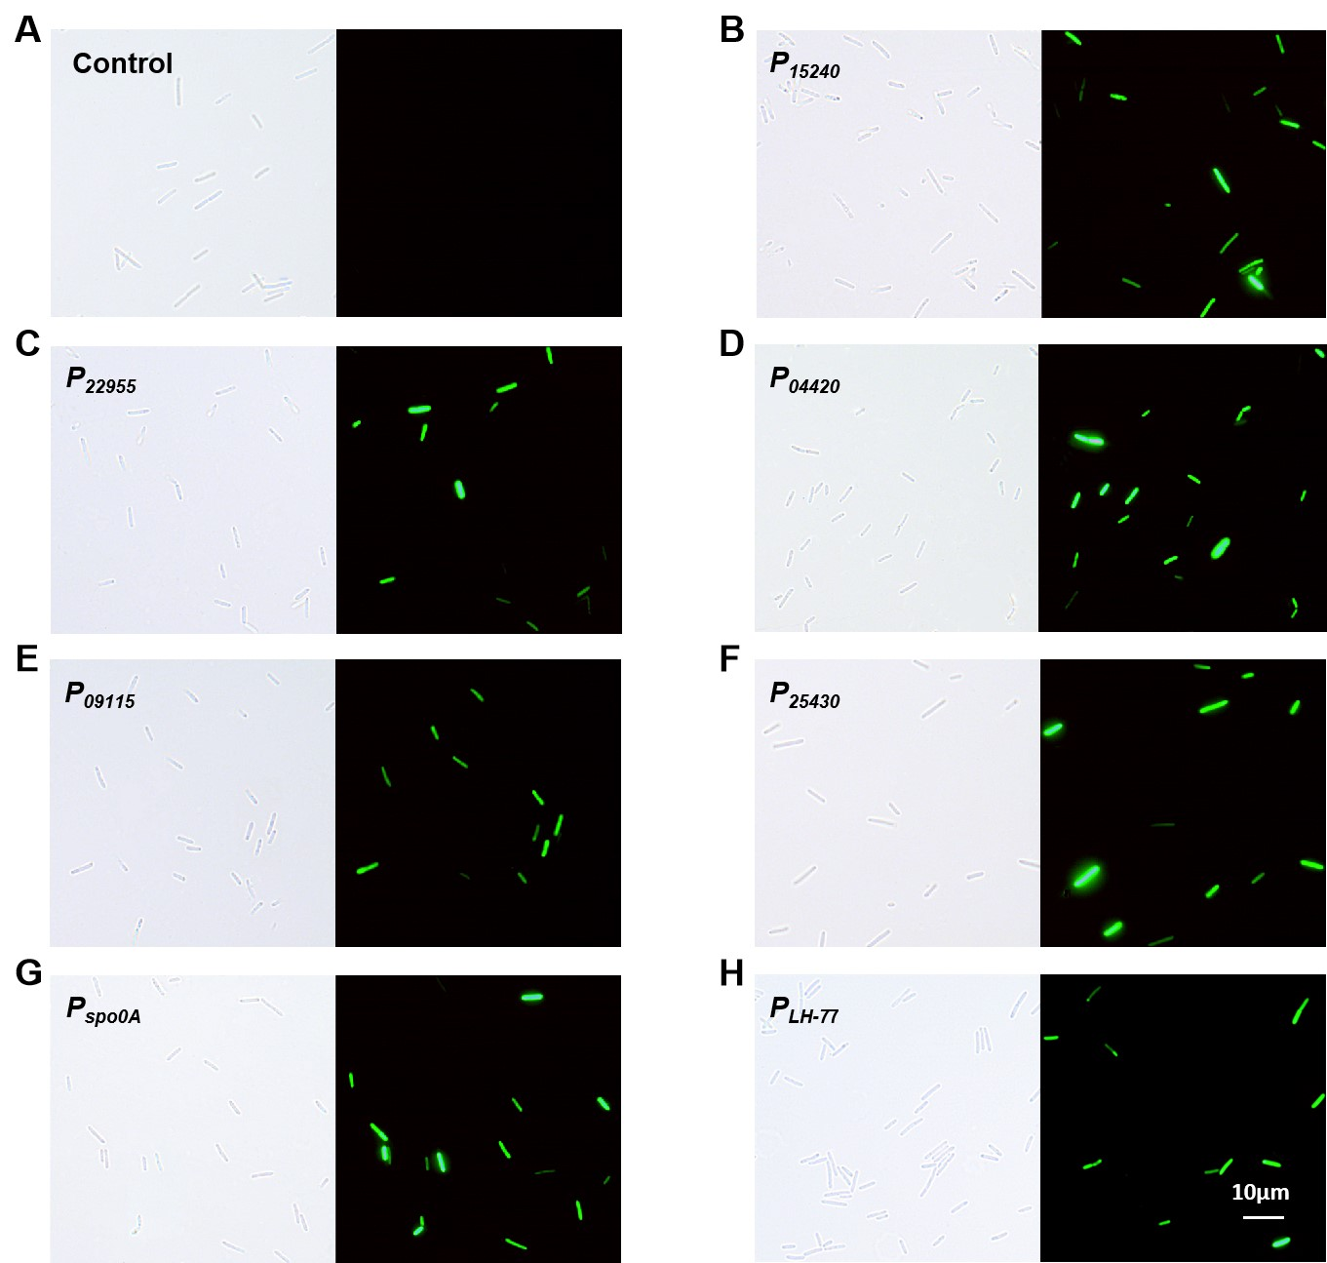

Figure S2 Fluorescent microscopic observation of GFP that expressed by high strengh promoters in strain SC2-M1. The growth time of all recombinant bacteria was 24 h, the laser intensity was 25, the exposure value was 85, and the gain value was 100. The left side of each picture was captured in bright field, and the right side was captured in the corresponding dark field when the blue excitation light was turned on. A was the negative control with no promoter, B to G were the experimental group with studied promoters P₁₅₂₄₀, P₂₂₉₅₅, P₀₄₄₂₀, P₀₉₁₁₅, P₂₅₄₃₀, and P_{spo0A}, respectively, and H was the positive control with promoter P_{LH-77}.

Figure S3 Fluorescence intensity of GFP that expressed by different promoters. Fluorescence intensity of GFP in E. coli DH5α (A) and B. subtilis 168 (B). Control represented the E. coli DH5α and B. subtilis 168 without promoter. The others represented the E. coli DH5α and B. subtilis 168 with different promoters.
B
A

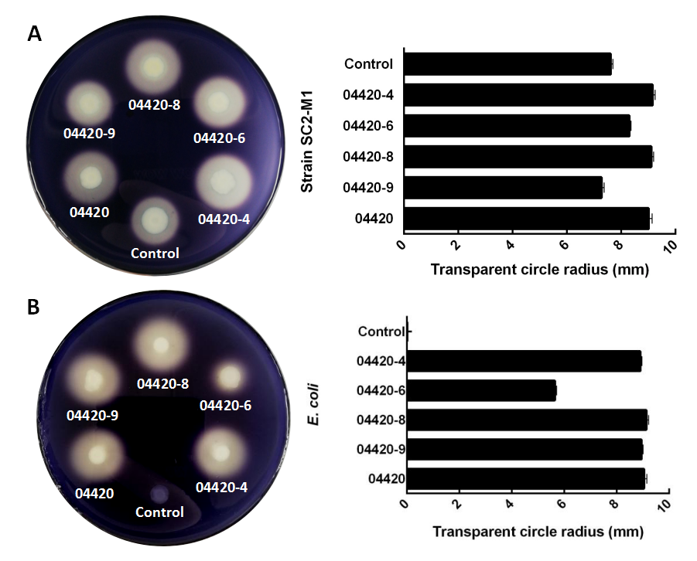

Figure S4 Assay of α-amylase activities by starch hydrolysis on plates. Recombinant bacteria were grown for 48 hours and the transparent circle radius were observed and caculated. Recombinants of P. polymyxa SC2-M1 (A) and E. coli DH5α (B). The control contained the empty plasmid pHY300PLK. Promoters P₀₄₄₂₀₋₄, P₀₄₄₂₀₋₆, P₀₄₄₂₀₋₈, P₀₄₄₂₀₋₉, and P₀₄₄₂₀ were represented with different express activities.

