Table S1 Primers used in this study.
Primer | Sequence and purpose (5'–3')
T-check-F | GGCGGTCAGATGATCGCCCTT
CGS9114_RS09730-up-F | aacgacggccagtgccaagct GTGATGTTCACGATCGTTCCC
CGS9114_RS09730-up-R | AAAAGGGCGATCATCTGACCGCCCCAACCTTCGCCACATGTTC
CGS9114_RS09730-down-F | GGGCGGTCAGATGATCGCCCTTTTTTTTTTTCGTCAGCGAATAACCATGC
CGS9114_RS09730-down-R | cggtacccggggatcctctag TCCGTCATCGCGTTGATC
acnR-up-F | aacgacggccagtgccaagctTGCTTTCGGCATCATCGAC
acnR-up-R | AAAAGGGCGATCATCTGACCGCCCTTGCACGCTTGTAGGAAACTCG
acnR-down-F | AAGGGCGGTCAGATGATCGCCCTTTTTTTTTTGGTGATCAACCAATTGCGG
acnR-down-R | cggtacccggggatcctctag AACGCGCCGATTGATGAG
pdxR -up-F | aacgacggccagtgccaagct TTTCGCAGCTTCCAACCAG
pdxR -up-R | AAAAGGGCGATCATCTGACCGCCC AATGCCGGAATTCTTGCAC
pdxR -down-F | GGGCGGTCAGATGATCGCCCTTTTTTTTTTATCCAGTCGTGTCGGTCTACC
pdxR -down-R | cggtacccggggatcctctag AAGCGATGTTTACGTGCATCC
P_{sod}-F | GCTGCCAATTATTCCGGGCTTG
qsuR -up-F | aacgacggccagtgccaagct CCAACCCCATGACATTAGAGC
qsuR - up-R | CGGAATAATTGGCA AGGGTCATACATCCACCCCTT
qsuR -P_{sod}-F | TGTATGACCCT TGCCAATTATTCCGGGCTTG
qsuR -P_{sod}-R | GGTATGCAAGAGATGGATATCATGGTTTCCGCACCGAGCATATACATCTT
qsuR -down-F | CCATGATATCCATCTCTTGCATACC
qsuR -down-R | cggtacccggggatcctctagTTCTGGATCAGGGCCTTCAC
prpC-up-F | aacgacggccagtgccaagct GTCGACAAGCATTTAAAGCGG
prpC - up-R | CGGAATAATTGGCA CGCAGGAGCTCATATAATCTGC
prpC -P_{sod}-F | GAGCTCCTGCG TGCCAATTATTCCGGGCTTG
prpC -P_{sod}-R | ATGTGCTGGTCAAAGACGTTGTATTTCCGCACCGAGCATATACATCTT
prpC -down-F | TACAACGTCTTTGACCAGCACAT
prpC -down-R | cggtacccggggatcctctag TTACGATCCAACGCCTTGC
CGS9114_RS08985-up-F | aacgacggccagtgccaagctTGACCGTCCTATGTGACCGAT
CGS9114_RS08985-up-R | CGGAATAATTGGCATAAGCGCAGTTCAGTAGGGG
CGS9114_RS089855-P_{sod}-F | AACTGCGCTTA TGCCAATTATTCCGGGCTTG
CGS9114_RS08985-P_{sod}-R | CTGGTTTCCAAGCATAGGCATTTCCGCACCGAGCATATACATCTT
CGS9114_RS08985-down-F | TGCCTATGCTTGGAAACCAG
CGS9114_RS08985-down-R | cggtacccggggatcctctagTCGCGATATACGCTGCTGC

Table S2 Promoter and terminator sequence used in this study.
Name | Sequence (5'–3')
P_{sod} | AGCTGCCAATTATTCCGGGCTTGTGACCCGCTACCCGATAAATAGGTC  GGCTGAAAAATTTCGTTGCAATATCAACAAAAAGGCCTATCATTGGGA  GGTGTCGCACCAAGTACTTTTGCGAAGCGCCATCTGACGGATTTTCAAA  AGATGTATATGCTCGGTGCGGAAA
T | GGGCGGTCAGATGATCGCCCTTTTTTTTTT

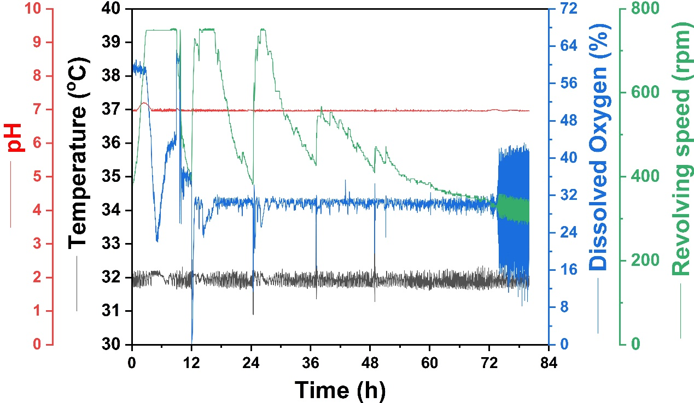
Figure S1 The dynamic curve of stirrer speed, temperature, dissolved oxygen, and pH overall fermentation process. The red, black, blue, and green curves represent pH, temperature, dissolved oxygen, and stirrer speed respectively.

