Additional file 12
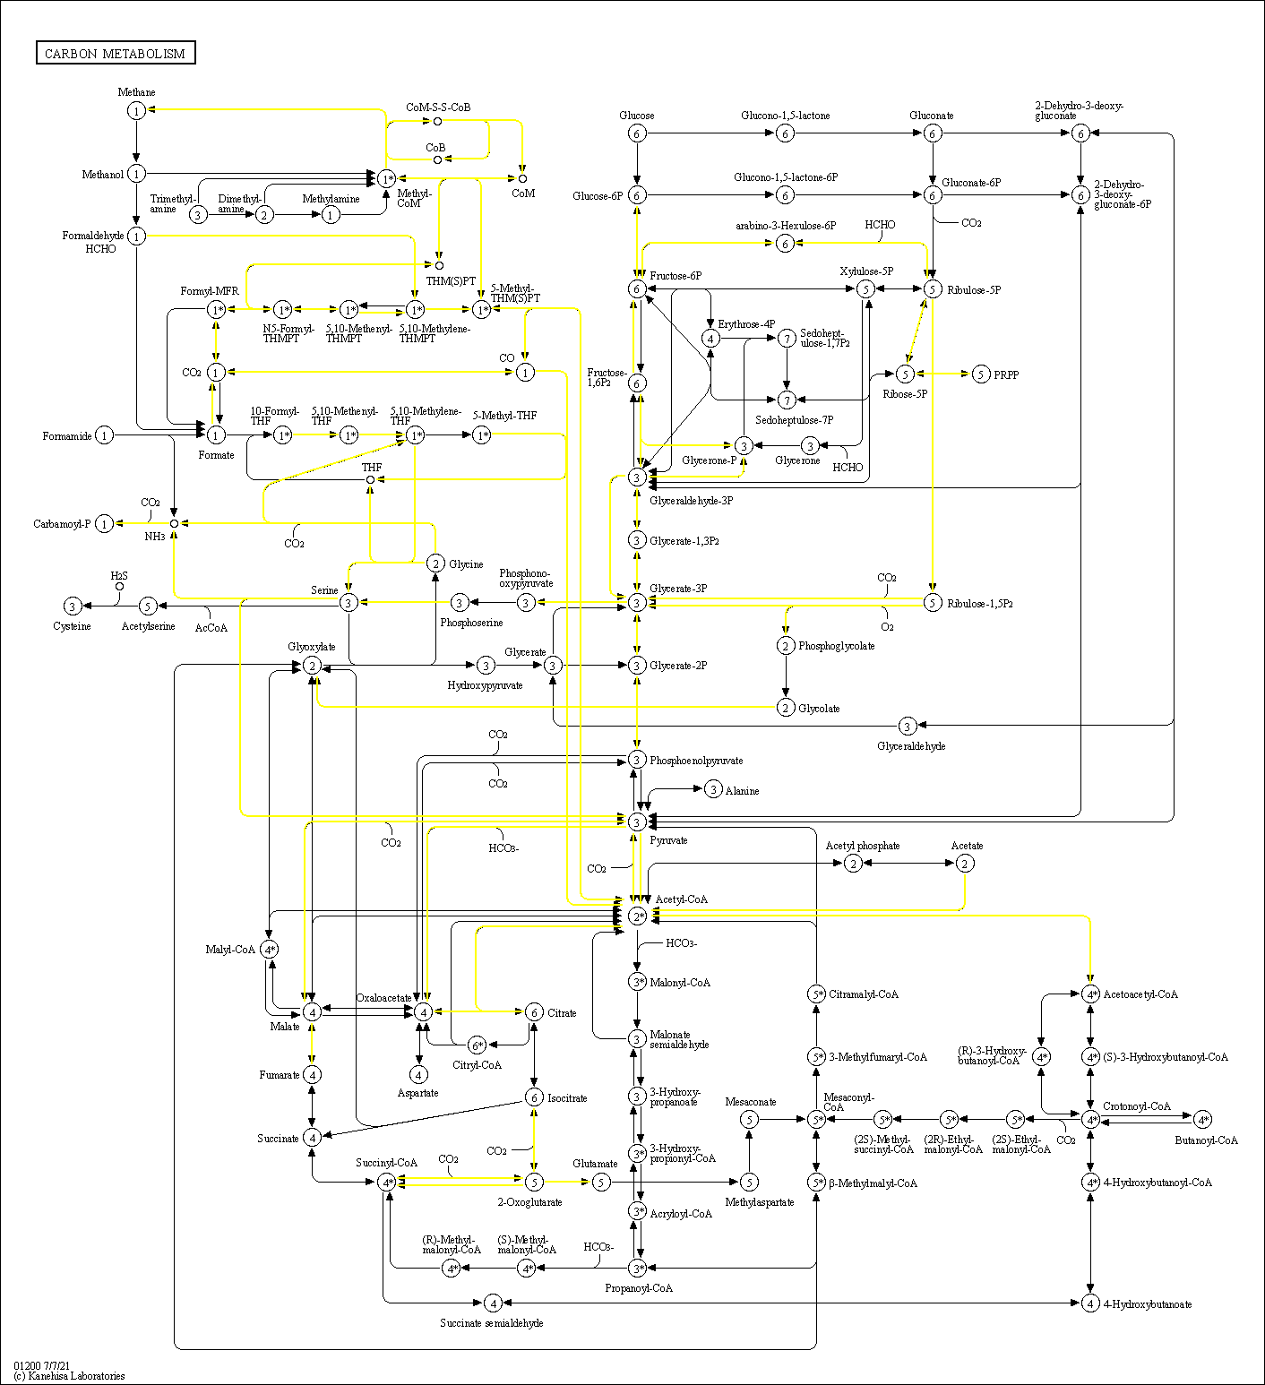
Fig. S12.1. The Kyoto encyclopaedia of genes and genomes (KEGG) map of the central carbon metabolism (map01200) of Methanothrix in the biological methanation reactor based on metagenomic data.

