Additional file 3
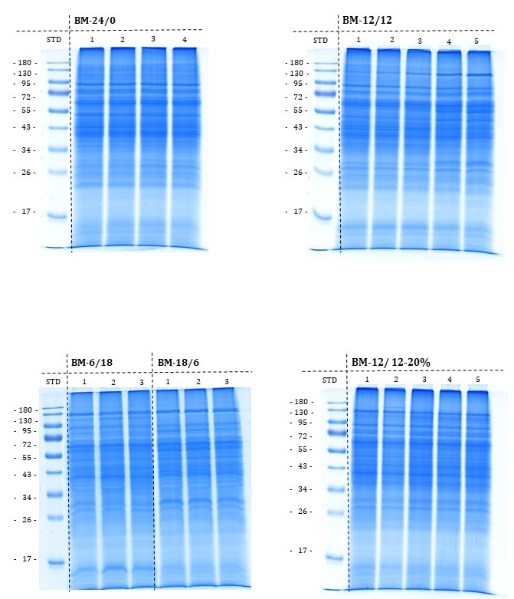
(D)
(C)
(B)
(A)

Fig. S3.1 Sodium dodecyl sulphate polyacrylamide gel electrophoresis (SDS–PAGE) of different H₂-feedings experiments using 25 µg protein extract of the corresponding feeding scheme. (A) Protein profile of four samples of BM-24/0. (B) Protein profile of five samples of BM-12/12. (C) Protein profiles of three samples of BM-18/6 and BM-6/18. (D) Protein profiles of five samples of BM-12/12-20%.

