Understanding of Bacterial Lignin Extracellular Degradation Mechanisms by Pseudomonas putida KT2440 via Secretomic Analysis

Zhangyang Xuª, Bo Pengª, Reta Birhanu Kitata^{b}, Carrie D. Nicora^{b}, Karl K. Weitz^{b}, Yunqiao Pu^{c}, Tujin Shi^{b}, John R. Cort^{b}, Arthur J. Ragauskas^{c,d,e}, and Bin Yang^{a,b*}

- Bioproducts, Sciences & Engineering Laboratory, Department of Biological Systems
Engineering, Washington State University, Richland, Washington, 99354, United States.
- Biological Sciences Division, Pacific Northwest National Laboratory, Richland, Washington, 99352, United States.
- Joint Institute for Biological Sciences, Biosciences Division, Oak Ridge National Laboratory, Oak Ridge, Tennessee, 37831, United States.
- Department of Chemical and Biomolecular Engineering, University of Tennessee,
Knoxville, Tennessee, 37996, United States.
- Department of Forestry, Wildlife, and Fisheries, Center for Renewable Carbon, University of Tennessee Institute of Agriculture, Knoxville, Tennessee, 37996, United States.

Additional Figures and Tables

Fig.S1. The overall workflow for identifying bacterial lignin degradation pathways.

Fig. S2. GC-MS analysis of lignin breakdown products. (a) lignin control, (b) lignin + 0.1 mM H₂O₂, (c) lignin + secretome, (d) lignin + secretome + 0.1 mM H₂O₂, (e) lignin + secretome + 0.1 mM H₂O₂ + 0.1 mM Mn²⁺, (f) secretome control. Detailed peak assignments are listed in Table S1.

Fig. S3. Lignin breakdown products identified by GC-MS. The detailed information for each compound is listed in Table S1.

Fig. S4. The variation of peaks area of all lignin breakdown products. Lignin breakdown products were identified by GC-MS after 5 days of different treatment conditions. Lignin concentration was set as 2 g/L. H₂O₂ and Mn²⁺ concentration were both set as 0.1 mM. Peak numbers represent the aromatic compounds, and the detailed information are listed in Table 1. (a) peak area for peak number 1, 5, 12, 16, 17, 21, 35, 36, 42, (b) peak area for peak number 2-4, 6-11, (c) peak area for peak number 13-15, 18-20, 22-24, (d) peak area for peak number 25-33, (e) peak area for peak number 34, 37-41, 43-45. All peak areas were calculated from three replicates (n=3).

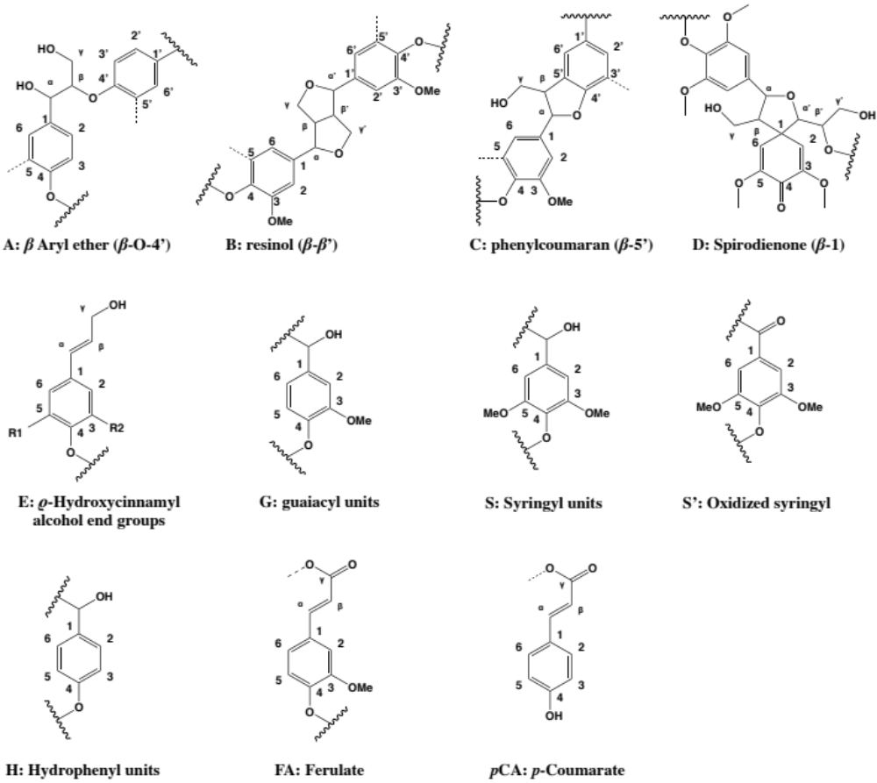
Fig. S5. Main detected lignin linkages.

Table S1. Occurence of putative degradation products of lignin in different treatment conditions ª.
No. | RT | Compounds | Treatment
No. | min | Compounds | L | L+H | S+L | S+L+H | S+L+H+M | S
Aromatic compounds
1 | 8.738 | Benzofuran, 2,3-dihydro- | + | + | + | + | + | -
2 | 9.019 | Benzene, 1,3-bis(1,1-dimethylethyl)- | + | - | + | + | + | +
3 | 9.289 | Phenol, 4-ethyl-2-methoxy- | + | + | + | + | - | -
4 | 9.375 | 4-tert-Butoxystyrene | - | + | - | - | - | -
5 | 9.634 | 2-Methoxy-4-vinylphenol | + | + | + | + | + | -
6 | 10.012 | Phenol, 2,6-dimethoxy- | - | + | - | - | - | -
7 | 10.497 | Vanillin | + | + | + | + | + | -
8 | 10.95 | Phenol, 2-methoxy-4-propyl- | - | - | + | + | + | -
9 | 11.198 | Acetovanillone | - | + | + | + | + | -
10 | 11.317 | Phenol, 2,4-bis(1,1-dimethylethyl)- | - | - | + | + | + | +
11 | 11.802 | Vanillic acid | + | + | + | + | + | -
12 | 12.385 | Benzenepropanoic acid, 4-hydroxy- | + | + | - | - | - | -
13 | 12.676 | 3-Benzofurancarboxylic acid, 2,3-dihydro-2-methoxy-, methyl ester, trans- | + | - | + | + | + | -
14 | 12.914 | Phenol, 2,6-dimethoxy-4-(2-propenyl)- | - | + | + | + | + | -
15 | 13.097 | 1H-Indene, 2,3-dihydro-1,1,3-trimethyl-3-phenyl- | + | - | + | + | + | +
16 | 13.184 | Ethanone, 1-(4-hydroxy-3,5-dimethoxyphenyl)- | + | + | + | + | + | -
17 | 13.227 | Benzeneacetic acid, .alpha.-hydroxy-3-methoxy-, methyl ester | - | + | - | - | - | -
18 | 14.068 | 4-Acetoxycinnamic acid | - | + | - | - | - | -
19 | 14.1 | Ethanone, 1-(2-hydroxy-4,6-dimethoxyphenyl)- | + | - | - | - | - | -
20 | 14.241 | 2,4-Diphenyl-4-methyl-2(E)-pentene | + | + | + | + | + | +
21 | 14.823 | Benzeneacetic acid, 4-(acetyloxy)-3-methoxy-, methyl ester | + | + | - | - | - | -
22 | 15.956 | 3,5-Dimethoxy-4-hydroxycinnamaldehyde | + | - | + | + | + | -
23 | 22.699 | 2,4-Diphenyl-4-methyl-1-pentene | + | + | + | + | + | -
24 | 23.023 | Phenol, 2,4-bis(1-methyl-1-phenylethyl)- | + | + | + | + | + | +
25 | 23.443 | Methanone, bis(2-hydroxy-4-methoxyphenyl)- | - | + | + | + | + | -
26 | 23.983 | 3-(4-Acetoxy-3-methoxyphenyl)-7-methoxy-4-oxo-4H-chromene | + | + | + | + | - | -
27 | 24.716 | Isobenzofuro[5,6-b]benzofuran-8-carboxylic acid, 1,3-dihydro-7,10-dimethoxy-9-methyl-1-oxo-, methyl ester | + | - | - | + | - | -
28 | 27.521 | Phenanthro[3,2-b]furan-7,11-dione, 1,2,3,4,8,9-hexahydro-4,4,8-trimethyl-, (+)- | + | + | - | + | - | -
29 | 28.579 | Oxirane, 2,2'-[(1-methylethylidene)bis(4,1-phenyleneoxymethylene)]bis- | - | - | + | + | - | -
30 | 28.784 | [1,1'-Biphenyl]-3,3'-dicarboxaldehyde, 6,6'-dihydroxy-5,5'-dimethoxy- | - | - | + | + | + | -
Furan
31 | 13.453 | Ethanone, 1-[3-[2-methyl-2-(5-methyl-2-furanyl)propyl]oxiranyl]- | - | - | + | + | + | -
Aldehydes
32 | 12.115 | Dodecan-1-yl acetate | + | - | - | - | - | -
33 | 27.198 | 3-Buten-2-one, 4-(2,6,6-trimethyl-1-cyclohexen-1-yl)- | - | - | + | + | + | -
Esters
34 | 5.135 | Pentanoic acid, ethyl ester | + | + | + | + | + | +
35 | 5.513 | Propanedioic acid, dimethyl ester | + | + | + | + | + | +
36 | 12.806 | 2-Propenoic acid, oxybis(methyl-2,1-ethanediyl) ester | + | - | + | + | + | +
37 | 15.19 | Hexadecanoic acid, methyl ester | + | - | + | + | - | +
38 | 17.79 | Octadecanoic acid, methyl ester | + | - | + | - | + | +
Organic acids
39 | 6.386 | Butanoic acid, 3-hydroxy- | - | - | - | + | - | -
40 | 15.6 | n-Hexadecanoic acid | + | + | + | + | + | +
41 | 18.254 | Octadecanoic acid | + | + | + | + | + | +
Alkanes
42 | 7.465 | Undecane | + | + | + | + | + | +
43 | 9.483 | Hexane, 2,3,4-trimethyl- | - | - | - | + | - | -
44 | 17.456 | Nonadecane | + | - | + | - | + | -
45 | 18.847 | Docosane | + | - | - | - | - | -
ª Note: “RT”, retention time; “min”, minute, “-”, compound was not detected; “+”, compound was detected; “L”, Lignin control; “L+H”, Lignin with the presence of 0.1 mM H₂O₂; “S+L”, Secretome with lignin; “S+L+H”, Secretome with the presence of lignin and 0.1 mM H₂O₂; “S+L+H+M”, Secretome with the presence of lignin, 0.1 mM H₂O₂ and 0.1 mM Mn²⁺; “S”, Secretome control, Lignin concentration was set as 2 g·L⁻¹ for all treatments. Structures are shown in the supplementary material, Figure S3.

Table S2. Grouped lignin breakdown products among all treatments ª.
 | Peak area
 | Increased | Decreased | Degraded | Not changed
Lignin + H₂O₂ | 1, 3, 4, 5, 6, 7, 9, 11, 12, 14, 16, 17, 18, 20, 21, 24, 25, 26, 34, 35, 42 | 40 | 2, 13, 15, 19, 22, 27, 32, 36, 37, 38, 44, 45 | 23, 28
Lignin+Secretome | 3, 7, 8, 9, 10, 13, 14, 25, 29, 30, 31, 33 | 1, 2, 5, 11, 15, 16, 20, 22, 23, 24, 26, 34, 35, 36, 37, 38, 40, 41, 42, 44 | 12, 19, 21, 27, 28, 32, 45 | 22
Lignin+Secretome+H₂O₂ | 3, 7, 8, 9, 10, 11, 13, 14, 25, 26, 29, 30, 31, 33, 39, 43 | 1, 2, 5, 15, 16, 20, 22, 24, 27, 28, 34, 35, 36, 37, 40, 41, 42 | 12, 19, 21, 32, 38, 44, 45 | 23
Lignin+Secretome+H₂O₂+Mn²⁺ | 7, 8, 9, 10, 11, 13, 14, 25, 30, 31, 33, 36 | 1, 2, 5, 11, 15, 16, 20, 22, 23, 24, 34, 35, 38, 40, 41, 42, 44 | 3, 12, 19, 21, 26, 27, 28, 32, 37, 45 | -
ª Note: Peak area alterations (increased and decreased) were compared to original lignin control. The degraded group indicated that the compounds were not detected in the treatment but in the original lignin control.

Table S3. Main lignin 2D ¹H-¹³C Cross-peak assignments in the HSQC Spectra.¹⁻³
Label | δH (ppm) | δC (ppm) | Assignments
-OMe | 3.70 | 55.6 | C-H in methoxyls
A_{α} | 4.83 | 71.6 | C_{α}-H_{α} in β-O-4' substructures (A)
A_{β(G)} | 4.34 | 83.6 | C_{β}-H_{β} in β-O-4' substructures linked to G units (A)
A_{β(S)} | 4.10 | 85.8 | C_{β}-H_{β} in β-O-4' substructures linked to S units (A)
A_{γ} | 3.20-3.50 | 59.5-60.1 | C_{γ}-H_{γ} in β-O-4' substructures (A)
A'_{γ} | 4.20 | 63.5 | C_{γ}-H_{γ} in γ-acylated β-O-4' substructures (A)
B_{α} | 4.60 | 84.8 | C_{α}-H_{α} in resinol (β-β’) substructures (B)
B_{β} | 3.05 | 55.1 | C_{β}-H_{β} in resinol (β-β’) substructures (B)
B_{γ} | 3.87;4.10 | 70.8 | C_{γ}-H_{γ} in resinol (β-β’) substructures (B)
C_{α} | 5.58 | 87.3 | C_{α}-H_{α} in phenylcoumaran (β-5’) substructures (C)
C_{β} | 3.49 | 52.3 | C_{β}-H_{β} in phenylcoumaran (β-5’) substructures (C)
C_{γ} | 3.65 | 61.9 | C_{γ}-H_{γ} in phenylcoumaran (β-5’) substructures (C)
D_{α} | 4.89 | 81.8 | C_{α}-H_{α} in spirodienone (β-1) substructures (D)
E_{γ} | 4.07 | 61.6 | C_{γ}-H_{γ} in hydroxycinnamyl substructures (E)
G₂ | 6.95 | 111.0 | C₂-H₂ in guaiacyl units (G)
G₅ | 6.77 | 115.4 | C₅-H₅ in guaiacyl units (G)
G₆ | 6.74 | 118.8 | C₆-H₆ in guaiacyl units (G)
S_{2/6} | 6.68 | 103.7 | C_{2,6}-H_{2,6} in etherified syringyl units (S)
S'_{2/6} | 7.30 | 106.3 | C_{2,6}-H_{2,6} in oxidized syringyl units (S')
H_{2/6} | 7.21 | 128.2 | C_{2,6}-H_{2,6} in p-hydroxyphenyl substructures (H)
FA₂ | 7.26 | 111.3 | C₂-H₂ in ferulate units (FA)
FA₆ | 7.09 | 121.9 | C₆-H₆ in ferulate units (FA)
FA_{α} | 7.47 | 143.8 | C_{α}-H_{α} in ferulate (FA)
FA_{β} | 6.39 | 116.5 | C_{β}-H_{β} in ferulic acid (FA)
ρCA_{2/6} | 7.44 | 129.9 | C_{2,6}-H_{2,6} in ρ-coumarate units (ρCA)
ρCA_{3/5} | 6.77 | 115.4 | C_{3,5}-H_{3,5} in ρ-coumarate units (ρCA)
ρCA_{α} | 7.47 | 143.8 | C_{α}-H_{α} in ρ-coumarate (ρCA)
ρCA_{β} | 6.23 | 113.7 | C_{β}-H_{β} in ρ-coumarate (ρCA)

References
1. J. C. del Río, J. Rencoret, P. Prinsen, Á. T. Martínez, J. Ralph and A. Gutiérrez, J. Agric. Food Chem, 2012, 60, 5922-5935.
2. L. Zhang, Z. Xu, J. R. Cort, T. Vuorinen and B. Yang, Energy Fuels, 2020, 34, 16310-16319.
3. L. Zhang, L. Yan, Z. Wang, D. D. Laskar, M. S. Swita, J. R. Cort and B. Yang, Biotechnol. Biofuels, 2015, 8, 203.

