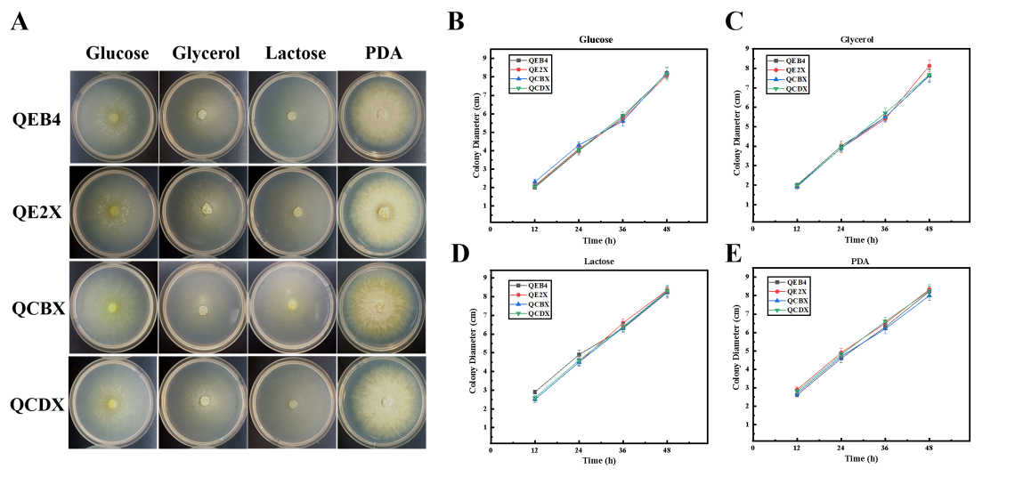
Figure S1. Growth assay of T. reesei QEB4 and the xyr1 overexpression strains. (A) Colonial phenotypes of the parental strain and three recombinant strains on MM with 2% glucose, 2% glycerol, and 2% lactose or on PDA. Plates were incubated at 30℃ and photos were taken at 48 h. Growth rates of hyphae were determined after cultivation on the MM plates wtih the following carbon sources: glucose (B), glycerol (C) and lactose (D), and on the PDA plates (E) at 30°C for 48 h. Results are means of three biological replicates and error bars indicate ± SD.

