Detailed description of transgene vector construction for gene overexpression or disruption in Aspergillus pseudoterreus or Aspergillus niger.

All transgene over-expression or gene disruption constructs were prepared by Gibson assembly method (reference, Ipswich, MA, USA 01938) with DNA fragments isolated by PCR from either related plasmid or genomic DNAs of Aspergillus carbonarius, A. niger, Aspergillus oryzae, or A. pseudoterreus with proper oligo pairs and Phusion high-fidelity DNA polymerase (Thermo Fisher Scientific, Waltham, MA, USA 02451). The first β-alanine pathway transgene expression cassette with pyrithiamine resistance gene (ptrA; Genbank: AF217503) of A. oryzae as a selection marker shown in supplementary Figure S1A was prepared as follows: the first 987bp DNA fragment of cad1 (Genbank: UDM55691.1, 5’-cad1) gene upstream region containing 535bp coding sequence of N-terminus was isolated by PCR with oligo pair 1969cad1/1670cad1 (Table S1); the second 813bp DNA fragment of A. niger gpdA (Genbank: XP_025477631, gpdAp) promoter with oligo pair 1971gpdA1/1972gpdA2; the third 1623bp DNA fragment of aspartate decarboxylase (Tribolium castaneum panD, PAND) with 1973pan1/1974pan2 and the synthetic plasmid DNA of codon usage optimization for A. pseudoterreus as a template; the forth 1040bp DNA fragment of bi-direction transcriptional terminator of A. niger elf3-multifunctional chaperone (elf3, Genbank: CAK43351.1, elf3t) with oligo pair 1975ter1/1976ter2; the fifth 1350bp reverse complement DNA fragment of β-alanine-pyruvate aminotransferase (Bacillus cereus bapat, BAPAT) with oligo pair 1977bap1/1978bap2 and the synthetic plasmid DNA of codon usage optimization for A. pseudoterreus as a template; and final 704bp complement DNA fragment of A. niger enolase (Genbank: AM270411.1, eno1p) promoter with oligo pair 1979eno1/1980eno2-HpaI. All 6 DNA fragments were assembled together into the pBSK(-) vector linearized with restriction endonuclease HindIII and PstI to form new intermediate vector 3HP4025. The 885bp DNA fragment of Aspergillus nidulans gpdA promoter was prepared by PCR with oligo pair 1981gpdA1/1982gpdA2 and pAN7-1 plasmid DNA (Genbank: Z32698.1, gpdAp) as a template; the 744bp DNA fragment of 3-hydroxypropionate dehydrogenase (Escherichia coli hpdh, HPDH) with oligo pair 1983hpd1/1984hpd2 and the synthetic plasmid DNA of codon usage optimization for A. pseudoterreus as a template; the 473bp DNA fragment of A. nidulans trpC (trpCt) transcriptional terminator with oligo pair 1985trp1/1986trp2 and pAN7-1 plasmid DNA as a template; the 2005bp DNA fragment of A. oryzae ptrA gene with oligo pair 1987ptrA1/1988ptrA2 (ptrA); and 908bp DNA fragment of A. pseudoterreus cad1 gene downstream region containing 519bp coding sequence of its C-terminus and transcriptional terminator with oligo pair 1989cad3/1990cad4 (3’-cad1). Above 5 DNA fragments were assembled into the intermediate vector 3HP4025 linearized with the restriction endonuclease HpaI, which was introduced into the 3HP4025 with oligo 1980eno2-HpaI, to form the entire β-alanine pathway transgene expression cassette 3HP4028. The entire transgene expression construct was verified by Sanger DNA sequencing. The second β-alanine pathway transgene expression cassette was to construct two identical copies of the β-alanine pathway, where the plasmid 3HP4028 was linearized by restriction endonuclease EcoRI and assembled with the entire fragment of the β-alanine pathway, which was isolated by PCR with oligo pair 2085HP2F/2086HP2R and 3HP4028 as a DNA template to form the plasmid 3HP4046 (supplementary Figure S3).
The third β-alanine pathway transgene expression cassette 3HP4070 with E. coli hygromycin B phosphotransferase (hph) marker gene (supplementary Figure S4) was prepared with the plasmid 3HP4028 and pCB1003 (http://www.fgsc.net/fgn41/carroll.html) as the DNA templates for PCR as follows: the first 2759bp DNA fragment containing 326bp of 5’-end cad1 coding sequence of A. pseudoterreus, 810bp of A. niger gpdA promoter, and 1623bp DNA fragment of panD with oligo pair 2201/2202; the second 3091bp DNA fragment containing the 1040bp DNA fragment of bi-direction transcriptional terminator of A. niger elf3, the 1350bp reverse complement DNA fragment of bapat, and 701bp reverse complement DNA fragment of A. niger eno1 promoter with oligo pair 2203/2204. These two fragments were assembled into the pBSK(-) vector linearized with restriction endonuclease HindIII and PstI to form new intermediate vector 3HP4069. The 1360bp DNA fragment of hph marker gene was prepared by PCR with oligo pair 2213hphF/2214hphR and plasmid DNA pCB1003 as a template. The 2385bp DNA fragment containing 885bp DNA fragment of A. nidulans gpdA promoter, 744bp DNA fragment of hpdh, 473bp DNA fragment of A. nidulans trpC transcriptional terminator, and 283bp upstream region of A. oryzae ptrA gene was isolated with oligo pair 2215hpdF/2216hpdR. These two fragments were further assembled into the 3HP4069 linearized with restriction endonuclease XbaI to form the 3HP4070 transgene expression vector. The entire transgene expression construct was verified by Sanger DNA sequencing.
The fourth β-alanine pathway transgene expression cassette with an additional A. pseudoterreus aspartate aminotransferase gene (Apaat1, jgi|Aspte1|7965|ATET_04402; supplementary Figure S5) was prepared by PCR with oligo pairs of PAptefF/PAptefR for 956bp A. pseudoterreus tef1 gene (Aptef1, jgi|Aspte1|9546|ATET_05983) promoter and the ApaatF/Apaat for 1898bp A. pseudoterreus aspartate aminotransferase entire coding region and 269bp its transcriptional terminator. The fragments were assembled into 3HP4070 linearized with restriction endonuclease XbaI to form transgene expression cassette 3HP4071. The entire transgene expression construct was verified by Sanger DNA sequencing.
The PCR fragments for A. niger aspartate aminotransferase gene (aat1, GenBank: EHA22111) over-expression construct 3HP4074 (supplementary Figure S7A, ble, tef1P:aat:pgk1T) were prepared with the oligo pair bleF1/bleR1 and plasmid DNA pAN8-1 (GenBank: Z32751.1) for 1550bp DNA fragment of the bacterial bleomycin resistance (ble) marker gene, the oligo pair PAntef1F/PAntef1R for 870bp DNA fragment of translation elongation factor 1 (tef1, Genbank: CBJ23536.1) promoter of A. niger, the oligo pair AnaatF/AnaatR for the 1401bp aat1 cDNA of A. niger, and the oligo pair TAnpgkF1/TAnpgkR1 for 772bp DNA fragment of the transcriptional terminator of phosphoglerate kinase (pgk, jgi|aspin7|1147902) gene of A. niger. All PCR fragments were assembled together into the pBSK(-) linearized by HindIII and PstI restriction enzymes with Gibson assembly master mix (NEB, Ipswich, MA, USA). Similarly, the over-expression transgene construct for pyruvate carboxylase were prepared with the oligo pairs of bleF1/bleR2 (ble) for 1550bp DNA fragment of the ble gene, TAnpgkF2/TAnpgkR1 (Tpgk) for 772bp DNA fragment of the transcriptional terminator of pgk, AnpycF/AnpycR for 3579bp cDNA fragment of A. niger pyruvate carboxylase cDNA (pyc; jgi|Aspni7|1031996), and PAnmbf1F/PAnmf1R for 1499bp DNA fragment of A. niger mbf1 gene (jgi|Aspni7|1145066) promoter (supplementary Figure S7B, 3HP4076) or their combination, where pyc overexpression cassette was incorporated into the downstream of aat1 overexpression cassette right after the TpgkF2/TpgkR1 (pgkt) DNA fragment (supplementary Figure S7C, 3HP4077). The entire transgene expression construct was verified by Sanger DNA sequencing.
Prior to building the transgene overexpression construct for A. niger monocarboxylate transporter (mct1, jgi|Aspni7|1163060), the new selection marker nat1 (Streptomyces noursei nourseothricin N-acetyl transferase optimized for the codon usage of Saccharomyces cerevisiae) gene under the control of A. nidulans trpC promoter and A. niger trpC transcriptional terminator cassette was prepared. The DNA fragment for A. nidulans trpC promoter and A. niger trpC transcriptional terminator were isolated with the oligo pair 2555trpF1/2556trpR1 and 2559trpF2/2560trpR2 with the pCSN44 plasmid (GenBank: LT726870.1) as a template for trpC promoter and with A. niger genomic DNA as a template for A. niger trpC transcriptional terminator, respectively. The nat1 coding region was obtained by PCR with oligo pair 2557nat1F/2558nat1R and the plasmid DNA CHCp9 (1) as a template. All three DNA fragments were assembled to form vector (supplementary Figure S7D, 3HP4114). The mct1 overexpression construct was prepared with the oligo pairs of nat1F/nat1R for 1250bp DNA fragment of nat1 marker gene with 3HP4114 as a template, PAnmbf1/PAnmbf1R for 1351bp DNA fragment of A. niger mbf1 gene promoter and AnmctF/AnmctR for 1544bp DNA fragment of A. niger mct gene coding sequence and its transcriptional terminator, which were assembled into pBSK(-) linearized with HindIII/PstI restriction endonucleases to form 3HP4126 (supplementary Figure S7E). The entire transgene expression construct was verified by Sanger DNA sequencing.
Gene disruption constructs for oahA (jgi/Aspni7/1145269), ald6a (jgi/Aspni7/1182225), ald6b (jgi/Aspni7/201822), ald3 (jgi/Aspni7/1126238), and uga2 (jgi/Aspni7/57046) from A. niger were prepared by Gibson assembly of related DNA fragments isolated via PCR with the following oligo pairs: 5AnoahAF/5AnoahAR, hphF1/hphR1, and 3AnoahAF/3AnoahAR for oahA gene (supplementary Figure S9A, 3HP4102); 5Anald6aF/5Anald6haR, hphF2/hphR2, and 3Anald6aF/3Anald6aR for ald6a gene (supplementary Figure S9B, 3HP4103); 5Anald6bF/5Anald6bR, hphF3/hphR3, and 3Anald6bF/3Anald6bR for ald6b gene (supplementary Figure S9C, 3HP4104); 5Anald3F/5Anald3R, hphF4/hphR4, and 3Anald3F/3Anald3R for ald3 gene (supplementary Figure S9D, 3HP4108); 5Anuga2F/5Anuga2R, hphF5/hphR5, and 3uga2F/3uga2R for uga2 gene (supplementary Figure S9E; 3HP4109).
For further genetic modification in the transgenic strain, the marker recycling strategy was applied to overcome the limitation of selection marker genes in A. niger. The Tet-On/Cre-loxP system (2, 3) was incorporated into the new transgene expression or gene disruption. The Tet-On/Cre-loxP transgene expression construct was prepared with the oligo pairs of nat1F/nat1R for 1250bp DNA fragment of entire nat1 marker gene with 3HP4114 as a template, ubi1F/ubi1R, rtTAF/rtTAR, tetO7F/tetO7R, and trpCF/trpCR for 848bp DNA fragment of A. niger ubi1S27 gene (jgi|Aspni7|1135631) promoter, 1036bp DNA fragment of reverse tetracycline transactivator (rtTA2S), 1550bp DNA fragment of tetracycline resistance operon/gpdA mini promoter of A. nidulans/Cre recombinase (tetO7-Pmn-Cre), in which the rtTA2S and tetO7-Pmn-Cre were synthesized with codon usage optimization for A. niger, and 554bp DNA fragment of A. carbonarius trpC transcriptional terminator, respectively. All DNA fragments were assembled into the pBSK(-) linearized with HindIII/PstI restriction endonucleases to form transgene expression vector 3HP4140 (supplementary Figure S10A). The entire transgene expression construct was verified by Sanger DNA sequencing.
The nptII [the neomycin phosphotransferase II gene, (4)] marker gene for A. niger was constructed with the DNA fragments isolated by PCR with oligo pair 2662mdhFp/2663mdhRp for 965bp DNA fragment of A. niger mdh (jgi|Aspni7|1143375) gene promoter and oligo pair 2664npt2F/2665npt2R for 1138 bp DNA fragment of nptII gene coding region (GenBank: AF485783.1, 795bp) and A. nidulans trpC transcriptional terminator (GenBank: U24705.1, 343bp). The DNA fragments were assembled into the pBSK(-) linearized with HindIII/PstI restriction endonucleases to form plasmid vector 3HP4134 (supplementary Figure S10B). To introduce the 31bp loxP fragments into the nptII marker gene, the oligo pair loxPnpt2F/loxPnpt2R was used to isolate the nptII marker gene from 3HP4134 plasmid DNA and assembled into the pBSK(-) linearized with HindIII/PstI restriction endonucleases to form plasmid vector 3HP4136 (supplementary Figure S10C).
To construct the fifth β-alanine 3HP pathway transgene expression cassette with loxP-nptII as a selection marker and a new set of A. niger promoters, the 3HP4028 plasmid DNA was used for a DNA template for isolation of panD, bapat, hpdh, elf3t and trpCt with the following oligo pairs: 2728pu4F/2729pu4R for 819bp DNA fragment of A. niger ubi4 (jgi|Aspni7|1146681) gene promoter, 2730panF/2731panR for 2198bp DNA fragment of panD gene and a part of elf3t, 2732bapatF/2733bapatR for 1823bp DNA fragment of bapat gene and a part of elf3t, and 847bp DNA fragment of 2734pus1F/2735pus1R for A. niger ubiS27 gene promoter in reverse complementation. The first 4 DNA fragments were assembled into the 3HP4136 vector linearized with restriction endonuclease XhoI to form plasmid 3HP4144 (supplementary Figure S10D). The oligo pair 2736pmbF/273pmbR for 1199bp DNA fragment of A. niger mbfA promoter, and 2738hpdhF/2739hpdhR for 1257bp DNA fragment of hpdh gene and A. nidulans trpC transcriptional terminator. These two fragments were assembled into the plasmid 3HP4144 linearized with restriction endonuclease XbaI to the final transgene expression construct 3HP4145 shown in supplementary Figure S10E. The entire transgene expression construct was verified by Sanger DNA sequencing.

1. Calvey CH, Willis LB, Jeffries TW. An optimized transformation protocol for Lipomyces starkeyi. Curr Genet. 2014;60(3):223-30.
2. Jiang B, Zhang R, Feng D, Wang F, Liu K, Jiang Y, et al. A Tet-on and Cre-lox P based genetic engineering system for convenient recycling of selection markers in Penicillium oxalicum. Front Microbiol. 2016;7:485.
3. Meyer V, Wanka F, van Gent J, Arentshorst M, van den Hondel CA, Ram AF. Fungal gene expression on demand: an inducible, tunable, and metabolism-independent expression system for Aspergillus niger. Appl Environ Microbiol. 2011;77(9):2975-83.
4. Beck E, Ludwig G, Auerswald EA, Reiss B, Schaller H. Nucleotide sequence and exact localization of the neomycin phosphotransferase gene from transposon Tn5. Gene. 1982;19(3):327-36.

Table S1: Oligos used for transgene vector constructions of selected gene over-expressions or disruptions
β-alanine pathway transgene expression cassette with ptrA marker gene
(plasmid vector 3HP4028)
1969cad1 | ccctcgaggtcgacggtatcgataGATATCGGTTGTAGCAGCGTAAACAC
1970cad2 | tctttcatagtagCCTTGGTGAACATCTTGAGG
1971gpdA1 | atgttcaccaaggCTACTATGAAAGACCGCGATG
1972gpdA2 | cgccggtggcgggCATTGTTTAGATGTGTCTATGTG
1973pan1 | catctaaacaatgCCCGCCACCGGCGAGGACCA
1974pan2 | atccaacccatcaGAGGTCGGAGCCCAGGCGTTCG
1975ter1 | gggctccgacctcTGATGGGTTGGATGACGATG
1976ter2 | tctggcccagctcTGAGTCCTAGATGGGTGGTG
1977bap1 | catctaggactcaGAGCTGGGCCAGACATTCCTTC
1978bap2 | gtccatcaacatgGAACTGATGATCGTCCAGGTCAC
1979eno1 | cgatcatcagttcCATGTTGATGGACTGGAGGG
1980eno2-HpaI | gaactagtggatcccccgggctgcGttaaCTCGAGCTTACAAGAAGTAGCC  GGCTACTTCTTGTAAGCTCGAGttaaCgcagcccgggggatccactagttc
1981tdhA1 | acaggctacttcttgtaagctcgagttTCTGTACAGTGACCGGTGAC
1982tdhA2 | tgaccagcacgatCATGGTGATGTCTGCTCAAG  C TTGAGCAGACATCACCATGatcgtgctggtca
1983hpd1 | agacatcaccatgATCGTGCTGGTCACGGGCGC
1984hpd2 | gccatcggtcctaTTGGCGGTGGACGTTCAGGC  GCCTGAACGTCCACCGCCAAtaggaccgatggc
1985trp1 | cgtccaccgccaaTAGGACCGATGGCTGTGTAG
1986trp2 | cccgtctgtcagaGAGCGGATTCCTCAGTCTCG  CGAGACTGAGGAATCCGCTCtctgacagacggg
1987ptrA1 | gaggaatccgctcTCTGACAGACGGGCAATTGATTAC
1988ptrA2 | gaatgttgctgagGAGCCGCTCTTGCATCTTTG  CAAAGATGCAAGAGCGGCTCctcagcaacattc
1989cad3 | gcaagagcggctcCTCAGCAACATTCGCCATGTTC
1990cad4 | actaaagggaacaaaagctggagctCAGCTCCACTGCTCATAGTCTTTG
 | Two copies of β-alanine pathway transgene expression cassette with ptrA marker gene (plasmid vector 3HP4046, 2x3HP)
2085HP2F | acacaattctctatctcagatttgCTACTATGAAAGACCGCGATGGGC
2086HP2R | ttcagtttcgtccgaggacttttggAATTCAAATCTGAGATAGAGAATTG
β-alanine pathway transgene expression cassette with hph marker gene
(plasmid vector 3HP4070)
2201 | cgaggtcgacggtatcgataACGGATCGGCAAAGCAATCTACG
2202 | atccaacccaTCAGAGGTCGGAGCCCAGGC
2203 | cgacctctgaTGGGTTGGATGACGATGACTTC
2212 | agtggatcccccgggctgcaCTCGAGCTTACAAGAAGTAGCCTG
2213hphF | gcccgggggatccactagttGCTGGAGCTAGTGGAGGTCAAC
2214hphR | ctgtacagagCGGTCGGCATCTACTCTATTC
2215hpdF | atgccgaccgCTCTGTACAGTGACCGGTGAC
2216hpdR-XbaI | agggaacaaaagctggagcttctAGAGAATTGTGTGGGATGAG
 | β-alanine pathway transgene expression cassette with hph marker gene and aat1 (plasmid vector 3HP4071)
PAptefF | ctctcatcccacacaattctGAGCATCATCCCATGATAGC
PAptefR | aaaggggcgaACTGTTGTAGAAGATATCCGTTAG
ApaatF | ctacaacagtTCGCCCCTTTCCTCCTCTTC
ApaatR | gggaacaaaagctggagcttctagaCGAGCAATACGGAAGCGAATATC
 | Over-expression of A. niger aat (plasmid vector 3HP4074)
bleF1 | ctcgaggtcgacggtatcgataGtttaaaCTGAGGTGCAGTGGATGATTATTAATC
bleR1 | gaggtcaacgTTGATCTGCTTGATCTCGTC
PAntef1F | agcagatcaaCGTTGACCTCACAGGGATTTC
PAntef1R | aaaggggcgaCTTACTGTTGTAGAAGATATCCGTTAG
Anaat1F | caacagtaagTCGCCCCTTTCCTCCTCTTC
Anaat1R | gacagggcagTTATGAAGTCTCCCGAACTACGC
TAnpgk1F | gacttcataaCTGCCCTGTCGAGTAAGTAAATTTG
TAnpgk1R | actagtggatcccccgggctgcaagcttACTACAGAGAGGAGCTGAAG
 | Over-expression of A. niger pyc (plasmid vector 3HP4076)
bleR2 | atggccactgTTGATCTGCTTGATCTCGTCTC
2271TAnpgkF2 | caaggcctagCTGCCCTGTCGAGTAAGTAAATTTG
AnpycF | TCttcagctcctctctgtagtaCTAGGCCTTGACGATCTTGCAGACAAGATCCTG
AnpycR | cttcaaaatgGCTGCTCCCCGCCAGCCCGA
PAnmbf1F | ggggagcagcCATTTTGAAGATGGATGAGAAGTC
PAnmbf1R | CTccaccgcggtggcggccgctGTTTAAACAGTGGCCATGAAATCCAATC
 | Nat1 selection marker gene construct (plasmid vector 3HP4114)
2555trpF1 | cgaggtcgacggtatcgataCAGAAGATGATATTGAAGGAGC
2556trpR1 | aagtagtcatTTGGATGCTTGGGTAGAATAG
2557nat1F | aagcatccaaATGACTACTTTGGATGACACTG
2558nat1R | aaagctagagTTATGGACATGGCATGGACATG
2559trpF2 | atgtccataaCTCTAGCTTTGTATTGTCTTTAAATTTAC
2560trpR2 | agtggatcccccgggctgcaGTAAGTAGAAAGCTTTGGGG
 | mct1 gene overexpression (plasmid vector 3HP4126)
nat1F | cgaggtcgacggtatcgataACAGAAGATGATATTGAAGGAGC
nat1R | aacgaagaggCAGTAAGTAGAAAGCTTTGGG
PAnmbf1F | ctacttactgCCTCTTCGTTTCTGTGATGC
PAnmbf1R | cggtcgtatgCATTTTGAAGATGGATGAGAAGTC
AnmctF | cttcaaaatgCATACGACCGAGAAGATACC
AnmctR | agtggatcccccgggctgcaGGTTCTCTCCTTGCAGCAAAG
 | oahA gene deletion (plasmid vector 3HP4102)
5AnoahAF | gaggtcgacggtatcgataagcttCTCAGCTGGGTGAAGAACAAC
5AnoahAR | tagctccagcGTGATAGTGTTGGTCATGCTG
hphF1 | acactatcacGCTGGAGCTAGTGGAGGTCAAC
hphR1 | cgttagtatgCGGTCGGCATCTACTCTATTCC
3AnoahAF | atgccgaccgCATACTAACGGAAGGGTCAG
3AnoahAR | agtggatcccccgggctgcaGTACCACGCAAGCTTCGATATG
 | ald6a gene deletion (plasmid vector 3HP4103)
5Anald6aF | gaggtcgacggtatcgatatctaGAGTAAACTGGTGCAGCTATC
5Anald6aR | tagctccagcAGGTGAGGATGAGGAGAGCTTAG
hphF2 | atcctcacctGCTGGAGCTAGTGGAGGTCAAC
hphR2 | gactgtcttgCGGTCGGCATCTACTCTATTCC
3Anald6aF | atgccgaccgCAAGACAGTCGATTTCATCCTC
3Anald6aR | agtggatcccccgggctgcaCACTTGTCCAGACCGAGGTAC
 | ald6b gene deletion (plasmid vector 3HP4104)
5Anald6bF | gaggtcgacggtatcgataGAGGATATGATCTCTTCAACTATAC
5Anald6bR | tagctccagcTCTCAGGAGACATCTGTCTC
hphF3 | tctcctgagaGCTGGAGCTAGTGGAGGTCAAC
hphR3 | ctaccatcgaCGGTCGGCATCTACTCTATTCC
3Anald6bF | atgccgaccgTCGATGGTAGTAGGATGTGG
3Anald6bR | agtggatcccccgggctgcaCAGAGAAGGTGCAGATTGTG
 | aldh3 gene deletion (plasmid vector 3HP4108)
5Anald3F | cgaggtcgacggtatcgataGCTGGCGGTAGAAGGATTTTC
5Anald3R | tagctccagcAATTGGCTGACGAAGAGTATAG
hphF4 | tcagccaattGCTGGAGCTAGTGGAGGTC
hphR4 | actgaagacgCGGTCGGCATCTACTCTATTC
3Anald3F | atgccgaccgCGTCTTCAGTGATGCCGATATC
3Anald3R | agtggatcccccgggctgcaCGTTTGGGCTTTGTCCTTTAG
 | uga2 gene deletion (plasmid vector 3HP4109)
5Anuga2F | cgaggtcgacggtatcgataCCAACTGGCGCTGTATAGATC
5Anuga2R | tagctccagcGGTCTGAAAGTAGTCCTGTG
hphF5 | ctttcagaccGCTGGAGCTAGTGGAGGTC
hphR5 | acgaggattgCGGTCGGCATCTACTCTATTC
5Anuga2F | atgccgaccgCAATCCTCGTCGACCATCAAAAAG
5Anuga2R | agtggatcccccgggctgcaAGAGGGTATGAAGGAGGAG
 | rtTA2S-TetO7-Cre system (plasmid vector 3HP4140)
nat1F | aggtcgacggtatcgatatcACAGAAGATGATATTGAAGGAGC
nat1R | gatagggtggttgtctggatCAGTAAGTAGAAAGCTTTGGG
ubi1F | cgaggtcgacggtatcgataTCCAGACAACCACCCTATCTC
ubi1R | gtctggacatCTTGATGAAGGTCTGGGTTG
rtTAF | cttcatcaagATGTCCAGACTCGATAAGTC
rtTAR | cgtgatacgcTCCATGATTCATGACGTATATTC
tetO7F | gaatcatggaGCGTATCACGAGGCCCTTTC
tetO7R | gccgaagaccGATCCTCAATCACCATCCTCC
trpCF | attgaggatcGGTCTTCGGCTATAGTTCATTTTTATC
trpCR | agtggatcccccgggctgcaGTTGCGATCAGGTGTGTAATTG
 | mdhP-neo marker gene (plasmid vector 3HP4134)
2662mdhFp | tcatcctcagGAACGACTCCAGAAGTGACTAAG
2663mdhRp | gttcaatcatGGTGAAATTTGGGATTGTGAC
2664npt2F | aaatttcaccATGATTGAACAAGATGGATTGC
2665npt2R | agtggatcccccgggctgcaGACTCTGCTAAGCTATTCTTC
 | LoxP-nptII vector (plasmid vector 3HP4136)
loxPnpt2F | ggtcgacggtatcgataATAACTTCGTATAGCATACATTATACGAAGTTATGAACGACTCCAGAAGTGAC
loxPnpt2R | atcccccgggctgcaataacttcgtataatgtatgctatacgaagttatGACTCTGCTAAGCTATTCTTC
 | New β-alanine 3-HP pathway
 | Intermediate vector (plasmid vector 3HP4144)
2728pu4F | attgggtaccgggcccccccgtttaaaCTTCGGAGTAGCAACGAGTATTTTC
2729pu4R | attgtttagaAGCGCAGTTAATGGTGTATG
2730panF | taactgcgctTCTAAACAATGCCCGCCACC
2731panR | TCCCATACTGCTCCCATAGAAG
2732bapatF | TCTATGGGAGCAGTATGGGATC
2733bapatR | cttcatcaagATGGAACTGATGATCGTCCAG
2734pus1F | tcagttccatCTTGATGAAGGTCTGGGTTG
2735pus1R | tattatcgataccgtcgaccTCCAGACAACCACCCTATCTC
 | Entire new β-alanine 3-HP pathway vector (plasmid vector 3HP4145)
2736pmbF | atacgaagttattgcagcccGGGACATGCTGGAAGGGATTTTC
2737pmbR | gcacgatcatTTTGAAGATGGATGAGAAGTCGG
2738hpdhF | catcttcaaaATGATCGTGCTGGTCACGGG
2739hpdhR | ctagaactagtggatcccccgtttaaaCCAATGGGATCCCGTAATCAATTG

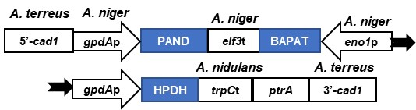
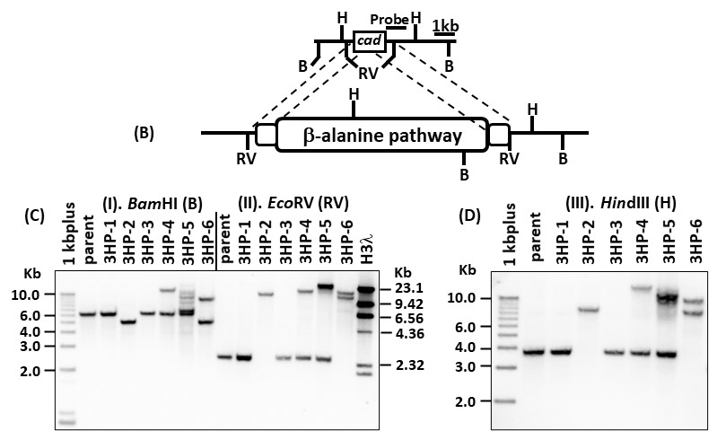

(A)
Figure S1. The diagram of the β-alanine 3HP pathway transgene expression cassette with A. pseudoterreus cad1 gene locus targeting and Southern blotting analyses of transgenic A. pseudoterreus. (A) the diagram of the β-alanine 3HP pathway (3HP4028, Ap3HP): 5’-Cad1, upstream region of cis-aconitate decarboxylase; gpdAp, glyceraldehyde-3-phosphate dehydrogenase promoter from either A. niger or A. nidulans; PAND, T. castaneum aspartate decarboxylase; elf3t, A. niger elongation factor 3 transcriptional terminator; BAPAT, B. cereus β-alanine-pyruvate aminotransferase; eno1
p, A. niger enolase; HPDH, E. coli 3-hydroxypropionate dehydrogenase; trpCt, A. nidulans trpC transcriptional terminator; ptrA, pyrithiamine resistance gene of A. oryzae, and 3’-Cad1, downstream region of cis-aconitate decarboxylase. (B) the diagram of the β-alanine 3HP pathway with the pattern of restriction endonuclease BamHI, EcoRV, and HindIII. (C) the restriction fragment length polymorphism of BamHI or EcoRV in selected transgenic strains. (D) the restriction fragment length polymorphism of HindIII in selected transgenic strains.

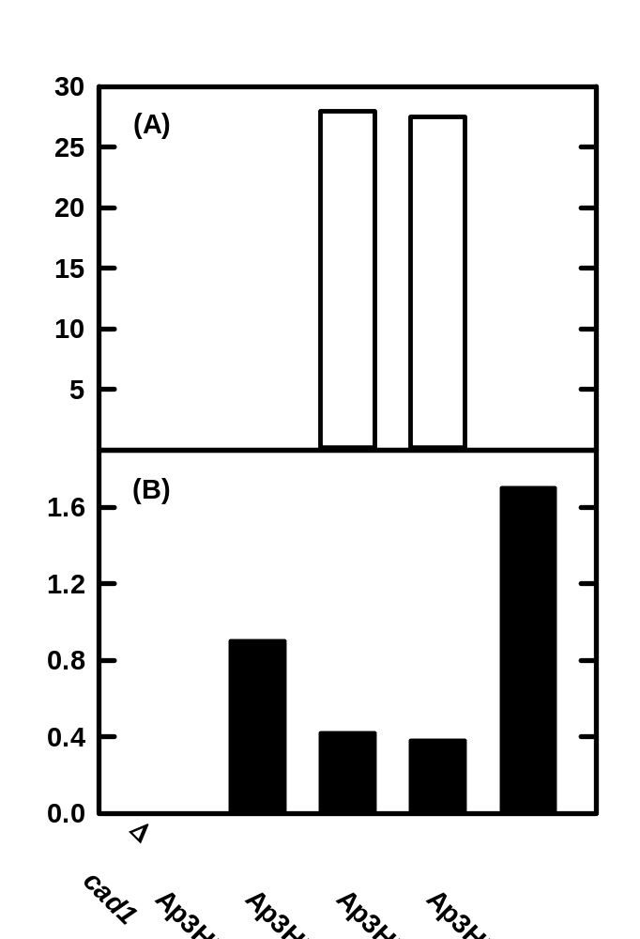
Figure S2. 3-hydroxypropionic acid and itaconic acid production in the selected individual transgenic strains of A. pseudoterreus with over-expression of the β-alanine 3HP pathway transgene expression cassette 3HP4028 (Ap3HP) in the modified RDM medium at 30ºC and 200 rpm for 7 days. The strain 2 and 6 were with the homologous recombination of transgene expression cassette Ap3HP at the cad1 locus (cad1Δ), while strain 4 & 5 with the random integration of the transgene cassette into the chromosomes. All data were average of two biological replates.

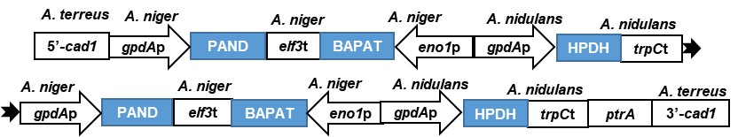

Figure S3. The diagram of β-alanine 3HP pathway transgene expression cassette with two identical copies of β-alanine 3HP pathway (3HP4046, 2x3HP). 5’-Cad1, upstream region of cis-aconitate decarboxylase; gpdAp, glyceraldehyde-3-phosphate dehydrogenase promoter from either A. niger or A. nidulans; PAND, T. castaneum aspartate decarboxylase; elf3t, A. niger elongation factor 3 transcriptional terminator; BAPAT, B. cereus β-alanine-pyruvate aminotransferase; eno1p, A. niger enolase promoter; HPDH, E. coli 3-hydroxypropionate dehydrogenase; trpCt, A. nidulans trpC transcriptional terminator; ptrA, pyrithiamine resistance gene of A. oryzae, and 3’-Cad1, downstream region of cis-aconitate decarboxylase.

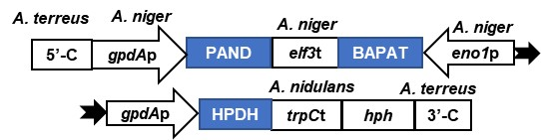

Figure S4. The diagram of β-alanine 3HP pathway transgene expression cassette with E. coli hygromycin B phosphotransferase (hph) marker gene (3HP4070). 5’-C, 326bp upstream region of cis-aconitate decarboxylase of A. pseudoterreus; gpdAp, glyceraldehyde-3-phosphate dehydrogenase promoter from either A. niger or A. nidulans; PAND, T. castaneum aspartate decarboxylase; elf3t, A. niger elongation factor 3 transcriptional terminator; BAPAT, Bacillus cereus β-alanine-pyruvate aminotransferase; eno1p, A. niger enolase promoter; HPDH, E. coli 3-hydroxypropionate dehydrogenase; trpCt, A. nidulans trpC transcriptional terminator; hph, E. coli hygromycin B phosphotransferase gene marker, and 3’-C, 283bp upstream region of ptrA gene.

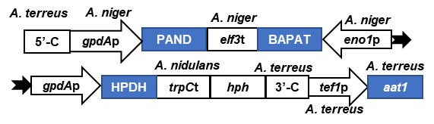

Figure S5. The diagram of β-alanine 3HP pathway along with an A. pseudoterreus aat1 transgene overexpression under the control of A. pseudoterreus tef1 gene promoter (3HP4071). 5’-C, 326bp upstream region of cis-aconitate decarboxylase of A. pseudoterreus; gpdAp, glyceraldehyde-3-phosphate dehydrogenase promoter from either A. niger or A. nidulans; PAND, T. castaneum aspartate decarboxylase; elf3t, A. niger elongation factor 3 transcriptional terminator; BAPAT, B. cereus β-alanine-pyruvate aminotransferase; eno1p, A. niger enolase promoter; HPDH, E. coli 3-hydroxypropionate dehydrogenase; trpCt, A. nidulans trpC transcriptional terminator; hph, E. coli hygromycin B phosphotransferase gene marker, and 3’-C, 283bp upstream region of ptrA gene; tef1p, translation elongation factor 1 (tef1) gene promoter of A. pseudoterreus, and aat1, A. pseudoterreus aspartate aminotransferase gene.

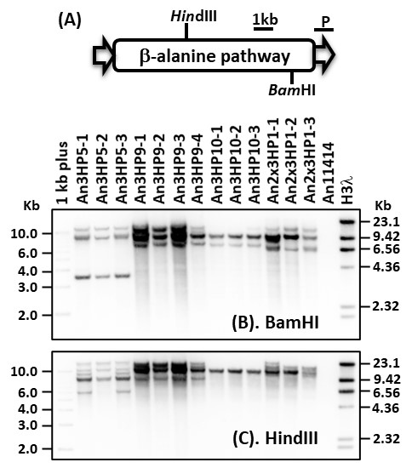
Figure S6. Southern blot analysis confirmed the β-alanine 3HP pathway random integrations into the chromosomes of A. niger in the selected single spore isolates of transgenic strain An3HP5, An3HP9, An3HP10, and An2x3HP1 with multiple copies of chromosomal insertion. (A). restriction map of the plasmid DNA fragments containing the β-alanine 3HP pathway used for random integration with restriction endonucleases of BamHI (B), or HindIII (C). Southern blot showing the hybridization pattern of the parent strain (no detection) and single spore isolates of transgenic strain An3HP5, An3HP9, An3HP10, and An2x3HP1. The expected sizes of the hybridizing fragments for the restriction endonuclease digestion were >2.34 kb (BamHI) or >7.43 kb (HindIII). P is probe used for Southern blot analysis.
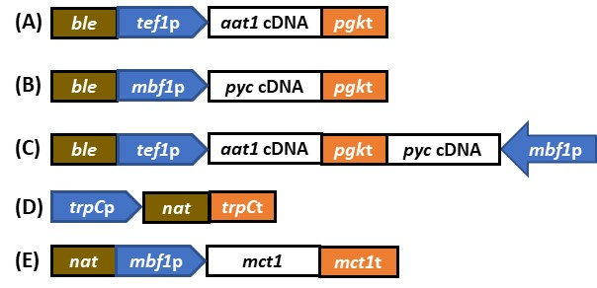
Figure S7. The diagram of transgene overexpression cassettes of A. niger aspartate aminotransferase (aat1), pyruvate carboxylase (pyc) or their combination, and monocarboxylate transporter (mct1). (A). The ble, the bacterial bleomycin resistance gene; tef1p, A. niger tef1 gene promoter; aat1, A. niger aspartate aminotransferase; pgkt, A. niger pgk gene transcriptional terminator (3HP4074); (B). & (C) mbf1P, A. niger mbf1 gene promoter; pyc, A. niger pyc gene without aat1 (3HP4076) & with aat1 (3HP4077); (D). the nat1 (Streptomyces noursei nourseothricin N-acetyl transferase optimized for the codon usage of Saccharomyces cerevisiae) selection marker under the control of A. nidulans trpC gene promoter and A. niger trpC gene transcriptional terminator (E). the nat selection marker gene; the mct1, A. niger monocarboxylate transporter; the mct1t, A. niger mct1 gene transcriptional terminator.
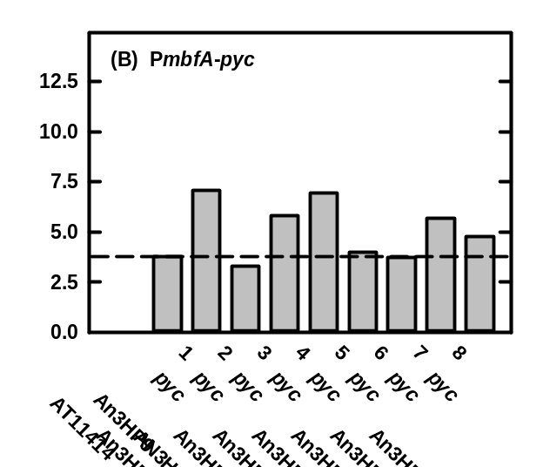
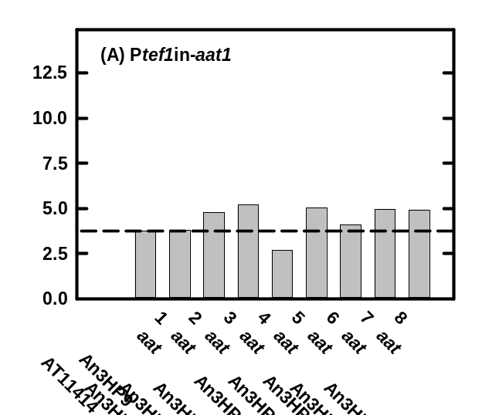
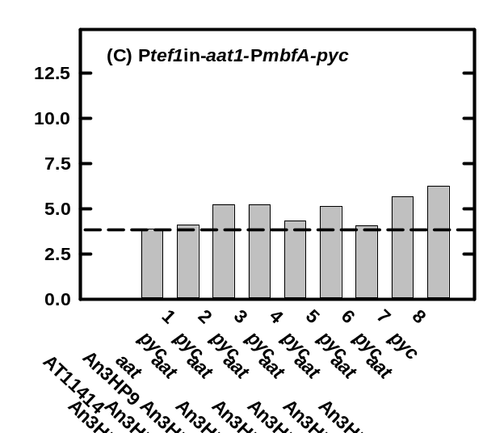
Figure S8. 3-hydroxypropionic acid production in the selected individual transgenic strains of Aspergillus niger with overexpression of cytosolic aspartate aminotransferase (aat, A), pyruvate carboxylase (pyc, B), or aspartate aminotransferase + pyruvate carboxylase (aat-pyc, C) in An3HP9 strain grown in modified RDM medium at 30ºC and 200 rpm for 7 days. All data were average of two biological replates.
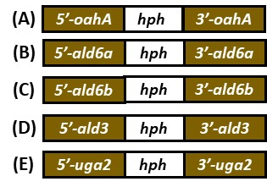

Figure S9. The diagram of gene disruption constructs of A. niger oahA, ald6a, ald6b, ald3, and uga2 gene. The hph, E. coli hygromycin B phosphotransferase (hph) gene for selection marker; (A). 5’-oahA and 3’-oahA are DNA fragments of upstream and downstream fragments of oahA gene (3HP4102); (B) 5’-ald6a and 3’-ald6a are DNA fragments of upstream and downstream of ald6a gene (3HP4103); (C). 5’-ald6b and 3’-ald6b are DNA fragments of upstream and downstream of ald6b gene (3HP4104); (D). 5’-ald3 and 3’-ald3 are DNA fragments of upstream and downstream of ald3 gene (3HP4108); and (E). 5’-uga2 and 3’-uga2 are DNA fragments of upstream and downstream fragments of uga2 gene (3HP4109).

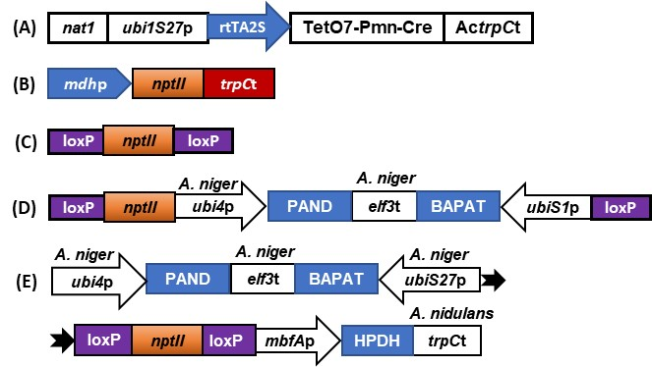

Figure S10. The diagram of the Tet-On/Cre-loxP (3HP4140) system and the new β-alanine 3HP pathway transgene expression cassette (3HP4145) with loxP-nptII marker gene recycle for A. niger. (A). the Tet-On/Cre-loxP system (3HP4140) for marker gene recycle conditionally activated by doxycycline, nat1, S. noursei nourseothricin acetyltransferase (resistance) gene; ubi1S27p, A. niger ubi1S27 promoter; rtTA2A, the reverse tetracycline transactivator; TetO7, tetracycline resistance operon; Pmn, A. nidulans gpdA minimal promoter; Cre, Cre recombinase; ActrpCt, A. carbonarius trpC transcriptional terminator; (B). the bacterial neomycin-resistance (nptII) marker gene under the control of A. niger malate dehydrogenase (mdhp) promoter and A. nidulans trpC transcriptional terminator (trpCt) (3HP4134); (C). the nptII marker gene cassette with 31 bp loxP fragments fused at 5’- and 3’-end of its marker gene cassette (3HP3136); (D). the intermediate transgene expression cassette (3HP4144) contains the ubi4p, A. niger ubi4 gene promoter; PAND, T. castaneum aspartate decarboxylase; elf3t, A. niger elongation factor 3 transcriptional terminator; BAPAT, B. cereus β-alanine-pyruvate aminotransferase; and ubiSp, A. niger ubi1S promoter. (E). the final new β-alanine 3HP pathway (3HP4145) was assembled with the HPDH, E. coli 3-hydroxypropionate dehydrogenase under the control of A. niger mbfA promoter (mbfAp) and A. nidulans trpC transcriptional terminator(trpCt).

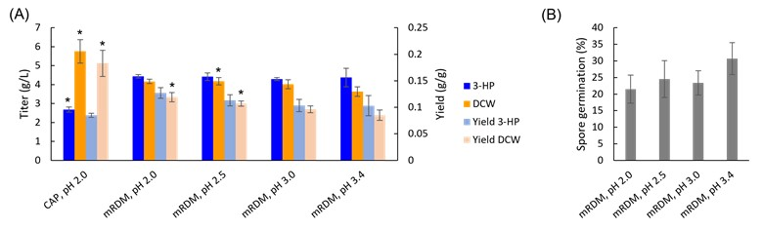

Figure S11. The effects of culture medium and pH on 3-HP production and spore germination in A. niger strain An3HP9 grown at 30ºC and 200 rpm for 7 days. (A) 3-HP and DCW titer and yield and (B) the percentage of spore germination. The data is the average of three biological replicates. Asterisks indicate statistically significant differences (p < 0.05) from mRDM, pH 3.4.

