Supporting Information

Stoichiometric balance ratio of cellobiose and gentiobiose induces cellulase production in Talaromyces cellulolyticus

Authors & Affiliation:
Shivam Aggarwal, Sathish Dorairaj and Nidhi Adlakha*
Synthetic Biology and Bioprocessing group, Regional Centre for Biotechnology, NCR-Biotech Science Cluster, Faridabad, India
*Any correspondence should be made to nidhi.adlakha@rcb.res.in

Figures

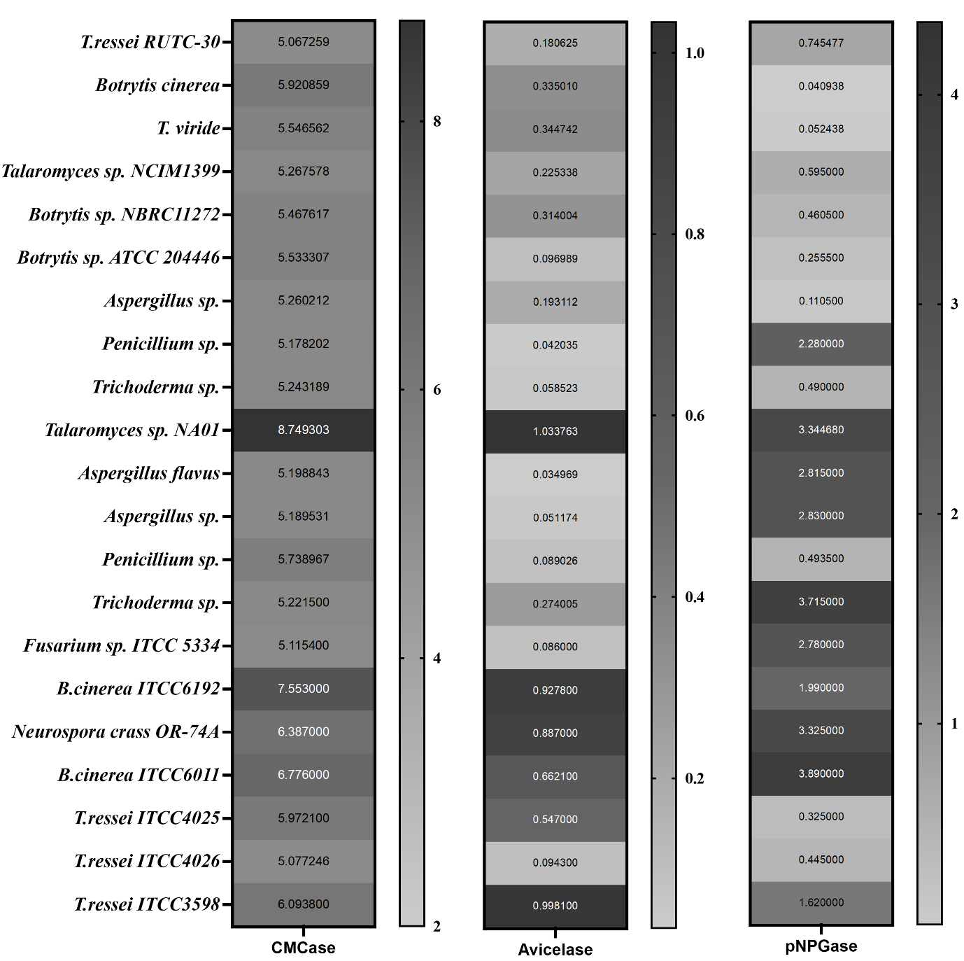
Fig. S1 Screening of hypercellulolytic fungi
Various fungal strains with cellulolytic potential were collected from Culture collection centres such as ATCC, NCIM and ITCC and were used for comparison

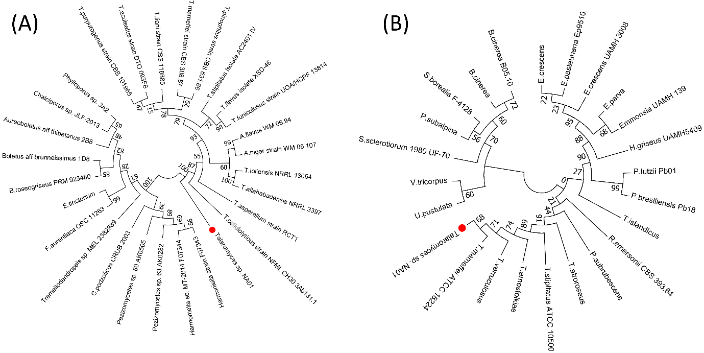
Fig. S2 Phylogenetic analysis of Talaromyces cellulolyticus MTCC25456
Phylogenetic relationships of Talaromyces sp. NA01 were predicted using Maximum likelihood Mega7 with JTT model and 1000 bootstrap value using Maximum Likelihood algorithm. The phylogenetic analysis performed based on (A) Interspacer Transcribed Sequences (ITS2) and (B) beta tubulin (BT2) predicted that the isolate is closely related to Talaromyces cellulolyticus and Taloromyces marneffei ATCC 18224.
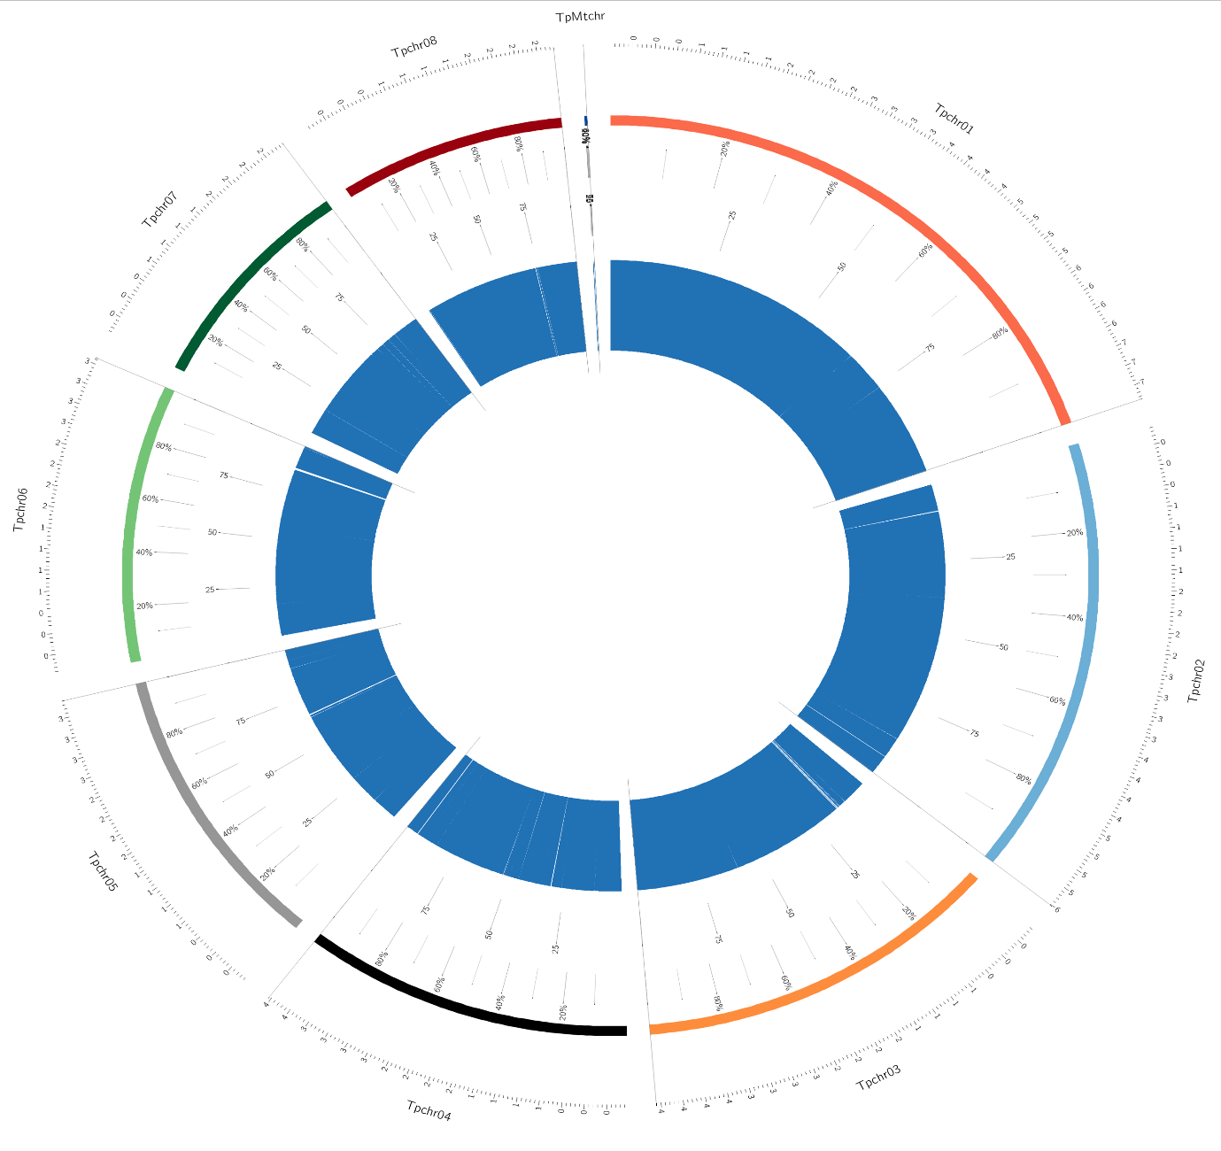
Fig. S3 Synteny plot of assembled contigs of Talaromyces cellulolyticus MTCC25456 (blue circle) with Talaromyces pinophilus Strain: 1-95 chromosomes (1–8).
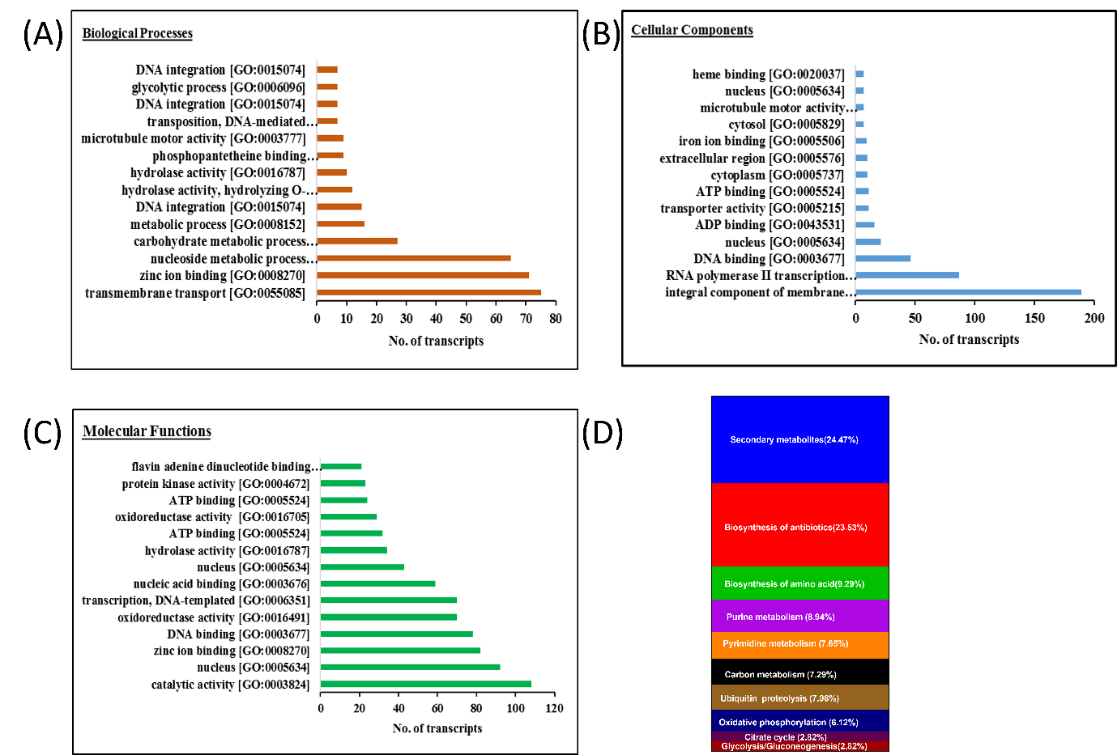

Fig. S4 Representation of top 15 hits of Gene Ontology
in(A) Biological (B) Cellular and (C) Molecular functions
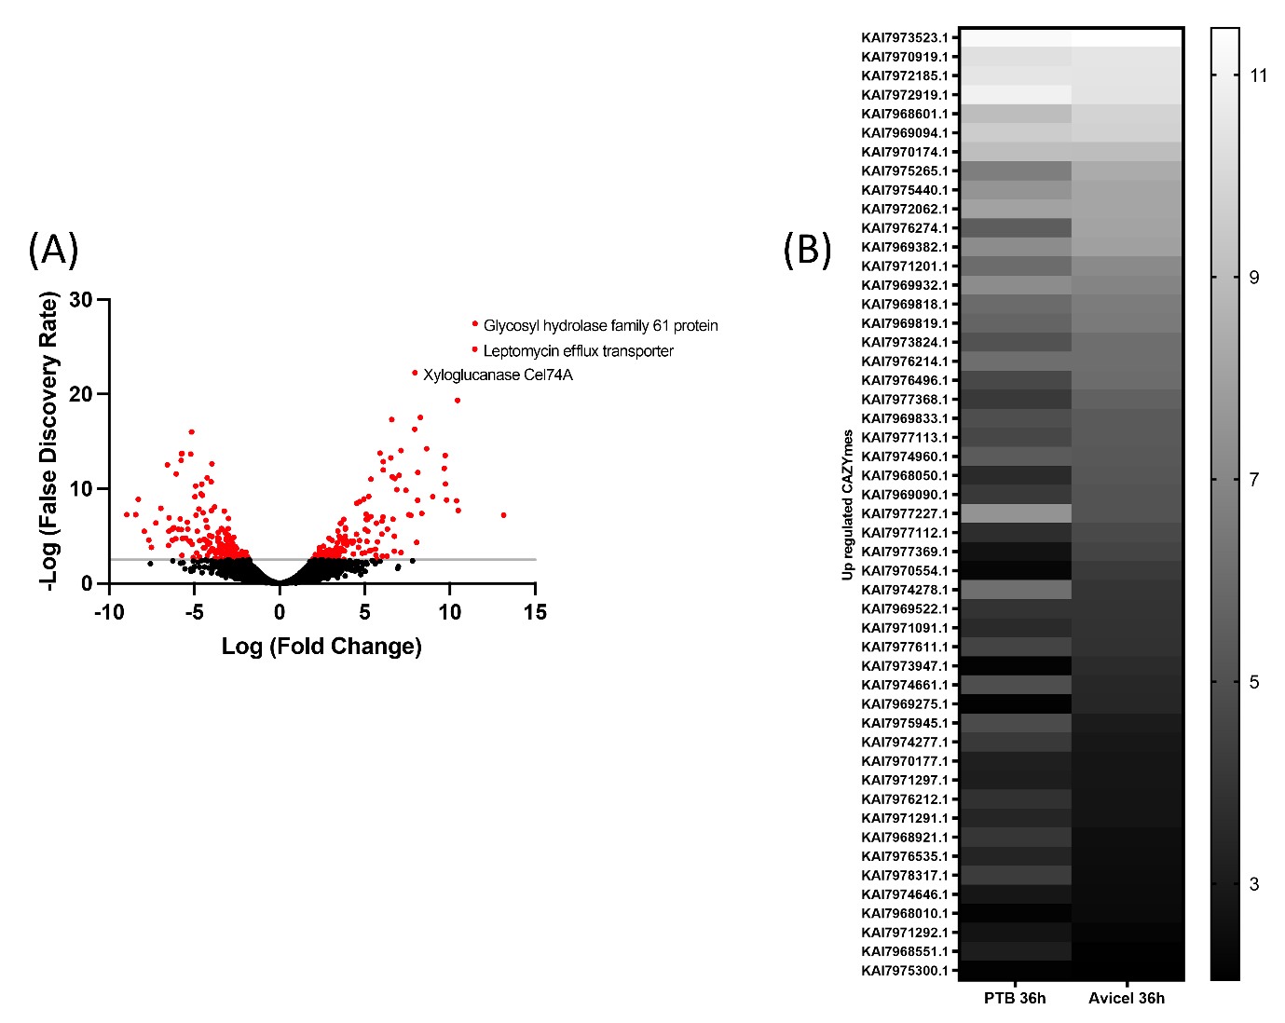
Fig. S5 Differentially expressed CAZYmes during cultivation on avicel and Pretreated biomass (PTB).
(A) Comparative transcriptome analysis of Talaromyces sp. in Avicel treatment and Glucose treatment. The volcano plot shows the differential gene expression in Avicel when compared with that in Glucose medium. (B) Heat map indicating common differentially upregulated CAZYmes 36h Avicel and 36h PTB induced compared to 24h Glc in Talaromyces sp. Shading is lighter for higher fold changes for all cases. Transcripts were considered significantly differentially expressed when fold change was at least two (p ≤ 0.05).

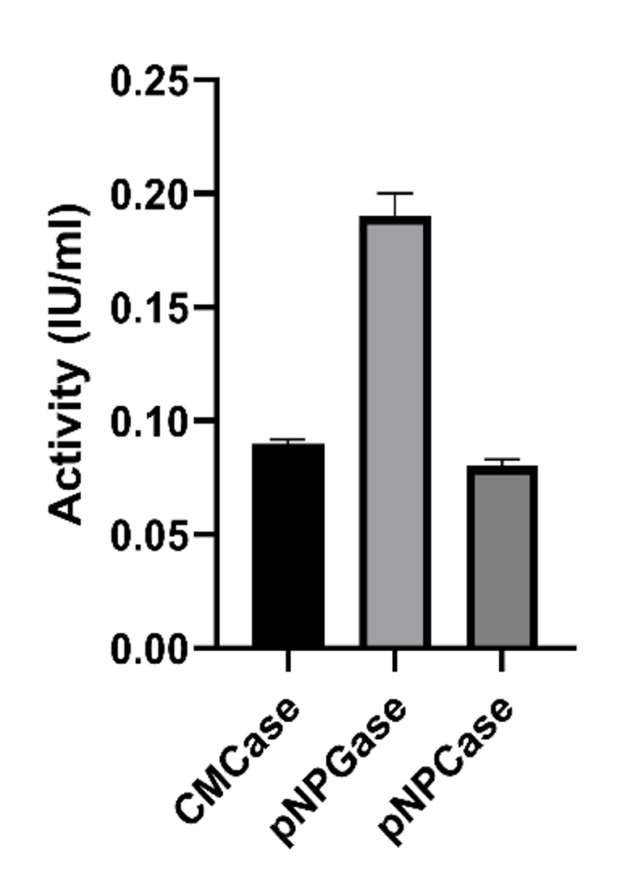
Fig. S6 Biochemical assay for membrane protein.
The membrane protein was extracted according to standard protocol and assayed for endoglucanase and glucosidase type activity. The experiment was done in triplicate and standard deviation was calculated accordingly.

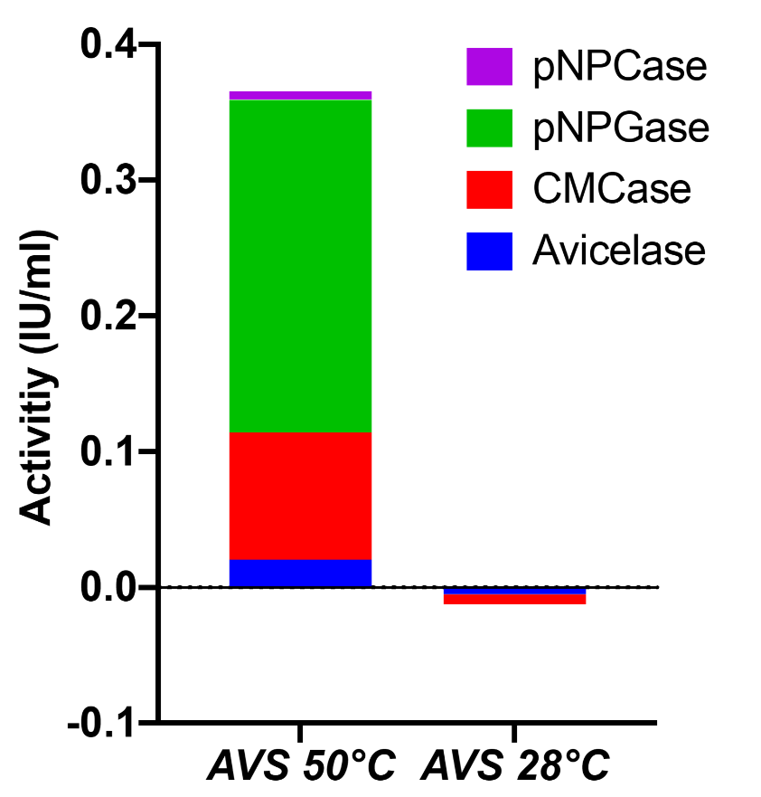
Fig. S7 Selection of optimum temperature for production of inducer molecules.
The 1X10⁹spore were incubated with 1% avicel at 50ºC and 28ºC separately for 72h. The supernatant was supplemented in the growth media containing 1% avicel. The active Talaromyces mycelium were inoculated and supernatant was withdrawn after 36h for enzyme assays.

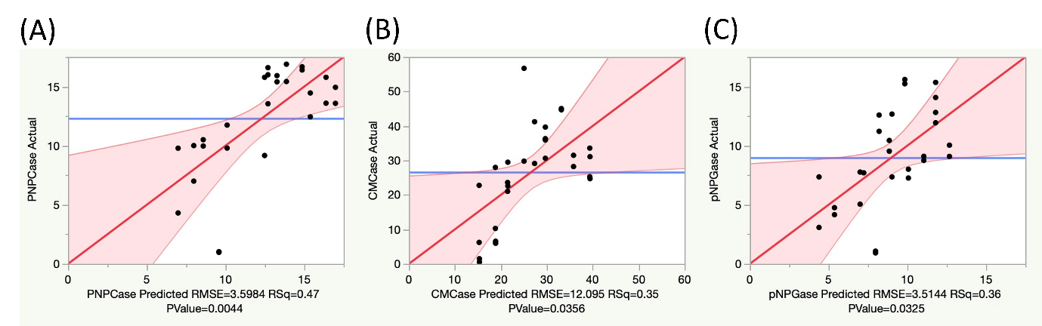
Fig. S8 Plackett Burman analysis.
Actual by predicted model of pNPCase (A); CMCase (B); pNPGase (C) shows that the data is significant

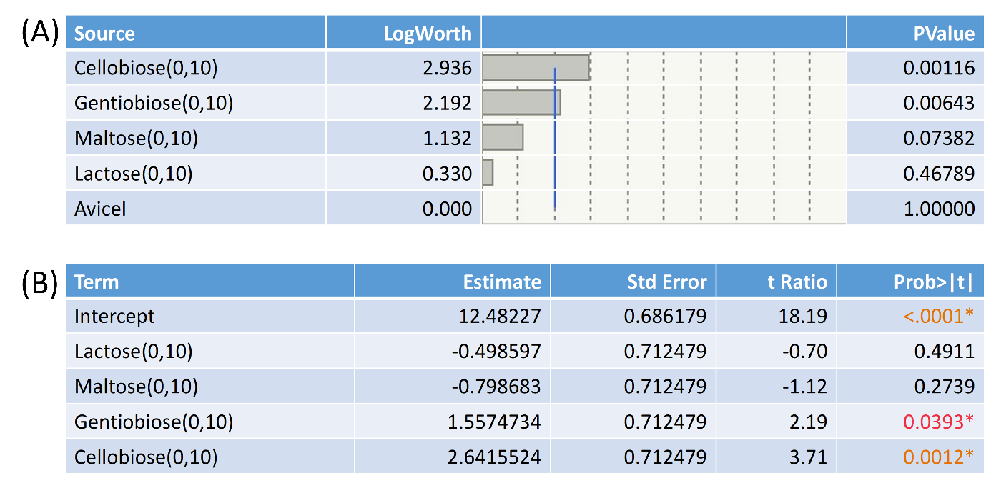
Fig. S9 Effect summary of Plackett Burman design
(A) Effect summary report of Plackett Burman design. (B)Effect test result and scaled estimate results of Plackett Burman design
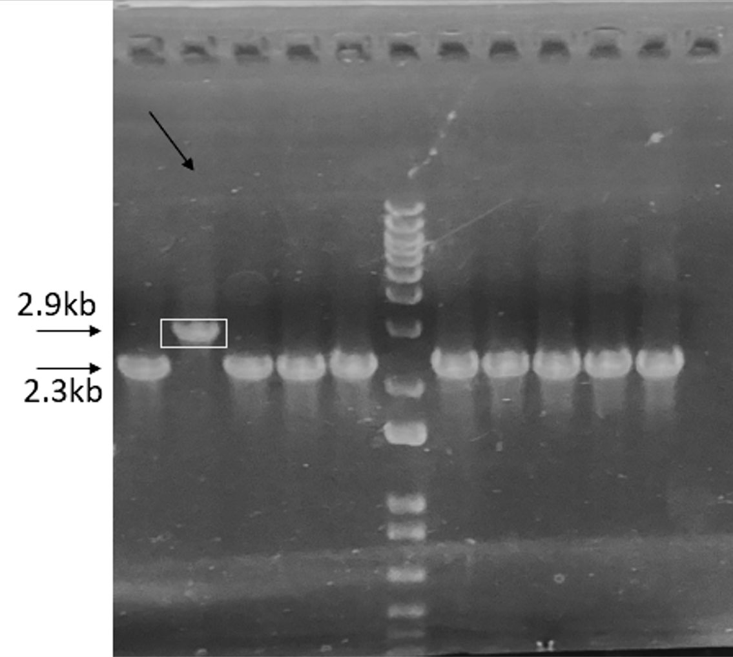
Fig. S10 CreA knock out
1% Agarose gel. CreA knock out in Lane 2 shows a shift in the band. primers– Fwd 5’GTCTGTCTGTCGCTGCTAAACTC3’ and Rev 5’ACTTGGTTCTGGATGTATATTGCC3’

Tables
Table S1: Assembly statics for contigs
Assembly | MaSuRCa | Soapdenovo k67 | Soapdenovo k78 | Spades
# contigs (>= 0 bp) | 887 | 3,861 | 3,975 | 1,595
# contigs (>= 1000 bp) | 676 | 1,164 | 1,250 | 577
# contigs (>= 5000 bp) | 323 | 670 | 760 | 292
# contigs (>= 10000 bp) | 230 | 502 | 583 | 213
# contigs (>= 25000 bp) | 160 | 346 | 392 | 150
# contigs (>= 50000 bp) | 116 | 219 | 227 | 112
Total length (>= 0 bp) | 38,561,598 | 37,974,115 | 37,927,754 | 37,859,397
Total length (>= 1000 bp) | 38,424,840 | 37,040,070 | 36,981,725 | 37,460,920
Total length (>= 5000 bp) | 37,690,310 | 35,934,868 | 35,882,673 | 36,783,097
Total length (>= 10000 bp) | 37,027,337 | 34,780,149 | 34,655,443 | 36,204,023
Total length (>= 25000 bp) | 35,875,216 | 32,232,579 | 31,518,356 | 35,195,785
Total length (>= 50000 bp) | 34,336,277 | 27,626,758 | 25,416,776 | 33,800,349
# contigs | 828 | 1,664 | 1,736 | 830
Largest contig | 1,633,654 | 394,282 | 371,764 | 2,804,526
Total length | 38,535,829 | 37,389,315 | 37,317,952 | 37,646,110
GC (%) | 47 | 47 | 47 | 47
N50 | 391,761 | 112,808 | 84,868 | 382,360
N75 | 192,766 | 48,035 | 40,989 | 194,981
L50 | 30 | 101 | 124 | 26
L75 | 66 | 228 | 284 | 60
# N's per 100 kbp | 0 | 0 | 0 | 0
Complete BUSCOs (C) | 1294 (98.4%) | 1288 (97.9%) | 1285 (97.7%) | 1294 (98.4%)
Fragmented BUSCOs (F) | 7 (0.5%) | 11 (0.8%) | 12 (0.9%) | 7 (0.5%)
Missing BUSCOs (M) | 14 (1.1%) | 16 (1.3%) | 18 (1.4%) | 14 (1.1%)
Total BUSCO groups searched | 1,315 | 1,315 | 1,315 | 1,315

Table S2: Membrane Bound cellulases
Protein NCBI ID | Transmembrane Helices | Putative Function
KAI7971606.1 | 15 | 1,3-beta-glucan synthase component FKS1
KAI7970451.1 | 13 | alpha-1,4-glucan synthase
KAI7969028.1 | 12 | Vacuolar membrane protein
KAI7973501.1 | 11 | 1,4-alpha-glucan-branching enzyme
KAI7968906.1 | 10 | Oligosaccharyl transferase, STT3 subunit
KAI7971961.1 | 9 | Concanavalin A-like lectin/glucanases superfamily
KAI7970707.1 | 8 | Uncharacterized protein
KAI7977301.1 | 6 | Cellobiose dehydrogenase, cytochrome
KAI7971353.1 | 6 | Concanavalin A-like lectin/glucanase
KAI7977641.1 | 6 | Chitin synthase (EC 2.4.1.16)
KAI7978342.1 | 5 | Fungal chitin synthase
KAI7978312.1 | 5 | Cellobiose dehydrogenase, cytochrome
KAI7975560.1 | 4 | chitin synthase
KAI7971960.1 | 4 | putative glycosyltransferase YdaM
KAI7973107.1 | 4 | Glycosyl transferase, family 39
KAI7977060.1 | 3 | Chitin Synthase
KAI7969626.1 | 3 | Cell wall acid trehalase
KAI7973529.1 | 3 | Fungal chitin synthase
KAI7974022.1 | 3 | D-lactate dehydrogenase
KAI7977256.1 | 3 | Mannan endo-1,6-alpha-mannosidase DCW1
KAI7971355.1 | 3 | Glucans biosynthesis glucosyltransferase H
KAI7976887.1 | 3 | Cellulose synthase catalytic subunit [UDP-forming]
KAF3388267.1 | 3 | Chitin synthase G
KAI7973657.1 | 3 | Chitin synthase C
KAI7973455.1 | 2 | Glycoside hydrolase, family 2
KAI7972919.1 | 2 | Beta-xylanase (EC 3.2.1.8)
KAI7978317.1 | 2 | Sterol esterase 2
KAI7972733.1 | 2 | Glycosyl transferase, family 54
KAI7976986.1 | 2 | putative glucan endo-1,3-beta-glucosidase btgC
KAI7974623.1 | 2 | Uncharacterized protein
KAI7977059.1 | 2 | Chitin synthase 6
KAI7968742.1 | 2 | Glucosidase
KAI7971201.1 | 2 | Uncharacterized protein
KAI7976937.1 | 2 | Chitin synthase (EC 2.4.1.16)
KAI7977684.1 | 2 | Cellulose synthase catalytic subunit [UDP-forming]

Table S3: Composition Analysis for different biomass
Composition | Cellulose (%) |  | Hemicellulose (%) |  | Lignin (%) |  | Ash (%)
Composition | Raw biomass | Treated biomass | Raw biomass | Treated biomass | Raw biomass | Treated biomass | Raw biomass | Treated biomass
Sugarcane Bagasse | 36.77 | 66.675 | 19.11 | 17.465 | 23.9 | 14.25 | 1.82 | 1.2
Wheat Straw | 35.11 | 68 | 18.78 | 13 | 21.98 | 11.51 | 1.77 | 0.98
Napier Grass | 22.34 | 59.01 | 18.21 | 20.98 | 29.37 | 18.64 | 3.32 | 0.62
Sorghum | 31.59 | 74.61 | 20.78 | 13.5 | 27.35 | 10.52 | 1.92 | 0.67

Table S4: Primers used for RT-PCR
Gene | Forward 5' to 3' | Reverse 5' to 3'
egl1 | TGAACTGGCTGGATAGTGGTAG | CGAAGTTGACGACGATGATGAA
cbh1 | CTGATGCCTGCGGTGGTA | TGGTGGTGTCAACGGTCTT
cbh2 | GGCTCAACTCTTCGCAACAG | GGAGTCGCCAGATGTGTATGA
bgl | CTGGCAAAGTGGGATTGAAGTT | TGGCACCTGGAAGAGTATCG

