Additional file 2: Additional Figures
for
The arabinose transporter MtLat-1 is involved in hemicellulase induction as a pentose transceptor in Myceliophthora thermophila

Gu et al.

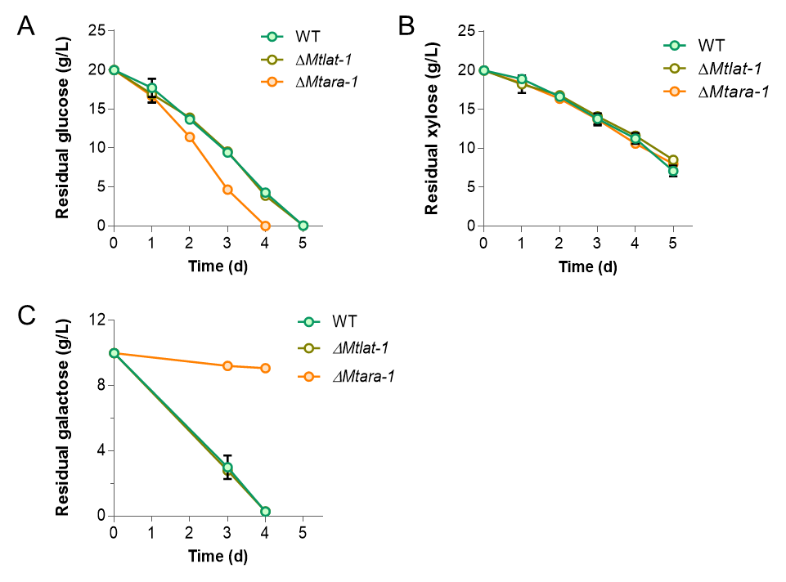
Fig. S1 Sugar consumption by M. thermophila strains WT, ΔMtlat-1, and ΔMtara-1, when grown in 1 × VMM with 2% D-glucose (A), 2% D-xylose (B), or 2% D-galactose (C). Error bars indicate the SD from at least three biological replicates.

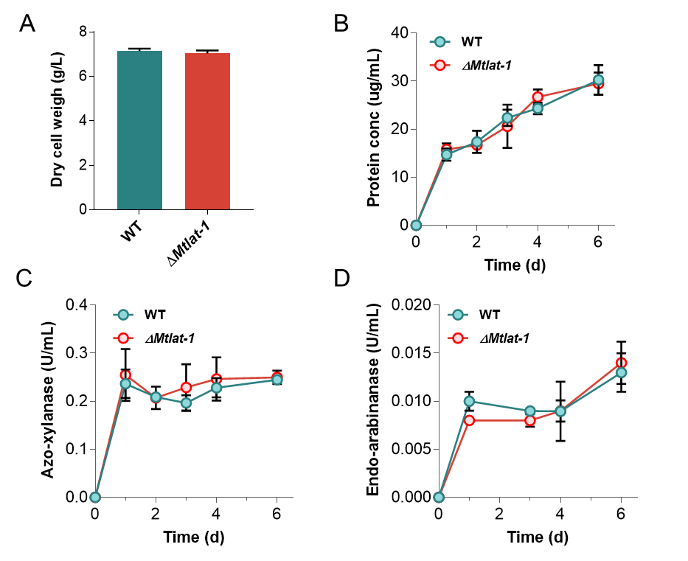
Fig. S2 Growth phenotypes of the M. thermophila ΔMtlat-1 mutant under xylan condition. (A) Cell dry weight of M. thermophila strains WT and ΔMtlat-1 after growth on 2% xylan for 2 d. (B) Protein concentrations, (C) xylanase activity, and (D) arabinanase activity of the culture supernatants for the M. thermophila strains grown in 2% xylanase medium. Error bars indicate the SD from at least three biological replicates.

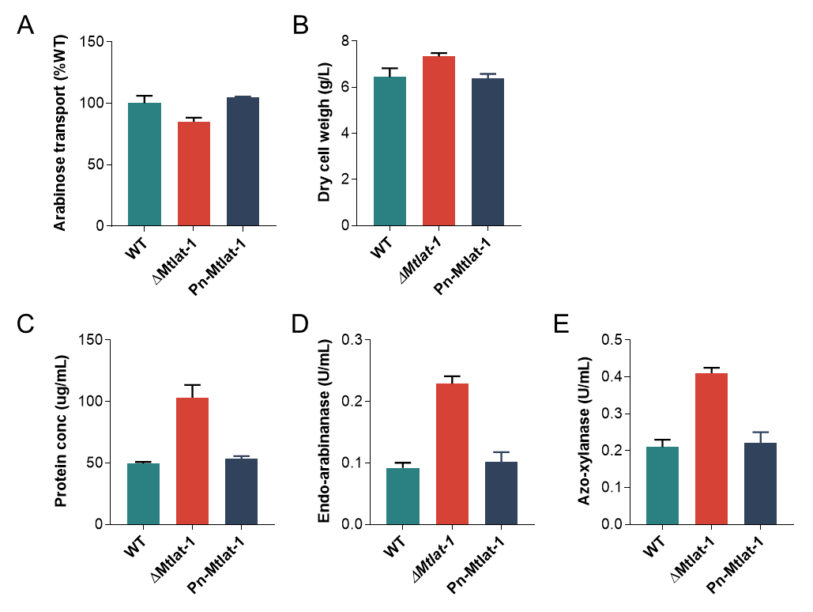
Fig. S3 Growth phenotypes of the complementation strain of the ΔMtlat-1 mutant. (A) L-arabinose transport rates of mycelia from the complementation strain Pn-Mtlat-1. (B) Cell dry weight of the M. thermophila complementation strain after growth on 2% arabinan for 4 d. (C) Protein concentrations, (D) arabinanase activity, and (E) xylanase activity of the culture supernatants for M. thermophila grown in 2% arabinan medium. Error bars indicate the SD from at least three biological replicates.

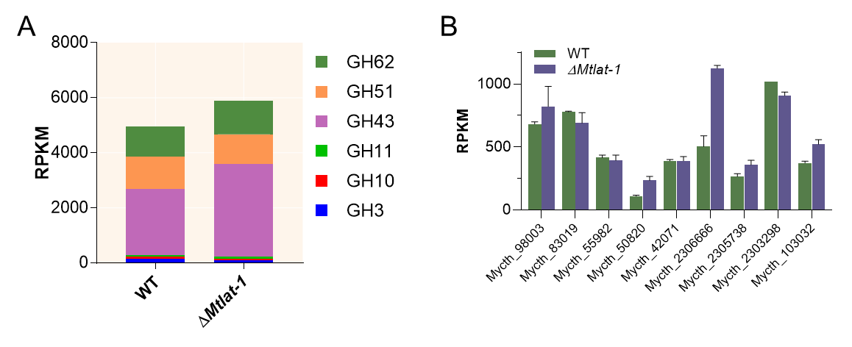
Fig. S4 Comparative transcriptomic analysis of the WT and ΔMtlat-1 M. thermophila strains grown in arabinan medium for 2 d. (A) Total expression of genes encoding major hemicellulases from RNA-Seq data. (B) Transcriptional profiles of genes encoding arabinanolytic enzymes in the ΔMtlat-1 and WT strains when grown on 2% arabinan for 4 d.

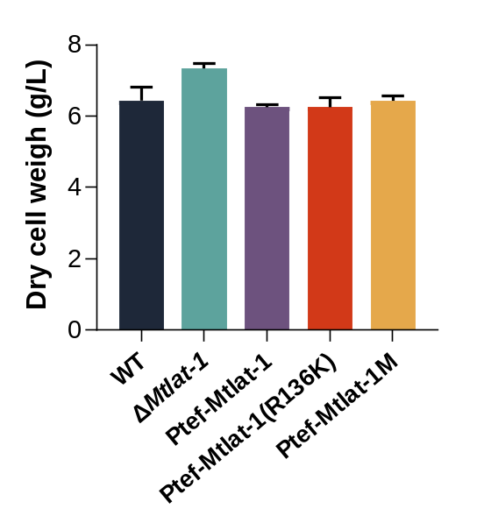
Fig. S5 Cell dry weight of M. thermophila strains after growth on 2% arabinan for 4 d.

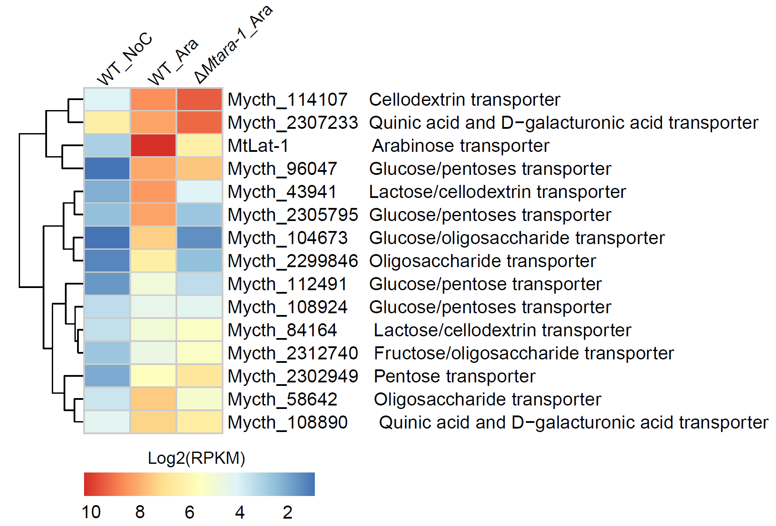
Fig. S6 Heatmap analysis of expression profiles for putative sugar transporter genes with statistically significant differences in transcript levels between ΔMtara-1 and the WT under L-arabinose condition. Log-transformed expression values are color-coded.

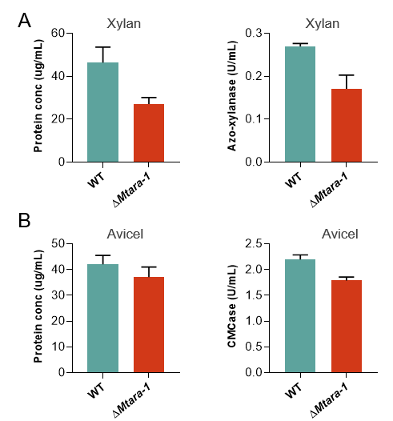
Fig. S7 Protein concentrations and hemicellulase/cellulase activity of the culture supernatants for M. thermophila strain ΔMtara-1 grown in 1 × VMM with 2% xylan (A) or 2% Avicel (B) for 4 d.

