Additional file
Table S1: Strains and plasmids used in this study
- No. | - Strain or plasmid | - Relevant characteristics | - Reference
 | - Strains
- S1 | - E. coli DH5α | - F-Φ80lacZΔM15 Δ(lacZYA-argF) U169 endA1 recA1 hsdR17 (rK⁻, mK⁺) supE44 thi-1 gyrA96 relA1 phoA | - (Hanahan, 1983)
- S2 | - E. coli K-12 MG1655 | - Wild type (WT) | - (Blattner et al., 1997)
- S3 | - C. glutamicum ATCC 13032 | - Wild type (WT) | - (Abe et al., 1967; Kinoshita et al., 1958)
- S4 | - C. glutamicum ΔfasR | - C. glutamicum ATCC 13032 derivate with deletion of the transcriptional regulator-encoding gene fasR | - This study
- S5 | - C. glutamicum ΔfasR cg2692_{GTG} | - C. glutamicum ∆fasR derivate with start codon GTG of the thioesterase-encoding gene cg2692 | - This study
- S6 | - C. glutamicum ΔfasR cg2692_{TTG} | - C. glutamicum ∆fasR derivate with start codon TTG of the thioesterase-encoding gene cg2692 | - This study
- S7 | - C. glutamicum ΔfasR CgLP11::(P_{tac}-maqu2220-T_{rrnB}) | - C. glutamicum ∆fasR derivate with maqu_2220 of M. hydrocarbonoclasticus VT8, under control of P_{tac} and terminated by T_{rrnB}, integrated into landing pad CgLP11 | - This study
- S8 | - C. glutamicum ΔfasR CgLP11::(P_{tac}-maqu2220-T_{rrnB}) cg2692_{GTG} | - C. glutamicum ΔfasR CgLP11::(P_{tac}-maqu_2220-T_{rrnB}) derivate with start codon GTG of the thioesterase-encoding gene cg2692 | - This study
- S9 | - C. glutamicum ΔfasR CgLP11::(P_{tac}-maqu2220-T_{rrnB}) cg2692_{TTG} | - C. glutamicum ΔfasR CgLP11::(P_{tac}-maqu_2220-T_{rrnB}) derivate with start codon TTG of the thioesterase-encoding gene cg2692 | - This study
- S10 | - C. glutamicum ΔactA::xylAB | - C. glutamicum ATCC 13032 derivate with the synthetic operon, consisting of xylA of Xanthomonas campestris and xylB of C. glutamicum WT, integrated into the gene locus actA (cg2840) | - This study
- S11 | - C. glutamicum gX | C. glutamicum ΔactA::xylAB derivate with evolved sequence upstream of xylA | - This study
- S12 | - C. glutamicum ΔfasR cg2692_{TTG} gX | - C. glutamicum ΔfasR cg2692_{TTG} derivate with insertion of the synthetic xylAB operon, harboring the evolved sequence upstream of xylA, integrated into the gene locus actA | - This study
S13 | C. glutamicum ΔfasR cg2692_{TTG} CgLP12::(P_{tac}-pntAB-T_{rrnB}) | C. glutamicum ΔfasR cg2692_{TTG} derivate with pntAB of E. coli, under control of P_{tac} and terminated by T_{rrnB}, integrated into landing pad CgLP12 | This study
S14 | C. glutamicum ΔfasR cg2692_{TTG} CgLP12::(P_{tac}-pntAB-T_{rrnB}) gX | C. glutamicum ΔfasR cg2692_{TTG} gX derivate with pntAB of E. coli, under control of P_{tac} and terminated by T_{rrnB}, integrated into landing pad CgLP12 | This study
S15 | - C. glutamicum ΔfasR cg2692_{TTG} CgLP12::(P_{tac}-pntAB-T_{rrnB}) ΔPgltA::PdapA-A25 gX | C. glutamicum ΔfasR cg2692_{TTG} CgLP12::(P_{tac}-pntAB-T_{rrnB}) gX with gltA promotor exchanged for the dapA promotor variant A25 | This study
S16 | C. glutamicum ΔfasR cg2692_{TTG} CgLP12::(P_{tac}-pntAB-T_{rrnB}) ΔPgltA::PdapA-C7 gX | C. glutamicum ΔfasR cg2692_{TTG} CgLP12::(P_{tac}-pntAB-T_{rrnB}) gX with gltA promotor exchanged for the dapA promotor variant C7 | This study
S17 | C. glutamicum ΔfasR cg2692_{TTG} CgLP12::(P_{tac}-pntAB-T_{rrnB}) ΔPgltA::PdapA-L1 gX | C. glutamicum ΔfasR cg2692_{TTG} CgLP12::(P_{tac}-pntAB-T_{rrnB}) gX with gltA promotor exchanged for the dapA promotor variant L1 | This study
S18 | C. glutamicum GRLys1ΔsugRΔldhA | C. glutamicum WT Δpck, pyc^{P458S}, hom^{V59A}, 2 copies of lysC^{T311I}, 2 copies of asd, 2 copies of dapA, 2 copies of dapB, 2 copies of ddh, 2 copies of lysA, 2 copies of lysE, in-frame deletion of prophages CGP1, CGP2 and CGP3, ΔsugRΔldhA | (Pérez-García et al., 2016)
S19 | C. glutamicum GRLys1ΔsugRΔldhA_gX | C. glutamicum GRLys1ΔsugRΔldhA derivate with insertion of the synthetic operon xylAB with evolved sequence upstream of xylA as in gX integrated into the gene locus actA | This study
S20 | C. glutamicum Dpa1 | C. glutamicum WT pyc^{P458S}, hom^{V59A}, lysC^{T311I}Δpck carrying pECXT_P_{syn}-dpaAB | (Schwardmann et al., 2022)
S21 | C. glutamicum Dpa1_gX | C. glutamicum Dpa1 derivate with insertion of the synthetic operon xylAB with evolved sequence upstream of xylA as in gX integrated into the gene locus actA | This study
S22 | C. glutamicum MePhe5* | C. glutamicum WT ΔqsuBCD::P_{tuf}-qsuCΔppc::P_{sod}-aroBΔP_{tkt}::P_{tuf}-tktΔiolR::P_{tuf}-aroEΔtrpEGΔilvEΔaroT carrying pEKEx3_pheA^{FBR} and pVWEx1_ pVWEx1_dpkA^{P262M141L} | (Kerbs et al., 2021)
S23 | C. glutamicum MePhe5*_gX | C. glutamicum MePhe5* derivate with insertion of the synthetic operon xylAB with evolved sequence upstream of xylA as in gX integrated into the gene locus actA | This study
 | - Plasmids
- P1 | - pK19mobsacB | - Km^{r}; Mobilizable cloning vector to construct insertion or deletion mutants of C. glutamicum (pK18 oriV_{E.c.}, sacB, lacZα) | - (Schäfer et al., 1994)
- P2 | - pK19mobsacB_GG | - Km^{r}; pK19mobsacB derivative with fusion sites and BsaI recognition site for Golden Gate assembly | - This study
- P3 | - pK19mobsacBlacI^{q} | - Km^{r}; pK19mobsacB derivate with lacI^{q} downstream of the multiple cloning site (MCS) | - This study
- P4 | - pK19mobsacB_ ΔfasR | - Km^{r}; pK19mobsacB derivate for the deletion of fasR | - This study
- P5 | - pK19mobsacB_ΔactA::xylAB | - Km^{r}; pK19mobsacB derivate for the deletion of actA and the integration of genes encoding XylA (xylose isomerase) of Xanthomonas campestris and XylB (xylulokinase) of C. glutamicum into the actA locus | - This study
P6 | pK19mobsacB_ ΔPgltA::PdapA-A25 | Km^{r}; pK19mobsacB derivate for exchanging the native promotor of gltA for the dapA promotor variant A25 | (van Ooyen et al., 2012)
P7 | pK19mobsacB_ ΔPgltA::PdapA-C7 | Km^{r}; pK19mobsacB derivate for exchanging the native promotor of gltA for the dapA promotor variant C7 | (van Ooyen et al., 2012)
P8 | pK19mobsacB_ ΔPgltA::PdapA-L1 | Km^{r}; pK19mobsacB derivate for exchanging the native promotor of gltA for the dapA promotor variant L1 | (van Ooyen et al., 2012)
- P9 | - pK19mobsacB_gX | Km^{r}; pK19mobsacB derivate for the deletion of actA and the integration of xylAB with evolved sequence upstream of xylA as in strain gX into the actA locus | - This study
- P10 | - pK19mobsacB_cg2692_{GTG} | - Km^{r}; pK19mobsacB derivate for exchanging the native start codon of cg2692 to GTG | - This study
- P11 | - pK19mobsacB_cg2692_{TTG} | - Km^{r}; pK19mobsacB derivate for exchanging the native start codon of cg2692 to TTG | - This study
- P12 | - pK19mobsacBlacI^{q}_ maqu2220_{CgLP11} | - Km^{r}; pK19mobsacBlacI^{q} derivate for the integration of maqu_2220, under the control of the tac promoter and terminated by the rrnB terminator, into the integration locus CgLP11 | - This study
P13 | pK19mobsacBlacI^{q}_pntAB_{CgLP12} | Km^{r}; pK19mobsacBlacI^{q} derivate for the integration of pntAB, under the control of the tac promoter and terminated by the rrnB terminator, into the integration locus CgLP12 | This study
- P14 | - pEKEx2 | - Km^{r}; E. coli-C. glutamicum shuttle vector (P_{tac}, lacI^{q}, pBL1 oriV_{C.g.}, pUC18 oriV_{E.c}) | - (Eikmanns et al., 1994)
- P15 | - pEKEx2-maqu2220 | - Km^{r}; pEKEx2 derivate with coding sequence of maqu_2220 of M. hydrocarbonoclasticus VT8 | - This study
- P16 | - pEKEx2-maqu2507 | - Km^{r}; pEKEx2 derivate with coding sequence of maqu_2507 of M. hydrocarbonoclasticus VT8 | - This study
- P17 | - pEKEx2-pntAB | - Km^{r}; pEKEx2 derivate with coding sequence of pntAB of E. coli K-12 MG1655 | - This study
- P18 | - pVWEx1-xylAB | - Km^{r}; P_{tac}, lacI^{q} pHM1519 oriV_{C.g,} oriV_{E.c.} C. glutamicum/E. coli expression shuttle vector for overexpression of xylA from Xanthomonas campestris SCC1758 and xylB from C. glutamicum WT | - (Meiswinkel et al., 2013)

Table S2: Oligonucleotides used in this study. Complementary overlaps are italicized, and synthetic RBS + spacer sequences, as described by Shi et al. (2018), are displayed in bold.
No. | Primer | Purpose | Sequence (5’ → 3’)
1 | pK19lacI_fw | Amplification of MCS of pK19mobsacB-derived plasmids & sequencing | TCAGTGAGCGAGGAAGCG
2 | pK19lacZ_rv | Amplification of MCS of pK19mobsacB-derived plasmids & sequencing | TTAGCAGCCCTTGCGCC
3 | FW_pEKEx2 | Amplification of MCS of pEKEx2-derived plasmids & sequencing | GCACTCCCGTTCTGGATAATGTT
4 | RW_pEKEx2 | Amplification of MCS of pEKEx2-derived plasmids & sequencing | GCGTTCTGATTTAATCTGTATCAGGCTG
5 | FW_upFasR | Amplification of Flank1 of fasR; Template: DNA of S3 | GTCGACTCTAGAGGATCCCCTGCCTAATGATTCGGGTTCGAC
6 | RV_upFasR | Amplification of Flank1 of fasR; Template: DNA of S3 | CGTGCGTGTTGACTATCCAGTAGTAAAATTTCAGTGCCTGCCGCT
7 | FW_downFasR | Amplification of Flank2 of fasR; Template: DNA of S3 | AGCGGCAGGCACTGAAATTTTACTACTGGATAGTCAACACGCACG
8 | RV_downFasR | Amplification of Flank2 of fasR; Template: DNA of S3 | TGAATTCGAGCTCGGTACCCGCCGACGGCGCCAACTCTGC
9 | FW_ΔfasR_validation | Validation of fasR deletion | CCATATGCAAGGTATCTACATCGAAGAG
10 | RV_ΔfasR_validation | Validation of fasR deletion | AACACCCTCCAACAGCTCG
11 | FW_Maqu_2220 | Amplification of maqu2220; sequencing | ATCCCCGGGTACCGAGCTCGGAAAGGAGAGGATTGATGGCAATACAGCAGGTACATCAC
12 | RV_Maqu_2220 | Amplification of maqu2220; sequencing | CTGTAAAACGACGGCCAGTGTCAGGCAGCTTTTTTGCGC
13 | FW_Maqu_2507 | Amplification of maqu2507; sequencing | ATCCCCGGGTACCGAGCTCGGAAAGGAGAGGATTGATGAATTATTTCCTGACAGGCGGC
14 | RV_Maqu_2507 | Amplification of maqu2507; sequencing | CTGTAAAACGACGGCCAGTGTTACCAGTATATCCCCCGCATAATCG
15 | FW_TrrnB | sequencing | CTGTTTTGGCGGATGAGAGAAGATT
16 | RV_TrrnB | sequencing | AGGAGAGCGTTCACCGACAA
17 | FW_F1_CgLP11 | Amplification of Flank1 of CgLP11; Template: DNA of S2; sequencing | GTCGACTCTAGAGGATCCCCGAATCGGCCTCCGTGGAATTC
18 | RV_F1_CgLP11_universal | Amplification of Flank1 of CgLP11; Template: DNA of S3 | AAATGGGAAAGGCGTGATTCCG
19 | FW_F2_CgLP11_universal | Amplification of Flank2 of CgLP11; Template: DNA of S3; sequencing | CCGCGTTAAAATACCAGGTCAACAC
20 | RV_F2_CgLP11 | Amplification of Flank2 of CgLP11; Template: DNA of S3; sequencing | TGAATTCGAGCTCGGTACCCCTGCGATGACATCGATGAGCAATTC
21 | FW_CgLP11_validation | Validation of insertion into CgLP11; sequencing | CGGCTAACGCCGTCTTAAAGG
22 | RV_CgLP11_validation | Validation of insertion into CgLP11; sequencing | CGCCGGTGGAGGTGTC
23 | FW_Ptac_pEKEx_CgLP11 | Amplification of (P_{tac}-maqu2220-T_{rrnB}); template: P15; sequencing | CGGAATCACGCCTTTCCCATTTGAGCTGTTGACAATTAATCATCGGC
24 | RV_Ptac_pEKEx_CgLP11 | Amplification of (P_{tac}-maqu2220-T_{rrnB}); template: P15 | GTGTTGACCTGGTATTTTAACGCGGCAAAAGAGTTTGTAGAAACGCAAAAAGG
25 | FW_lacIq_2 | Amplification of lacI^{q}; template: P14 | ATGGCGAATGGCGCGATAAGTCAAGCCTTCGTCACTGGTC
26 | RV_laqIq | Amplification of lacI^{q}; template: P14 | GTGCTTGCGGCAGCGTGAAGGCGGCATGCATTTACGTTGAC
27 | FW_F1_cg2692 | Amplification of Flank1 of cg2692; Template: DNA of S3 | GTCGACTCTAGAGGATCCCCCCGCACCTGAGGTGATAGAAAGAG
28 | RV_F1_cg2692GTG | Amplification of Flank1 of cg2692 for GTG start codon mutation; Template: DNA of S3 | TAGGCGAACCCCGTGGCAG
29 | FW_F2_cg2692GTG | Amplification of Flank2 of cg2692 with GTG start codon mutation; Template: DNA of S3 | CTGCCACGGGGTTCGCCTA
30 | RV_F2_cg2692 | Amplification of Flank2 of cg2692; Template: DNA of S3 | TGAATTCGAGCTCGGTACCCGATCGCTACAGCTGCGCTCC
31 | RV_F1_cg2692TTG | Amplification of Flank1 of cg2692 for TTG start codon mutation; Template: DNA of S3 | TAGGCGAACCCCTTGGCAGC
32 | FW_F2_cg2692TTG | Amplification of Flank2 of cg2692 with TTG start codon mutation; Template: DNA of S3 | CTGCCAAGGGGTTCGCCTA
33 | FW_cg2692_validation | Validation of start codon mutation of cg2692; sequencing | CGACGCCGTCACGTTGAA
34 | RV_cg2692_validation | Validation of start codon mutation of cg2692; sequencing | GCGGATCCCCATGGTTTAGG
35 | FW_F1_CgLP12 | Amplification of Flank1 of CgLP12; Template: DNA of S3 | GTCGACTCTAGAGGATCCCCTGCAGACCGAAGGTGAAATCG
36 | RV_F1_CgLP12_universal | Amplification of Flank1 of CgLP12; Template: DNA of S3 | AATATGCCGATTGCAAGAAACGAGAAG
37 | FW_F2_CgLP12_universal | Amplification of Flank2 of CgLP12; Template: DNA of S3 | CAGTCAAAAAATGTTGAAATCAGCACTTTCA
38 | RV_Flank2_CgLP12 | Amplification of Flank2 of CgLP12; Template: DNA of S3 | TGAATTCGAGCTCGGTACCCCAATAATTGGTGCCCCAACTTTTGGA
39 | FW_Ptac_pEKEx2_CgLP12 | Amplification of (P_{tac}-pntAB-T_{rrnB}); template: P17 | CTTCTCGTTTCTTGCAATCGGCATATTGAGCTGTTGACAATTAATCATCGGC
40 | RV_TrrnB_pEKEx2_CgLP12 | Amplification of (P_{tac}-pntAB-T_{rrnB}); template: P17 | TGAAAGTGCTGATTTCAACATTTTTTGACTGCAAAAGAGTTTGTAGAAACGCAAAAAGG
41 | FW_pntAB_Ec_pEKEx2 | Amplification of pntAB; template: S2 | ATCCCCGGGTACCGAGCTCGGAAAGGAGAGGATTGATGCGAATTGGCATACCAAGAGAAC
42 | RV_pntAB_Ec_pEKEx2 | Amplification of pntAB; template: S2 | CTGTAAAACGACGGCCAGTGTTACAGAGCTTTCAGGATTGCATCCA
43 | FW_pntAB_Ec | Sequencing | GAAACCTACGAAAGGATTTTTTACCCATGCGAATTGGCATACCAAGAGAAC
44 | RV_pntAB_Ec | Sequencing | AATCTTCTCTCATCCGCCAAAACAGTTACAGAGCTTTCAGGATTGCATCCA
45 | FW_pntAB_Ec_seq1 | Sequencing | CGCGGAATTCCTCGAGCTG
46 | FW_pntAB_Ec_seq2 | Sequencing | GCTTCCTTAGTTTTATCGCGGTGC
47 | FW_pntAB_Ec_seq3 | Sequencing | GCGGGCTTTATGCTCAGCAA
48 | FW_seq1_F1_CgLP12 | Sequencing | CGCACCAGTCCCATTCCAC
49 | FW_seq1_F2_CgLP12 | Sequencing | TTGGATTTGTGCTTTTACTTGTCTCG
50 | FW_gltA_validation | Validation of gltA promotor exchange; sequencing | AGCCAAGGAGCAAGCTTAGAAG
51 | RV_gltA_validation | Validation of gltA promotor exchange; sequencing | CATGAGGCGAACGGTTGC
52 | actA-UF-fw | Amplification of Flank 1 of actA; Template: DNA of S3 | GGTCTCTCAGAACCTAACTATTGTCCCCCGTGAATC
53 | actA-UF-rv | Amplification of Flank 1 of actA; Template: DNA of S3 | GGTCTCATAGTTGAATACCTCCTCAGGTAATCGGAC
54 | actA-DF-fw | Amplification of Flank 2 of actA; Template: DNA of S3 | GGTCTCTCATAGTTTTTTCTTGGTTTAGAAACCGCCG
55 | actA-DF-rv | Amplification of Flank 2 of actA; Template: DNA of S3 | GGTCTCAATACCACCACGATAACGCGGACG
56 | xylAB-fw | Amplification of xylAB; template: P18 | GGTCTCTACTAATGAGCAACACCGTTTTCATCG
57 | xylAB-rv | Amplification of xylAB; template: P18 | GGTCTCATATGCTAGTACCAACCCTGCGTTGC
58 | actA-UF-g2 | Verification and sequencing of xylAB integration | CTCATTGCGCTCAACAAGAGC
59 | actA-DF-g2 | Verification and sequencing of xylAB integration | GACCGTCGTCTTCGGAAGAG
60 | gX-fw | Amplification of gX module; ; Template: DNA of S11 | GCTTGCATGCCTGCAGGTCGACTCTAGAGACCTAACTATTGTCCCCCGTGAATC
61 | gX-rv | Amplification of gX module ; Template: DNA of S11 | GGCCAGTGAATTCGAGCTCGGTACCCGGGCACCACGATAACGCGGACGGG
62 | xylA-qrt-fw | qRT-PCR fwd primer for analysis of xylA expression | GGTGTACGACGCCAACAAG
63 | xylA-qrt-rv | qRT-PCR rv primer for analysis of xylA expression | GTGAAAGCAGTAATACGGCACG
64 | xylB-qrt-fw | qRT-PCR fwd primer for analysis of xylB expression | GCGTGGAATGGGAAGAGTTC
65 | xylB-qrt-rv | qRT-PCR rv primer for analysis of xylB expression | CATCATCCAATGCCAACAACAAG
66 | sigA-qrt-fw | qRT-PCR fwd primer for analysis of sigA expression | AACCATCCGTATCCCAGTCC
67 | sigA-qrt-rv | qRT-PCR rv primer for analysis of sigA expression | AGTCTTCGATGAAGTCGCC

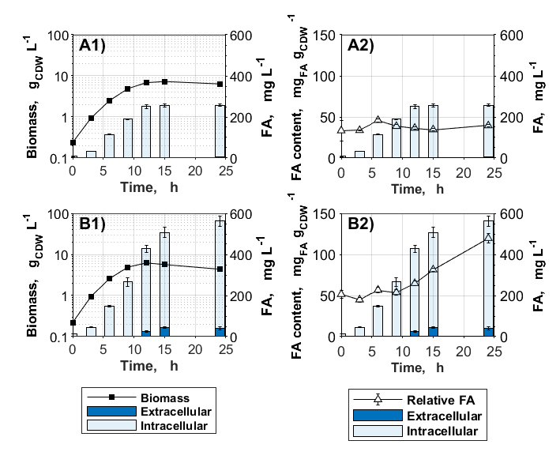
Figure S1: Influence of fasR deletion on fatty acid production under nitrogen-limiting conditions. Cultivations were conducted in the nitrogen-limiting NL-CgXII medium containing per liter 20 g glucose as the carbon source. A) C. glutamicum WT; B) C. glutamicum ΔfasR. Data represent means of ≥ 3 biological replicates with standard deviations.

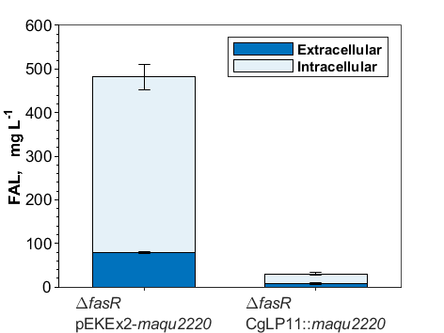
Figure S2: Fatty alcohol production of plasmid-harboring and plasmid-free C. glutamicum ΔfasR mutants with the FAR Maqu2220. Cultivations were conducted in NL-CgXII medium containing 20 g glucose L⁻¹. Samples for FAL analysis were taken after 48 h. Data represent means of 3 biological replicates with standard deviations.

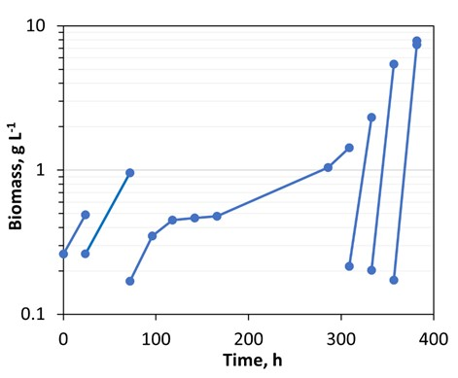
Figure S3: ALE of C. glutamicum ΔactA::xylAB in shaking flasks in 6 serial batch cultivations over 382 h in total, using CgXII medium containing 40 g xylose L⁻¹ as sole carbon source. Transfers to fresh CgXII medium were performed when OD₆₀₀ surpassed at least 2 after 24 h or more.
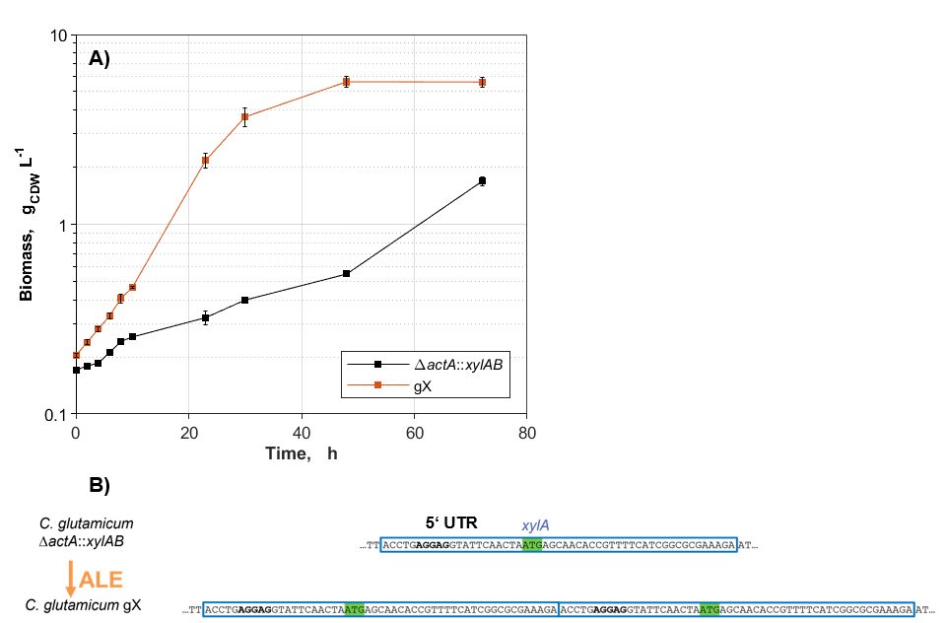

Figure S4: ALE of C. glutamicum ΔactA::xylAB on xylose. A) Growth curves of C. glutamicum ΔactA::xylAB and the evolved strain gX. Cultivations were conducted in CgXII medium containing 40 g xylose L⁻¹ as the sole carbon source. Data represent means of 3 biological replicates with standard deviations. B) Nucleotide sequence of the 5’ untranslated regions (UTR) of C. glutamicum ΔactA::xylAB and C. glutamicum gX. The duplicated region, comprising 21 bp of the 5’UTR and 32 bp of the beginning of xylose isomerase gene xylA, is highlighted (blue box) in the parental strain C. glutamicum ΔactA::xylAB and in the evolved strain gX. The putative RBS (Pfeifer-Sancar et al., 2013) is indicated in bold letters, and the start codon of xylA is highlighted in green.
Figure S5: FAL production on wheat straw hydrolysate. Cultivations were conducted in CgXII medium supplemented with 195 µM PCA. The carbon source was provided by hydrolysate, normalized to a concentration of 20 g glucose L⁻¹. A) C. glutamicum ΔfasR cg2692_{TTG} (pEKEx2-maqu2220); B) C. glutamicum ΔfasR cg2692_{TTG} gX (pEKEx2-maqu2220). Data represent means of 3 biological replicates with standard deviations.

Abe, S., Takayama, K.-I., & Kinoshita, S. (1967). Taxonomical studies on glutamic acid-producing bacteria. The Journal of General and Applied Microbiology, 13(3), 279-301. https://doi.org/10.2323/jgam.13.279
Blattner, F. R., Plunkett, G., Bloch, C. A., Perna, N. T., Burland, V., Riley, M., Collado-Vides, J., Glasner, J. D., Rode, C. K., Mayhew, G. F., Gregor, J., Davis, N. W., Kirkpatrick, H. A., Goeden, M. A., Rose, D. J., Mau, B., & Shao, Y. (1997). The complete genome sequence of Escherichia coli K-12. Science, 277(5331), 1453-1462. https://doi.org/10.1126/science.277.5331.1453
Eikmanns, B. J., Thum-Schmitz, N., Eggeling, L., Lüdtke, K.-U., & Sahm, H. (1994). Nucleotide sequence, expression and transcriptional analysis of the Corynebacterium glutamicum gltA gene encoding citrate synthase. Microbiology, 140(8), 1817-1828. https://doi.org/10.1099/13500872-140-8-1817
Hanahan, D. (1983). Studies on transformation of Escherichia coli with plasmids. Journal of Molecular Biology, 166(4), 557-580. https://doi.org/10.1016/S0022-2836(83)80284-8
Kerbs, A., Mindt, M., Schwardmann, L., & Wendisch, V. F. (2021). Sustainable production of N-methylphenylalanine by reductive methylamination of phenylpyruvate using engineered Corynebacterium glutamicum. Microorganisms, 9(4). https://doi.org/10.3390/microorganisms9040824
Kinoshita, S., Nakayama, K., & Akita, S. (1958). Taxonomical study of glutamic acid accumulating bacteria, Micrococcus glutamicus nov. sp. Bulletin of the Agricultural Chemical Society of Japan, 22(3), 176-185. https://doi.org/10.1080/03758397.1958.10857463
Meiswinkel, T. M., Gopinath, V., Lindner, S. N., Nampoothiri, K. M., & Wendisch, V. F. (2013). Accelerated pentose utilization by Corynebacterium glutamicum for accelerated production of lysine, glutamate, ornithine and putrescine. Microbial biotechnology, 6(2), 131-140. https://doi.org/10.1111/1751-7915.12001
Pérez-García, F., Peters-Wendisch, P., & Wendisch, V. F. (2016). Engineering Corynebacterium glutamicum for fast production of l-lysine and l-pipecolic acid. Applied Microbiology and Biotechnology, 100(18), 8075-8090. https://doi.org/10.1007/s00253-016-7682-6
Pfeifer-Sancar, K., Mentz, A., Rückert, C., & Kalinowski, J. (2013). Comprehensive analysis of the Corynebacterium glutamicum transcriptome using an improved RNAseq technique. Bmc Genomics, 14(1), 888. https://doi.org/10.1186/1471-2164-14-888
Schäfer, A., Tauch, A., Jäger, W., Kalinowski, J., Thierbach, G., & Pühler, A. (1994). Small mobilizable multi-purpose cloning vectors derived from the Escherichia coli plasmids pK18 and pK19: selection of defined deletions in the chromosome of Corynebacterium glutamicum. Gene, 145(1), 69-73. https://doi.org/10.1016/0378-1119(94)90324-7
Schwardmann, L. S., Dransfeld, A. K., Schäffer, T., & Wendisch, V. F. (2022). Metabolic engineering of Corynebacterium glutamicum for sustainable production of the aromatic dicarboxylic acid pipicolinic acid. Microorganisms, 10(4). https://doi.org/10.3390/microorganisms10040730
Shi, F., Luan, M., & Li, Y. (2018). Ribosomal binding site sequences and promoters for expressing glutamate decarboxylase and producing γ-aminobutyrate in Corynebacterium glutamicum. AMB Express, 8(1), 61. https://doi.org/10.1186/s13568-018-0595-2
van Ooyen, J., Noack, S., Bott, M., Reth, A., & Eggeling, L. (2012). Improved L-lysine production with Corynebacterium glutamicum and systemic insight into citrate synthase flux and activity. Biotechnology and Bioengineering, 109(8), 2070-2081. https://doi.org/10.1002/bit.24486

