Table S1 Plasmids used or created in the present study
Plasmids | Description | Source of reference
pYLXP | URA3, LEU2, pTEF-tXPR | [1]
pYL1 | LEU2, pTEF-tXPR | [1]
pYU1 | URA3, pTEF-tXPR | This investigation
pYL4 | LEU2, p4UASTEF-tXPR | This investigation
pYU4 | URA3, p4UATEF-tXPR | This investigation
pYL8 | LEU2, p8UASTEF-tXPR | This investigation
pYU8 | URA3, p8UATEF-tXPR | This investigation
pYL1-Ctcbp1 | LEU2, pTEF-Ctcbp1-tXPR | This investigation
pYL1-Ctcdp1 | LEU2, pTEF-Ctcdp1-tXPR | This investigation
pYL1-NcCDT1 | LEU2, pTEF-NcCDT1-tXPR | This investigation
pYL1-ScPGM2 | LEU2, pTEF-ScPGM2-tXPR | This investigation
pYL4-Ctcbp1 | LEU2, p4UATEF-Ctcbp1-tXPR | This investigation
pYL4-Ctcdp1 | LEU2, p4UATEF-Ctcdp1-tXPR | This investigation
pYL4-NcCDT1 | LEU2, p4UATEF-NcCDT1-tXPR | This investigation
pYL4-ScPGM2 | LEU2, p4UATEF-ScPGM2-tXPR | This investigation
pYL8-Ctcbp1 | LEU2, p8UATEF-Ctcbp1-tXPR | This investigation
pYL8-Ctcdp1 | LEU2, p8UATEF-Ctcdp1-tXPR | This investigation
pYL8-NcCDT1 | LEU2, p8UATEF-NcCDT1-tXPR | This investigation
pYL8-ScPGM2 | LEU2, p8UATEF-ScPGM2-tXPR | This investigation
pYL1-BDP | LEU2, pTEF-Ctcbp1-tXPR, pTEF-Ctcdp1-tXPR, pTEF-NcCDT1-tXPR, pTEF-ScPGM2-tXPR | This investigation
pYL4-BDP | LEU2, p4UATEF-Ctcbp1-tXPR, p4UATEF-Ctcdp1-tXPR, p4UATEF-NcCDT1-tXPR, pTEF-ScPGM2-tXPR | This investigation
pYL8-BDP | LEU2, p8UATEF-Ctcbp1-tXPR, p8UATEF-Ctcdp1-tXPR, p8UATEF-NcCDT1-tXPR, pTEF-ScPGM2-tXPR | This investigation
pYU1-SsXR | URA3, pTEF-SsXR-tXPR | This investigation
pYU1-SsXDH | URA3, pTEF-SsXDH-tXPR | This investigation
pYU1-CiGXF | URA3, pTEF-CiGXF1-tXPR | This investigation
pYU4-SsXR | URA3, p4UATEF-SsXR-tXPR | This investigation
pYU4-SsXDH | URA3, p4UATEF-SsXDH-tXPR | This investigation
pYU4-CiGXF | URA3, p4UATEF-CiGXF1-tXPR | This investigation
pYU1-XKS | URA3, pTEF-XKS1-tXPR | This investigation
pYU1-ZWF | URA3, pTEF-ZWF1-tXPR | This investigation
pYU1-GND | URA3, pTEF-GND1-tXPR | This investigation
pYU4-XKS | URA3, p4UATEF-XKS-tXPR | This investigation
pYU4-ZWF | URA3, p4UATEF-ZWF1-tXPR | This investigation
pYU4-GND | URA3, p4UATEF-GND1-tXPR | This investigation
pYU1-XRK | URA3, pTEF-SsXR-tXPR, pTEF-SsXDH-tXPR | This investigation
pYU4-XRK | URA3, p4UATEF-SsXR-tXPR, p4UATEF-SsXDH-tXPR, p4UATEF-XKS-tXPR, p4UATEF-CiGXF1-tXPR, p4UATEF-ZWF1-tXPR, p4UATEF-GND1-tXPR | This investigation
pYU1-GPD | URA3, pTEF-GPD1-tXPR | This investigation
pYL1-DGA | LEU2, pTEF-DGA2-tXPR | This investigation

Table S2 The sequences of the oligonucleotide primers used in this study
Primer | Sequence (5’-3’) | Restriction sites | Template | Product
Vec1f | tatgctagcgagacaataacgga | - | pYL1/4/8 or pYU1/4/8 | Plasmid backbone
Vec1r | acgaagttatcctaggctttcatc | - | pYL1/4/8 or pYU1/4/8 | Plasmid backbone
ASS1f | cctaggataacttcgggttggcggcgcatttgtgt | - | pYL1-Ctcbp1, pYU1-SsXR, pYL4-Ctcbp1, pYU4-SsXR | pTEF-Ctcbp-tXPR, pTEF-SsXR-tXPR,
ASS1r | caccttcgatttcgaggacacgggcatctcacttgcat | - | pYL1-Ctcbp1, pYU1-SsXR, pYL4-Ctcbp1, pYU4-SsXR | p4UASTef-Ctcbp-tXPR, p4UASTef-SsXR-tXPR
ASS2f | tcgaaatcgaaggtgggttggcggcgcatttgtgt | - | pYL1-Ctcdp1, pYU1-SsXDH, pYL4-Ctcdp1, pYU4-SsXDH | pTEF-Ctcdp-tXPR, pTEF-SsXDH-tXPR,  p4UASTef-Ctcdp-tXPR, p4UASTef-SsXDH-tXPR
ASS2r | gtctaccctcaccttggacacgggcatctcacttgcat | - | pYL1-Ctcdp1, pYU1-SsXDH, pYL4-Ctcdp1, pYU4-SsXDH
ASS3f | aaggtgagggtagacggttggcggcgcatttgtgt | - | pYL1-NcCDT1, pYU1-XK, pYL4-NcCDT1, pYU4-XK | pTEF-NcCDT1-tXPR, pTEF-XK-tXPR,  p4UASTef-NcCDT1-tXPR, p4UASTef-XK-tXPR
ASS3r | ctgtttgagtacctgggacacgggcatctcacttgcat | - | pYL1-NcCDT1, pYU1-XK, pYL4-NcCDT1, pYU4-XK
ASS4f | aggtactcaaacagcggttggcggcgcatttgtgt | - | pYL1-PGM, pYU1-GXF | pTEF-PGM2-tXPR, pTEF-GXF1-tXPR
ASS4r | tgtctcgctagcataggacacgggcatctcacttgcat | - | pYL1-PGM, pYU1-GXF | pTEF-PGM2-tXPR, pTEF-GXF1-tXPR
XRf | gctctagacacaatgccttctattaagttgaactctggt | XbaI | Genomic DNA of S. stipites | SsXR
XRr | ggggtaccttagacgaagataggaatcttgtccc | KpnI | Genomic DNA of S. stipites | SsXR
XDHf | gctctagacacaatgactgctaacccttccttggtgttg | XbaI | Genomic DNA of S. stipites | SsXDH
XDHr | ggactagtttactcagggccgtcaatgagacac | SpeI | Genomic DNA of S. stipites | SsXDH
PGMf | gctctagacacaatgtcatttcaaattgaaacggttccca | XbaI | Genomic DNA of S. cerevisiae | ScPGM2
PGMr | ggactagtttaagtacgaaccgttggttcttcagttcc | SpeI | Genomic DNA of S. cerevisiae | ScPGM2
XKf | gctctagacacaatgtatctcggactggatctttcgactc | XbaI | Genomic DNA of Y. lipolytica | YlXK
XKr | ggggtaccttatttctccaggcaggcgttttc | KpnI | Genomic DNA of Y. lipolytica | YlXK
ZWFf | gctctagacacaatgactggcaccttacccaagtt | XbaI | Genomic DNA of Y. lipolytica | YlZWF1
ZWFr | ggggtacctcacgaggagcccttggtg | KpnI | Genomic DNA of Y. lipolytica | YlZWF1
GNDf | gctctagacacaatgactgacacttcaaacatcaag | XbaI | Genomic DNA of Y. lipolytica | YlGND1
GNDr | ggggtaccttaagcatcgtaagtggaagaag | KpnI | Genomic DNA of Y. lipolytica | YlGND1
GPDf | ggggtaccatgagcgctctacttcgatcgt | KpnI | Genomic DNA of Y. lipolytica | YlGPD1
GPDr | ggactagttagttggcgtggtaaagaatctcgggg | SpeI | Genomic DNA of Y. lipolytica | YlGPD1
DGAf | gctctagaatggaagtccgacgacgaaaaatc | XbaI | Genomic DNA of Y. lipolytica | YlGPD1
DGAf | gctctagaatggaagtccgacgacgaaaaatc | KpnI | Genomic DNA of Y. lipolytica | YlDGA2
VPEX10f | atgtggggaagttcacatgcattc |  | gDNA of Y. lipolytica po1f-1 (ΔMEF1, ΔPEX10, ΔTGL4) | Disrupted PEX10 (637 bp)
VPEX10r | ttatctgataggcaacaagttctgctct |  | gDNA of Y. lipolytica po1f-1 (ΔMEF1, ΔPEX10, ΔTGL4) | Disrupted PEX10 (637 bp)
VMFE1f | atgtctggagaactaagatacgacgg |  | gDNA of Y. lipolytica po1f-1 (ΔMEF1, ΔPEX10, ΔTGL4) | Disrupted MEF1 (2321 bp)
VMFE1r | ttagagcttagcatccttggggaag |  | gDNA of Y. lipolytica po1f-1 (ΔMEF1, ΔPEX10, ΔTGL4) | Disrupted MEF1 (2321 bp)
VTGL4f | atgttcacctccagagtttccg |  | gDNA of Y. lipolytica po1f-1 (ΔMEF1, ΔPEX10, ΔTGL4) | Disrupted TGL4 (1417 bp)
VTGL4r | ttagcacgagtcagaacagttctc |  | gDNA of Y. lipolytica po1f-1 (ΔMEF1, ΔPEX10, ΔTGL4) | Disrupted TGL4 (1417 bp)
Restriction sites are italic/underlined.
Homologous sequence for infusion or recombination is double underlined.

Table S3 sgRNA for gene deletion
Target gene | The sequence of sgRNA (5’-3’)
PEX10 | AGACCGAACAGCTCTACCGG (386 fwd)
PEX10 | CCTTCTGTATCCTCAATGAA (886 rev)
MFE1 | GTCTGCTATTCTGAAGCGAT (901 fwd)
MFE1 | CTTAAGGAAGTGGGGCCACG (1363 rev)
TGL1 | ACTTTATCCGGCCGACGGCA (58 fwd)
TGL1 | CCGACCAAATGAGTACGTTG (1095 rev)

Table S4 The composition of steam-pretreated wheat straw
Component | Content
WIS content (wt%) | 12±1.2
Composition of WIS (wt%)
Glucan | 48.9±1.4
Xylan | 1.4±0.5
Galactan | -
Arabinan | 0.08±0.03
Mannan | 0.06±0.02
Composition of hydrolysate
Glucose | 8.6±0.9
Xylose | 33.5±1.7
Galactose | 1.2±0.4
Arabinose | 2.2±0.8
Mannose | 1.0±0.3
Formic acid | 0.9±0.1
Levulinic acid | 0.6±0.2
Acetic acid | 4.8±0.6
HMF | 0.4±0.1
Furfural | 2.9±0.2
± the standard deviation.

Lipid accumulation on glucose
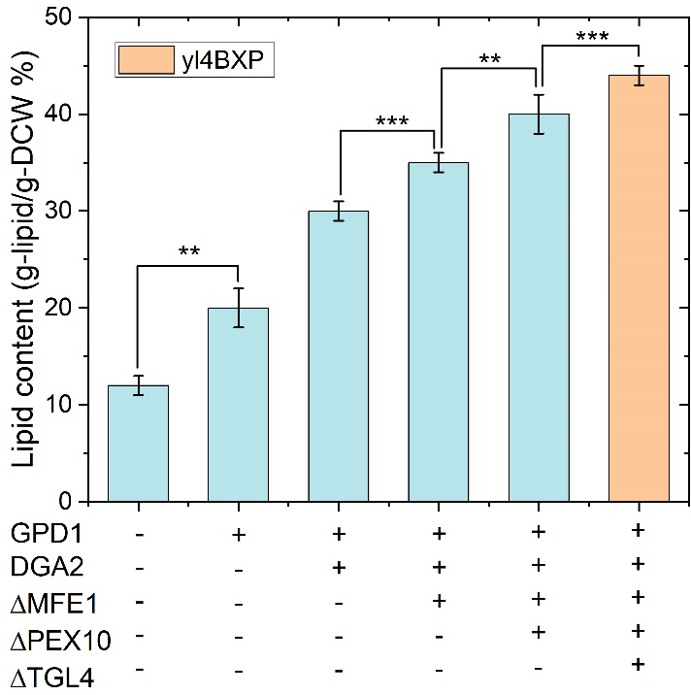
The preculture was carried out in YNB media and used to inoculate 1.2L YNB media containing 75 g/L glucose in a 3.0-liter stirred-tank bioreactor (Sartorius, Germany) to reach an initial OD600nm of 1.0. A feeding of 75 g/L of glucose was performed when the concentration of total reducing sugars dropped below 10 g/L. NH₄Cl was added into the media at the concentration to yield a C/N ratio of 60:1. Throughout the fermentation process, the pH was maintained at 5.5 with the automatic addition of 2.0 M NaOH and the temperature was kept at 28°C. An aeration of 0.5 vvm was set up and the stirring speed was automatically controlled to keep the dissolved oxygen at 20% of air saturation. Samples were taken regularly to analyze the concentrations of biomass, metabolites and carbon source in culture media.
Fig. 2 Comparsion of cellular lipid content of recombinant strains of Y. lipolytica constructed in this work. The strategy used to increase lipid accumulation including overexpress GPD1 and DGA2, and interruption of MFE1, PEX10 and TGL4. (** P value<0.05, ***P value<0.01, two-tailed Student’s t-tests).

Reference
1. Xu P, Qiao K, Ahn WS, Stephanopoulos G: Engineering Yarrowia lipolytica as a platform for synthesis of drop-in transportation fuels and oleochemicals. Proc Natl Acad Sci U S A 2016, 113(39):10848-10853.

