High-throughput droplet microfluidics screening and genome sequencing analysis for improved amylase-producing Aspergillus oryzae
Qinghua Li^{1,2}, Jinchang Lu^{1,2}, Jingya Liu^{1,2}, Jianghua Li^{1,3}, Guoqiang Zhang^{1,2}*, Guocheng Du^{1,3,4}, Jian Chen^{1,2,3,4}

1. Science Center for Future Foods, Jiangnan University, 1800 Lihu Road, Wuxi, Jiangsu 214122, China
2. National Engineering Research Center for Cereal Fermentation and Food Biomanufacturing, Jiangnan University, 1800 Lihu Road, Wuxi, Jiangsu 214122, China
3. School of Biotechnology and Key Laboratory of Industrial Biotechnology, Ministry of Education, Jiangnan University, 1800 Lihu Road, Wuxi, Jiangsu 214122, China
4. The Key Laboratory of Carbohydrate Chemistry and Biotechnology, Ministry of Education, Jiangnan University, 1800 Lihu Road, Wuxi, Jiangsu 214122, China

* Corresponding authors: gqzhang@jiangnan.edu.cn

Supplementary data:
This file contains 7 figures and 5 tables.
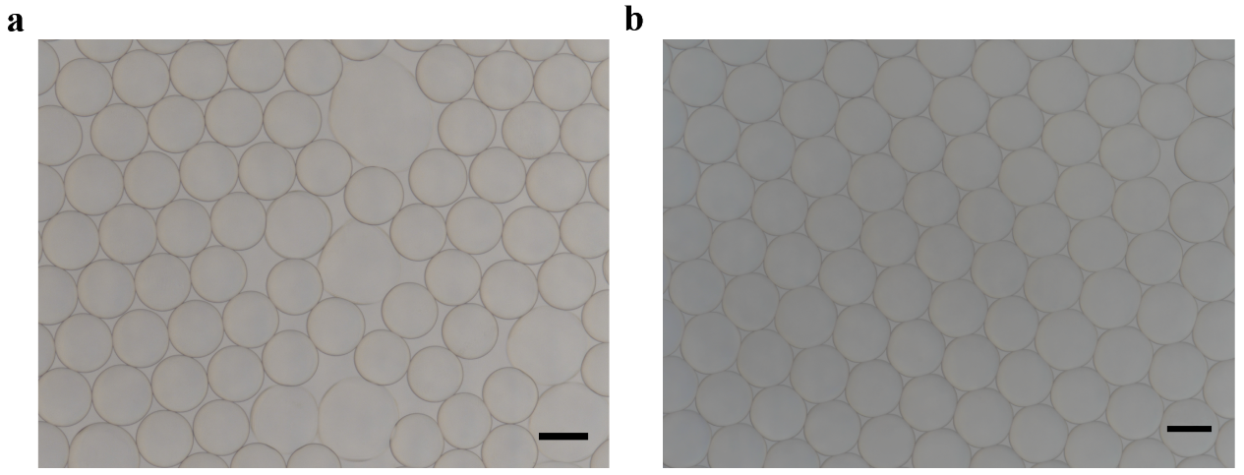
Fig. S1 Optimization of oils for microdroplet generation. a Droplet generation using Bio-Rad. Scale bar: 200 µm; b Droplet generation using Novec7500. Scale bar: 200 µm.
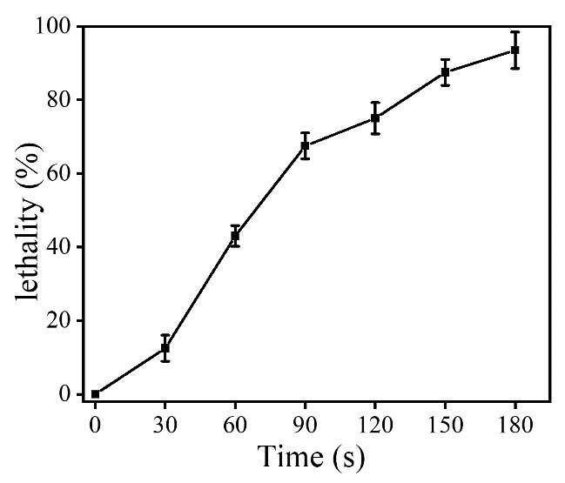
Fig. S2 The Lethality curve of ARTP mutagenesis of A. oryzae spores. Other mutagenesis conditions were set as follows: the distance between the slide and the jet outlet of the plasma generator was 2 mm; the ventilation volume was 10 SLM; and the irradiation power was 120 W.
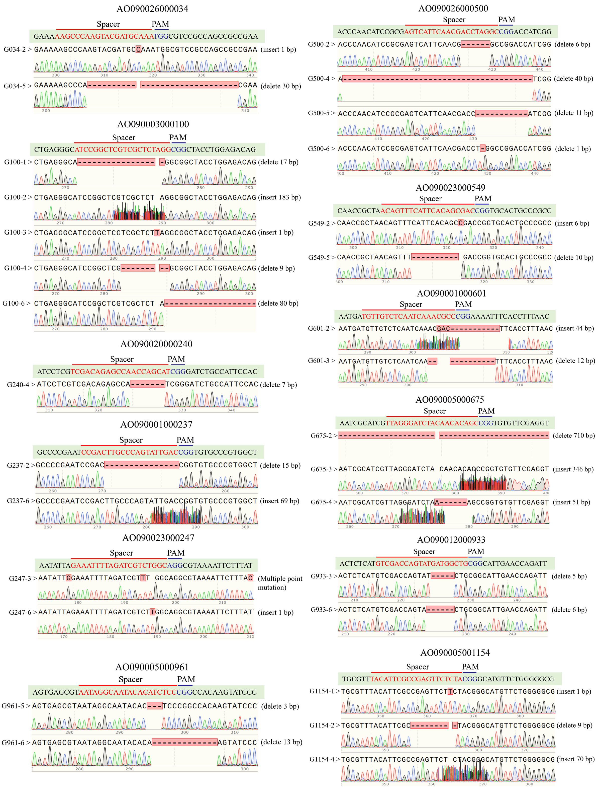
Fig. S3 The genetic information of mutations in relevant target genes. The sequence with green shading is original sequence.
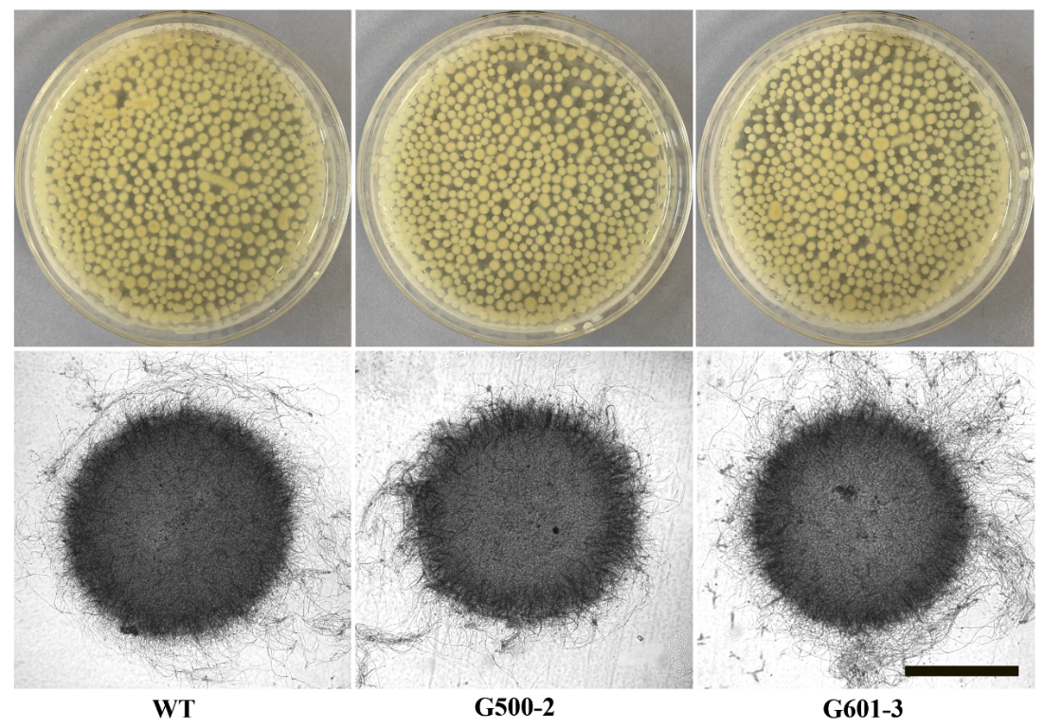
Fig. S4 The pellet morphology of mutants of AO090026000500 and AO090001000601. Scale bar: 500 µm.
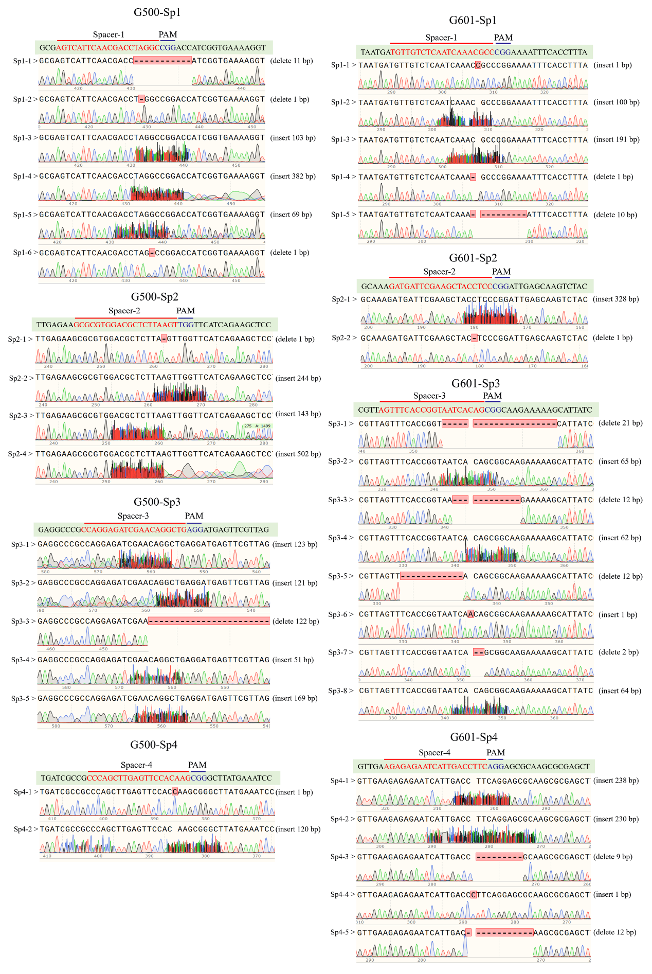
Fig. S5 The genetic information of different mutants of AO090026000500 and AO090001000601. The sequence with green shading is original sequence.
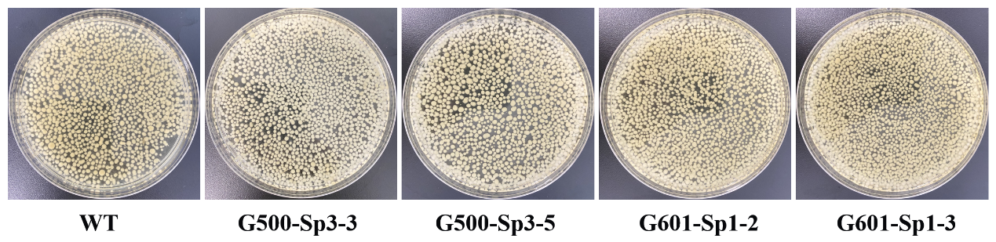
Fig. S6 The pellet morphology of mutants of AO090026000500 and AO090001000601.
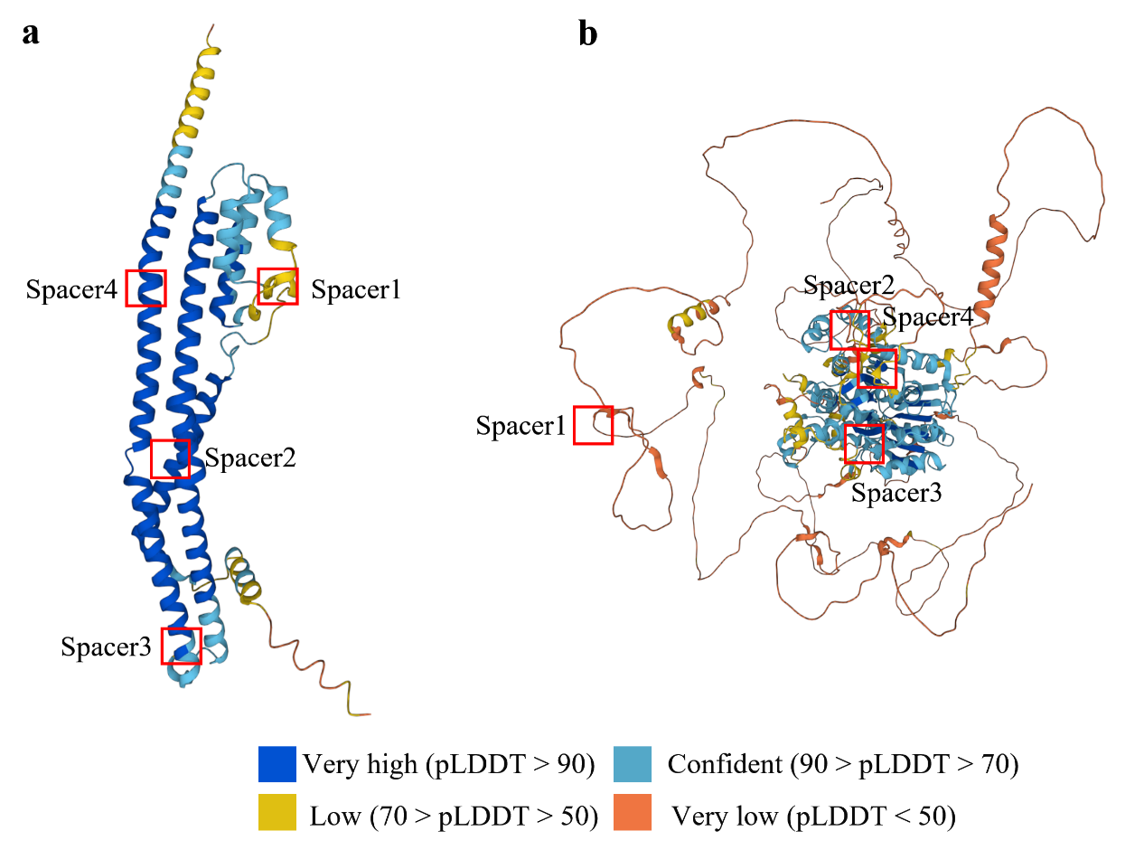
Fig. S7 The protein structure prediction of AO090026000500 and AO090001000601 based on AlphaFold. AlphaFold produces a per-residue confidence score (pLDDT) between 0 and 100. Some regions below 50 pLDDT may be unstructured in isolation.
Table S1. The main primers used in this study.
Primers | Sequence (5’ to 3’)
G237-F | ccagtattgacGTTTTAGAGCTAGAAATAGCAAG
G237-R | ggcaagtcggTGCATCATCCGTGAATCG
G261-F | ggcttcagtcGTTTTAGAGCTAGAAATAGCAAG
G261-R | tcggtgtggaTGCATCATCCGTGAATCG
G364-F | catccaagaaGTTTTAGAGCTAGAAATAGCAAG
G364-R | cggtcgaggtTGCATCATCCGTGAATCG
G601-F1 | atcaaacgccGTTTTAGAGCTAGAAATAGCAAG
G601-R1 | tgagacaacaTGCATCATCCGTGAATCG
G100-F | tcgctctaggGTTTTAGAGCTAGAAATAGCAAG
G100-R | cgagccggatTGCATCATCCGTGAATCG
G675-F | acaacacagcGTTTTAGAGCTAGAAATAGCAAG
G675-R | agatccctaaTGCATCATCCGTGAATCG
G961-F | acacatctccGTTTTAGAGCTAGAAATAGCAAG
G961-R | attgcctattTGCATCATCCGTGAATCG
G1154-F | gagttctctaGTTTTAGAGCTAGAAATAGCAAG
G1154-R | ggcgaatgtaTGCATCATCCGTGAATCG
G933-F | atgatggctgGTTTTAGAGCTAGAAATAGCAAG
G933-R | actggtcgacTGCATCATCCGTGAATCG
G240-F | caaccagcatGTTTTAGAGCTAGAAATAGCAAG
G240-R | gctctgtcgaTGCATCATCCGTGAATCG
G247-F | atcgtctggcGTTTTAGAGCTAGAAATAGCAAG
G247-R | ctaaaatttcTGCATCATCCGTGAATCG
G549-F | tcacagcgacGTTTTAGAGCTAGAAATAGCAAG
G549-R | atgaaactgtTGCATCATCCGTGAATCG
G034-F | acgatgcaaaGTTTTAGAGCTAGAAATAGCAAG
G034-R | acttgggcttTGCATCATCCGTGAATCG
G500-F1 | cgacctaggcGTTTTAGAGCTAGAAATAGCAAG
G500-R1 | ttgaatgactTGCATCATCCGTGAATCG
G001-F | tgctatcatcGTTTTAGAGCTAGAAATAGCAAG
G001-R | accggccatcTGCATCATCCGTGAATCG
HiFi-const-F | TGTGGATAACCGTATTACCGCCTTTGAGTGAGCTGATTTAATTA  AGCCGACATAGCTGTTTCCGCTGAGG
HiFi-const-R | GCTACAGGGCGCGTACTATGGTTGCTTTGACGTATGCGTCCCTGGGAG
G500-F2 | gctcttaagtGTTTTAGAGCTAGAAATAGCAAG
G500-R2 | gtccacgcgcTGCATCATCCGTGAATCG
G500-F3 | gaacaggctgGTTTTAGAGCTAGAAATAGCAAG
G500-R3 | gatctcctggTGCATCATCCGTGAATCG
G500-F4 | gttccacaagGTTTTAGAGCTAGAAATAGCAAG
G500-R4 | tcaagctgggTGCATCATCCGTGAATCG
G601-F2 | agctacctccGTTTTAGAGCTAGAAATAGCAAG
G601-R2 | tcgaatcatcTGCATCATCCGTGAATCG
G601-F3 | gtaatcacagGTTTTAGAGCTAGAAATAGCAAG
G601-R3 | cggtgaaactTGCATCATCCGTGAATCG
G601-F4 | attgaccttcGTTTTAGAGCTAGAAATAGCAAG
G601-R4 | gattctctctTGCATCATCCGTGAATCG

Table S2. The main plasmids used in this study.
Plasmids | Source
pPTR II | Takara Bio Inc.
pC9sgR-Model | This study constructed
pC9sgR-yA-G1154 | This study constructed
pC9sgR-yA-G961 | This study constructed
pC9sgR-yA-G675 | This study constructed
pC9sgR-yA-G261 | This study constructed
pC9sgR-yA-G364 | This study constructed
pC9sgR-yA-G601 | This study constructed
pC9sgR-yA-G100 | This study constructed
pC9sgR-yA-G549 | This study constructed
pC9sgR-yA-G500 | This study constructed
pC9sgR-yA-G034 | This study constructed
pC9sgR-yA-G933 | This study constructed
pC9sgR-yA-G240 | This study constructed
pC9sgR-yA-G001 | This study constructed
pC9sgR-yA-G237 | This study constructed
pC9sgR-yA-G247 | This study constructed
pTR-C9sgR-yA-G1154 | This study constructed
pTR-C9sgR-yA-G961 | This study constructed
pTR-C9sgR-yA-G675 | This study constructed
pTR-C9sgR-yA-G261 | This study constructed
pTR-C9sgR-yA-G364 | This study constructed
pTR-C9sgR-yA-G601 | This study constructed
pTR-C9sgR-yA-G100 | This study constructed
pTR-C9sgR-yA-G549 | This study constructed
pTR-C9sgR-yA-G500 | This study constructed
pTR-C9sgR-yA-G034 | This study constructed
pTR-C9sgR-yA-G933 | This study constructed
pTR-C9sgR-yA-G240 | This study constructed
pTR-C9sgR-yA-G001 | This study constructed
pTR-C9sgR-yA-G237 | This study constructed
pTR-C9sgR-yA-G247 | This study constructed
pC9sgR-yA-G500-2 | This study constructed
pC9sgR-yA-G500-3 | This study constructed
pC9sgR-yA-G500-4 | This study constructed
pC9sgR-yA-G601-2 | This study constructed
pC9sgR-yA-G601-3 | This study constructed
pC9sgR-yA-G601-4 | This study constructed
pTR-C9sgR-yA-G500-2 | This study constructed
pTR-C9sgR-yA-G500-3 | This study constructed
pTR-C9sgR-yA-G500-4 | This study constructed
pTR-C9sgR-yA-G601-2 | This study constructed
pTR-C9sgR-yA-G601-3 | This study constructed
pTR-C9sgR-yA-G601-4 | This study constructed

Table S3 The mutations involved in high-yielding strains. fs means frameshift, * means Stop gained, del means deletion, Ter means stop codon, and ext* means stop lost. The selected genes for validation are marked in orange shading.
No. | Genes | Type | Mutations
1 | AO090009000606 | SNP | Ala579Thr
2 | AO090005001154 | SNP | Tyr44Ser
3 | AO090005000961 | SNP | Leu1422Pro
4 | AO090005000675 | SNP | Val471Ala
5 | AO090001000199 | SNP | Pro178Leu
6 | AO090001000237 | INDEL | Pro11fs
7 | AO090001000261 | INDEL | Val209fs
8 | AO090001000364 | SNP | Glu165Lys
9 | AO090001000601 | INDEL | Glu337del
10 | AO090003000100 | SNP | Ala256Thr
11 | AO090003000209 | INDEL | Lys192fs
12 | AO090003000220 | INDEL | Arg90fs
13 | AO090003000635 | INDEL | Glu124fs
14 | AO090003000984 | SNP | Ter280Lys and ext*
15 | AO090023000107 | SNP | Tyr52Cys
16 | AO090023000247 | SNP | Asp119Asn Cys113Tyr Asn111Asp
17 | AO090023000249 | SNP | His41His Gln32* Leu29Ser Ser20Leu Gly13Asp Gly13Ser Glu12Lys Gln11* Pro2Ser Met1lys
18 | AO090023000549 | SNP | Asp308Ala
19 | AO090026000500 | SNP | Val239Ile
20 | AO090026000066 | SNP | Phe330Ser
21 | AO090026000034 | SNP | Ser431Leu
22 | AO090012000933 | SNP | Asn49Asp
23 | AO090166000031 | SNP | Glu23*
24 | AO090113000116 | SNP | Met1lys
25 | AO090020000240 | SNP | Lys432Glu
26 | AO090038000001 | SNP | Ile323Ile Tyr324Asp Ter327Ter
27 | AO090011000163 | INDEL | Lys32fs
28 | AO090011000694 | SNP | Arg26His
29 | AO090010000247 | INDEL | Glu499del

Table S4 The result of Gene Ontology (GO) enrichment.
Ontology | Description | Id | Significant | Annotated | P value | Q value
biological process | multicellular organismal process | GO:0032501 | 1(7) | 43(3719) | 0.0782 | 1
biological process | developmental process | GO:0032502 | 1(7) | 313(3719) | 0.4599 | 1
biological process | multi-organism process | GO:0051704 | 1(7) | 323(3719) | 0.4709 | 1
biological process | cellular process | GO:0009987 | 7(7) | 3373(3719) | 0.5045 | 1
biological process | reproductive process | GO:0022414 | 1(7) | 383(3719) | 0.533 | 1
biological process | metabolic process | GO:0008152 | 6(7) | 2951(3719) | 0.5588 | 1
biological process | reproduction | GO:0000003 | 1(7) | 415(3719) | 0.5635 | 1
biological process | negative regulation of biological process | GO:0048519 | 1(7) | 612(3719) | 0.7163 | 1
biological process | positive regulation of biological process | GO:0048518 | 1(7) | 640(3719) | 0.7337 | 1
biological process | biological regulation | GO:0065007 | 2(7) | 1537(3719) | 0.8583 | 1
biological process | establishment of localization | GO:0051234 | 1(7) | 959(3719) | 0.8763 | 1
biological process | response to stimulus | GO:0050896 | 1(7) | 1085(3719) | 0.9108 | 1
biological process | localization | GO:0051179 | 1(7) | 1134(3719) | 0.9218 | 1
biological process | regulation of biological process | GO:0050789 | 1(7) | 1288(3719) | 0.9492 | 1
biological process | cellular component organization or biogenesis | GO:0071840 | 1(7) | 1622(3719) | 0.982 | 1
cellular component | organelle | GO:0043226 | 6(6) | 2974(3545) | 0.3483 | 1
cellular component | organelle part | GO:0044422 | 4(6) | 2028(3545) | 0.4865 | 1
cellular component | protein-containing complex | GO:0032991 | 3(6) | 1612(3545) | 0.5681 | 1
cellular component | membrane part | GO:0044425 | 1(6) | 861(3545) | 0.8119 | 1
cellular component | membrane-enclosed lumen | GO:0031974 | 1(6) | 930(3545) | 0.8391 | 1
cellular component | cell | GO:0005623 | 6(6) | 3467(3545) | 0.875 | 1
cellular component | cell part | GO:0044464 | 6(6) | 3467(3545) | 0.875 | 1
cellular component | membrane | GO:0016020 | 1(6) | 1183(3545) | 0.9127 | 1
molecular function | enzyme regulator activity | GO:0030234 | 1(5) | 178(3227) | 0.2471 | 1
molecular function | structural molecule activity | GO:0005198 | 1(5) | 187(3227) | 0.2582 | 1
molecular function | molecular function regulator | GO:0098772 | 1(5) | 209(3227) | 0.2847 | 1
molecular function | catalytic activity | GO:0003824 | 3(5) | 1913(3227) | 0.6702 | 1
molecular function | binding | GO:0005488 | 1(5) | 1618(3227) | 0.9693 | 1
Table S5 The result of euKaryotic Ortholog Groups (KOG) enrichment.
Description | Significant | Annotated | P value | Q value | Symbol
General function prediction only | 4(13) | 1087(5626) | 0.231920672 | 0.573644775 | AO090038000001  AO090001000261  AO090005001154  AO090012000933
Carbohydrate transport and metabolism | 2(13) | 414(5626) | 0.247431159 | 0.573644775 | AO090005000675  AO090026000034
Lipid transport and metabolism | 2(13) | 454(5626) | 0.2828354 | 0.573644775 | AO090023000549  AO090005000961
Secondary metabolites biosynthesis, transport and catabolism | 2(13) | 495(5626) | 0.31923819 | 0.573644775 | AO090001000261  AO090020000240
Replication, recombination and repair | 1(13) | 181(5626) | 0.346605345 | 0.573644775 | AO090001000601
Transcription | 1(13) | 252(5626) | 0.449204516 | 0.573644775 | AO090001000601
Function unknown | 1(13) | 266(5626) | 0.467589589 | 0.573644775 | AO090003000100
Translation, ribosomal structure and biogenesis | 1(13) | 300(5626) | 0.509906466 | 0.573644775 | AO090001000364
Signal transduction mechanisms | 1(13) | 407(5626) | 0.623670625 | 0.623670625 | AO090026000500

