Sequential catalytic lignin valorization and bio-ethanol production: an integrated biorefinery strategy

Yilu Wu ª, Changsheng Su ª, Zicheng Liao ^{b}, Gege Zhang ^{c}, Yongjie Jiang ª, Yankun Wang ª, Changwei Zhang ª, Di Cai ^{a,}*, Peiyong Qin ^{b}, Tianwei Tan ª

ª National Energy R&D Center for Biorefinery, Beijing University of Chemical Technology, Beijing 100029, PR China
^{b} College of Life Science and Technology, Beijing University of Chemical Technology, Beijing 100029, PR China
^{c} School of International Education, Beijing University of Chemical Technology, Beijing 100029, PR China

Corresponding author
Email: caidibuct@163.com (D. Cai)

Fig. S1 (A) Scatter plot of δ_{T} versus lignin monomers yields with different ratios of 2-PrOH:H₂O (v/v) in initial liquor. (B) Scatter plot of δ_{T} versus delignification of pulps with different ratios of 2-PrOH:H₂O (v/v) in initial liquor. (C) Scatter plot of RED versus lignin monomers yields with different ratios of 2-PrOH/H₂O in initial liquor. (D) Scatter plot of RED versus delignification of pulps with different ratios of 2-PrOH/H₂O in initial liquor.

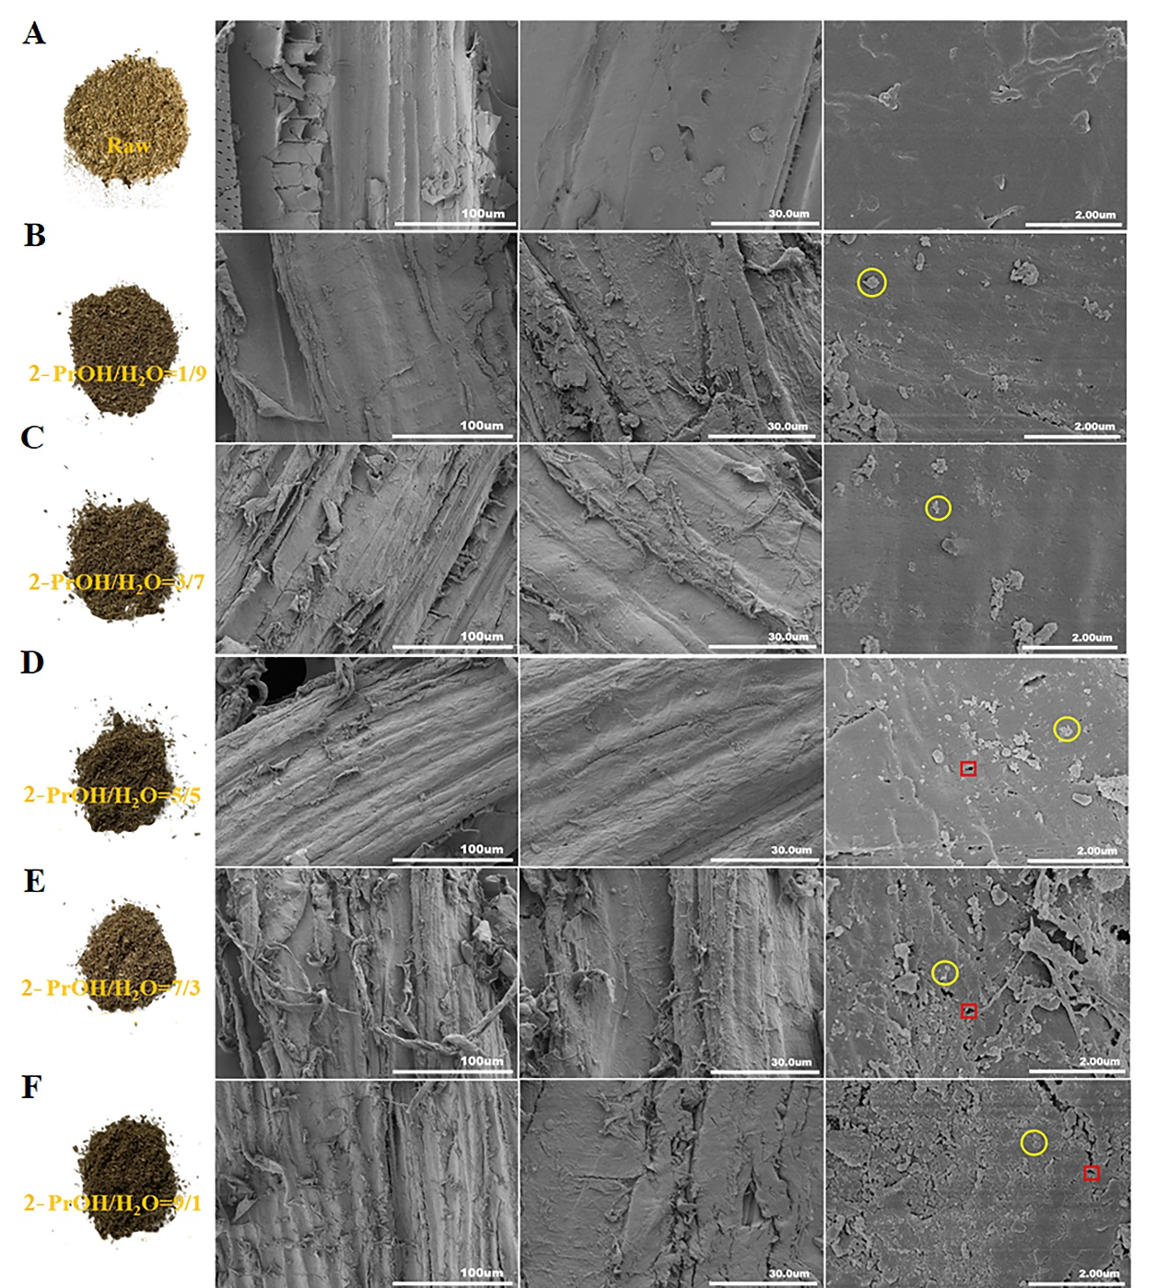
Fig. S2 SEM images of RCF pulps using the pulping liquor with different 2-PrOH:H₂O ratios. (A)-(F) represented to the raw poplar sawdust, and the pulps after RCF using the liquor that consisted of 1:9, 3:7, 5:5. 7:3 and 9:1 of 2-PrOH:H₂O (v/v), respectively.

Fig. S3 Fermentation performances of the parent S. cerevisiae and engineered S. cerevisiae strains for ethanol production using the YPX medium containing 40 g/L of xylose. Time course of (A) OD₆₀₀, (B) xylose, and (C) ethanol concentration in batch fermentation process. (D) Comparison of ethanol concentration, yield, and OD_{600max} in YPD medium using different strains.

Table S1 Sugar concentrations after enzymatic hydrolysis of RCF pulps by different ratios of 2-PrOH:H₂O (v/v).
6 wt% solid dosage | Glucose concentration (g/L) | Xylose concentration (g/L) | Total sugar concentration (g/L)
1:9 | 28.10±0.12 | 1.64±0.08 | 29.74±0.25
3:7 | 36.42±0.15 | 3.38±0.21 | 39.80±0.32
5:5 | 35.42±1.26 | 4.51±0.28 | 39.93±1.67
7:3 | 29.60±0.34 | 4.38±0.33 | 33.98±0.62
9:1 | 17.71±0.09 | 3.92±0.10 | 21.63±0.31
12 wt% solid dosage | Glucose concentration (g/L) | Xylose concentration (g/L) | otal sugar concentration (g/L)
1:9 | 42.17±0.15 | 3.23±0.15 | 45.40±0.76
3:7 | 55.20±0.38 | 5.70±0.33 | 60.90±0.67
5:5 | 55.80±1.03 | 7.65±0.75 | 63.45±0.39
7:3 | 45.60±0.78 | 7.47±0.45 | 53.07±0.46
9:1 | 30.18±0.62 | 6.00±0.23 | 36.18±0.62

Table S2 Yield of RCF oil (wt%) using different ratios of 2-PrOH:H₂O (v/v) as initial liquor, in which process 11.70 g dry poplar sawdust was mixture with the initial liquor for before fractionation.
2-PrOH:H₂O (v/v) | 1:9 | 3:7 | 5:5 | 7:3 | 9:1
Mass (g) | 2.003 ± 0.027 | 2.135 ± 0.020 | 2.289 ± 0.013 | 2.416 ± 0.020 | 2.420 ± 0.033
Yield (wt%) | 17.12 ± 0.41 | 18.25 ± 0.33 | 19.56 ± 0.26 | 20.65 ± 0.31 | 20.63 ± 0.44

Table S3 Hildebrand solubility parameter (δ_{T}) and HSP (δ_{D}, δ_{P}, δ_{H}) for selected solvents (2-PrOH:H₂O) and poplar lignin.
 | δ_{D} (MPa^{½}) | δ_{P} (MPa^{½}) | δ_{H} (MPa^{½}) | δ_{T} (MPa^{½}) | RED
Lignin [1] | 21.9 | 14.1 | 16.9 | 31.0 | /
2-PrOH [2] | 15.8 | 6.1 | 16.4 | 23.6 | 1.07
H₂O [3] | 15.5 | 16.0 | 42.3 | 47.8 | 2.10
1:9 | 15.5 | 15.0 | 39.7 | 45.2 | 1.92
3:7 | 15.6 | 13.0 | 34.5 | 40.1 | 1.60
5:5 | 15.7 | 11.1 | 29.4 | 35.0 | 1.32
7:3 | 15.7 | 9.1 | 24.2 | 30.2 | 1.12
9:1 | 15.8 | 7.1 | 19.0 | 25.7 | 1.05
The δ-values of aqueous solutions of selected solvents (2-PrOH:H₂O) are calculated by δ_{M} = φ₁δ₁ + φ₂δ₂, where φ is the volume fraction of the 2-PrOH (index 1) or H₂O (index 2), and δ is the δ-value of 2-PrOH (index 1) or H₂O (index 2) [4].
δ_{T}² = δ_{D}²+δ_{P}²+δ_{H}², δ_{T} represented Hildebrand solubility parameter.
RED: Relative energy difference, was used to determine the miscibility of poplar lignin with selected solvents (2-PrOH:H₂O). RED = R_{a} / R₀. R₀ is the radius of the Hansen sphere obtained by a computerized optimization method as described above. R_{a}² = 4(δ_{D1}-δ_{D2})²+(δ_{P1}-δ_{P2})²+(δ_{H1}-δ_{H2})². The “1” referred to the selected solvents and “2” referred to lignin [2, 3].

Table S4 Molecular weight distribution of the lignin oil fractionated by different proportion of 2-PrOH:H₂O (v/v) in the initial liquor.
2-PrOH:H₂O (v/v) | Mn (Da) | Mw (Da) | PDI
1:9 | 620 | 1050 | 1.694
3:7 | 681 | 1101 | 1.616
5:5 | 723 | 1282 | 1.773
7:3 | 724 | 1255 | 1.735
9:1 | 904 | 1114 | 1.233

Table S5 Lignin monomers yield (wt%, lignin monomers yield=lignin monomers mass in the lignin oil / raw poplar sawdust × 100 %) using different proportion of 2-PrOH:H₂O (v/v) in initial liquor.
Types ª | Lignin monomers | Lignin monomers yields (wt%) using different proportion of 2-PrOH:H₂O (v/v) in initial liquor
Types ª | Lignin monomers | 1:9 | 3:7 | 5:5 | 7:3 | 9:1
S | 4-(3-Hydroxypropyl)-2,6-dimethoxyphenol | 0.83 | 2.01 | 1.84 | 2.00 | 1.00
S | 4-Propyl-2,6-dimethoxyphenol | 0.28 | 0.21 | 0.17 | 0.16 | 0.08
S | 4-Ethyl-2,6-dimethoxyphenol | 0.00 | 0.00 | 0.00 | 0.00 | 0.00
S | 4-Methyl-2,6-dimethoxyphenol | 0.07 | 0.01 | 0.25 | 0.35 | 0.04
S | 2,6-Dimethoxyphenol | 0.02 | 0.03 | 0.01 | 0.02 | 0.04
G | 4-(3-Hydroxypropyl)-2-methoxyphenol | 0.44 | 0.99 | 0.72 | 0.78 | 0.48
G | 4-Propylguaiacol | 0.07 | 0.05 | 0.07 | 0.08 | 0.02
G | 4-Ethyl-guaiacol | 0.26 | 0.13 | 0.30 | 0.29 | 0.11
G | 4-Methylguaiacol | 0.07 | 0.07 | 0.03 | 0.03 | 0.01
H | 4-(3-Hydroxypropyl)phenol | 0.83 | 0.07 | 0.74 | 0.67 | 0.62
H | 4-Propylphenol | 0.07 | 0.13 | 0.07 | 0.06 | 0.03
H | 4-Ethylphenol | 0.02 | 0.01 | 0.12 | 0.01 | 0.01
H | 4-Methylphenol | 0.00 | 0.00 | 0.00 | 0.00 | 0.00
Others | 4-Propylcyclohexanol | 0.01 | 0.05 | 0.08 | 0.02 | 0.04
Others | 4-Ethylcyclohexanol | 0.04 | 0.02 | 0.03 | 0.05 | 0.04
Others | 4-Methylcyclohexanol | 0.00 | 0.00 | 0.00 | 0.00 | 0.00
 | Total | 3.01 | 3.78 | 4.43 | 4.52 | 2.52
ª S: Syringl units; G: Guaiacyl units; H: p-Hydroxyphenyl units.

Table S6 Types and contents of hydroxyl groups in the RCF oil.
2-PrOH:H₂O ratios (v/v) | S-OH  (mmol/g) | G-OH  (mmol/g) | H-OH  (mmol/g) | Phenolic-OH  (mmol/g) | Aliphatic-OH  (mmol/g) | COOH  (mmol/g)
1:9 | 0.413 | 0.111 | 0.467 | 1.991 | 21.580 | 4.203
3:7 | 0.070 | 1.104 | 0.007 | 1.181 | 28.601 | 3.871
5:5 | 0.420 | 1.192 | 0.458 | 2.070 | 29.860 | 4.268
7:3 | 0.229 | 0.845 | 0.279 | 1.353 | 31.724 | 4.827
9:1 | 0.081 | 1.018 | 0.222 | 1.321 | 13.752 | 4.806

Table S7 Crystallinity (CrI %) of the RCF pulps fractionated by different ratios of 2-PrOH:H₂O.
2-PrOH:H₂O (v/v) | CrI (%)
1:9 | 51.42
3:7 | 51.38
5:5 | 53.60
7:3 | 66.50
9:1 | 63.72

Table S8 Ethanol fermentation performances by parent S. cerevisiae and the engineered S. cerevisiae using YPX as substrate (40 g/L xylose).
Strain | M3013 | YL13 | YL23 | YL23-1
Residual xylose (g/L) | 38.25±0.18 | 8.77±1.01 | 5.91±1.74 | 0±0.00
OD_{600max} | 3.20±0.32 | 9.70±0.38 | 10.54±0.10 | 11.64±0.70
Ethanol concentration (g/L) | 0±0.00 | 10.63±0.33 | 11.24±0.18 | 14.77±0.60
Ethanol yield (g/g) | 0±0.00 | 0.277±0.009 | 0.292±0.005 | 0.371±0.003

Table S9 Ethanol fermentation performances by S. cerevisiae YL23-1 using enzymatic hydrolysates of the RCF pulps.
2-PrOH:H₂O (v/v) | 1:9 | 3:7 | 5:5 | 7:3 | 9:1
Ethanol concentration (g/L) | 18.19±1.02 | 24.63±1.05 | 25.49±1.02 | 21.61±0.62 | 14.38±0.90
Ethanol yield (g/g) | 0.422±0.023 | 0.426±0.018 | 0.423±0.017 | 0.429±0.010 | 0.418±0.026

Table S10 Ethanol fermentation performances by S. cerevisiae YL23-1 using synthetic medium, enzymatic hydrolysates of the 5:5 of 2-PrOH:H₂O (v/v) ratio group with and without nutrients (YP) addition.
Medium | Synthetic medium | Enzymatic hydrolysate with nutrients addition | Enzymatic hydrolysate without nutrients addition
Ethanol concentration (g/L) | 26.38±0.48 | 26.12±0.88 | 25.49±1.02
Ethanol yield (g/g) | 0.434±0.08 | 0.431±0.015 | 0.423±0.017

Table S11 Saccharomyces cerevisiae, plasmid, gRNA and primers used in this study.
Strain | Relevant Genotype and Manipulation |  | Source
M3013 | Parent strain used for bioethanol fermentation. |  | Laboratory preservation
YL13 | M3013 derivative, XI-3:: P_{TEF2}-XYL1, P_{TEF1}-mXYL1, P_{PGK1p}-XYL2, P_{HXT7p}-XKS1, PHO13::gRNA, GRE3::gRNA, XII-2:: P_{TDH1p}-RPE1, P_{PGK1p}-TAL1, P_{TEF1p}-RKI1, P_{TDH3p}-TKL1
YL23 | YL13 derivative, XI-5:: P_{PGK1}-XUT4, P_{PGK1}-XUT6 |  | This work
YL23-1 | YL23 derivative, single-colony isolate from adaptive laboratory evolution by xylose |  | This work
Plasmid | Relevant properties or genotype |  | Source
pRS03 | pSPGM1 carrying XUT4 and XUT6 |  | This work
pLacZ-XII-5 | ori, AmpR, 2μ, G418, pTEF1-iCas9-tADH1, pSNR52-(XII-5 gRNA)-gRNA scaffold-tSNR52  20bp Target Sequence: CTATAACCGGTTTGAATTTA, TTGTCACAGTGTCACATCAG |  | This work
Primer |  | Nucleotide sequence (5’ >3’)
P-XUT4-F |  | CGCGGATCCGCGTTCCATCtCATTCAACTTGTACTTAAAGAT
P-XUT4-R |  | TCCCCGCGGGGAATGTCTTCGTTATTGACTAACGAATACTT
XUT4-YAN-F |  | TGTGACAACAACAGCCTGTTCTCA
XUT4-YAN-R |  | TTGCTTTTATCTGGATCTGTGCTCA
P-XUT6-F |  | TCCCACTAGTGGGAATGTCCAGTGTTGAAAAAAGTGCT
P-XUT6-R |  | CGGGAGCTCCCGTTAGCTGATGTTTTCGACATGCTCT
XUT6-YAN-F |  | GTGCGGGCCTCTTCGCTA
XUT6-YAN-R |  | CCTGGTTAGGTGGATCCTGGT
Donor-XUT4-F |  | GATGAGTCACTGACAGCCACCGCAGAGGTTCTGACTCCTACTGAGCTCTATACGACTCACTATAGGGCGAATTGGGTACC
Donor-XUT6-R |  | CTGTCACTGAACTAAAACAATAAGGCTAGTTCGAATGATGAACTTGCTTGATCAAGCTTATCGATACCGTCGACCTCGAG
Goden-XII-5-F |  | AAAGGTCTCTGATCTTGTCACAGTGTCACATCAGGTTTTAGAGCTAGAAATAGCAAGTTAAAATAAGGC
Goden-XII-5-R |  | AAAGGTCTCTAAACTAAATTCAAACCGGTTATAGGATCATTTATCTTTCACTGCGGAGAAGT
Cas9-I-F |  | CGATTTTTGTGATGCTCGTCAGGG
Cas9-I-R |  | AAAAAGAAGAGAAAGGTCTGACTCGAG

References

[1] K. Huang, M. Mohan, A. George, B.A. Simmons, Y. Xu, J.M. Gladden, Integration of acetic acid catalysis with one-pot protic ionic liquid configuration to achieve high-efficient biorefinery of poplar biomass, Green Chemistry. 2021; 23(16): 6036-6049. https://doi.org/10.1039/d1gc01727f.
[2] S.R. Haiyue Ni, G. Fang, Y. Ma, Determination of Alkali Lignin Solubility Parameters by Inverse Gas Chromatography and Hansen Solubility Parameters, BioResources. 2016; 11(2): 4353-4368.
[3] R. Rinken, D. Posthuma, R. Rinaldi, Lignin Stabilization and Carbohydrate Nature in H‐transfer Reductive Catalytic Fractionation: The Role of Solvent Fractionation of Lignin Oil in Structural Profiling**, ChemSusChem. 2022; 16(3). https://doi.org/10.1002/cssc.202201875.
[4] F. Cheng, T. Ouyang, J. Sun, T. Jiang, J. Luo, Using Solubility Parameter Analysis to Understand Delignification of Poplar and Rice Straw with Catalyzed Organosolv Fractionation Processes, BioResources. 2019; 14(1): 486-499.

