Additional files
Table S1: Reactor components.
 | No. per module | 1 m² reactor
Reactor
Borosilicate glass panels | 3 | 9
Gas Control
THERM. MFC red-y smart for Ambient Air | 1 | 3
THERM. MFC red-y smart for O₂ | 1 | 3
THERM. MFC red-y smart for CO₂ | 1 | 3
Illumination
Phillips MAS LEDspot CLA D 6-50W 840 PAR20 25D | 143 | 429
Dimmerpack Stairville DS-2 RF DMX | 3 | 9
USB to DMX Interface USB2DMX PRO |  | 1
Cooling
Plate heat exchanger Hrale B3-12-20 | 3 | 9
Circulation pump Halm BUPA(N) 15-6.0 N 130 | 3 | 9
Pump control system |  | 1
KOH pump Ismatec Reglo ICC |  | 1
Measurement
Control cabinet |  | 1
pH-probe Polilyte Plus H Arc 120 | 3 | 9
pO2-probe VisiFerm DO Arc 120 H0 | 3 | 9
Light measurement | 1 | 3
IR detector | 1 | 3

Table S2: Theoretical volume activity during one year of production if the duration of the glycolate production phase is doubled compared to the measurements presented in the manuscript. The number of runs will be reduced to 24 runs y⁻¹.
 | Number | volume productivity VP_{Glycolate}
 | of runs | [mg Glycolate l⁻¹ h⁻¹] | [g Glycolate l⁻¹ d⁻¹]
Measured data from the manuscript | 30 | 14.83 ± 0.61 | 0.36 ± 0,01
Theoretical data of doubled production time | 24 | 23.54 ± 0.97 | 0.56 ± 0,02

Figures
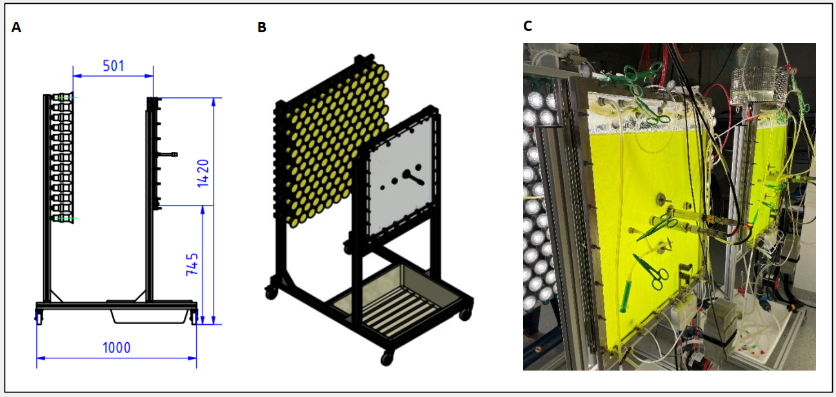
Figure S1: Flat panel photobioreactor. A: Schematic side view. B: Schematic overview. C: Photobioreactor in operation.
Figure S2: LED emission spectrum at a light intensity of PAR = 250 µmol photons m⁻² s⁻¹.

