Engineering Escherichia coli for High-Yielding 2,5-Dimethylpyrazine Synthesis from L-Threonine by Reconstructing Metabolic Pathways and Enhancing Cofactors Regeneration
Figure S1. The agarose gel electrophoresis analysis for PCR products of EcTDH and double enzyme digestion verification of recombinant E. coli BL21(DE3)/pACYCDuet-1-Ectdh.
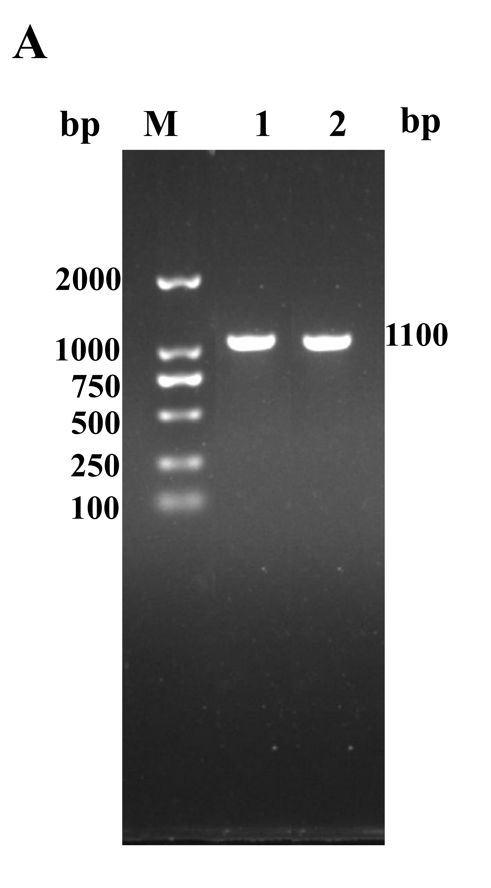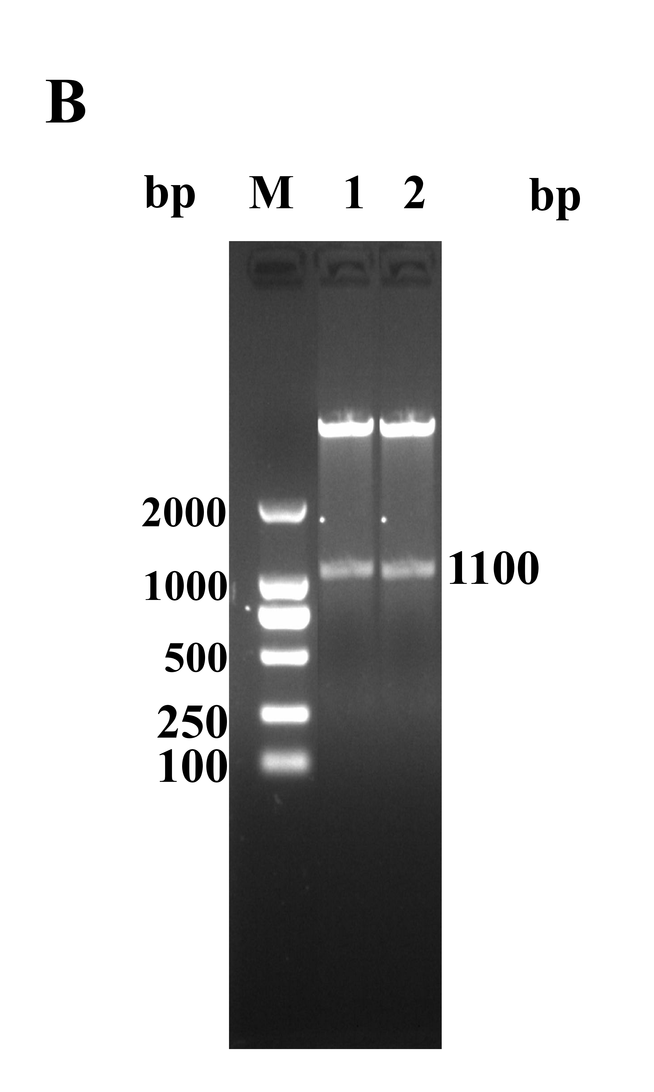
(A) PCR detection. Lane M, DNA marker; lane 1-2, PCR products from different strains of E. coli BL21(DE3)/pACYCDuet-1-Ectdh; (B) Double digestion detection. Lane M, DNA marker; lane 1-2, Double digestion products of E. coli BL21（DE3）/pACYCDuet-1-Ectdh by BamH Ⅰ and Hind Ⅲ.

Figure S2. The agarose gel electrophoresis analysis for PCR products of EhNOX and double enzyme digestion verification of recombinant E. coli BL21(DE3)/pACYCDuet-1-Ectdh-Ehnox
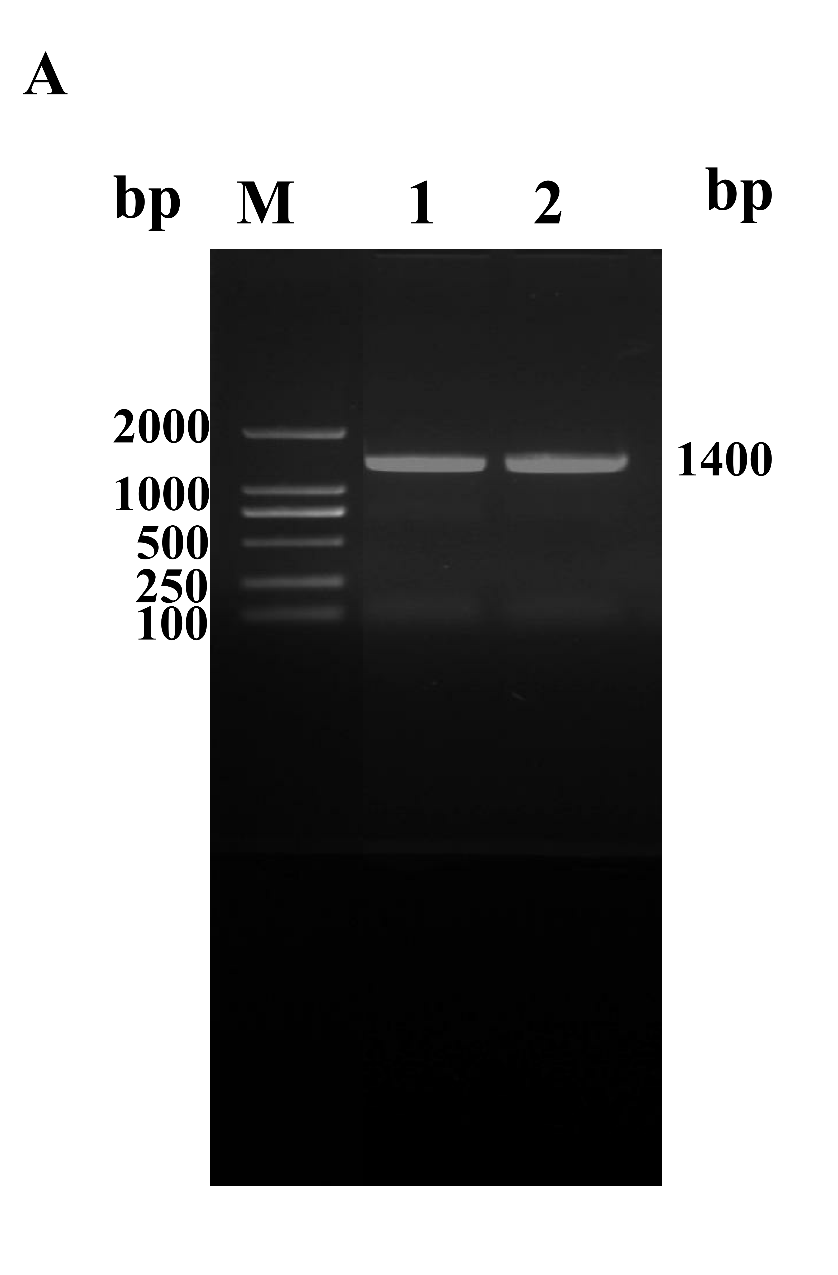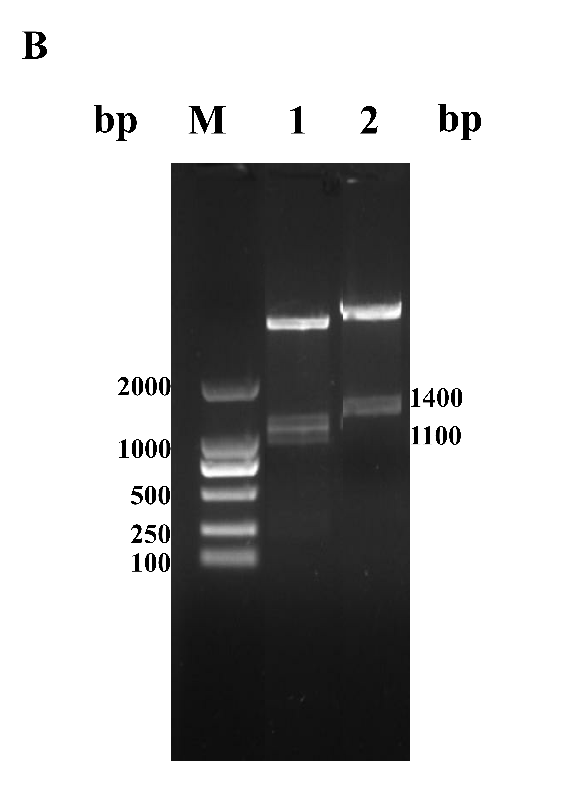
(A) PCR detection. Lane M, DNA marker; lane 1-2, PCR products from different strains of E. coli BL21(DE3)/pACYCDuet-1-Efnox; (B) Double digestion detection. Lane M, DNA marker; lane 1, Double digestion products of E. coli BL21（DE3）/pACYCDuet-1-Ectdh-Efnox by BamH Ⅰ and Hind Ⅲ; lane 2, Double digestion products of E. coli BL21（DE3）/pACYCDuet-1-Ectdh-Efnox by Nde Ⅰ and Xho Ⅰ

Figure S3. Analysis of PCR products of vector pETDuet-1 by agarose gel electrophoresis.
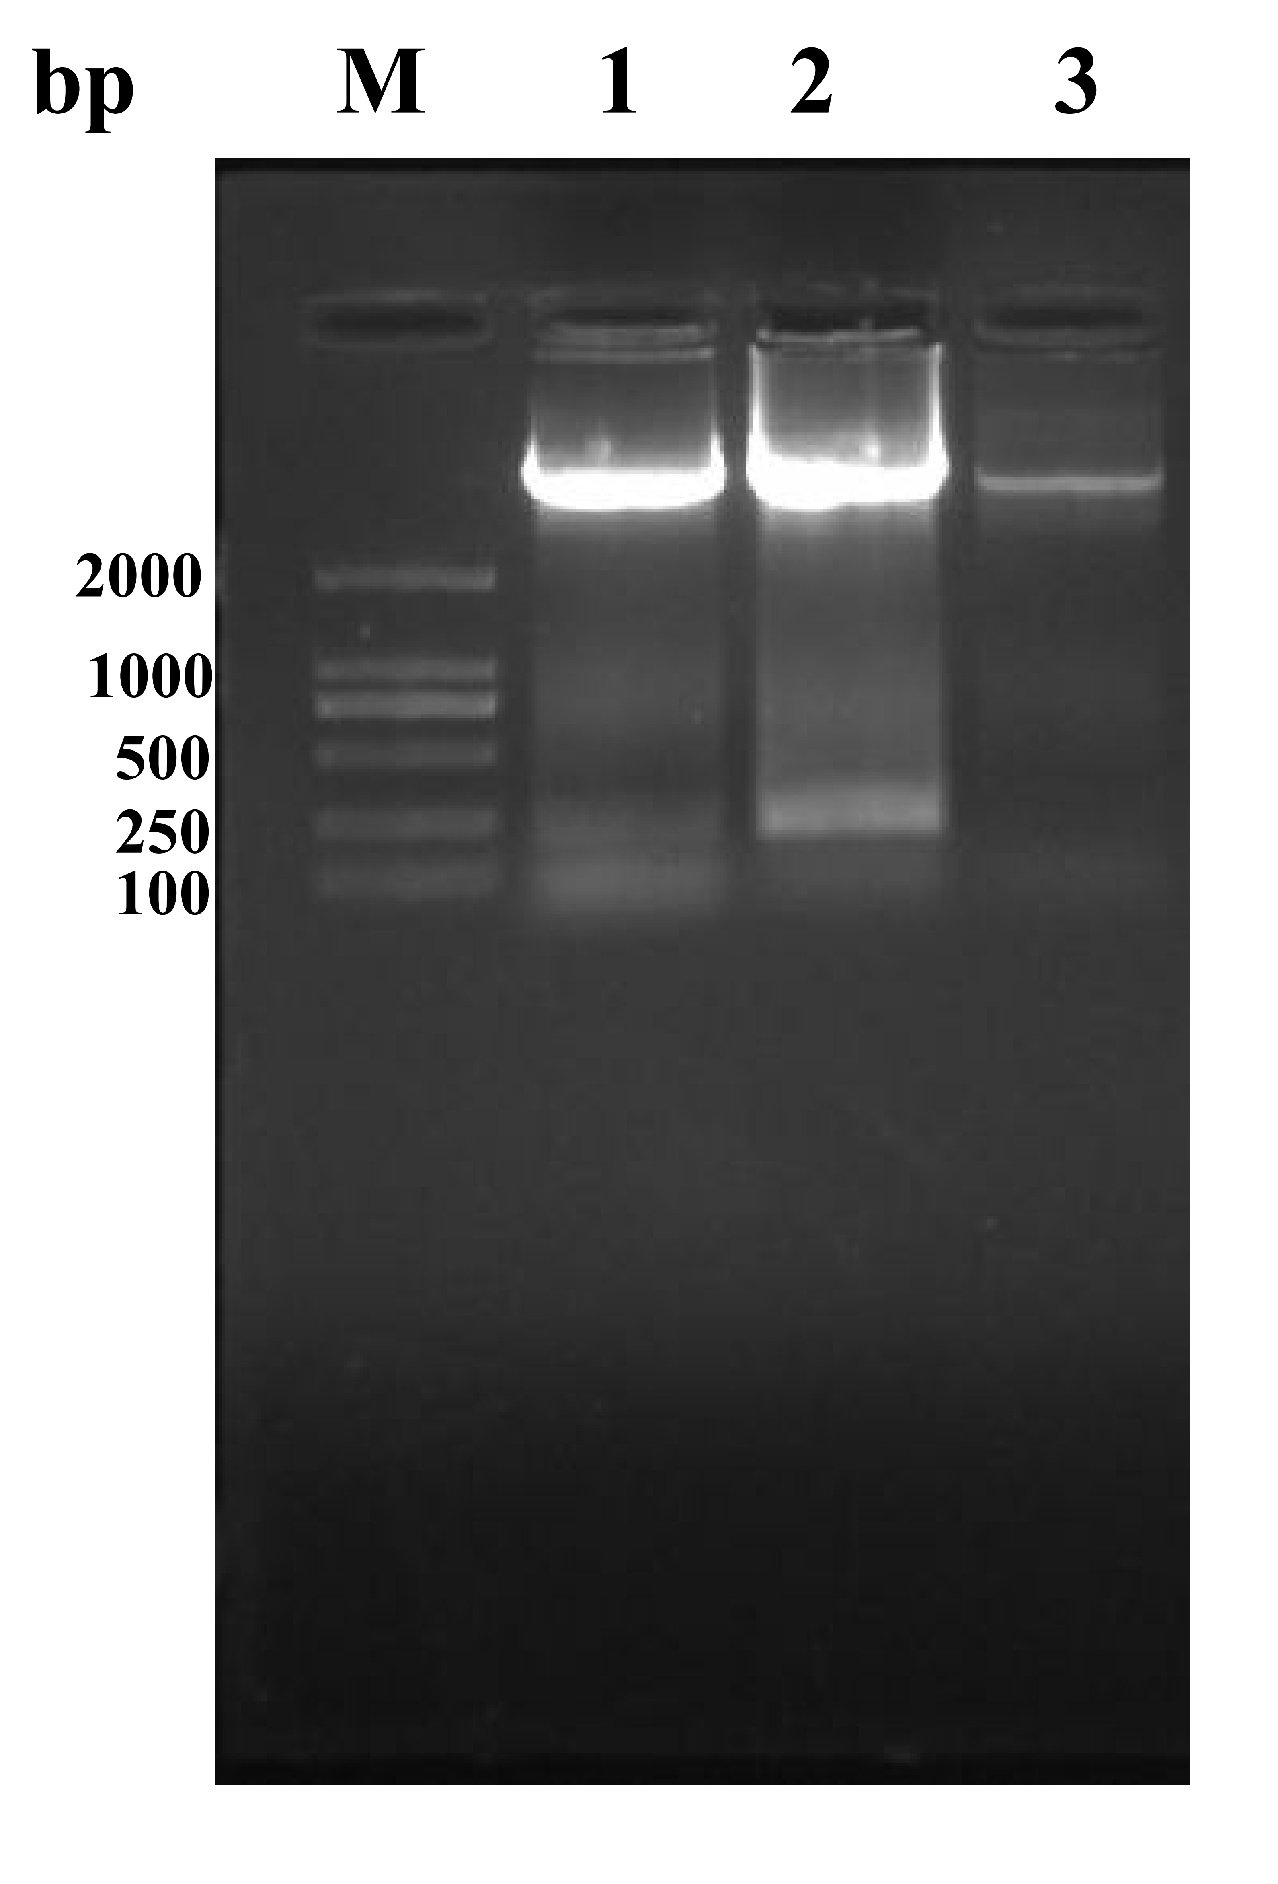
PCR detection. Lane M, DNA marker; lane 1-3, PCR products from linearization product of the vector pETDuet-1.

Figure S4. The agarose gel electrophoresis analysis for PCR products of EcSstT and ScAAO and universal primer validation of recombinant E. coli BL21(DE3)/pETDuet-1-Scaao-Ecsstt
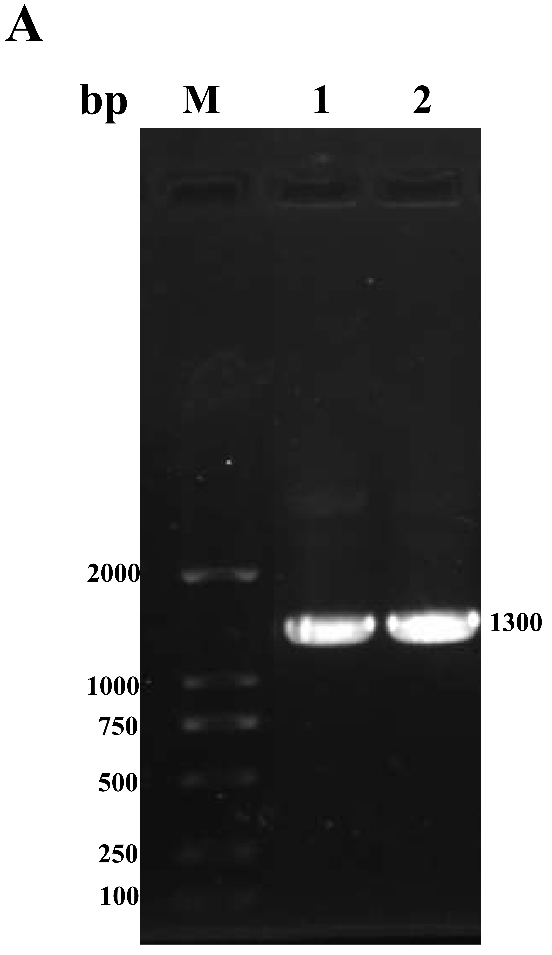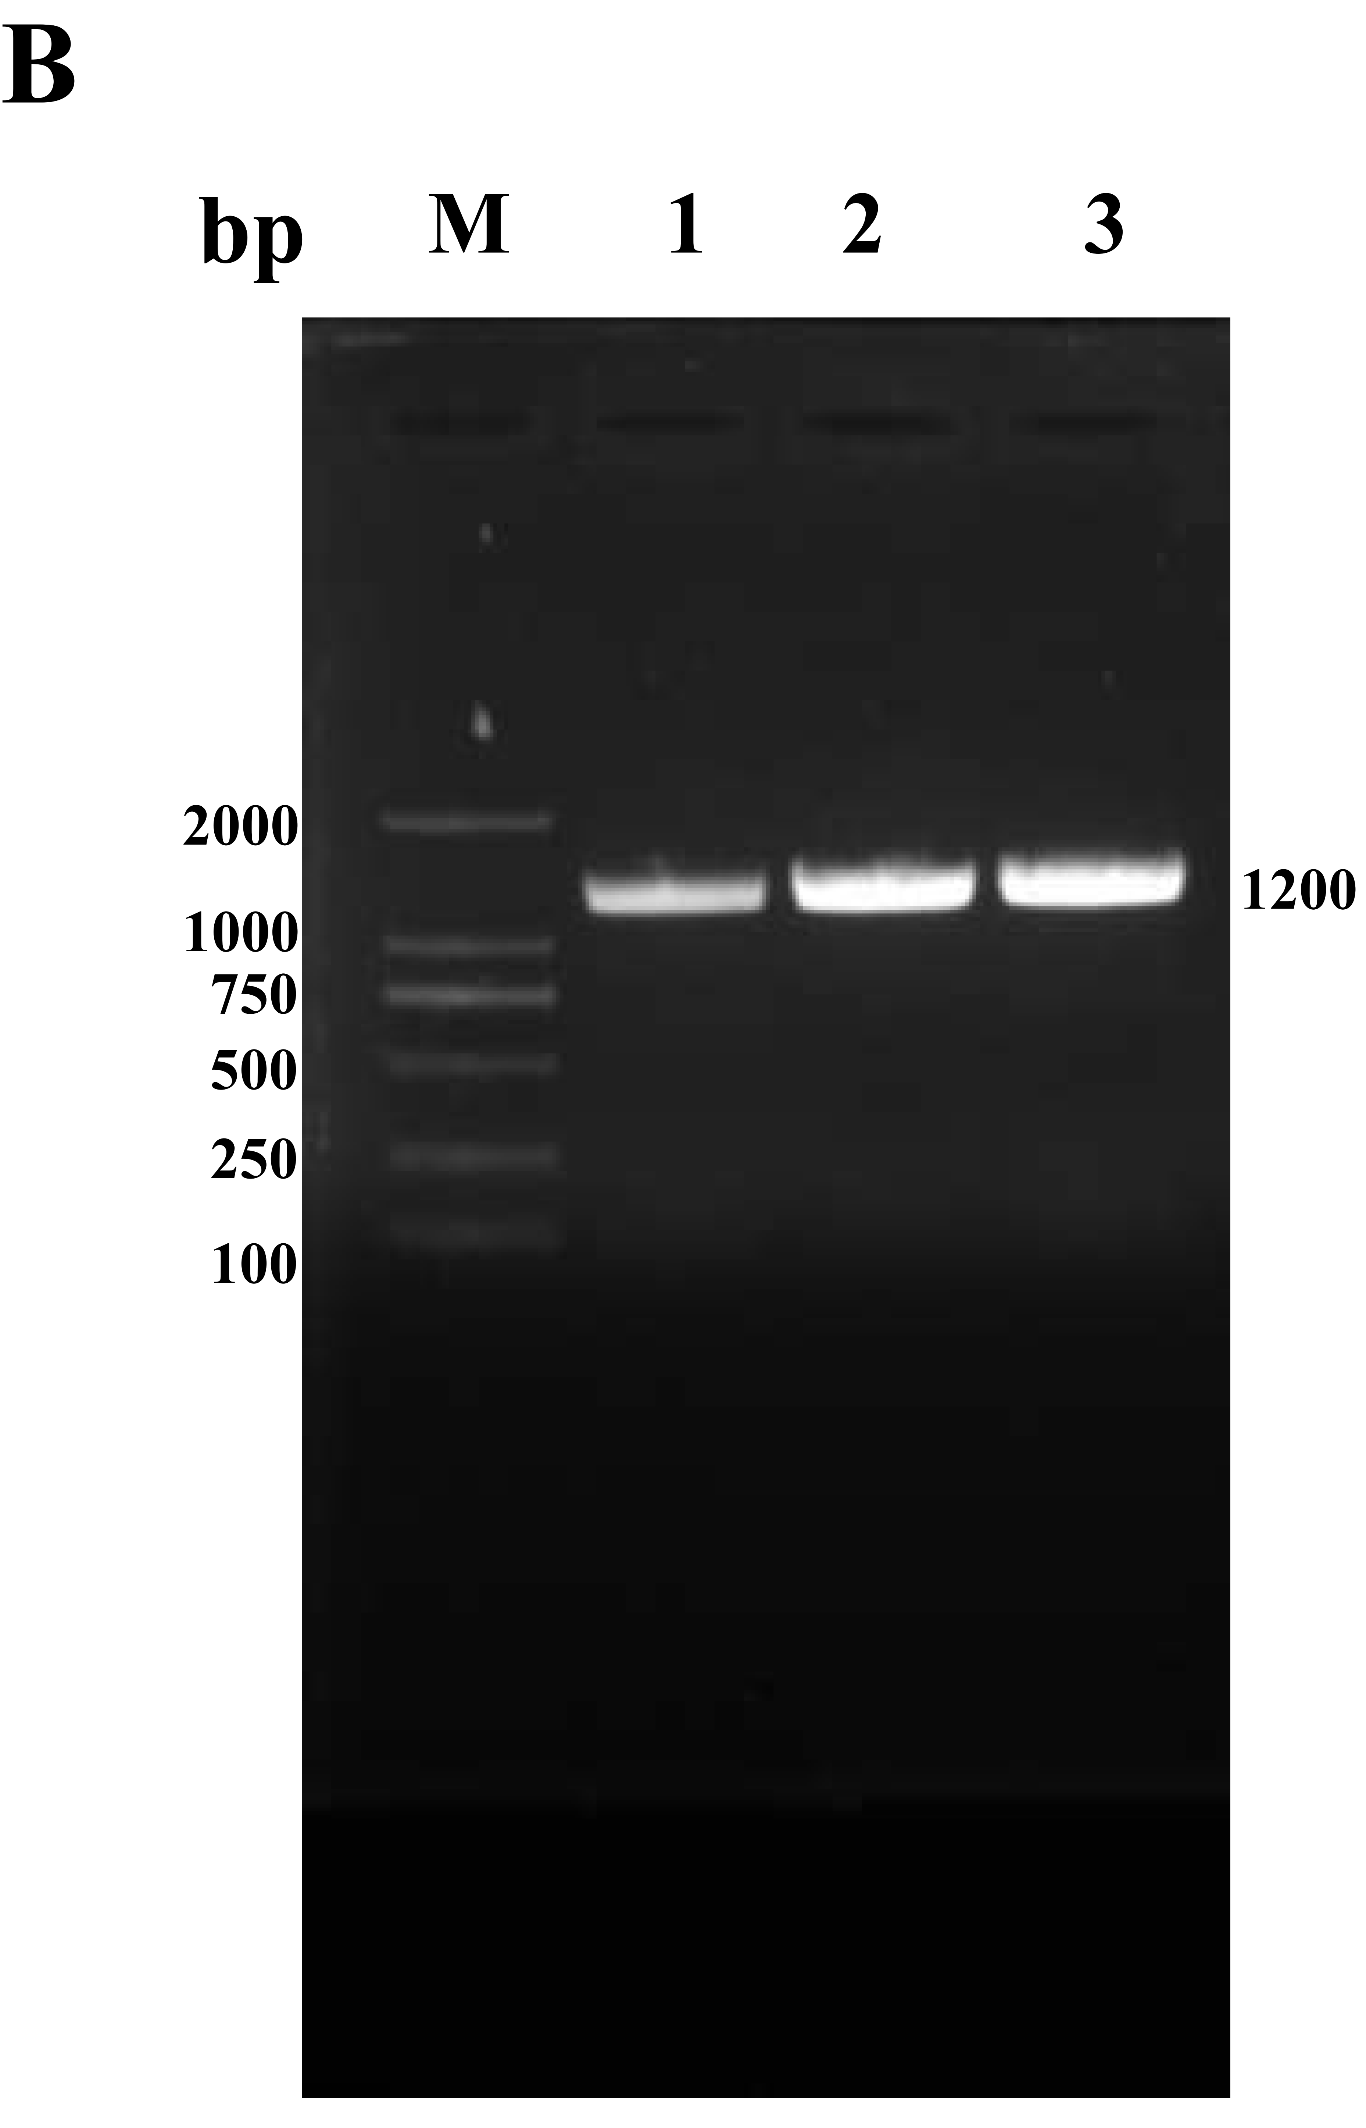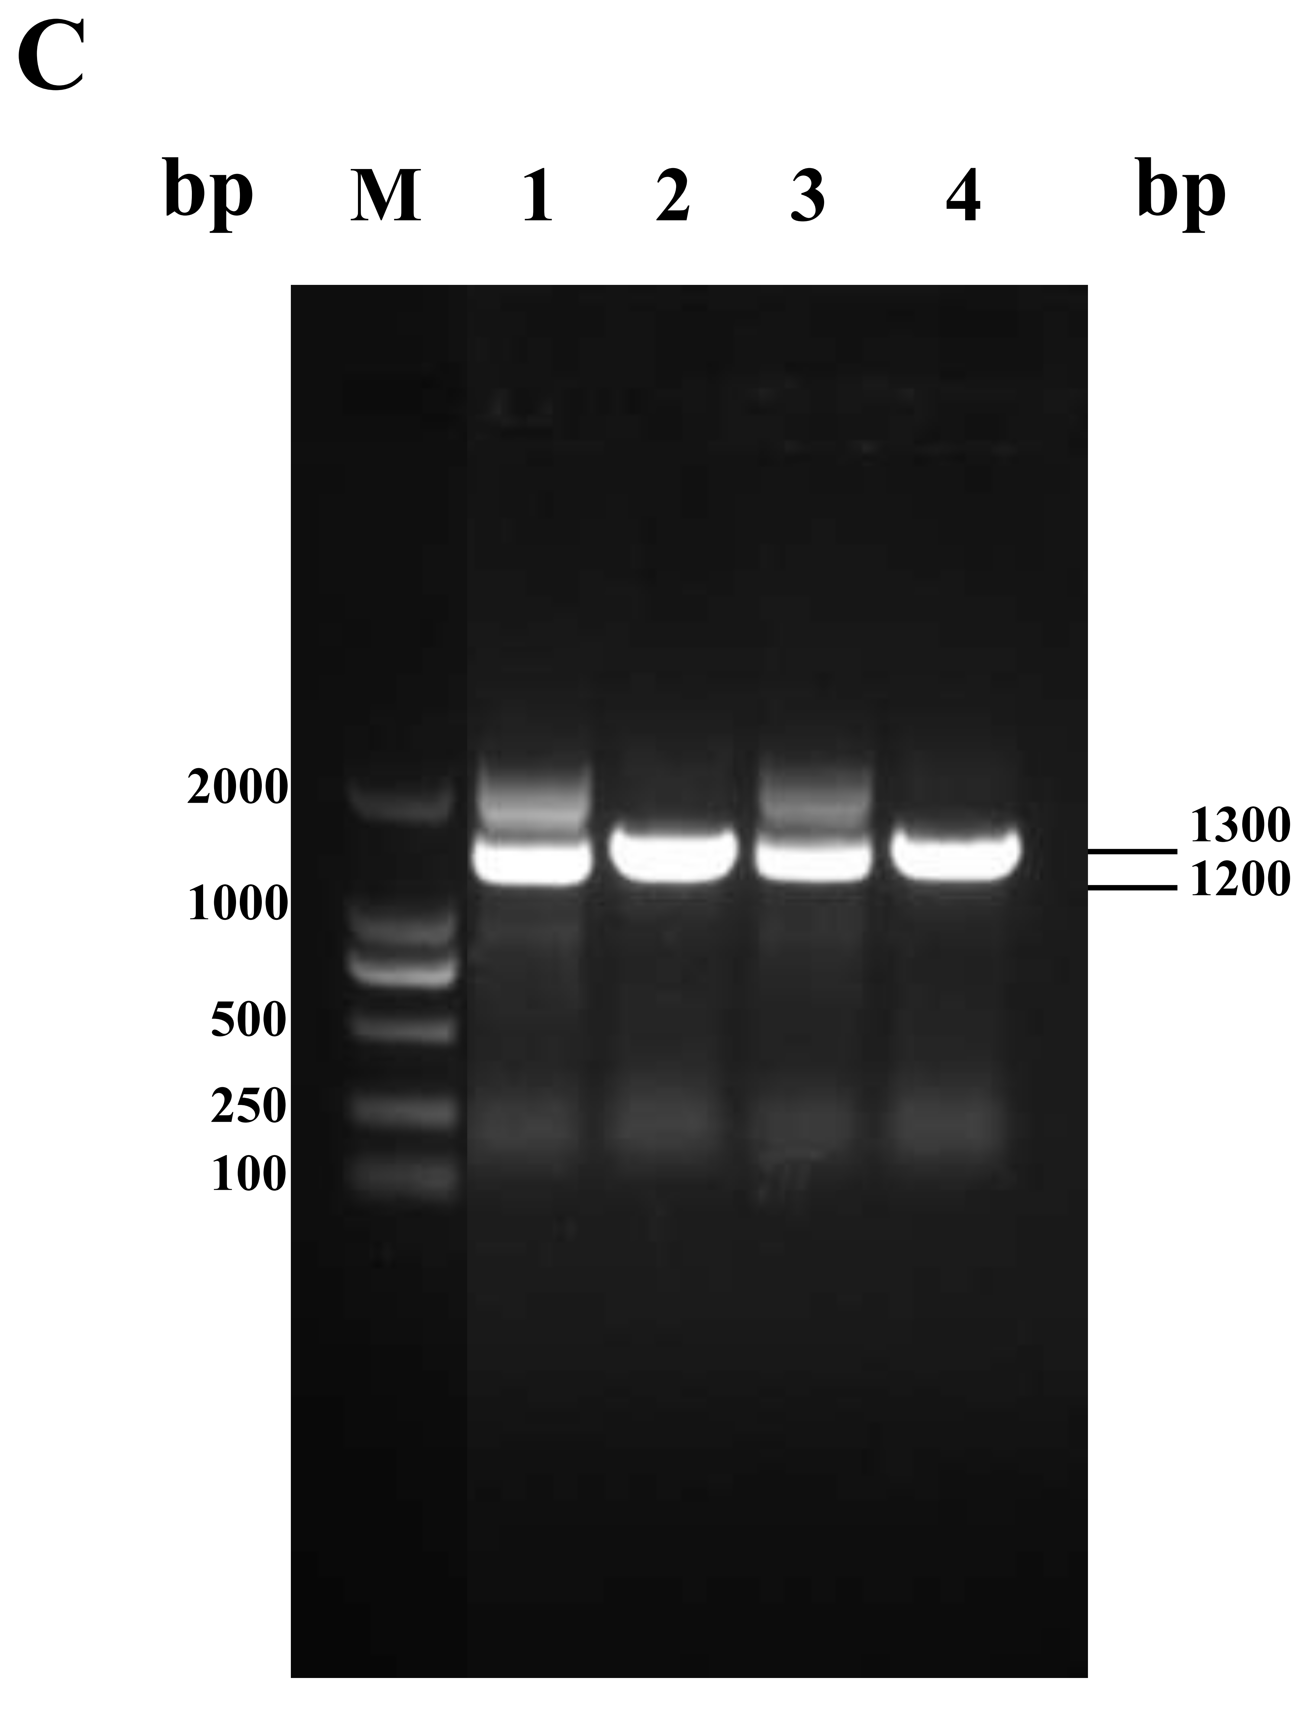
(A) PCR detection. Lane M, DNA marker; lane 1-2, PCR products from different strains of E. coli BL21(DE3)/pETDuet-1-Ecsstt; (B) PCR detection. Lane M, DNA marker; lane 1-3, PCR products from different strains of E. coli BL21(DE3)/pETDuet-1-Scaao;
(C) Universal primer validation EcSstT and ScAAO. Lane M, DNA marker; lane 1 and 3, Universal primer DuetUP₂ and T₇ Terminator validation; lane 2 and 4, Universal primer upstream primer and DuetDOWN₁ validation.

Figure S5. The universal primer validation of recombinant E. coli BL21(DE3)/pACYCDuet-1-Ectdh-Ehnox: pETDuet-1-Scaao-Ecsstt
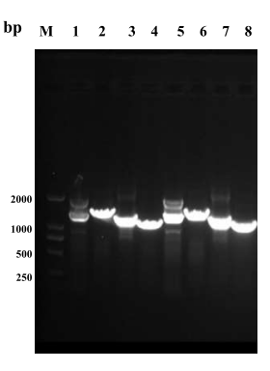
Universal primer validation EcTDH、EhNOX、EcSstT and ScAAO. Lane M, DNA marker; lane 1 and 5, pETDuet-1: Universal primer DuetUP₂ and T₇ Terminator validation; lane 2 and 6, pETDuet-1: Universal primer upstream primer and DuetDOWN₁ validation; lane 3 and 7, pACYCDuet-1: Universal primer DuetUP₂ and T₇ Terminator validation; lane 4 and 8, pACYCDuet-1: Universal primer ACYCDuetUP₁ and DuetDOWN₁ validation.

Figure S6. Correlation analysis of 2,5-DMP with peak area. Prepare 9.1 mM 2,5-DMP stock solution and dilute it to standard solutions of 1.82 mM, 2.27 mM, 3.03 mM, 4.55 mM and 9.10 mM respectively as standard koji of immobilized enzyme. The abscissa is the 2,5-DMP standard concentration, and the ordinate is the peak area.
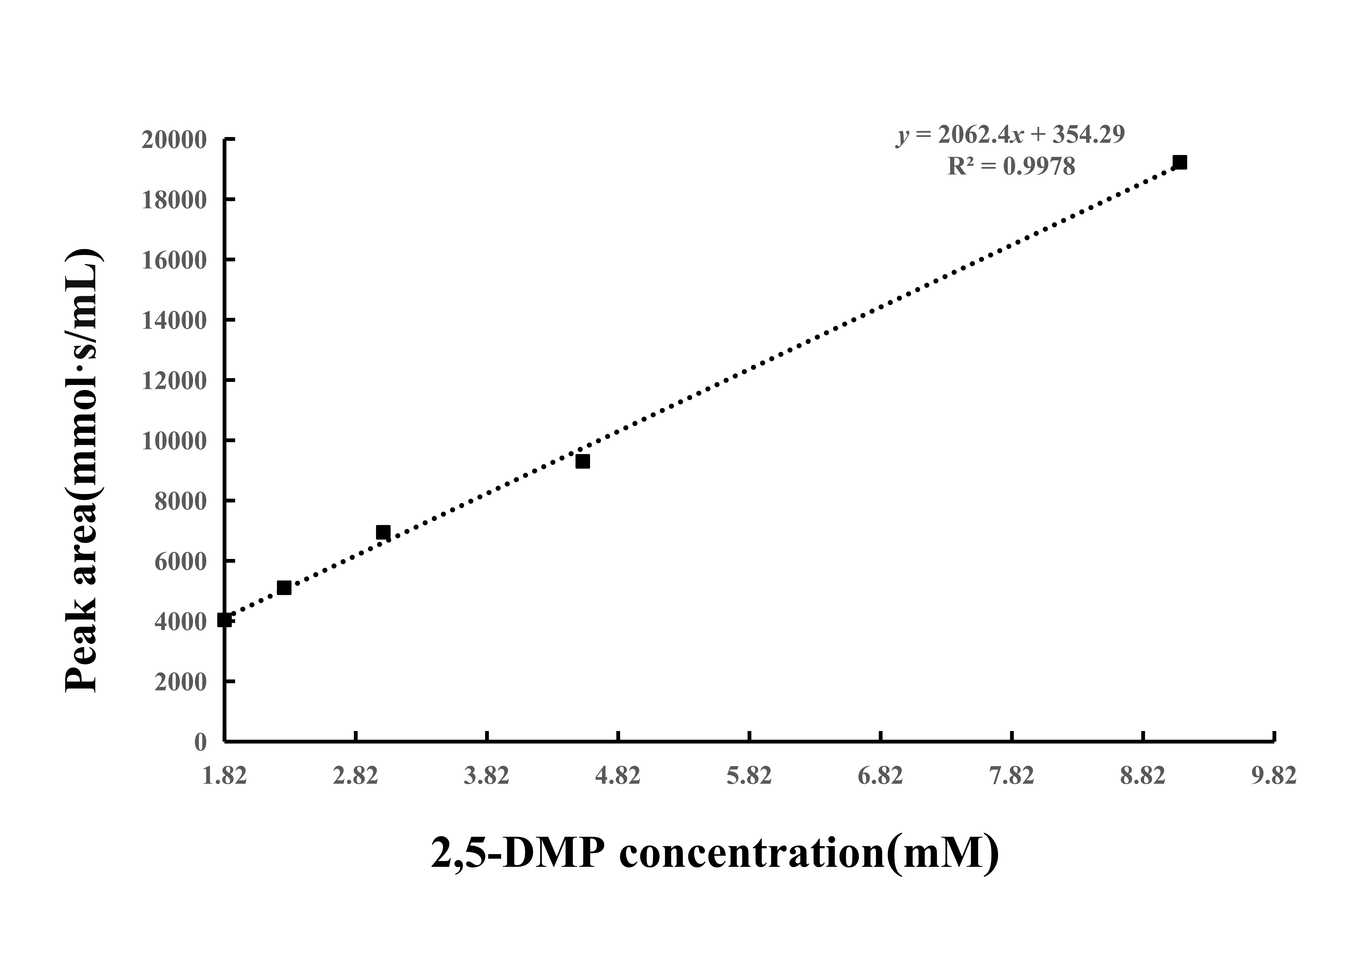

Figure S7A. HPLC analysis of substrate L- threonine standard and product 2,5-DMP. (A)Retention time of L-threonine standard in HPLC.
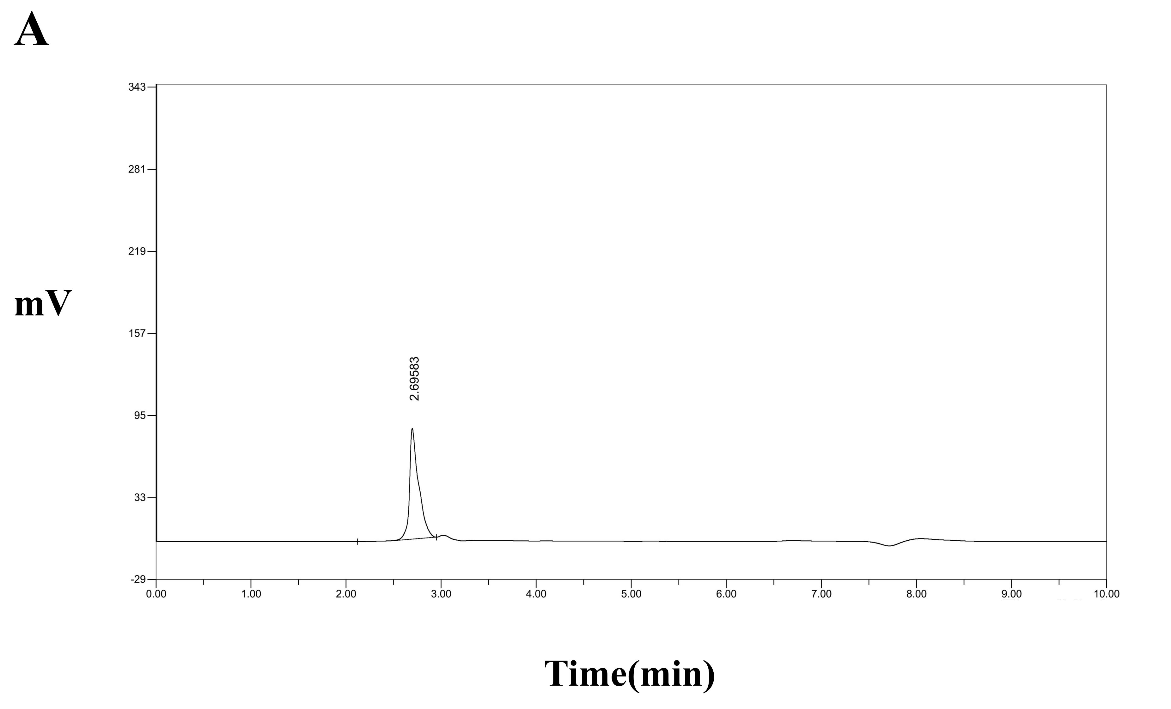

Figure S7B. HPLC analysis of substrate L- threonine standard and product 2,5-DMP. (B) Retention time of 2,5-DMP standard in HPLC.
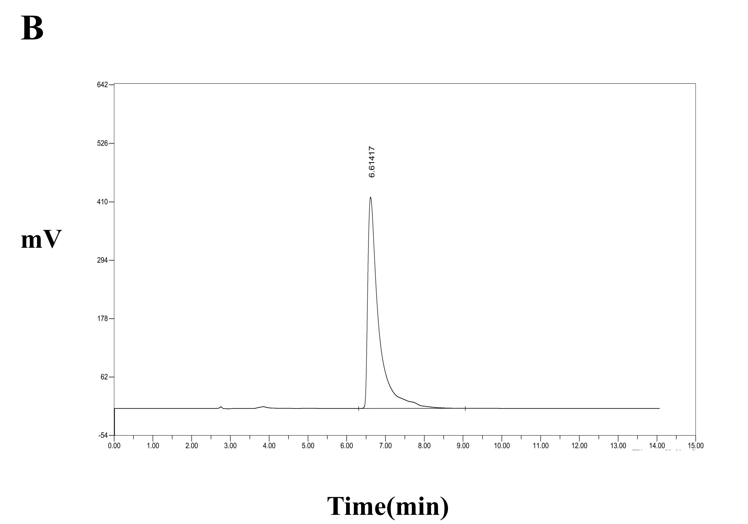

Figure S8. HPLC analysis catalytic products.
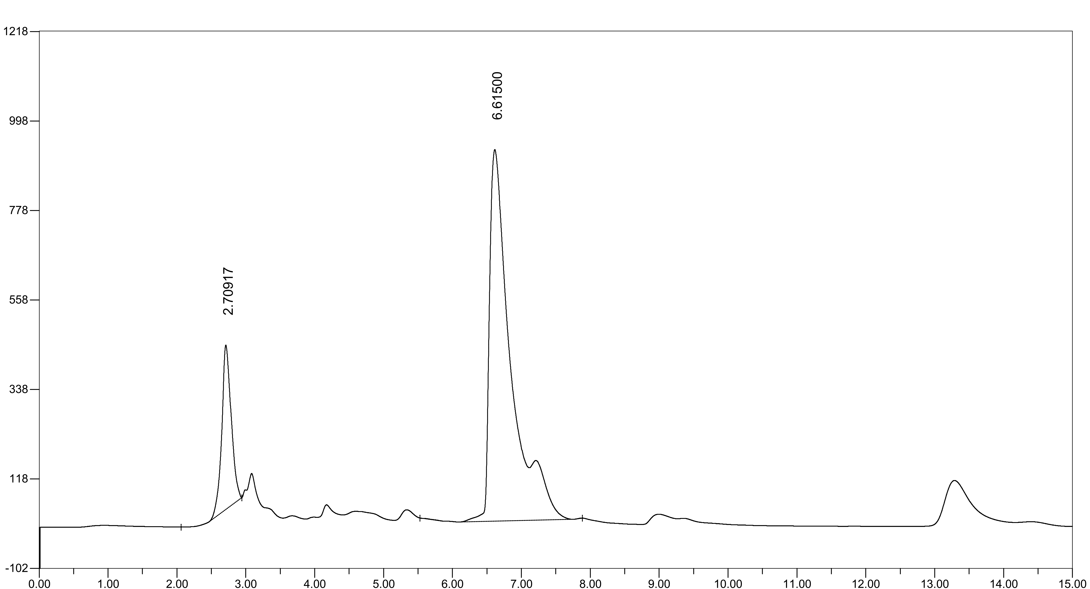
mV
Time(min)

Figure S9A. NMR and MS plots of products in fermentation broths.
(A) NMR analysis of products in fermentation broths.
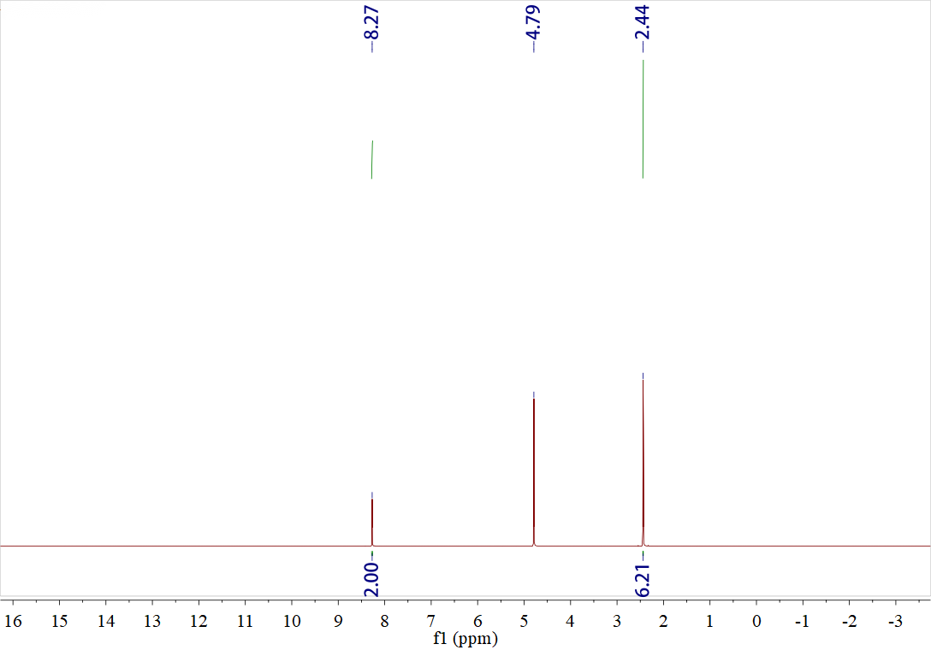
¹H NMR (600 MHz, D₂O) δ : 8.27（s, 2H）,2.44(s, 6H)

Figure S9B. NMR and MS plots of products in fermentation broths.
(B) MS analysis of products in fermentation broths.
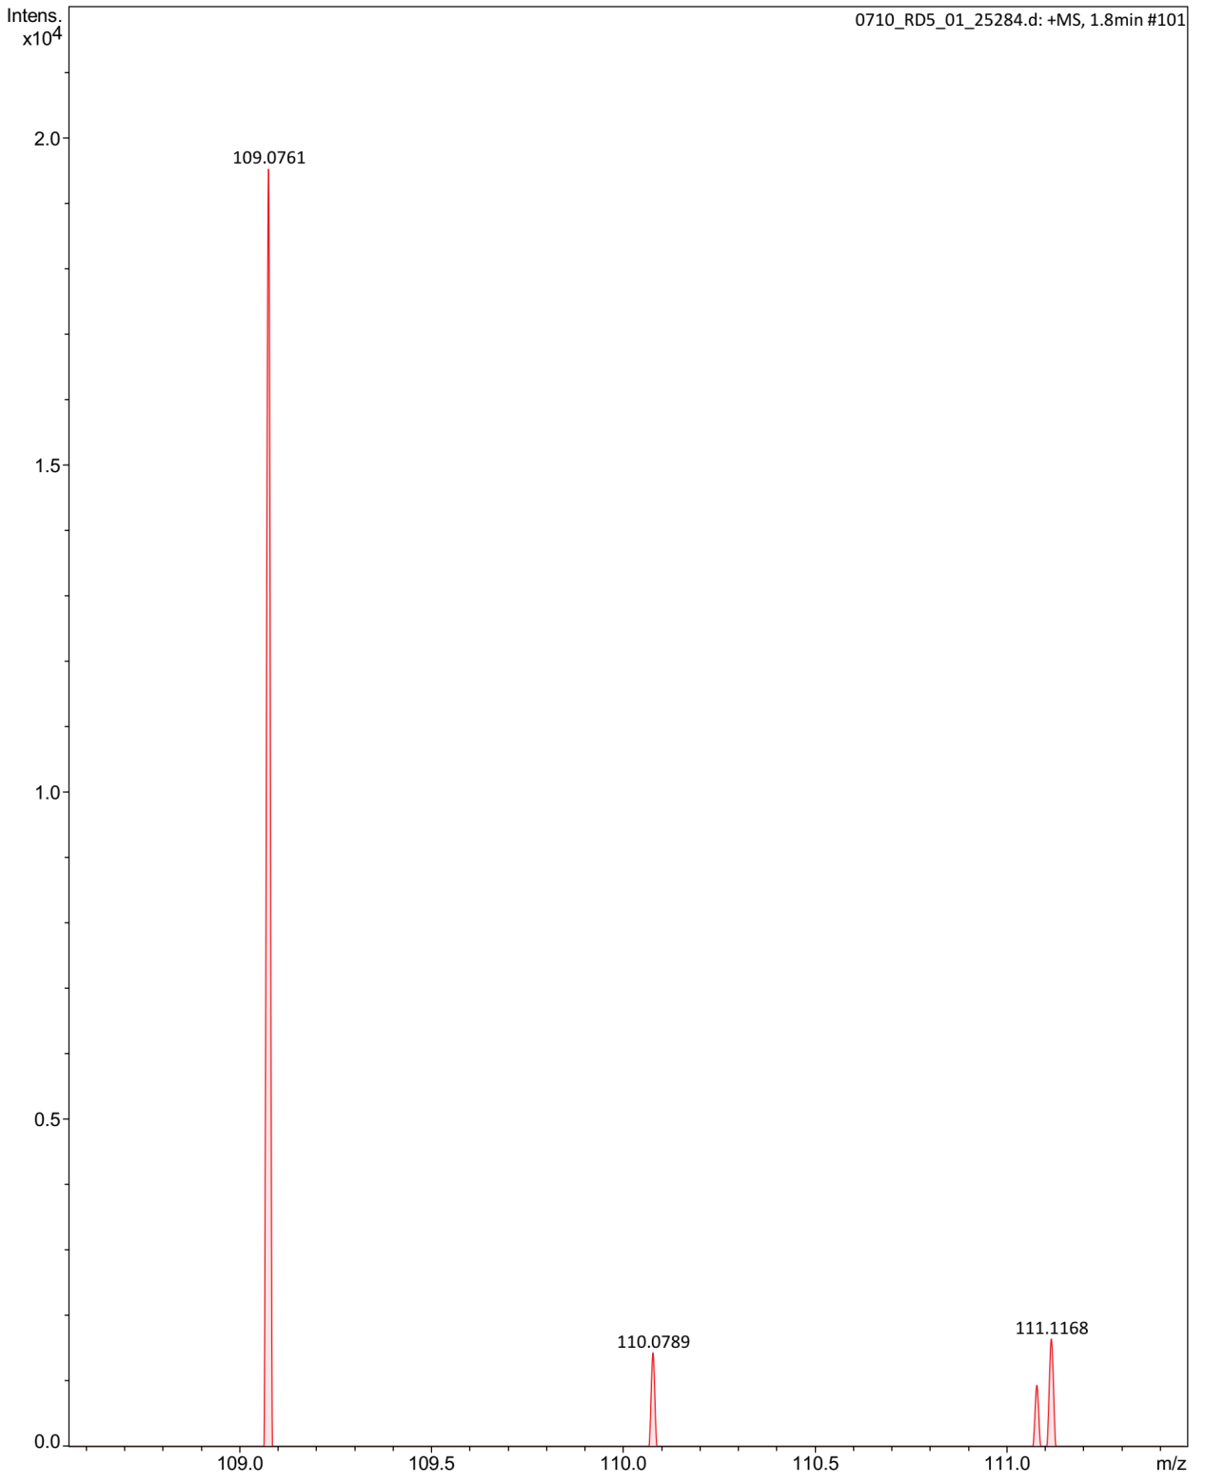
+ESI-HRMS: Calcd for C₆H₈N₂ [M+H]⁺ 109.0760, found: 109.0761.

Figure S10A. NMR and MS plots of substrates in fermentation broths.
(A) NMR analysis of substrates in fermentation broths.
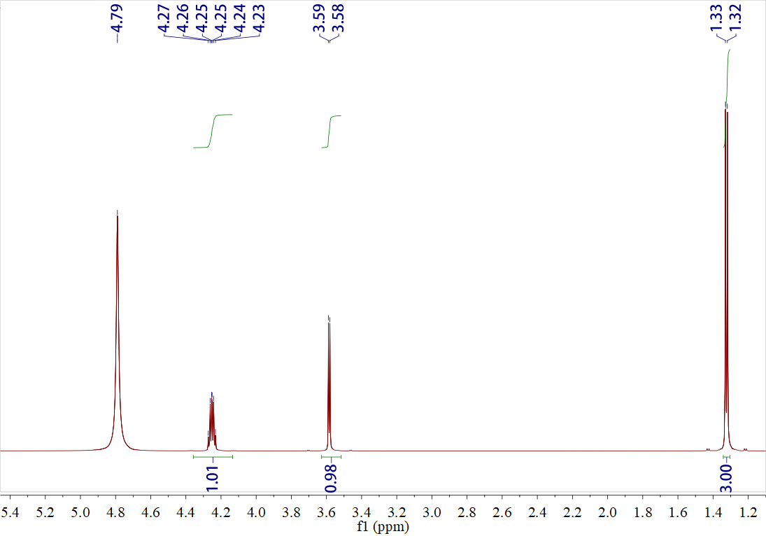
¹H NMR (600 MHz, D₂O) δ : 4.27-4.23 (td, 1H)，3.59-3.58（d, 1H）,1.33-1.32(d, 3H)

Figure S10B. NMR and MS plots of substrates in fermentation broths.
(B) MS analysis of substrates in fermentation broths.
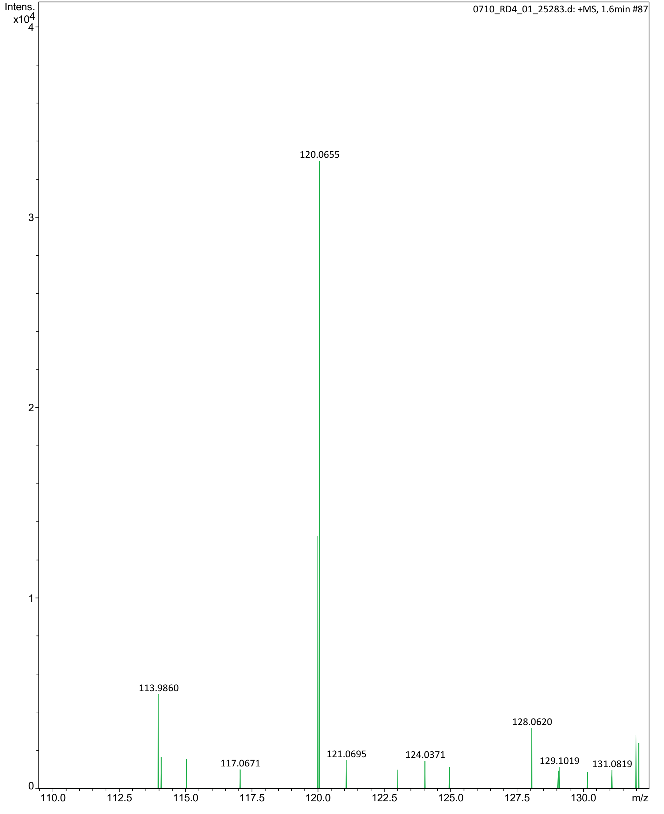
+ESI-HRMS: Calcd for C₄H₉NO₃ [M+H]⁺120.0661, found: 120.0655.

Figure S11. The results in Figure 4 were analyzed for significance of differences.

Figure S12. The results in Figure 5 were analyzed for significance of differences.

Figure S13. The results in Figure 6 were analyzed for significance of differences.

Figure S14. The results in Figure 7 were analyzed for significance of differences.

Table S1. Strains and plasmids used in this study.
Strains and plasmids | features | source
Strains
E. coli BL21(DE3) | Clone hosts and expression hosts | This laboratory preserves
Enterococcus hirae | Clone the host | This laboratory preserves
Streptococcus cristatus | Clone the host | This laboratory preserves
E. coli BL21/pACYCDuet-1 | The E. coli BL21 strain carries the plasmid pACYCDuet-1 | This study builds
E. coli BL21/pACYCDuet-1-Ectdh | The E. coli BL21 strain carries the plasmid pACYCDuet-1-Ectdh, an exogenous expression of EcTDH | This study builds
E. coli BL21/pACYCDuet-1-Ectdh-Ehnox | The E. coli BL21 strain carries exogenous co-expression of the plasmid pACYCDuet-1-Ectdh-Ehnox, Co-expression of EhNOX and EcTDH | This study builds
E. coli BL21/pETDuet-1 | The E. coli BL21 strain carries the plasmid pETDuet-1 | This study builds
E. coli BL21/pETDuet-1-Scaao-Ecsstt | The E. coli BL21 strain carries exogenous co-expression of the plasmid pETDuet-1-Scaao-Ecsstt, Co-expression of EcSstT and ScAAO | This study builds
E. coli BL21/pACYCDuet-1-Ectdh-Ehnox: pETDuet-1-Scaao-Ecsstt | The E. coli BL21 strain carries exogenous co-expression of the double plasmid pACYCDuet-1-Ectdh-Ehnox and pETDuet-1-Scaao-Ecsstt, Co-expression of EcTDH、EhNOX、EcSstT and ScAAO | This study builds
plasmid
pACYCDuet-1 | E. coli expression vectors | This study builds
pACYCDuet-1-Ectdh | Exogenously expressed recombinant plasmid of TDH derived from E. coli BL21, plasmid pACYCDuet-1 carries the EcTDH gene (Cm^{r}) derived from E. coli BL21 | This study builds
pACYCDuet-1-Ectdh-Ehnox | Exogenous co-expression recombinant plasmids derived from TDH from E. coli BL21 and NOX from Enterococcus hirae, plasmid pACYCDuet-1 carries the EcTDH gene derived from E. coli BL21 and the EhNOX gene (Cm^{r}) derived from Enterococcus hirae | This study builds
pETDuet-1 | E. coli expression vectors | This study builds
pETDuet-1-Scaao-Ecsstt | Exogenous co-expression recombinant plasmids derived from SstT from E. coli BL21 and AAO from Streptococcus cristatus, plasmid pETDuet-1 carries the EcSstT gene derived from E. coli BL21 and the ScAAO gene (Amp^{r}) derived from Streptococcus cristatus | This study builds
pACYCDuet-1-Ectdh-Ehnox: pETDuet-1-Scaao-Ecsstt | Exogenous co-expression recombinant plasmids derived from TDH and SstT from E. coli BL21 and NOX from Enterococcus hirae and AAO from Streptococcus cristatus, plasmid pACYCDuet-1 carries the EcTDH gene derived from E. coli BL21 and the EhNOX gene (Cm^{r}) derived from Enterococcus hirae and plasmid pETDuet-1 carries the EcSstT gene derived from E. coli BL21 and the ScAAO gene (Amp^{r}) derived from Streptococcus cristatus | This study builds

Table S2. Primers used in this study.
Primer name | Primer sequences（5’→3’） | description
Ectdh-F | CGCGGATCCGATGAAAGCGTTATCCAAACTG | Amplification of the gene fragment EcTDH for the construction of the plasmid pACYCDuet-1-Ectdh
Ectdh-R | CCCAAGCTTTTAATCCCAGCTCAGAATAAC
Ehnox-F | GGAATTCCATATGAAAGTAGTAGTAATTGGT | Amplification of the gene fragment EhNOX for the construction of the plasmid pACYCDuet-1-Ectdh-Ehnox
Ehnox-R | CCGCTCGAGTTATTGTTTTGTTTCCATTTC
pETDuet-1-F₁ | GTGGTGATGATGGTGATGGCTG | The vector pETDuet-1 is linearized and contains a homologous arm of the EcSstT gene
pETDuet-1-R₁ | AGCCAGGATCCGAATTCGAGCT
pETDuet-1-F₂ | CATATGTATATCTCCTTCTTATACTTAAC | The vector pETDuet-1 is linearized and contains a homologous arm of the ScAAO gene
pETDuet-1-R₂ | AGCCTGCACTATGATTAGGCAGATCTCAATTGGATATCG
Ecsstt-F | CATCACCATCATCACCACATGACTACGCAACGTTCACCG | Amplification of the gene fragment EcSstT for the construction of the plasmid pETDuet-1-Ecsstt
Ecsstt-R | CGAATTCGGATCCTGGCTTTAATTACGCAGGGCGCTATT
Scaao-F | GAAGGAGATATACATATGATGAATCACTTTGATACAATT | Amplification of the gene fragment ScAAO for the construction of the plasmid pETDuet-1-Scaao-Ecsstt
Scaao-R | CTAATCATAGTGCAGGCTGCC

Table S3. HPLC gradient elution of the product 2,5-DMP.

Number | Time（min） | Mobile phase A（%） | Mobile phase B（%）
1 | 0.00 | 69 | 31
2 | 3.00 | 31 | 69
3 | 3.01 | 69 | 31
4 | 10.00 | 69 | 31

