Efficient production of itaconic acid from the single carbon substrate methanol with engineered Komagataella phaffii
Manja Mølgaard Severinsen¹, Simone Bachleitner¹, Viola Modenese^{1,3}, Özge Ata^{1,2}, Diethard Mattanovich^{1,2}
¹ BOKU University, Vienna, Department of Biotechnology, Institute of Microbiology and Microbial Biotechnology, 1190 Vienna, Austria
² Austrian Centre of Industrial Biotechnology, Vienna, 1190, Austria
³ Department of Food, Environmental and Nutritional Sciences, University of Milan, Milan, Italy
* Corresponding author: diethard.mattanovich@boku.ac.at

Table S1. Primer names and sequences.
Name | Sequence | Comments
Primers used for diagnostic verification of generated strains
dia_GUT1_check_fwd | GATTCCAAACTGCAGGAACGCAG | Primers bind outside the GUT1 locus and are used for verification of GUT1 insertions.
dia_GUT1_check_rev | GAGGAGTCGGCAAAGTACCC
dia_RGI_check_fwd | ATCAAACTTTTTGAATGGA | Primers bind outside the RGI2 locus and are used for verification of RGI2-directed inserts.
dia_RGI_check_rev | CTATAAGAAACTGGAGACT
BB2_check_fwd | CTGCGTTATCCCCTGATTCT | Primers used to verify integration of transcription unit in BB2 plasmids.
BB2_check_rev | GGGTGAGCAAAAACAGGAAG
BB3_check_fwd | TTAGTATGCTGTGCTTGGGTG | Primers used to verify multicopy integration of the heterologous genes. The respective genes were told apart based on size observed via gel electrophoresis.
BB3_check_rev | GAGGTATGTAGGCGGTGCTA
Primers used for RT-qPCR analysis
q_act1_fw | CCTGAGGCTTTGTTCCACCCATCT | Primers used to analyze gene expression via RT-qPCR
q_act1_rv | GGAACATAGTAGTACCACCGGACATAACGA | Primers used to analyze gene expression via RT-qPCR
q_cadA_fw | GGGTCGCGTGAGGATTGAGTTC | Primers used to analyze gene expression via RT-qPCR
q_cadA_rv | CTACCCGCAAGGGTTCGGTAT | Primers used to analyze gene expression via RT-qPCR
q_mttA_fw | GCAACACCTTCAACTGCGTCAA | Primers used to analyze gene expression via RT-qPCR
q_mttA_rv | GACCTTCTCGTAAACGGGGAACAT | Primers used to analyze gene expression via RT-qPCR
q_mfsA_fw | AGTGCGTCATCACCTTCGTC | Primers used to analyze gene expression via RT-qPCR
q_mfsA_rv | AGGGAGGAGTAGCCCATAGC | Primers used to analyze gene expression via RT-qPCR
Primers used for diagnostic verification of the generated strains, for RT-qPCR analysis and for cDNA synthesis.

Table S2. Process parameters of the respective fed-batch cultivations.
Total cultivation time [h] | MeOH phase time [h] | Strain | Temperature | Initial batch volume [mL] (Bioreactor model) | MeOH flow rate  [g·L⁻¹·h⁻¹] | Feed-medium flow rate [mL·h⁻¹] | Volume [mL] | YDM [g·L⁻¹]
126 | 73 | cadA+mttA | 25 °C | 320 (SR0700ODLS) | 0.028·t+0.6 | 0.225·t+1.95  3.65-0.111·t | 556.7 | 140.2
126 | 73 | cadA+mttA+mfsA_{pGAP} |  |  |  |  | 552.2 | 138.8
65 | 40 | cadA+mttA+mfsA_{pGAP} | 25 °C | 820 (SR1000ODLS) | 3.1 | 10.3 | 1028.5 | 76.1
65 | 40 | cadA+mttA+mfsA_{pGAP} | 30 °C | 820 (SR1000ODLS) | 3.1 | 10.3 | 1053.3 | 66.3
138 | 114 | cadA+mttA+mfsA_{pGAP} | 30 °C | 320 (SR0700ODLS) | 2.0 | 4 | 447.2 | 66.6
138 | 114 | MC I | 30 °C | 320 (SR0700ODLS) | 2.0 | 4 | 476.1 | 62.6
138 | 114 | MCII | 30 °C | 320 (SR0700ODLS) | 1.9 | 4 | 470.7 | 67.0
138 | 114 | MCIII | 30 °C | 320 (SR0700ODLS) | 2.5 | 4 | 449.1 | 48.0
137 | 115 | MC I | 28 °C | 320 (SR0700ODLS) | 1.6 | 4 | 464.5 | 65.8
137 | 115 | MC I | 30 °C | 320 (SR0700ODLS) | 1.8 | 4 | 472.3 | 63.7
137 | 115 | MC I | 32 °C | 320 (SR0700ODLS) | 2.2 | 4 | 451.9 | 65.9
137 | 115 | MC I | 34 °C | 320 (SR0700ODLS) | 1.8 | 4 | 443.2 | 60.6
Total cultivation time [h], duration of MeOH phase [h], strain, temperature, batch volume and reactor model, average MeOH flow rate [g·L⁻¹·h⁻¹], glycerol-feed flow rate [mL·h⁻¹] and final volume [mL], final itaconic acid titer [g·L⁻¹] and yeast dry cell mass (YDM) [g·L⁻¹] are given.

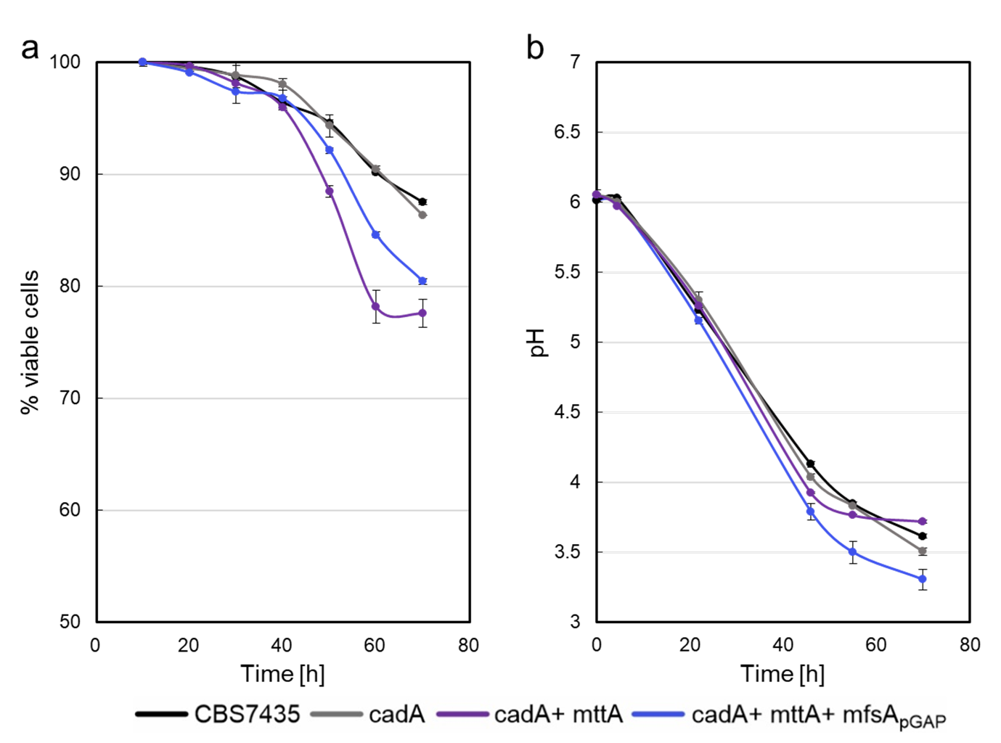
Figure S1. Viability of strains during pH change. During the comparative shake flask cultivation of the K. phaffii strain CBS7435 with the generated strains (cadA, cadA+mttA and cadA+mttA+mfsA_{pGAP} a) viability of the strains was estimated with PI-staining at every sampling point, whilst b) pH was also measured. The strains were cultivated in biological duplicates and averages and standard deviations are shown for both viability and pH.

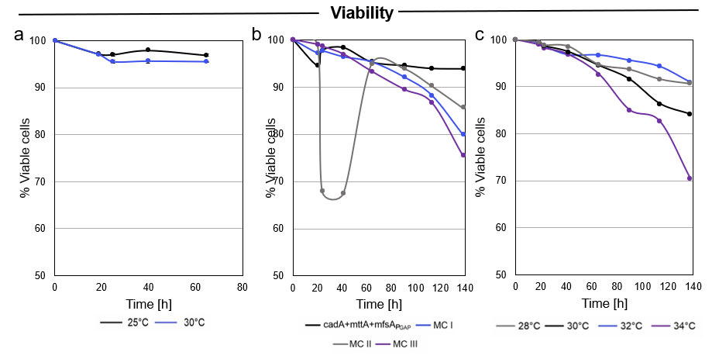
Figure S2. Viability of strains in fed-batch cultivations. a) The viability of the cells remained high during the fed-batch cultivation where an increased cultivation temperature of 30 °C was compared to 25 °C. In b) the viability of the multicopy strains (MC I, MC II and MC III) during the fed-batch cultivation at 30 °C is shown. Whilst the cadA+mttA+mfsA_{pGAP} and the MC I, MC III have a stable decrease in viability over time, the MC II shows a decreased viability (> 67.5 %) at the end of the batch phase. Upon methanol induction, the viability did however recover during the methanol feed phase. In c) the viability of the MC I strain when cultivated at 28, 30, 32 and 34 °C is shown, at 34 °C the greatest drop in viability (70.5 %) over time is experienced.

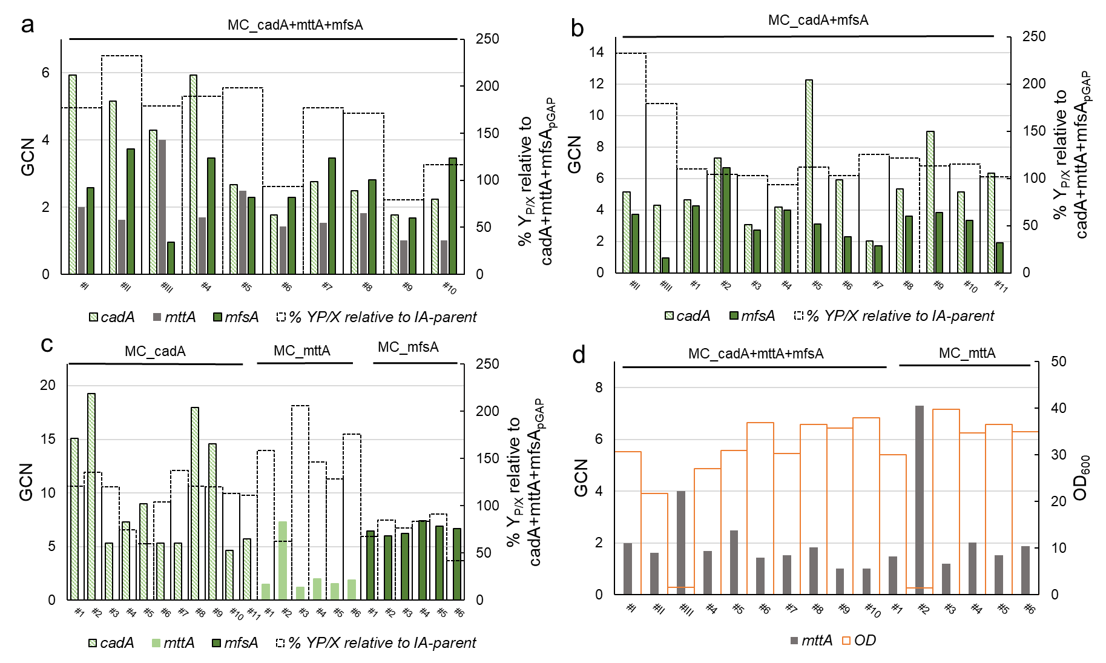
Figure S3. The gene copy numbers (GCN) of the three heterologous genes (cadA, mttA, mfsA) of the generated multicopy strains (MC) was investigated via RT-qPCR relative to the cadA+mttA+mfsA_{pGAP} strain. In a-c) GCN of multicopy strains is shown with the relative yield obtained in the 24-deep-well plate screening in comparison to the cadA+mttA+mfsA_{pGAP} strain. In d) the GCN of mttA in the MC_mttA and MC_cadA+mttA+mfsA is shown with final OD of the 24-deep well plate screening.

Table S3. OD₆₀₀ and itaconic acid obtained from 24-deeep-well plate screening after 48 hours.
Strain | Clone no. | OD₆₀₀ | Itaconic acid [g·L⁻¹]
cadA+mttA+mfsA_{pGAP} |  | 31.4 | 1.5
MC_cadA+mttA+mfsA | #I | 30.8 | 2.8
MC_cadA+mttA+mfsA | #II | 21.8 | 2.6
MC_cadA+mttA+mfsA | #III | 1.6 | 0.1
MC_cadA+mttA+mfsA | #4 | 27.0 | 2.6
MC_cadA+mttA+mfsA | #5 | 31.0 | 3.2
MC_cadA+mttA+mfsA | #6 | 37.0 | 1.8
MC_cadA+mttA+mfsA | #7 | 30.3 | 2.7
MC_cadA+mttA+mfsA | #8 | 36.5 | 3.2
MC_cadA+mttA+mfsA | #9 | 35.8 | 1.5
MC_cadA+mttA+mfsA | #10 | 38.0 | 2.3
MC_cadA+mfsA | #1 | 34.5 | 1.9
MC_cadA+mfsA | #2 | 34.5 | 1.8
MC_cadA+mfsA | #3 | 37.8 | 2.0
MC_cadA+mfsA | #4 | 37.5 | 1.8
MC_cadA+mfsA | #5 | 32.8 | 1.9
MC_cadA+mfsA | #6 | 36.8 | 1.9
MC_cadA+mfsA | #7 | 39.0 | 2.5
MC_cadA+mfsA | #8 | 30.3 | 1.9
MC_cadA+mfsA | #9 | 35.8 | 2.1
MC_cadA+mfsA | #10 | 37.5 | 2.2
MC_cadA+mfsA | #11 | 36.5 | 1.9
MC_cadA | #1 | 30.8 | 1.9
MC_cadA | #2 | 27.0 | 1.9
MC_cadA | #3 | 38.8 | 2.4
MC_cadA | #4 | 24.5 | 0.9
MC_cadA | #5 | 6.2 | 0.2
MC_cadA | #6 | 36.3 | 1.9
MC_cadA | #7 | 32.5 | 2.3
MC_cadA | #8 | 38.8 | 2.4
MC_cadA | #9 | 37.0 | 2.3
MC_cadA | #10 | 36.3 | 2.1
MC_cadA | #11 | 39.8 | 2.3
MC_mttA | #1 | 30.0 | 2.4
MC_mttA | #2 | 1.4 | 0.0
MC_mttA | #3 | 39.8 | 4.2
MC_mttA | #4 | 34.8 | 2.6
MC_mttA | #5 | 36.5 | 2.4
MC_mttA | #6 | 35.0 | 3.2
MC_mfsA | #1 | 36.5 | 1.3
MC_mfsA | #2 | 36.8 | 1.6
MC_mfsA | #3 | 41.5 | 1.6
MC_mfsA | #4 | 42.8 | 1.8
MC_mfsA | #5 | 44.8 | 2.1
MC_mfsA | #6 | 28.5 | 0.6
Strain name and clone number, OD₆₀₀ and itaconic acid titer [g·L⁻¹] measured after 48 hours of cultivation in 24-deep-well plate are given.
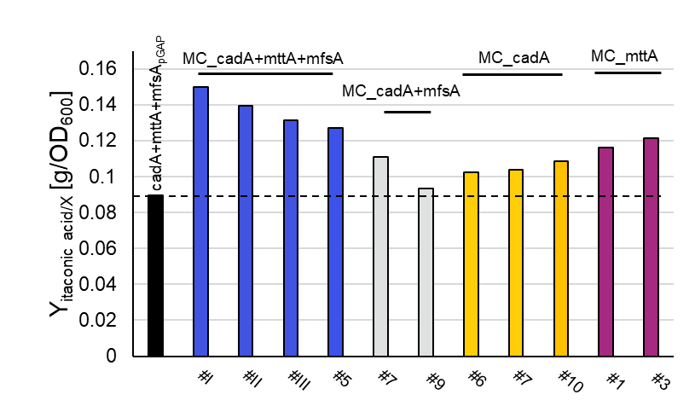
Figure S4. Shake flask screening with multicopy strains. A set of multicopy clones with different genotypes were selected for further investigation in a shake flask screening with the parent strain, cadA+mttA+mfsA_{pGAP}, as reference. The itaconic acid yields per biomass after 70 hours are shown.

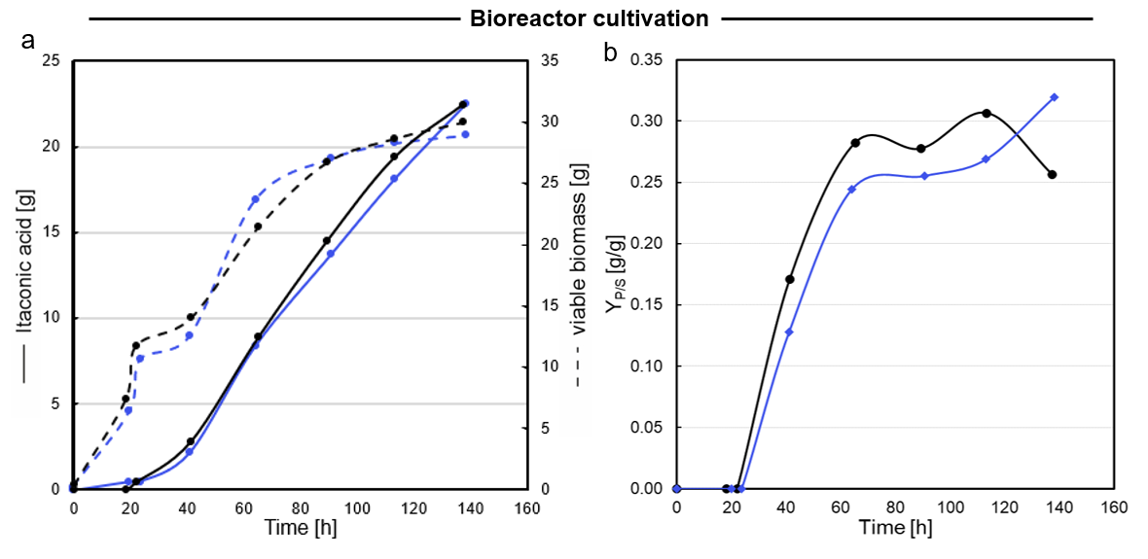
Figure S5. Overlay of fed-batch cultivations performed at 30°C with MC I. In blue is the fed-batch cultivation of MC I cultivated at 30°C displayed in Figure 6, in black is the fed-batch cultivation of MC I cultivated at 30°C displayed in Figure 8. a) Growth and production profiles are shown for the both fed-batch cultivations performed with MC I cultivated at 30°C. b) the yield of itaconic acid per gram of methanol during the fed-batch cultivation.

