Appendix
Table S1: Used organisms and strains with their relevant genotype and plasmids combined with the used primers and restriction enzymes to produce them.
Organism / Strain  specific strain Number | Relevant Genotype | Plasmid |  | Restriction enzyme | Primer | Sequence [5’-3’] | Source
E. coli WM 3064  JG 98 | thrB1004 pro thi rpsL hsdS lacZ ΔM15RP4–1360 Δ(araBAD)567 ΔdapA1341::[erm pir(wt)] |  |  |  |  |  | W. Metcalf, University of Illinois
C. necator H16  JG 1070 |  |  |  |  |  |  | DSM 428
C. necator H16 del  JG 1232 | ∆acoABC ∆phaC1 ∆phaC2 |  |  |  |  |  | Windhorst & Gescher 2019
pKR_alsSD  JG 1233 | ∆acoABC ∆phaC1 ∆phaC2 | pKR_{phb}_alsSD | tc^{R}, P_{phb}, RSF1010 mob and origin of replication, par, alsSD (codon optimized*) |  |  |  | Windhorst & Gescher 2019
pKR_budC (K. pneumoniae)  JG 1304 | ∆acoABC ∆phaC1 ∆phaC2 | pKR_{phb}_alsSD _budC | tc^{R}, P_{phb}, RSF1010 mob and origin of replication, par, alsSD, budC (codon optimized*) |  |  |  | This work
 |  |  |  | HindIII, AP |  |  | New England Biolabs (NEB; Frankfurt, Germany)
 |  |  |  |  | for: 3292 | ATCGAAACCACCGAAGGCT | This work
 |  |  |  |  | rev: 3293 | TAACTGTGATAAACTACCGCA | This work
 |  | pBBR1MCS-2 | km^{R}, P_{lac}, oriV, mob, lacZα |  |  |  | Kovach et al. 1995
pBBR1_alsSD  JG 1884 | ∆acoABC ∆phaC1 ∆phaC2 | pBBR1_{phb}_alsSD | km^{R}, P_{phb}, oriV, mob, lacZα, alsSD (codon optimized*) |  |  |  | This work
 |  |  | km^{R}, P_{phb}, oriV, mob, lacZα, alsSD (codon optimized*) | XbaI, BamHI |  |  | NEB
 |  |  | km^{R}, P_{phb}, oriV, mob, lacZα, alsSD (codon optimized*) |  | for: 3464 | aattggagctccaccgcggtggcggccgctGTGTGGGGCCGCACCTAT | This work
 |  |  | km^{R}, P_{phb}, oriV, mob, lacZα, alsSD (codon optimized*) |  | rev: 3465 | tatcgaattcctgcagcccgggggatccacTTATTCaGGCGAGCCTTCGG | This work
pBBR1_budC (K. aerogenes)  JG 1885 | ∆acoABC ∆phaC1 ∆phaC2 | pBBR1_{phb}_alsSD_budC | km^{R}, P_{phb}, oriV, mob, lacZα, alsSD, budC (codon optimized*) |  |  |  | This work
 |  |  |  | BamHI, HindIII |  |  | NEB
 |  |  |  |  | for: 3292  for: 3514 | ATCGAAACCACCGAAGGCT  gaaaccaccgaaggctcgcctgaataagtgCAGCACTAAATAAAGGAGGT | This work  This work
 |  |  |  |  | rev: 3518 | ccccctcgaggtcgacggtatcgataagctTTAGTTGAACACCATGCCAC | This work
pBBR1_budC (K. pneumoniae)  JG 1886 | ∆acoABC ∆phaC1 ∆phaC2 | pBBR1_{phb}_alsSD_budC | km^{R}, P_{phb}, oriV, mob, lacZα, alsSD, budC (codon optimized*) |  |  |  | This work
 |  |  |  | BamHI, HindIII |  |  | NEB
 |  |  |  |  | for: 3515 | gaaaccaccgaaggctcgcctgaataagtgCAGCACTAAATAAAGGAGGT | This work
 |  |  |  |  | rev: 3518 | ccccctcgaggtcgacggtatcgataagctTTAGTTGAACACCATGCCAC | This work
pBBR1_budC (E. cloacae)  JG 1887 | ∆acoABC ∆phaC1 ∆phaC2 | pBBR1_{phb}_alsSD_budC | km^{R}, P_{phb}, oriV, mob, lacZα, alsSD, budC (codon optimized*) |  |  |  | This work
 |  |  |  | BamHI, HindIII |  |  | NEB
 |  |  |  |  | for: 3515 | gaaaccaccgaaggctcgcctgaataagtgCAGCACTAAATAAAGGAGGT | This work
 |  |  |  |  | rev: 3519 | ccccctcgaggtcgacggtatcgataagctTTAGTTGAACACCATCCCAC | This work
pBBR1_cag (K. pneumoniae)  JG 1843 | ∆acoABC ∆phaC1 ∆phaC2 | pBBR1_{phb}_alsSD_budC_cag | km^{R}, P_{phb}, oriV, mob, lacZα, alsSD, budC (codon optimized*), cag |  |  |  | This work
 |  |  |  | HindIII, XhoI |  |  | NEB
 |  |  |  |  | for: 4077 | ctgatcgacggtggcatggtgttcaactaaACCCTGGCCCTTTAAAGTCC | This work
 |  |  |  |  | rev: 4112 | gggaacaaaagctgggtaccgggcccccccGGTCGTCAGCCGATCCGC | This work
pBBR1_cag (E. cloacae)  JG 1852 | ∆acoABC ∆phaC1 ∆phaC2 | pBBR1_{phb}_alsSD_budC_cag | km^{R}, P_{phb}, oriV, mob, lacZα, alsSD, budC (codon optimized*), cag |  |  |  | This work
 |  |  |  | HindIII, XhoI |  |  | NEB
 |  |  |  |  | for: 4113 | ctgattgatggtgggatggtgttcaactaaACCCTGGCCCTTTAAAGTCC | This work
 |  |  |  |  | rev: 4112 | gggaacaaaagctgggtaccgggcccccccGGTCGTCAGCCGATCCGC | This work
* Sequence is available in the supplements (supplement sequence alsS, alsD, all budC versions and cag).

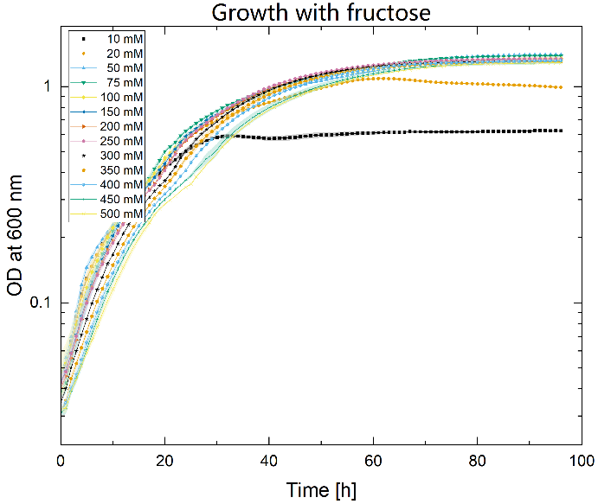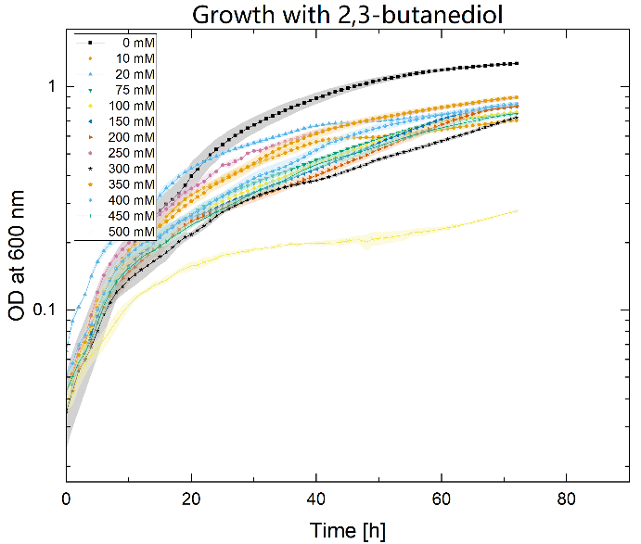
Figure S1: Growth experiments were conducted with C. necator H16 WT using increasing concentrations of fructose (left) and 2,3-BDO (right) over 72 and 98 hours to assess possible substrate and product inhibition. Triplicates are indicated by the surrounding color clouds.
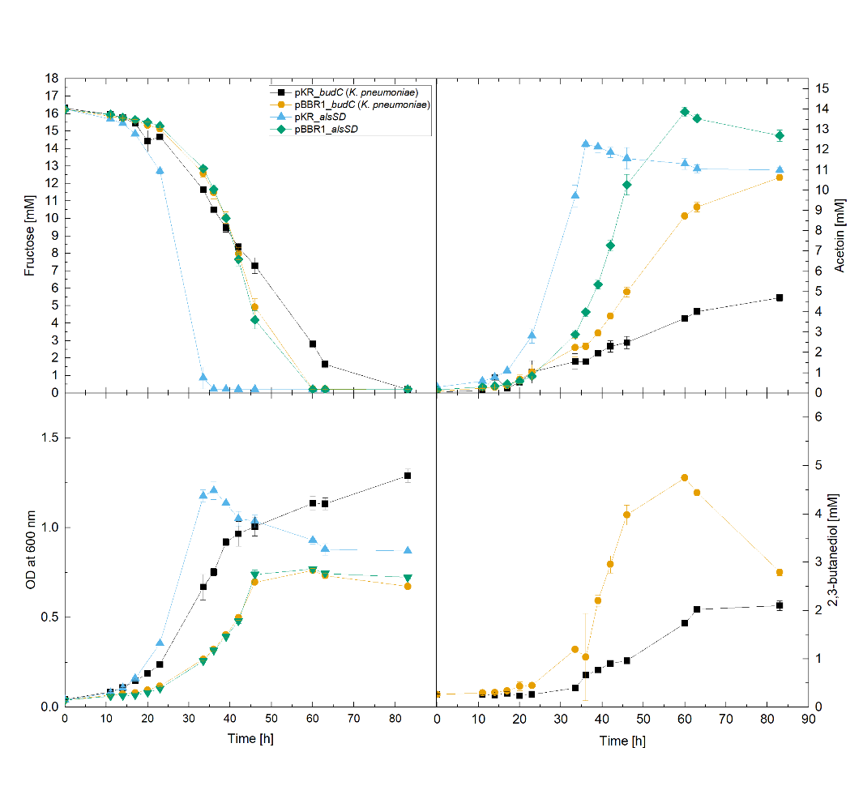
Figure S1: Comparison of production plasmids (organism of origin specified in parentheses) under heterotrophic conditions. For each case, acetoin, 2,3-BDO, fructose and measured OD₆₀₀ values are displayed.
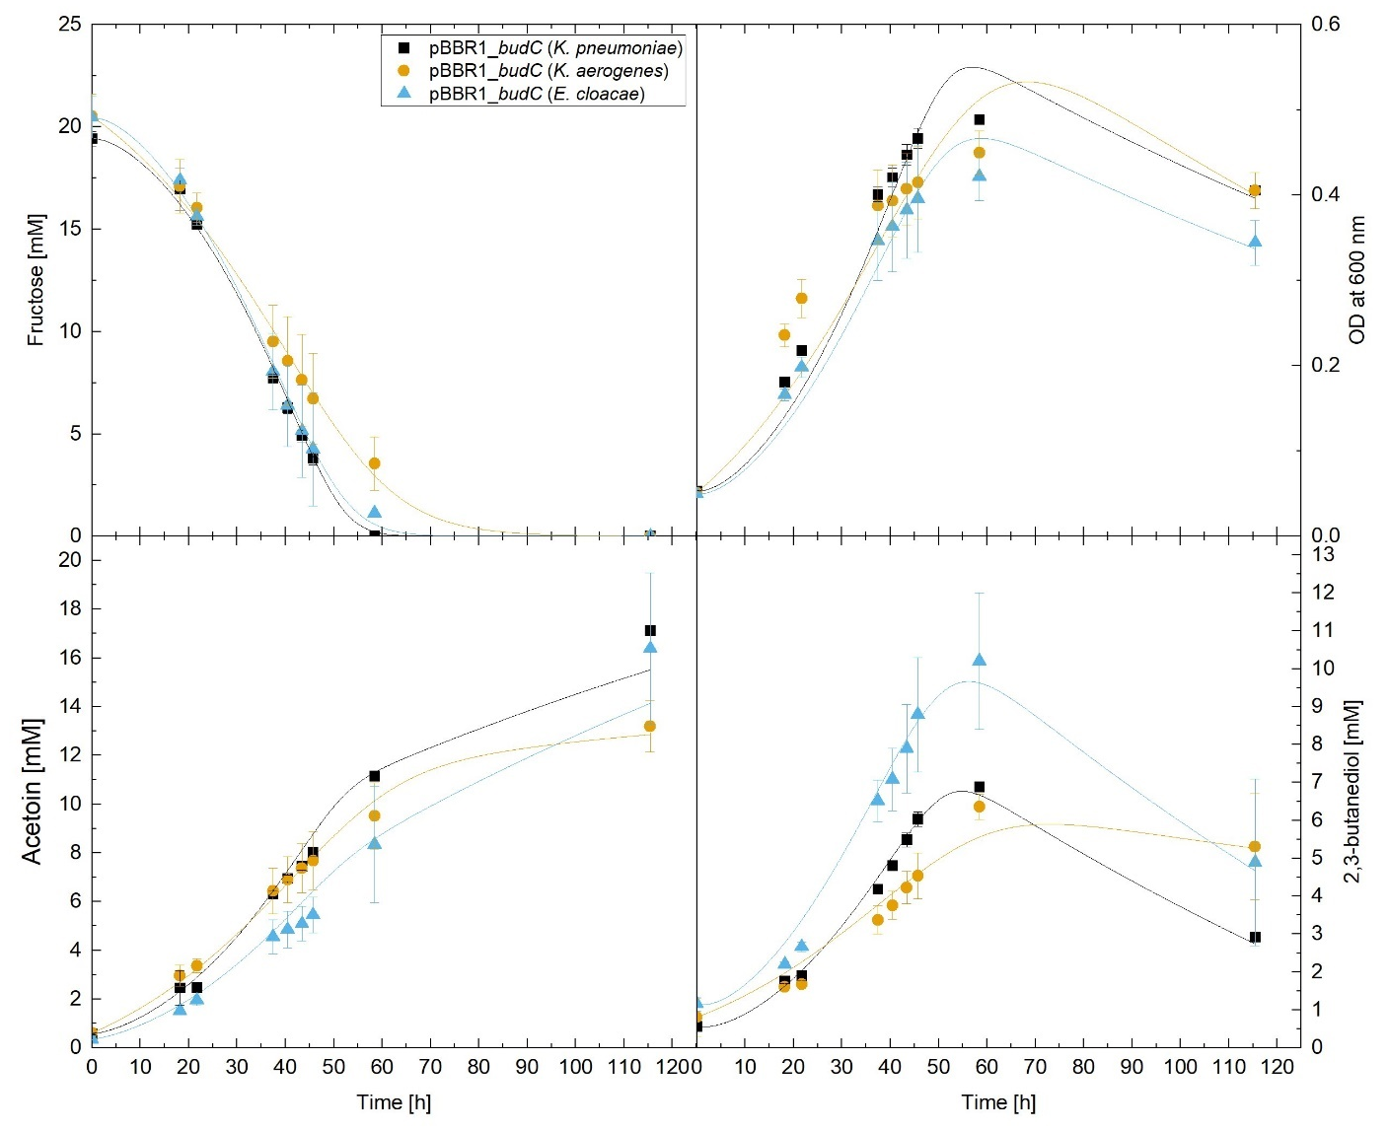
Figure S2: Comparison of variants of budC from different organisms (organism of origin specified in parentheses) under heterotrophic conditions. For each case, acetoin, 2,3-BDO, fructose and measured OD₆₀₀ values are displayed. Measured experiment values are shown in symbols while estimated data from the mathematic model are shown as lines in the corresponding colors.
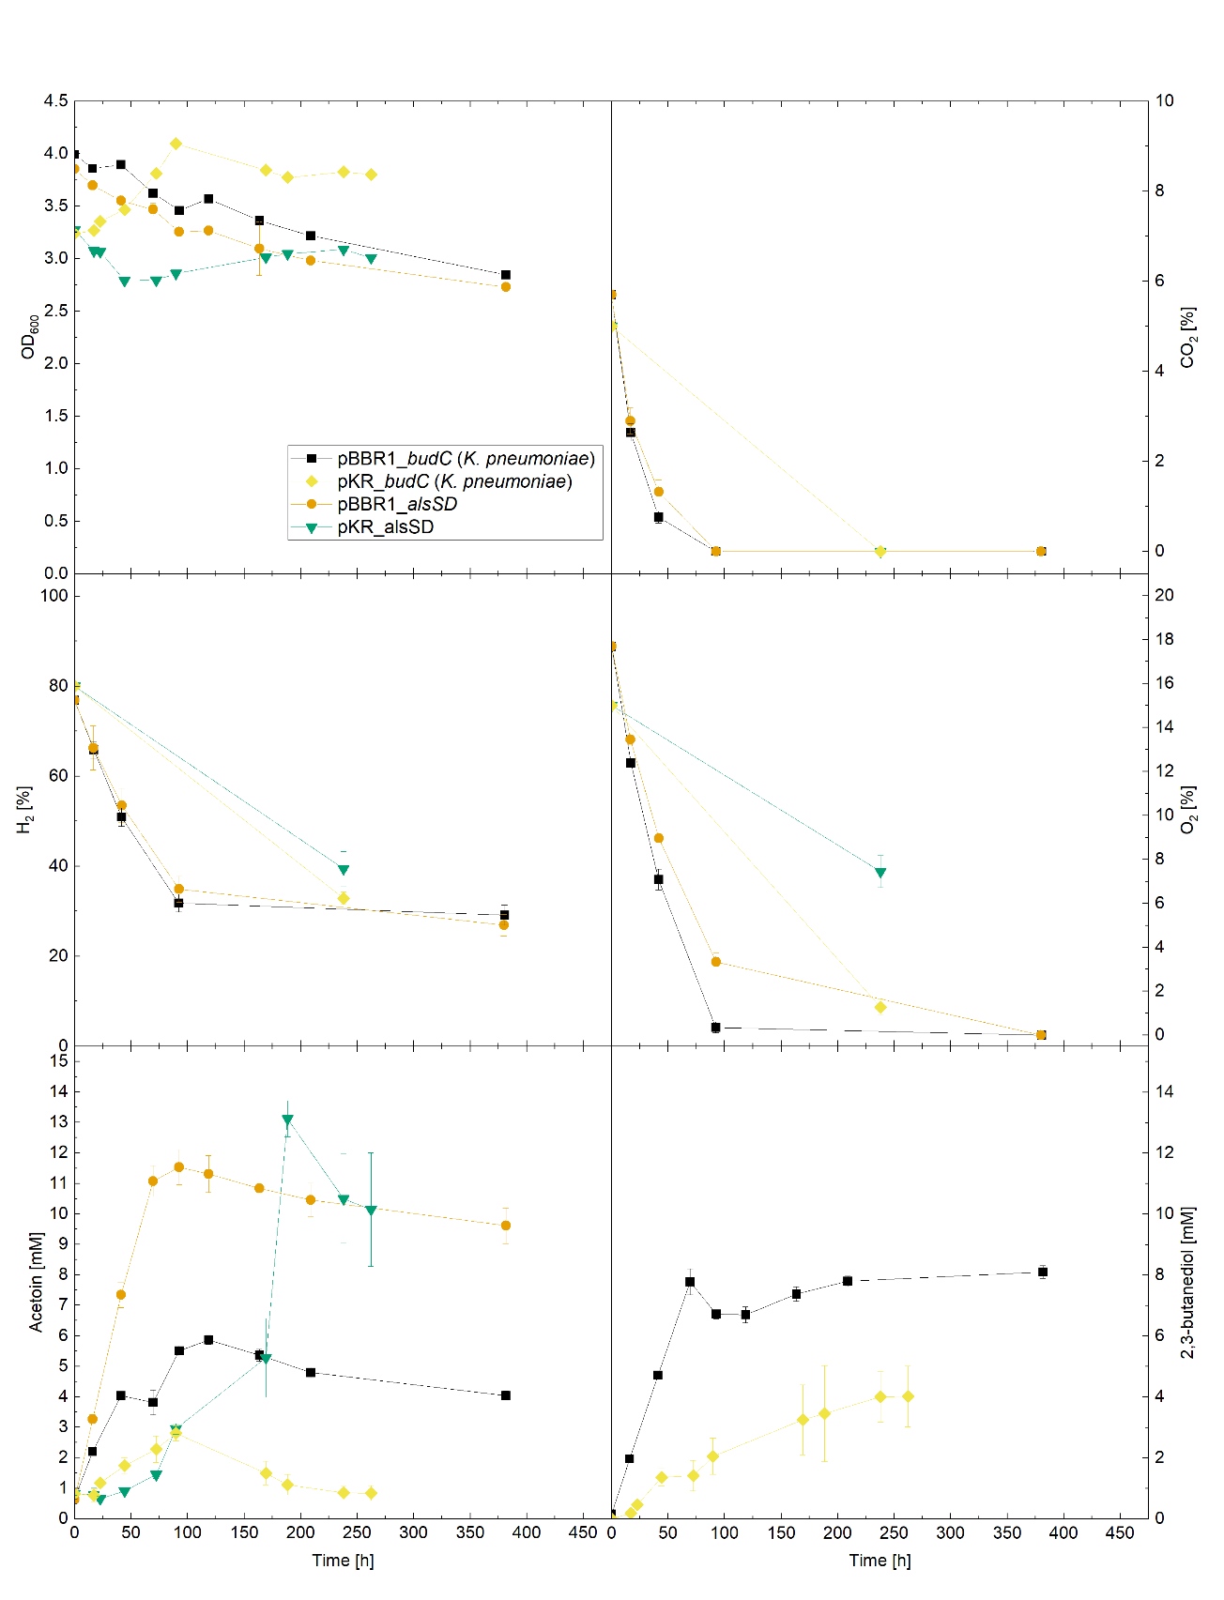
Figure S3: Comparing production plasmids (organism of origin for budC as indicated by organism names in parentheses) under autotrophic conditions. Each case displays acetoin, 2,3-BDO values, optical density and gas measurements.

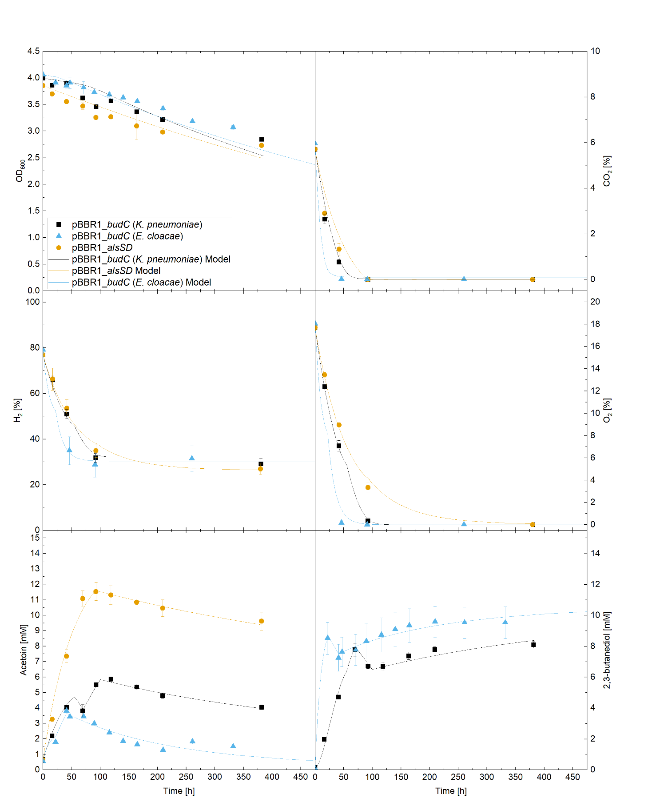
Figure S4: Comparison of variants of budC from different organisms (organism of origin specified in parentheses) under autotrophic conditions. Each case displays acetoin, 2,3-BDO values, optical density and gas measurements. Measured experiment values are shown in symbols while estimated data from the mathematic model are shown as lines in the corresponding colors.

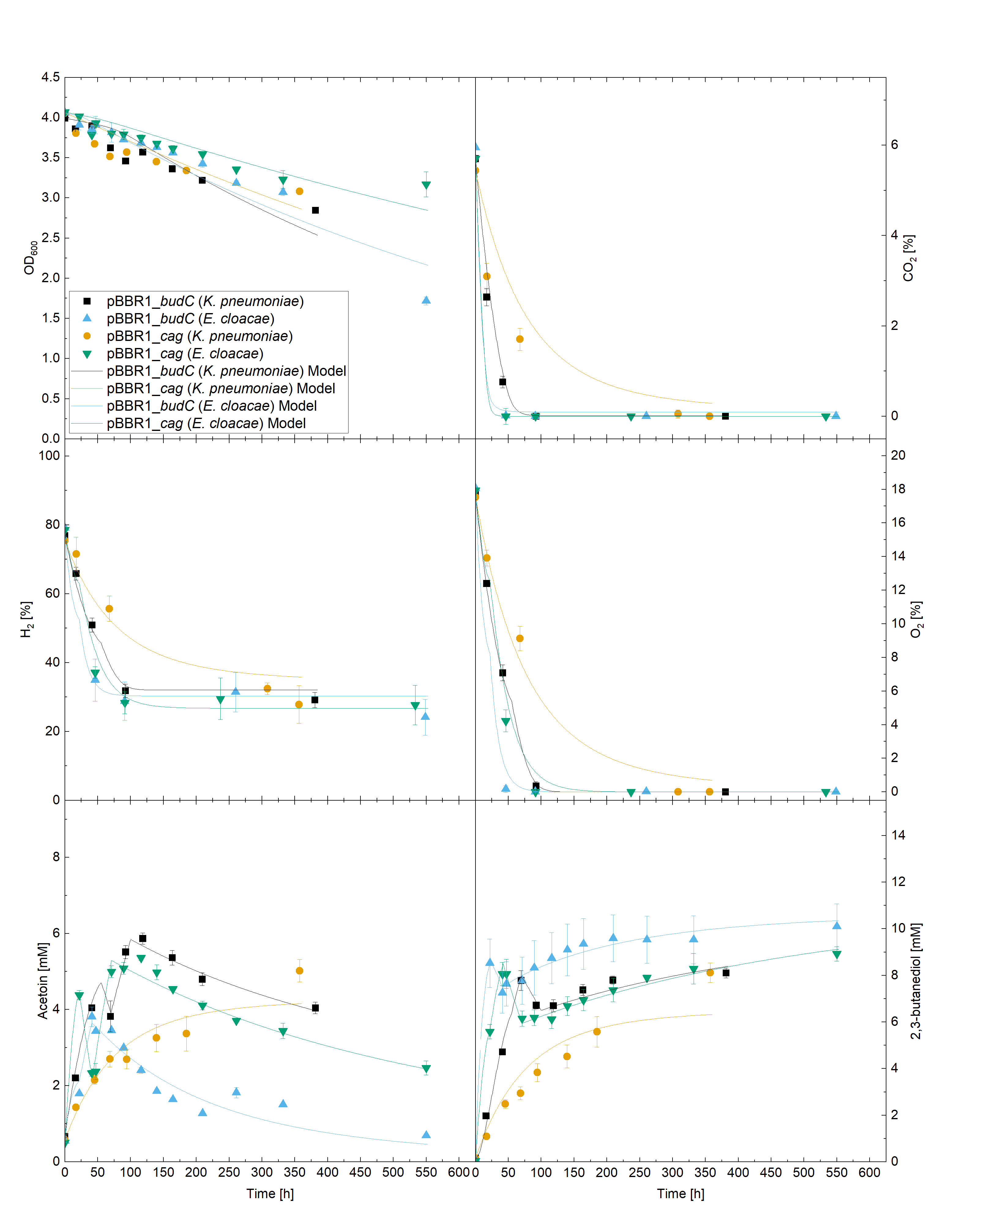
Figure S5: Comparison of budC variations from different organisms (as indicated by organism names in parentheses) and strains carrying a CA gene under autotrophic conditions. Each case displays acetoin, 2,3-BDO values, optical density and gas measurements. Measured experiment values are shown in symbols while estimated data from the mathematic model are shown as lines in the corresponding colors.

