Codon optimized gene sequences

budC Klebsiella pneumoniae

Locus budC 771 bp
Organism Klebsiella pneumoniae IAM1063

Sequence:

1 | ATGAAGAAGG | TGGCCCTGGT | GACCGGTGCA | GGCCAGGGCA | TCGGCAAGGC | CATCGCCCTG
61 | CGCCTGGTGA | AGGACGGCTT | CGCCGTGGCC | ATCGCCGACT | ACAACGACGC | CACCGCCAAG
121 | GCCGTGGCCT | CGGAAATCAA | CCAGGCAGGA | GGCCACGCCG | TGGCCGTGAA | GGTGGACGTG
181 | TCGGACCGCG | ACCAGGTGTT | CGCAGCCGTG | GAACAGGCAC | GCAAGACCCT | GGGTGGCTTC
241 | GACGTGATCG | TGAACAACGC | AGGCGTGGCA | CCGTCGACCC | CGATCGAATC | GATCACCCCG
301 | GAAATCGTGG | ACAAGGTGTA | CAACATCAAC | GTGAAGGGCG | TGATCTGGGG | CATCCAGGCA
361 | GCCGTGGAAG | CCTTCAAGAA | GGAAGGCCAC | GGTGGCAAGA | TCATCAACGC | CTGCTCGCAG
421 | GCAGGCCACG | TGGGCAACCC | GGAACTGGCC | GTGTACTCGT | CGTCGAAGTT | CGCCGTGCGT
481 | GGCCTGACCC | AGACCGCAGC | ACGCGACCTG | GCACCGCTGG | GCATCACCGT | GAACGGCTAC
541 | TGCCCTGGCA | TCGTGAAGAC | CCCGATGTGG | GCAGAAATCG | ACCGCCAGGT | GTCGGAAGCC
601 | GCAGGCAAGC | CGCTGGGCTA | CGGCACTGCC | GAATTCGCCA | AGCGCATCAC | CCTGGGTCGC
661 | CTGTCGGAAC | CGGAAGACGT | GGCAGCCTGC | GTGTCGTACC | TGGCCTCGCC | GGACTCGGAC
721 | TACATGACCG | GCCAGTCGCT | GCTGATCGAC | GGTGGCATGG | TGTTCAACTA | A

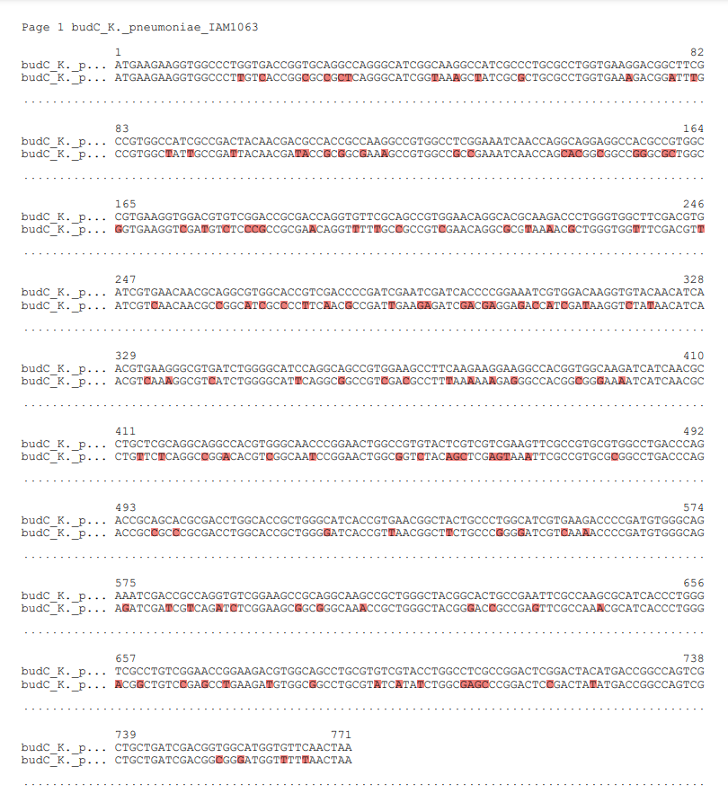

budC Klebsiella aerogenes

Locus budC 771 bp
Organism Klebsiella aerogenes AUH-KAM-9

Sequence:

1 | ATGAAGAAGG | TGGCCCTGGT | GACCGGTGCA | GGCCAGGGCA | TCGGCAAGGC | CATCGCCCTG
61 | CGCCTGGTGA | AGGACGGCTT | CGCCGTGGCC | ATCGCCGACT | ACAACGACGT | GACCGCCAAG
121 | GCCGTGGCCG | ACGAAATCAA | CCAGCACGGA | GGCCGCGCCA | TCGCCGTGAA | GGTGGACGTG
181 | TCGGACCGCG | AGCAGGTGTT | CGCAGCCGTG | GAACAGGCAC | GCAAGACCCT | GGGTGGCTTC
241 | GAGGTGATCG | TGAACAACGC | AGGCGTGGCA | CCGTCGACCC | CGATCGAATC | GATCACCCCG
301 | GAAATCGTGG | ACAAGGTGTA | CAACATCAAC | GTGAAGGGCG | TGATCTGGGG | CATCCAGGCA
361 | GCCGTGGAAG | CCTTCAAGAA | GGAAGGCCAC | GGTGGCAAGA | TCATCAACGC | CTGCTCGCAG
421 | GCAGGCCACG | TGGGCAACCC | GGAACTGGCC | GTGTACTCGT | CGTCGAAGTT | CGCCGTGCGT
481 | GGCCTGACCC | AGACCGCAGC | ACGCGACCTG | GCACCGCTGG | GCATCACCGT | GAACGGCTAC
541 | TGCCCTGGCA | TCGTGAAGAC | CCCGATGTGG | GCAGAAATCG | ACCGCCAGGT | GTCGGAAGCC
601 | GCAGGCAAGC | CGCTGGGCTA | CGGCACTGCC | GAATTCGCCA | AGCGCATCAC | CCTGGGTCGC
661 | CTGTCGGAAC | CGGAAGACGT | GGCAGCCTGC | GTGTCGTACC | TGGCCTCGCC | GGACTCGGAC
721 | TACATGACCG | GCCAGTCGCT | GCTGATCGAC | GGTGGCATGG | TGTTCAACTA | A

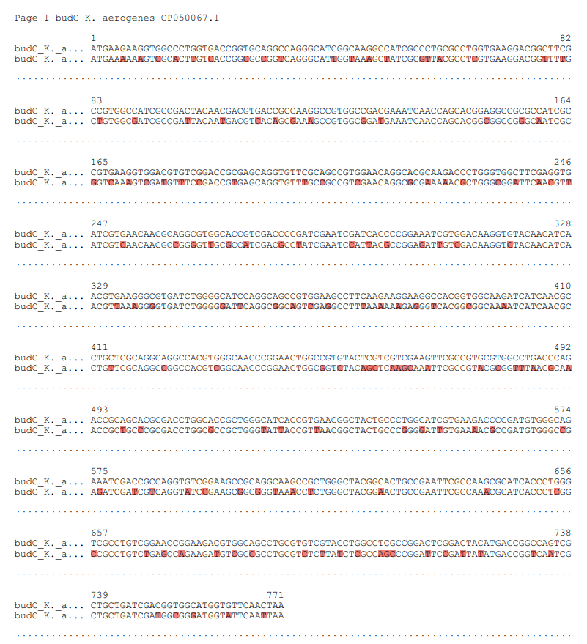

budC Enterobacter cloacae

Locus budC 771 bp
Organism Enterobacter cloacae 3849

Sequence:

1 | ATGCAAAGAG | TGGCTCTCGT | AACCGGCTCC | GGCCAGGGGA | TTGGCAAAGC | GATCGCGCTT
61 | CGCCTGGTGA | AGGACGGCTT | TGCCGTCGCT | ATCGCGGATT | ACAACGAAGA | GACGGCGAAA
121 | GCGGTCGCGG | ATGAGATCAC | CCGCAACGGC | GGGAAAGCCG | TCGCCGTGAA | GGTGGACGTC
181 | TCTGACCGCG | ACCAGGTGTT | TGCGGCGGTG | GAAAAAGCCC | GCACTGCGCT | GGGCGGCTTC
241 | AACGCCATTG | TCAATAACGC | CGGGGTGGCG | CCGTCTACCC | CTATCGAATC | CATCACGCCG
301 | GAAATTGTCG | ACAAGGTCTA | CAACATCAAC | GTGAAAGGGG | TGATCTGGGG | CATTCAGGCC
361 | GCGATTGACG | CGTTCCGCAA | AGAGGGGCAC | GGCGGTAAAA | TCATCAACGC | CTGCTCCCAG
421 | GCGGGCCATA | CCGGCAACCC | GGAACTGGCG | GTGTACAGCT | CCAGCAAGTT | CGCGGTGCGT
481 | GGCTTAACCC | AGACCGCCGC | GCGGGATCTC | GCGCCGCTGG | GGATCACCGT | TAACGCCTAT
541 | TGCCCGGGCA | TCGTCAAAAC | GCCGATGTGG | GCGGAAATCG | ACCGTCAGGT | CTCCGAGGCG
601 | GCGGGTAAAC | CGCTCGGCTA | CGGAACGGAA | ACCTTTGCCA | AACGCATCAC | GCTTGGCCGT
661 | TTGTCCGAAC | CGGAAGATGT | GGCCGCCTGC | GTCTCTTACC | TCGCCGGACC | AGACTCCGAC
721 | TACATGACCG | GTCAGTCGCT | GCTGATTGAT | GGTGGGATGG | TGTTCAACTA | A

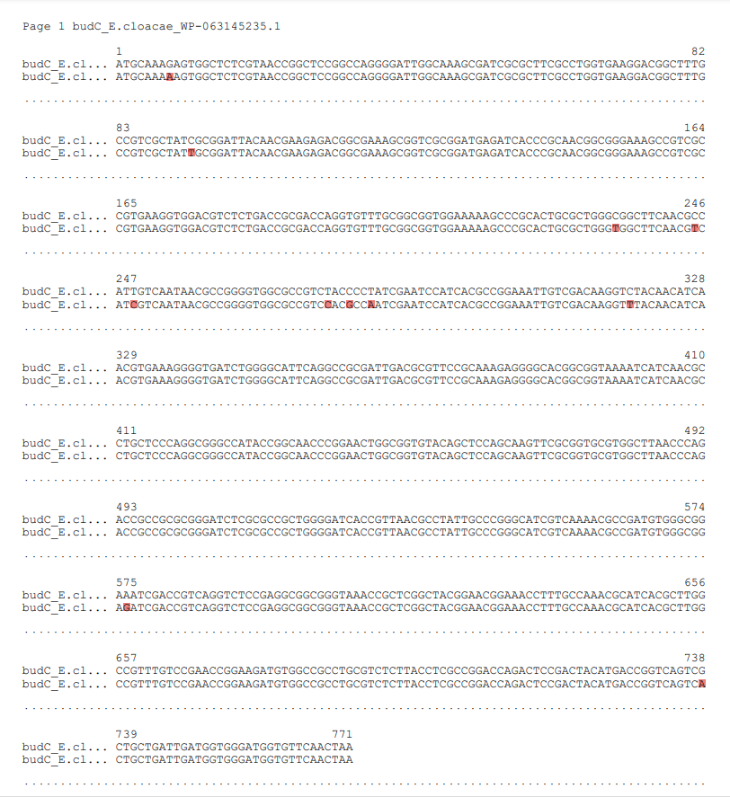

Cag (naturally occurring)

Locus cag 525 bp
Organism Cupriavidus necator H16

Sequence:

1 | ATGGCGCTTT | ACCAGCTCGG | CGACGTCAAG | CCCAATATCG | ACAGCGATGC | CTACGTGGCC
61 | CCCGAAGCCA | CCGTCATCGG | CAACGTGACC | CTCAAGTCCC | GCGCCAGCGC | CTGGCCCGGT
121 | GTCGTGATCC | GCGGCGACAA | CGAACCGATC | GTGGTGGGCG | AGGACACCAA | CATCCAGGAA
181 | GGCTCGGTGC | TGCATACCGA | CCCGGGCTGC | CCGCTGACCC | TGGGCGACAA | GGTCTCGATC
241 | GGCCACCAGG | CCATGCTGCA | TGGCTGCACC | GTAGGCGAAG | GCTCGCTCAT | CGGGATCCAG
301 | GCCGTGGTGC | TGAACCGCGC | CGTGATCGGC | AAGGAATGCC | TGGTCGGCGC | CGGTGCCGTG
361 | GTGACCGAGG | GCAAGGTCTT | CCCGGACCGC | TCGCTGATCC | TGGGCGCGCC | GGCCAAGGTG
421 | GTGCGCCAGC | TGACCGACGC | CGACGTCGCC | AACCTGTACC | GCAACGCCGA | GACCTACGCC
481 | ACCCGGCAGG | CCATGTACAA | GCAACAGCTC | AAGCGGATCG | GCTGA

