Supplementary Tables & Figures

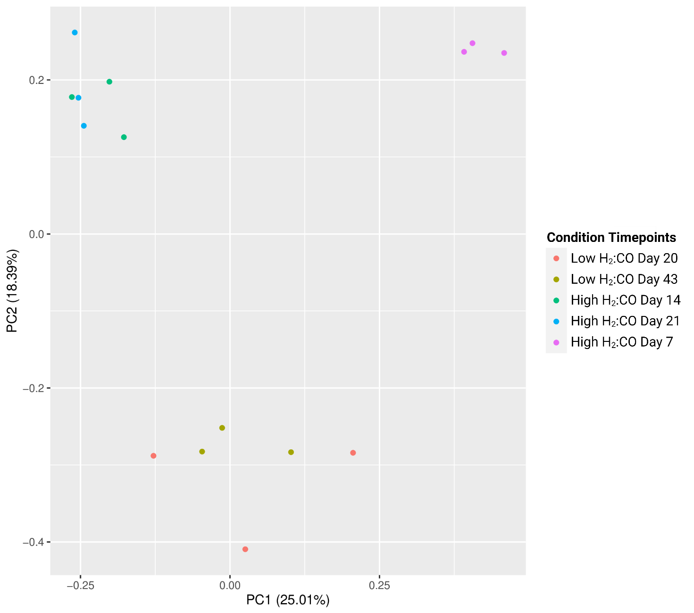Figure S1. Separation of Proteomes by Condition. A PCA plot showing the groupings of replicates for each of the conditions.

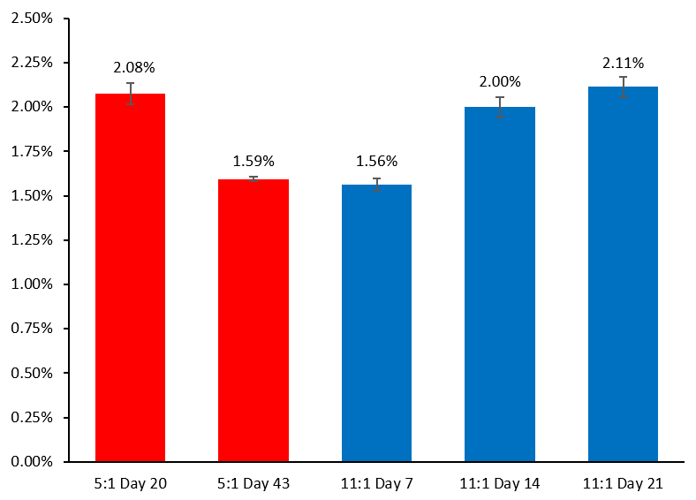
Figure S2. Total Lysine Acetylation Percentage. A bar chart depicting the percentage of acetylated peptides in proportion to total detected peptides.

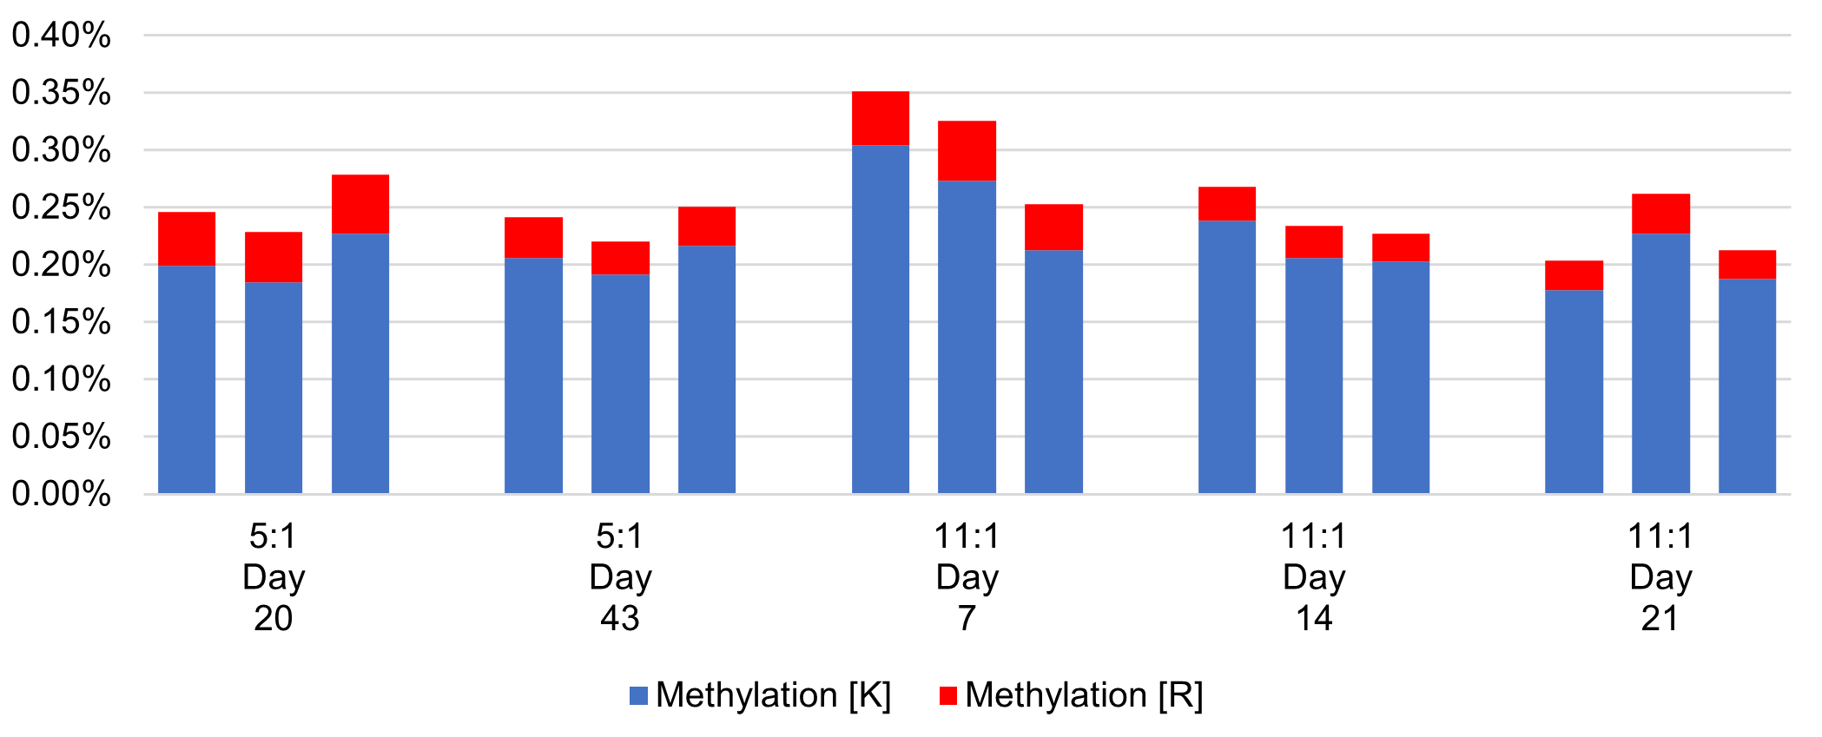
Figure S3. The Total Lysine and Arginine Methylation Percentage. A bar chart depicting the percentage of methylated peptides in proportion to total detected peptides. The red represents peptides methylated on the arginine residues, and the blue peptides methylated at lysine residues.

