Supplementary material of:

Engineering the L-tryptophan metabolism for efficient de novo biosynthesis of tryptophol in Saccharomyces cerevisiae

Ye Li ^{a, #, *}, Jingzhen Sun ^{a, #}, Zhenhao Fu ^{a, #}, Yubing He ª, Xiaorui Chen ª, Shijie Wang ª, Lele Zhang ^{a, b}, Jiansheng Jian ^{b}, Weihua Yang ^{c}, Chunli Liu ª, Xiuxia Liu ª, Yankun Yang ª, Zhonghu Bai ^{a, *}

ª Key Laboratory of Industrial Biotechnology of Ministry of Education and School of Biotechnology, Jiangnan University, Wuxi 214122, China.
^{b} Wuxi Tmaxtree Biotechnology Co., Ltd, Wuxi 214072, China.
^{c} Changxing Pharmaceutical Co. Ltd., Huzhou 313100, China.

# First authors

* Corresponding authors
Ye Li: yeli0622@jiangnan.edu.cn
Zhonghu Bai: baizhonghu@jiangnan.edu.cn

ORCID ID
Ye Li: 0000-0002-1650-8277

Abbreviations
Metabolites:
AA, anthranilic acid; CPdRibp, 1-(2-carboxyphenylamino)-1-deoxy-D-ribulose 5-phosphate; CA, chorismate; DAHP, 3-deoxy-D-arabinoheptulosonate-7-phosphate; EPSP, 5-enolpyruvylshikimate-3-phosphate; E4P, erythrose 4-phosphate; F1,6BP, fructose 1,6-bisphosphate; F6P, fructose 6-phosphate; Glc, glucose; G6P, glucose 6-phosphate; G3P, glyceraldehyde 3-phosphate; 4-HPP, 4-hydroxyphenylpyruvate; IAA, indole-3-acetate; IAC, indole-3-acetaldehyde; IET, tryptophol (indole-ethanol); I3GP, indole-3-glycerol phosphate; IPY, indole-3-pyruvate; PAA, 4-hydroxyphenyl acetate; L-Phe, L-phenylalanine; PET, phenylethanol; PP, phenylpyruvate; PEP, phosphoenolpyruvate; pPET, 4-hydroxyphenylethanol; N-PRAA, N-(5-phospho-β-D-ribosyl)anthranilate; PRE, prephenate; Ru5P, ribulose 5-phosphate; L-Trp, L-tryptophan ; L-Tyr, L-tyrosine; X5P, xylulose 5-phosphate.

Enzymes:
Adh1/2/3/4/5/Sfa1, alcohol dehydrogenases; Aro1, pentafunctional protein; Aro2, chorismate synthase; Aro3/Aro4, DAHP synthase isozymes; Aro7, chorismate mutase; Aro8/Aro9, aromatic amino acid transaminases; Aro10/Thi3/Pdc1/5/6, decarboxylases; Pha2, prephenate dehydratase; Tal1, transaldolase; Tkl1, transketolase; Trp1, phosphoribosylanthranilate isomerase; Trp2/Trp3C, anthranilate synthase; Trp3B, InGP synthase; Trp4, anthranilate phosphoribosyl transferase; Trp5, bi-functional L-Trp synthase; Tyr1, prephenate dehydrogenase; Zwf1, glucose 6-phosphate dehydrogenase.

Table S1. plasmids used in this study
1. Part Plasmids
Name | Description | Part Type | References
pYTK001 | Entry vector | Entry vector | [1]
pYTK002 | ConLS | 1 | [1]
pYTK003 | ConL1 | 1 | [1]
pYTK004 | ConL2 | 1 | [1]
pYTK005 | ConL3 | 1 | [1]
pYTK006 | ConL4 | 1 | [1]
pYTK008 | ConLS' | 1 | [1]
pYTK009 | pTDH3 | 2 | [1]
pYTK010 | pCCW12 | 2 | [1]
pYTK011 | pPGK1 | 2 | [1]
pYTK012 | pHHF2 | 2 | [1]
pYTK013 | pTEF1 | 2 | [1]
pYTK014 | pTEF2 | 2 | [1]
pYTK015 | pHHF1 | 2 | [1]
pYTK017 | pRPL18B | 2 | [1]
pYTK036 | Cas9 | 3 | [1]
pBL501 | ARO4^{K229L} | 3 | This work
pBL523 | TRP1 | 3 | This work
pBL525 | TRP3 | 3 | This work
pBL526 | TRP4 | 3 | This work
pBL527 | TRP5 | 3 | This work
pBL560 | TRP2^{S65R, S76L} | 3 | This work
pBL561 | MtAAMT1 | 3 | This work
pBL587 | ARO1 | 3 | This work
pBL588 | BBxfpk | 3 | This work
pBL589 | Ckpta | 3 | This work
pBL590 | RKI1 | 3 | This work
pBL599 | EcaroB | 3 | This work
pBL600 | EcaroK | 3 | This work
pBL601 | EcaroL | 3 | This work
pBL617 | ARO8 | 3 | This work
pBL618 | ARO9 | 3 | This work
pBL621 | ARO10 | 3 | This work
pBL622 | THI3 | 3 | This work
pBL623 | PDC1 | 3 | This work
pBL624 | PDC5 | 3 | This work
pBL625 | PDC6 | 3 | This work
pBL626 | ADH1 | 3 | This work
pBL627 | ADH2 | 3 | This work
pBL628 | ADH3 | 3 | This work
pBL629 | ADH4 | 3 | This work
pBL630 | ADH5 | 3 | This work
pBL631 | SFA1 | 3 | This work
pYTK047 | GFP dropout | 234r | [1]
pYTK048 | Spacer | 234 | [1]
pYTK050 | sgRNA dropout | 234 | [1]
pYTK051 | tENO1 | 4 | [1]
pYTK052 | tSSA1 | 4 | [1]
pYTK053 | tADH1 | 4 | [1]
pYTK054 | tPGK1 | 4 | [1]
pYTK055 | tENO2 | 4 | [1]
pYTK056 | tTDH1 | 4 | [1]
pYTK067 | ConR1 | 5 | [1]
pYTK068 | ConR2 | 5 | [1]
pYTK069 | ConR3 | 5 | [1]
pYTK070 | ConR4 | 5 | [1]
pYTK072 | ConRE | 5 | [1]
pYTK073 | ConRE' | 5 | [1]
pYTK074 | URA3 | 6 | [1]
pYTK075 | LEU2 | 6 | [1]
pYTK076 | HIS3 | 6 | [1]
pYTK077 | KanamycinR | 6 | [1]
pYTK079 | HygromycinR | 6 | [1]
pYTK081 | CEN6/ARS4 | 7 | [1]
pYTK082 | 2micron | 7 | [1]
pYTK083 | AmpR-ColE1 | 8 | [1]
pYTK084 | KanR-ColE1 | 8 | [1]
pYTK086 | URA3 3' Homology | 7 | [1]
pYTK087 | LEU2 3' Homology | 7 | [1]
pYTK088 | HO 3' Homology | 7 | [1]
pYTK100 | chrXI 3' homology | 7 | This work
pYTK089 | AmpR-ColE1 | 8a | [1]
pYTK090 | KanR-ColE1 | 8a | [1]
pYTK092 | URA3 5' Homology | 8b | [1]
pYTK093 | LEU2 5' Homology | 8b | [1]
pYTK094 | HO 5' Homology | 8b | [1]
pYTK101 | chrXI 5' homology | 8b | This work
pYTK095 | AmpR-ColE1 | 678 | [1]

2. Expression cassette plasmids
Name | Features | References
pBL506 | pTDH3-ARO4^{K229L}-tENO1, 2micro | This work
pBL507 | pTDH3-ARO4^{K229L}-tENO1, CEN6/ARS4 | This work
pBL508 | pTDH3-ARO4^{K229L}-tENO1, Integration (ura3-locus) | This work
pBL544 | pPGK1-TRP1-tENO1, pHHF2- TRP2^{S65R, S76L}-tSSA1, pTEF1-TRP3-tADH1, pTEF2-TRP4-tPGK1, pHHF1-TRP5-tENO2, CEN6/ARS4 | This work
pBL545 | pPGK1-TRP1-tENO1, pHHF2- TRP2^{S65R, S76L} -tSSA1, pTEF1-Trp3-tADH1, pTEF2-Trp4-tPGK1, pHHF1-Trp5-tENO2, 2micro | This work
pBL546 | pPGK1-Trp1-tENO1, pHHF2- TRP2^{S65R, S76L}-tSSA1, pTEF1-Trp3-tADH1, pTEF2-Trp4-tPGK1, pHHF1-Trp5-tENO2, Integration (leu2-locus) | This work
pBL563 | pHHF2-TRP2^{S65R, S76L}-tSSA1, CEN6/ARS4 | This work
pBL564 | pHHF2-TRP2^{S65R, S76L}-tSSA1, 2micro | This work
pBL565 | pHHF2-TRP2^{S65R, S76L}-tSSA1, Integration (leu2-locus) | This work
pBL567 | pPGK1-TRP1-tENO1-pHHF2-TRP2^{S65R, S76L}-tSSA1-pTEF1-TRP3-tADH1-pTEF2-TRP4-tPGK1-pHHF1-TRP5-tENO2, CEN6/ARS4 | This work
pBL568 | pPGK1-TRP1-tENO1-pHHF2-TRP2^{S65R, S76L}-tSSA1-pTEF1-TRP3-tADH1-pTEF2-TRP4-tPGK1-pHHF1-TRP5-tENO2, 2micro | This work
pBL569 | pPGK1-TRP1-tENO1-pHHF2-TRP2^{S65R, S76L}-tSSA1-pTEF1-TRP3-tADH1-pTEF2-TRP4-tPGK1-pHHF1-TRP5-tENO2, Integration (leu2-locus) | This work
pBL577 | pHHF2-TRP2^{S65R, S76L}-tSSA1-pTEF1-TRP3-tADH1-pTEF2-TRP4-tPGK1-pHHF1-TRP5-tENO2, Integration (leu2-locus) | This work
pBL578 | pPGK1-TRP1-tENO1-pTEF1-TRP3-tADH1-pTEF2-TRP4-tPGK1-pHHF1-TRP5-tENO2, Integration (leu2-locus) | This work
pBL579 | pPGK1-TRP1-tENO1-pHHF2-TRP2^{S65R, S76L}-tSSA1-pTEF2-TRP4-tPGK1-pHHF1-TRP5-tENO2, Integration (leu2-locus) | This work
pBL580 | pPGK1-TRP1-tENO1-pHHF2-TRP2^{S65R, S76L}-tSSA1-pTEF1-TRP3-tADH1-pHHF1-TRP5-tENO2, Integration (leu2-locus) | This work
pBL581 | pPGK1-TRP1-tENO1-pHHF2-TRP2^{S65R, S76L}-tSSA1-pTEF1-TRP3-tADH1-pTEF2-TRP4-tPGK1, Integration (leu2-locus) | This work
pBL554 | pPGK1-CAS9-tPGK1, sg1-ARO7_D, 2micro | This work
pBL555 | pPGK1-CAS9-tPGK1, sg2-ARO7_D, 2micro | This work
pBL556 | pPGK1-CAS9-tPGK1, sg3-ARO7_D, 2micro | This work
pBL608 | pTDH3-EcaroB-tTDH1-pCCW12-EcaroK-tENO1-pPGK1-EcaroL-tSSA1, Integration (HO-locus) | This work
pBL609 | pTDH3-BBxfpk-tTDH1-pCCW12-Ckpta-tENO1, Integration (HO-locus) | This work
pBL609 | pTDH3- RKI1-tTDH1, Integration (HO-locus) | This work
pBL610 | pPGK1-CAS9-tPGK1, sg1-RIC1_D, 2micro | This work
pBL611 | pPGK1-CAS9-tPGK1, sg2-RIC1_D, 2micro | This work
pBL619 | pTDH3-ARO8-tTDH1, Integration (HO-locus) | This work
pBL620 | pTDH3-ARO9-tTDH1, Integration (HO-locus) | This work
pBL639 | pTDH3-ARO10-tTDH1, Integration (ChrXI-locus) | This work
pBL640 | pTDH3-THI3-tTDH1, Integration (ChrXI-locus) | This work
pBL641 | pTDH3-PDC1-tTDH1, Integration (ChrXI-locus) | This work
pBL642 | pTDH3-PDC5-tTDH1, Integration (ChrXI-locus) | This work
pBL643 | pTDH3-PDC6-tTDH1, Integration (ChrXI-locus) | This work
pBL644 | pTDH3-ADH1-tTDH1, Integration (ChrXI-locus) | This work
pBL645 | pTDH3-ADH2-tTDH1, Integration (ChrXI-locus) | This work
pBL646 | pTDH3-ADH3-tTDH1, Integration (ChrXI-locus) | This work
pBL647 | pTDH3-ADH4-tTDH1, Integration (ChrXI-locus) | This work
pBL648 | pTDH3-ADH5-tTDH1, Integration (ChrXI-locus) | This work
pBL649 | pTDH3-SFA1-tTDH1, Integration (ChrXI-locus) | This work
pBL651 | pTDH3- MtAAMT1-tTDH1, Integration (HO-locus) | This work
pBL656 | pCCW12-ARO10-tENO1-pTDH3-ADH1-tTDH1, Integration (ChrXI-locus) | This work
pBL657 | pCCW12-THI3-tENO1-pTDH3-ADH1-tTDH1, Integration (ChrXI-locus) | This work
pBL658 | pCCW12-PDC1-tENO1-pTDH3-ADH1-tTDH1, Integration (ChrXI-locus) | This work
pBL596 | pTDH3-ARO1-tTDH1, Integration (HO-locus) | This work
pBL608 | pTDH3-EcaroB-tTDH1-pCCW12-EcaroK-tENO1-pPGK1-EcaroL-tSSA1, Integration (HO-locus) | This work
pBL609 | pTDH3-BBxfpk-tTDH1-pCCW12-Ckpta-tENO1, Integration (HO-loci) | This work

Table S2. Strains used in this study
Strain Name | Parent strains | Description | References
BY4741 |  | MATa his3Δ1 leu2Δ0 met15Δ0 ura3Δ0 | [2]
CEN.PK2-1D |  | MATα his3-Δ1 leu2-3_112 ura3-52 trp1-289 MAL2-8c SUC2 | [3]
yBL502 | BY4741 | ura3::pTDH3-ARO4^{K229L}-tENO1 | This work
yBL503 | BY4741 | pBL507 (pTDH3-ARO4^{K229L}-tENO1, CEN6/ARS4) | This work
yBL504 | BY4741 | pBL506 (pTDH3-ARO4^{K229L}-tENO1, 2micro) | This work
yBL512 | BY4741 | ura3::pTDH3-ARO4^{K229L}-tENO1, pBL563 (pHHF2-TRP2^{S65R, S76L}-tSSA1, CEN6/ARS4) | This work
yBL513 | BY4741 | ura3::pTDH3-ARO4^{K229L}-tENO1, pBL564 (pHHF2-TRP2^{S65R, S76L}-tSSA1, 2micro) | This work
yBL514 | BY4741 | ura3::pTDH3-ARO4^{K229L}-tENO1, leu2::  pHHF2-TRP2^{S65R, S76L}-tSSA1 | This work
yBL515 | BY4741 | ura3::pTDH3-ARO4^{K229L}-tENO1,  pBL567 (pPGK1-TRP1-tENO1-pHHF2-TRP2^{S65R, S76L}-tSSA1-pTEF1-TRP3-tADH1-pTEF2-TRP4-tPGK1- pHHF1-TRP5-tENO2, CEN6/ARS4) | This work
yBL516 | BY4741 | ura3:: pTDH3-ARO4^{K229L}-tENO1,  pBL568 (pPGK1-TRP1-tENO1-pHHF2-TRP2^{S65R, S76L}-tSSA1-pTEF1-TRP3-tADH1-pTEF2-TRP4-tPGK1-pHHF1-TRP5-tENO2, 2micro) | This work
yBL518 | BY4741 | ura3::pTDH3-ARO4^{K229L}-tENO1,  leu2::pPGK1-TRP1-tENO1-pHHF2-TRP2^{S65R, S76L}-tSSA1-pTEF1-TRP3-tADH1-pTEF2-TRP4-tPGK1-pHHF1-TRP5-tENO2 | This work
yBL519 | BY4741 | ura3::pTDH3-ARO4^{K229L}-tENO1, leu2::  pHHF2-TRP2^{S65R,S76L}-tSSA1-pTEF1-TRP3-tADH1-pTEF2-TRP4-tPGK1-pHHF1-TRP5-tENO2 | This work
yBL520 | BY4741 | ura3::pTDH3-ARO4^{K229L}-tENO1, leu2::pPGK1-TRP1-tENO1-pTEF1-TRP3-tADH1-pTEF2-TRP4-tPGK1-pHHF1-TRP5-tENO2 | This work
yBL521 | BY4741 | ura3::pTDH3-ARO4^{K229L}-tENO1, leu2::  pPGK1-TRP1-tENO1-pHHF2-TRP2^{S65R,S76L}-tSSA1-pTEF2-TRP4-tPGK1-pHHF1-TRP5-tENO2 | This work
yBL522 | BY4741 | ura3::pTDH3-ARO4^{K229L}-tENO1, leu2::pPGK1-TRP1-tENO1-pHHF2-TRP2^{S65R,S76L}-tSSA1-pTEF1-TRP3-tADH1-pHHF1-TRP5-tENO2 | This work
yBL523 | BY4741 | ura3::pTDH3-ARO4^{K229L}-tENO1, leu2::pPGK1-TRP1-tENO1-pHHF2- TRP2^{S65R, S76L} -tSSA1-pTEF1-TRP3-tADH1-pTEF2-TRP4-tPGK1 | This work
yBL551 | BY4741 | ura3::pTDH3-ARO4^{K229L}-tENO1, leu2::pPGK1-TRP1-tENO1-pHHF2-TRP2^{S65R,S76L}-tSSA1-pTEF1-TRP3-tADH1-pHHF1-TRP5-tENO2, HO::pTDH3- MtAAMT1-tTDH1 | This work
yBL552 | BY4741 | ura3::pTDH3-ARO4^{K229L}-tENO1,  leu2::pPGK1-TRP1-tENO1-pHHF2-TRP2^{S65R,S76L}-tSSA1-pTEF1-TRP3-tADH1-pTEF2-TRP4-tPGK1-pHHF1-TRP5-tENO2, HO::pTDH3- MtAAMT1-tTDH1 | This work
yBL517 | BY4741 | ura3::pTDH3-ARO4^{K229L}-tENO1,  leu2::pPGK1-TRP1-tENO1-pHHF2-TRP2^{S65R,S76L}-tSSA1-pTEF1-TRP3-tADH1-pTEF2-TRP4-tPGK1-pHHF1-TRP5-tENO2, aro7Δ | This work
yBL532 | BY4741 | ura3::pTDH3-ARO4^{K229L}-tENO1,  leu2::pPGK1-TRP1-tENO1-pHHF2-TRP2^{S65R,S76L}-tSSA1-pTEF1-TRP3-tADH1-pTEF2-TRP4-tPGK1-pHHF1-TRP5-tENO2, aro7Δ, HO::pTDH3-ARO8-tTDH1 | This work
yBL533 | BY4741 | ura3::pTDH3-ARO4^{K229L}-tENO1,  leu2::pPGK1-TRP1-tENO1-pHHF2-TRP2^{S65R,S76L}-tSSA1-pTEF1-TRP3-tADH1-pTEF2-TRP4-tPGK1-pHHF1-TRP5-tENO2, aro7Δ, HO::pTDH3-ARO9-tTDH1 | This work
yBL537 | BY4741 | ura3::pTDH3-ARO4^{K229L}-tENO1,  leu2::pPGK1-TRP1-tENO1-pHHF2-TRP2^{S65R,S76L}-tSSA1-pTEF1-TRP3-tADH1-pTEF2-TRP4-tPGK1-pHHF1-TRP5-tENO2, aro7Δ, HO::pTDH3-ARO9-tTDH1, ChrXI::pTDH3-ARO10-tTDH1 | This work
yBL538 | BY4741 | ura3::pTDH3-ARO4^{K229L}-tENO1,  leu2::pPGK1-TRP1-tENO1-pHHF2-TRP2^{S65R,S76L}-tSSA1-pTEF1-TRP3-tADH1-pTEF2-TRP4-tPGK1-pHHF1-TRP5-tENO2, aro7Δ, HO::pTDH3-ARO9-tTDH1, ChrXI::pTDH3-THI3-tTDH1 | This work
yBL539 | BY4741 | ura3::pTDH3-ARO4^{K229L}-tENO1,  leu2::pPGK1-TRP1-tENO1-pHHF2-TRP2^{S65R,S76L}-tSSA1-pTEF1-TRP3-tADH1-pTEF2-TRP4-tPGK1-pHHF1-TRP5-tENO2, aro7Δ, HO::pTDH3-ARO9-tTDH1, ChrXI::pTDH3-PDC1-tTDH1 | This work
yBL540 | BY4741 | ura3::pTDH3-ARO4^{K229L}-tENO1,  leu2::pPGK1-TRP1-tENO1-pHHF2-TRP2^{S65R,S76L}-tSSA1-pTEF1-TRP3-tADH1-pTEF2-TRP4-tPGK1-pHHF1-TRP5-tENO2, aro7Δ, HO::pTDH3-ARO9-tTDH1, ChrXI::pTDH3-PDC5-tTDH1 | This work
yBL541 | BY4741 | ura3::pTDH3-ARO4^{K229L}-tENO1,  leu2::pPGK1-TRP1-tENO1-pHHF2-TRP2^{S65R,S76L}-tSSA1-pTEF1-TRP3-tADH1-pTEF2-TRP4-tPGK1-pHHF1-TRP5-tENO2, aro7Δ, HO::pTDH3-ARO9-tTDH1, ChrXI::pTDH3-PDC6-tTDH1 | This work
yBL542 | BY4741 | ura3::pTDH3-ARO4^{K229L}-tENO1,  leu2::pPGK1-TRP1-tENO1-pHHF2-TRP2^{S65R,S76L}-tSSA1-pTEF1-TRP3-tADH1-pTEF2-TRP4-tPGK1-pHHF1-TRP5-tENO2, aro7Δ, HO::pTDH3-ARO9-tTDH1, ChrXI::pTDH3-ADH1-tTDH1 | This work
yBL543 | BY4741 | ura3::pTDH3-ARO4^{K229L}-tENO1,  leu2::pPGK1-TRP1-tENO1-pHHF2-TRP2^{S65R,S76L}-tSSA1-pTEF1-TRP3-tADH1-pTEF2-TRP4-tPGK1-pHHF1-TRP5-tENO2, aro7Δ, HO::pTDH3-ARO9-tTDH1, ChrXI::pTDH3-ADH2-tTDH1 | This work
yBL544 | BY4741 | ura3::pTDH3-ARO4^{K229L}-tENO1,  leu2::pPGK1-TRP1-tENO1-pHHF2-TRP2^{S65R,S76L}-tSSA1-pTEF1-TRP3-tADH1-pTEF2-TRP4-tPGK1-pHHF1-TRP5-tENO2, aro7Δ, HO::pTDH3-ARO9-tTDH1, ChrXI::pTDH3-ADH3-tTDH1 | This work
yBL545 | BY4741 | ura3::pTDH3-ARO4^{K229L}-tENO1,  leu2::pPGK1-TRP1-tENO1-pHHF2-TRP2^{S65R,S76L}-tSSA1-pTEF1-TRP3-tADH1-pTEF2-TRP4-tPGK1-pHHF1-TRP5-tENO2, aro7Δ, HO::pTDH3-ARO9-tTDH1, ChrXI::pTDH3-ADH4-tTDH1 | This work
yBL546 | BY4741 | ura3::pTDH3-ARO4^{K229L}-tENO1,  leu2::pPGK1-TRP1-tENO1-pHHF2-TRP2^{S65R,S76L}-tSSA1-pTEF1-TRP3-tADH1-pTEF2-TRP4-tPGK1-pHHF1-TRP5-tENO2, aro7Δ, HO::pTDH3-ARO9-tTDH1, ChrXI::pTDH3-ADH5-tTDH1 | This work
yBL547 | BY4741 | ura3::pTDH3-ARO4^{K229L}-tENO1,  leu2::pPGK1-TRP1-tENO1-pHHF2-TRP2^{S65R,S76L}-tSSA1-pTEF1-TRP3-tADH1-pTEF2-TRP4-tPGK1-pHHF1-TRP5-tENO2, aro7Δ, HO::pTDH3-ARO9-tTDH1, ChrXI::pTDH3-SFA1-tTDH1 | This work
yBL548 | BY4741 | ura3::pTDH3-ARO4^{K229L}-tENO1,  leu2::pPGK1-TRP1-tENO1-pHHF2-TRP2^{S65R,S76L}-tSSA1-pTEF1-TRP3-tADH1-pTEF2-TRP4-tPGK1-pHHF1-TRP5-tENO2, aro7Δ, HO::pTDH3-ARO9-tTDH1, ChrXI::pCCW12-ARO10-tENO1-pTDH3-ADH1-tTDH1 | This work
yBL549 | BY4741 | ura3::pTDH3-ARO4^{K229L}-tENO1,  leu2::pPGK1-TRP1-tENO1-pHHF2-TRP2^{S65R,S76L}-tSSA1-pTEF1-TRP3-tADH1-pTEF2-TRP4-tPGK1-pHHF1-TRP5-tENO2, aro7Δ, HO::pTDH3-ARO9-tTDH1, ChrXI::pCCW12-THI3-tENO1-pTDH3-ADH1-tTDH1 | This work
yBL550 | BY4741 | ura3::pTDH3-ARO4^{K229L}-tENO1,  leu2::pPGK1-TRP1-tENO1-pHHF2-TRP2^{S65R,S76L}-tSSA1-pTEF1-TRP3-tADH1-pTEF2-TRP4-tPGK1-pHHF1-TRP5-tENO2, aro7Δ, HO::pTDH3-ARO9-tTDH1, ChrXI::pCCW12-PDC1-tENO1-pTDH3-ADH1-tTDH1 | This work
yBL529 | BY4741 | ura3::pTDH3-ARO4^{K229L}-tENO1,  leu2::pPGK1-TRP1-tENO1-pHHF2-TRP2^{S65R,S76L}-tSSA1-pTEF1-TRP3-tADH1-pTEF2-TRP4-tPGK1-pHHF1-TRP5-tENO2, HO::pTDH3-ARO1-tTDH1 | This work
yBL530 | BY4741 | ura3::pTDH3-ARO4^{K229L}-tENO1,  leu2::pPGK1-TRP1-tENO1-pHHF2-TRP2^{S65R,S76L}-tSSA1-pTEF1-TRP3-tADH1-pTEF2-TRP4-tPGK1-pHHF1-TRP5-tENO2, HO::pTDH3-EcaroB-tTDH1-pCCW12-EcaroK-tENO1-pPGK1-EcaroL-tSSA1 | This work
yBL531 | BY4741 | ura3::pTDH3-ARO4^{K229L}-tENO1,  leu2::pPGK1-TRP1-tENO1-pHHF2-TRP2^{S65R,S76L}-tSSA1-pTEF1-TRP3-tADH1-pTEF2-TRP4-tPGK1-pHHF1-TRP5-tENO2, HO::pTDH3-BBxfpk-tTDH1-pCCW12-Ckpta-tENO1 | This work
yBL534 | BY4741 | ura3::pTDH3-ARO4^{K229L}-tENO1,  leu2::pPGK1-TRP1-tENO1-pHHF2-TRP2^{S65R,S76L}-tSSA1-pTEF1-TRP3-tADH1-pTEF2-TRP4-tPGK1-pHHF1-TRP5-tENO2, HO::pTDH3-RKI1-tTDH1 | This work
yBL535 | BY4741 | ura3::pTDH3-ARO4^{K229L}-tENO1,  leu2::pPGK1-TRP1-tENO1-pHHF2-TRP2^{S65R,S76L}-tSSA1-pTEF1-TRP3-tADH1-pTEF2-TRP4-tPGK1-pHHF1-TRP5-tENO2, ric1Δ | This work

Table S3. The main primers used in this study
Purpose |  | Oligo name |  | Sequence (5'3')
Aro4^{K229L} |  | Aro4-1-F |  | GCATCGTCTCATCGGTCTCATATGAGTGAATCTCCAATGTTCGCTG
 |  | Aro4-1-R |  | AGTAACACCCATGAAATGGTG
 |  | Aro4-2-F |  | CTCACCATTTCATGGGTGTTACTTTGCATGGTGTTGCTGCTATCAC
 |  | Aro4-2-R |  | ATGCCGTCTCAGGTCTCAGGATCCTTTCTTGTTAACTTCTCTTCTTTGTCTG
TRP1 |  | TRP1-F |  | GCATCGTCTCATCGGTCTCATATGTCTGTTATTAATTTCACAGGTAGTTCT
 |  | TRP1-R |  | ATGCCGTCTCAGGTCTCAGGATCCTTTCTTAGCATTTTTGACGAAATTTGCT
TRP2^{S65R, S76L} |  | TRP2-1-F |  | GCATCGTCTCATCGGTCTCATATGACCGCTTCCATCAAAATTCA
 |  | TRP2-1-R |  | CGATCTAATTCATTATTTGTCTTAGCtCTTTCCA
 |  | TRP2-2-F |  | CTAAGACAAATAATGAATTAGATCGTTATTtgTTCATAGGTA
 |  | TRP2-2-R |  | ATGCCGTCTCAGGTCTCAGGATCCAGCTGATCCTACGATATCGG
TRP3 |  | TRP3-F |  | GCATCGTCTCATCGGTCTCATATGTCTGTGCACGCTGCAA
 |  | TRP3-R |  | ATGCCGTCTCAGGTCTCAGGATCCTTCGCATAATTCATGAATGAACTTCTTCA
TRP4 |  | TRP4-F |  | GCATCGTCTCATCGGTCTCATATGTCCGAGGCGACTTTG
 |  | TRP4-R |  | ATGCCGTCTCAGGTCTCAGGATCCCAAGGAGCTCACACTATCTATAAA
TRP5 |  | TRP5-1-F |  | GCATCGTCTCATCGGTCTCATATGTCAGAACAACTCAGACAAACA
 |  | TRP5-1-R |  | ATGCCGTCTCAGGTCTCAGGATCCGGCAGATGGGTCTTCTTCGA
MtAAMT1 |  | AAMT-F |  | GCATCGTCTCATCGGTCTCATATGGAAGTTGCTCAAGTTTTGCC
 |  | AAMT-R |  | ATGCCGTCTCAGGTCTCAGGATCCAGCTTTTCTAGTCATCATCAAAGTCAAATT
ARO1 |  | ARO1-1-F |  | GCATCGTCTCATCGGTCTCATATGGTGCAGTTAGCCAAAGT
 |  | ARO1-1-R |  | ATGCCGTCTCAGGTCTCAGGATCCCTCTTTCGTAACGGCATCAAA
BBxfpk |  | BBxfpk-F |  | GCATCGTCTCATCGGTCTCATATGACTTCTCCTGTTATTGGTACTCCA
 |  | BBxfpk-R |  | ATGCCGTCTCAGGTCTCAGGATCCTTCATTATCACCAGCAGTAGCAGCAG
Ckpta |  | Ckpta-F |  | GCATCGTCTCATCGGTCTCATATGAAATTGATGGAAAATATTTTTGGTTTG
 |  | Ckpta-R |  | ATGCCGTCTCAGGTCTCAGGATCCACCTTGAGCTTGAGCTTGAA
RKI1 |  | RKI1-F |  | GCATCGTCTCATCGGTCTCATATGGCTGCCGGTGTCC
 |  | RKI1-R |  | ATGCCGTCTCAGGTCTCAGGATCCCTTTTCGGTAACTTCAACACTACCGTCA
EcaroB | EcaroB-F |  | GCATCGTCTCATCGGTCTCATATGGAGAGGATTGTCGTTACTCTC
EcaroB | EcaroB-R |  | ATGCCGTCTCAGGTCTCAGGATCCCGCTGATTGACAATCGGCAAT
EcaroK | EcaroK-F |  | GCATCGTCTCATCGGTCTCATATGGCAGAGAAACGCAATATCTTTC
EcaroK | EcaroK-R |  | ATGCCGTCTCAGGTCTCAGGATCCGTTGCTTTCCAGCATGTGAATAA
EcaroL | EcaroL-F |  | GCATCGTCTCATCGGTCTCATATGACACAACCTCTTTTTCTGATCG
EcaroL | EcaroL-R |  | ATGCCGTCTCAGGTCTCAGGATCCACAATTGATCGTCTGTGCCAG
ARO8 | ARO8-F |  | GCATCGTCTCATCGGTCTCATATGACTTTACCTGAATCAAAAGACTTTTCTT
ARO8 | ARO8-R |  | ATGCCGTCTCAGGTCTCAGGATCCTTTGGAAATACCAAATTCTTCGTATAAAGT
ARO9 | ARO9-1-F |  | GCATCGTCTCATCGGTCTCATATGACTGCTGGTTCTGCC
ARO9 | ARO9-1-R |  | ATGCCGTCTCAGGTCTCAGGATCCACTTTTATAGTTGTCAAAAAATTCTTTTATGCC
ARO10 | ARO10-F |  | GCATCGTCTCATCGGTCTCATATGGCACCTGTTACAATTGAAAAGT
ARO10 | ARO10-R |  | ATGCCGTCTCAGGTCTCAGGATCCTTTTTTATTTCTTTTAAGTGCCGCTGC
THI3 | THI3-F |  | GCATCGTCTCATCGGTCTCATATGAATTCTAGCTATACACAGAGATATGCA
THI3 | THI3-R |  | ATGCCGTCTCAGGTCTCAGGATCCGTATCCAACTTGATTTTTTTTTAGAAGTGGT
PDC1 | PDC1-F |  | GCATCGTCTCATCGGTCTCATATGTCTGAAATTACTTTGGGTAAATATTTGT
PDC1 | PDC1-R |  | ATGCCGTCTCAGGTCTCAGGATCCTTGCTTAGCGTTGGTAGCAG
PDC5 | PDC5-1-F |  | GCATCGTCTCATCGGTCTCATATGTCTGAAATAACCTTAGGTAAATATTTATTTGAA
PDC5 | PDC5-1-R |  | ATGCCGTCTCAGGTCTCAGGATCCTTGTTTAGCGTTAGTAGCGGC
PDC6 | PDC6-F |  | GCATCGTCTCATCGGTCTCATATGTCTGAAATTACTCTTGGAAAATACTT
PDC6 | PDC6-R |  | ATGCCGTCTCAGGTCTCAGGATCCTTGTTTGGCATTTGTAGCGG
ADH1 | ADH1-F |  | GCATCGTCTCATCGGTCTCATATGTCTATCCCAGAAACTCAAAAAGG
ADH1 | ADH1-R |  | ATGCCGTCTCAGGTCTCAGGATCCTTTAGAAGTGTCAACAACGTATCTACCA
ADH2 | ADH2-F |  | GCATCGTCTCATCGGTCTCATATGTCTATTCCAGAAACTCAAAAAGCC
ADH2 | ADH2-R |  | ATGCCGTCTCAGGTCTCAGGATCCTTTAGAAGTGTCAACAACGTATCTACCA
ADH3 | ADH3-F |  | GCATCGTCTCATCGGTCTCATATGTTGAGAACGTCAACATTGTTCA
ADH3 | ADH3-R |  | ATGCCGTCTCAGGTCTCAGGATCCTTTACTAGTATCGACGACGTATCTACCC
ADH4 | ADH4-1-F |  | GCATCGTCTCATCGGTCTCATATGTCTTCCGTTACTGGGTTTTAC
ADH4 | ADH4-1-R |  | ATGCCGTCTCAGGTCTCAGGATCCATATTCATAGGCTTTCTTGATAATGGCA
ADH5 | ADH5-1-F |  | GCATCGTCTCATCGGTCTCATATGCCTTCGCAAGTCATTCC
ADH5 | ADH5-1-R |  | ATGCCGTCTCAGGTCTCAGGATCCTTTAGAAGTCTCAACAACATATCTACCAAC
SFA1 | SFA1-F |  | GCATCGTCTCATCGGTCTCATATGTCCGCCGCTACTGTT
SFA1 | SFA1-R |  | ATGCCGTCTCAGGTCTCAGGATCCTTTTATTTCATCAGACTTCAAGACGGTTC
ARO7 sgRNA1 | ARO7 sgRNA1-F |  | GACTTTAGATGAATTAGTTAGAATGG
ARO7 sgRNA1 | ARO7 sgRNA1-R |  | AAACTCCATTCTAACTAATTCATCTAA
ARO7 sgRNA2 | ARO7 sgRNA2-F |  | GACTTTTGGTTTGCCTCATAAACTGA
ARO7 sgRNA2 | ARO7 sgRNA2-R |  | AAACTCAGTTTATGAGGCAAACCAAA
ARO7 sgRNA3 | ARO7 sgRNA3-F |  | GACTTTTCAAAAGTAAAGATGTCGAG
ARO7 sgRNA3 | ARO7 sgRNA3-R |  | AAACCTCGACATCTTTACTTTTGAAA

Supplementary figures
Fig. S1. Separation of metabolites relating to AAAs metabolism by HPLC. See Section 2.7 for the HPLC methods for details. Mixed compounds were tested, each having a final concentration of 0.625 mM.

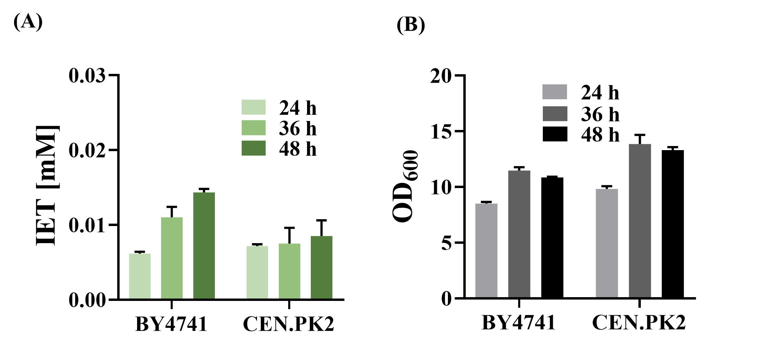

Fig. S2. Comparison of BY4741 and CEN.PK2-1D for the production of IET when cultured in the SC medium. (A) IET titer and (B) OD₆₀₀.

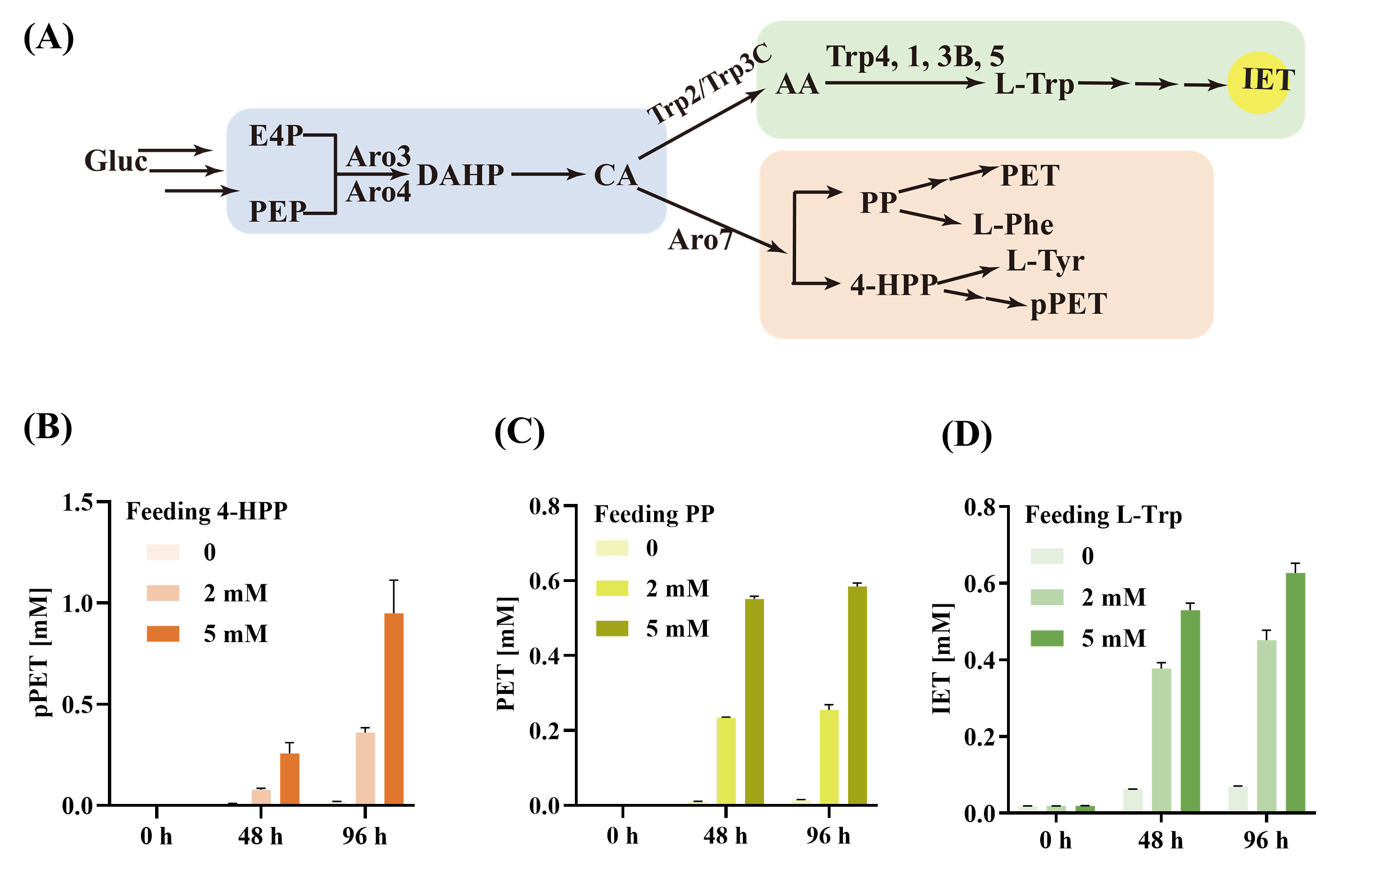

Fig. S3. Feeding experiments by adding 4-HPP, PP, or L-Trp into the SC media at 0 h. (A) The schematic diagram of the AAAs pathway. 4-HPP, PP, and L-Trp are the precursors of pPET, PET, and IET, respectively. (B) The production of pPET upon feeding 4-HPP. (C) The production of PET upon feeding PP. (D) The production of IET upon feeding L-Trp.

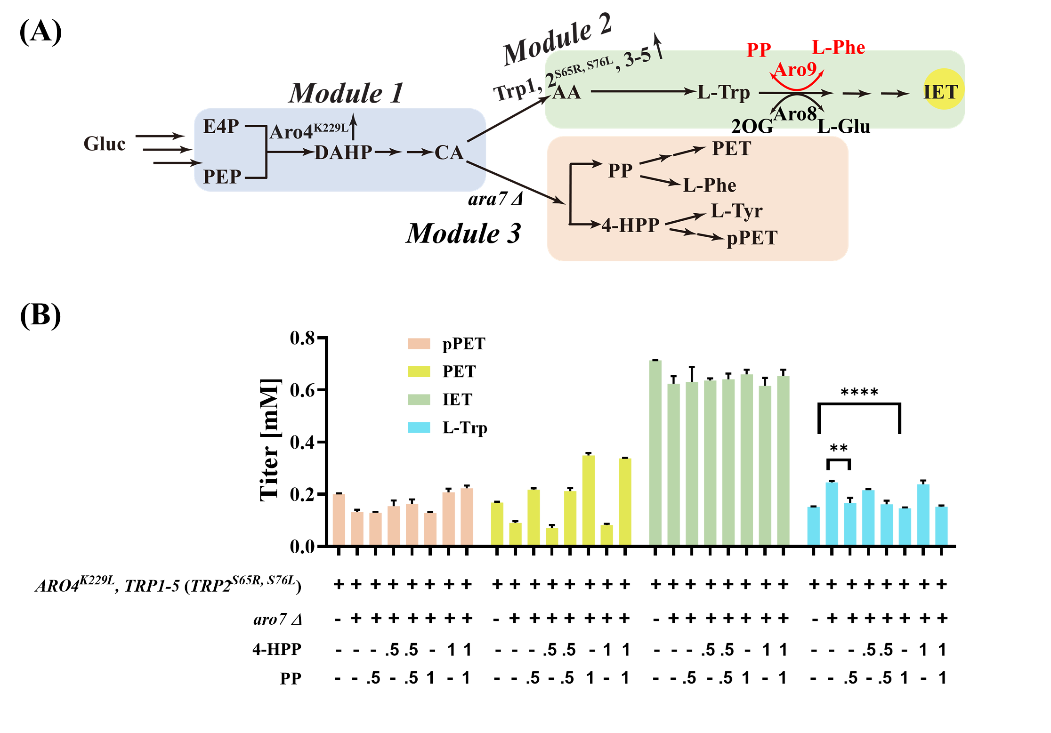
Fig. S4. Effects of PP on extracellular L-Trp accumulation. (A) The schematic diagram of the AAAs pathway indicates PP is the substrate (amino group acceptor) of the transamination reaction catalyzed by Aro9. (B). Titers of fusel alcohols and L-Trp produced by genetically modified S. cerevisiae strains after cultivated in SC media for 36 h. 4-HPP and/or PP were fed into the media at 0 h. “.5” and “1” indicate the final concentration (mM) of a compound (4-HPP or PP) fed into the media.

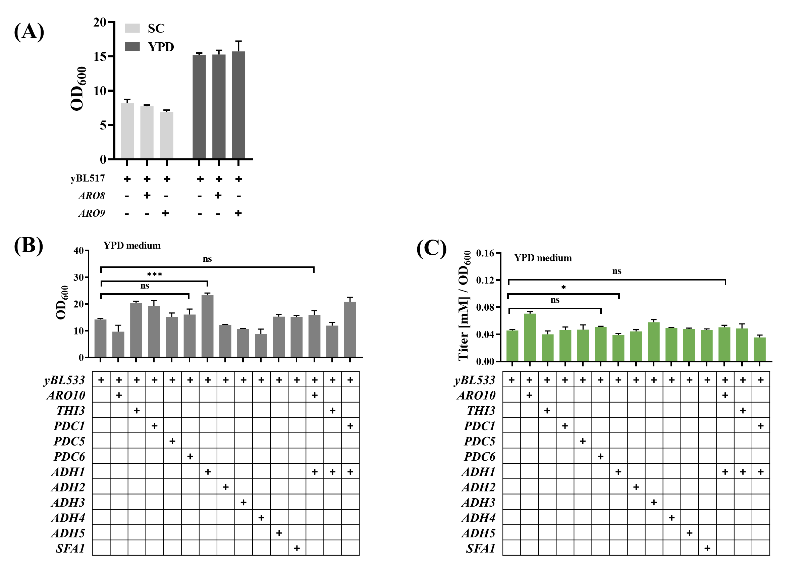
Fig. S5. Engineering the Ehrlich pathway (Module 4) for improved IET production. (A) Cell densities of yBL517 and its derived strains with upregulated ARO8 or ARO9 when cultivated in SC or YPD media. (B) Cell densities of yBL533 and its derived strains with upregulated ARO8 or ARO9 when cultivated in SC or YPD media. Cell density (B) and normalized IET production (titer [mM]/OD₆₀₀) (C) were compared among yBL533 and its derived strains with upregulated genes of the second and third steps of the Ehrlich pathway after 36 h cultivation in YPD medium.

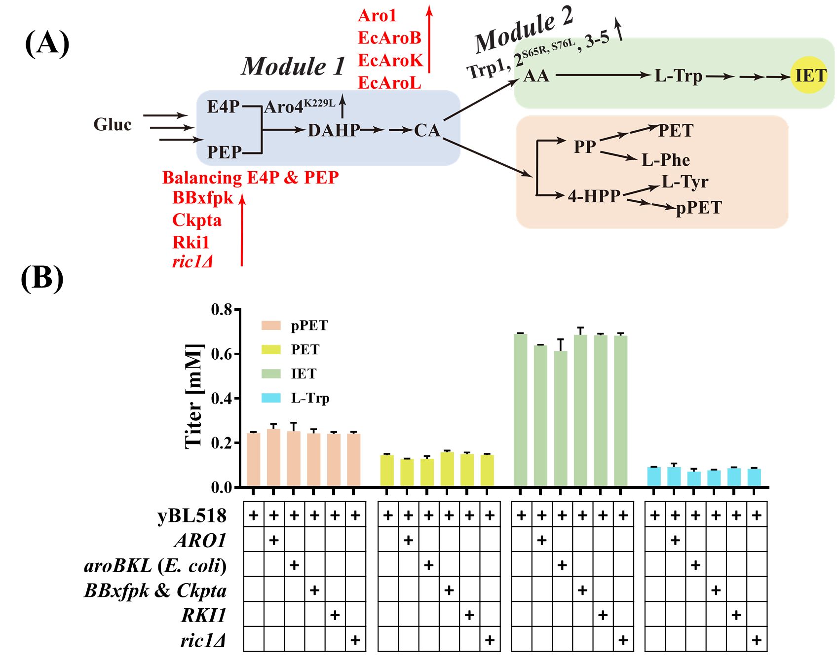
Fig. S6. Effects of engineering several miscellaneous gene targets on IET production. (A) The schematic diagram of the metabolic pathways of S. cerevisiae. Targets to be modified are highlighted in red. (B) Effects of overexpressing the endogenous ARO1 and RKI1, aroB, aroK, and aroL from E.coli, BBxfpk from Bifidobacterium breve and Ckpta from Clostridium kluyveri, as well as ric1Δ on the production of fusel alcohols. The parent strain used is yBL518 that overexpresses ARO4^{K229L}, TRP1, TRP2^{S65R, S76L}, TRP3-5. Yeast strains were cultivated in SC medium for 36 h.

Supplementary references
1. Lee ME, DeLoache WC, Cervantes B, Dueber JE. A highly characterized yeast toolkit for modular, multipart assembly. ACS Synth Biol. 2015;4:975–86.
2. Brachmann CB, Davies A, Cost GJ, Caputo E, Li J, Hieter P, et al. Designer deletion strains derived from Saccharomyces cerevisiae S288C: A useful set of strains and plasmids for PCR-mediated gene disruption and other applications. Yeast. 1998;14:115–32.
3. Entian KD, Kötter P. 25 yeast genetic strain and plasmid collections. Methods Microbiol. 2007. p. 629–66.

