Optimizing Phaeodactylum tricornutum Cultivation: Integrated Strategies for Enhancing Biomass, Lipid, and Fucoxanthin Production
Mostafa Elshobary^{1,2}, Walaa A. Abo-Shanab¹, Stephan Ende², Mohammed Alquraishi³, Rania A. El-Shenody¹
¹ Botany and Microbiology Department, Faculty of Science, Tanta University, 31527 Tanta, Egypt.
² Aquaculture Research, AWI – Helmholtz Centre for Polar and Marine Research, Am Handelshafen, 27570 Bremerhaven, Germany
³ Department of Community Health Sciences, College of Applied Medical Sciences, King Saud University, 11421 Riyadh, Saudi Arabia

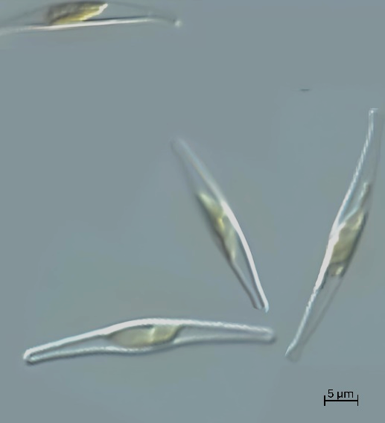
Fig.S1. Light microscopic images of cell morphology of the isolated P. tricornutum, Scale bars: 5 μm.

Table S1. F/2 medium composition
Nutrients | concentrations
NaNO₃ | 880 μM
NaH₂PO₄ | 36 μM
Na₂SiO₃ | 140 μM
FeCl₃ | 12 μM
CuSO₄ | 41 μM
ZnSO₄ | 76 μM
MnSO₄ | 940 μM
Na₂MoO₄ | 37 μM
CoCl₂ | 37 μM
vitamins | (Thiamin HCl (200 mg L⁻¹), Cyanocobalamin (10 mg L⁻¹) and Biotin (100 mg L⁻¹)

Table S2 Different Exp.s of optimized media consists of different concentrations of major nutrients [Nitrogen (N): Zero-N, −50%N%, +50%N; Phosphorus (P): Zero-P, −50%P, P+50%P; Silicate (Si): Si-Zero, −50%Si, +50%Si and glycerol concentration of (0.5, 1, 1.5, and 2 g L⁻1)], different glycerol concentrations (0.5ml, 1ml, 1.5ml and 2ml) and diﬀerent light regimes (WH; white high, WL; while low, BH; blue high; BL; blue low; GH; green high; GL; green low; RH; red high and RL; red low) compared with control F/2 media for cultivation of P. tricornutum
 | Factors
Experiments | Nitrate | Phosphate | Silicate | Glycerol (g)
Control Exp. 1 | 880 μM | 36 μM | 140 μM | -
Exp. 2 | +50 (1320 μM) | 36 μM | 140 μM | -
Exp. 3 | -50 (440 μM) | 36 μM | 140 μM | -
Exp. 4 | Zero | 36 μM | 140 μM | -
Exp. 5 | 880 μM | +50 (54 μM) | 140 μM | -
Exp. 6 | 880 μM | -50 (18 μM) | 140 μM | -
Exp. 7 | 880 μM | Zero | 140 μM | -
Exp. 8 | 880 μM | 36 μM | +50 (210 μM) | -
Exp. 9 | 880 μM | 36 μM | -50 (70 μM) | -
Exp. 10 | 880 μM | 36 μM | Zero | -
Exp. 11 | 880 μM | 36 μM | 140 μM | 0.5
Exp. 12 | 880 μM | 36 μM | 140 μM | 1
Exp. 13 | 880 μM | 36 μM | 140 μM | 1.5
Exp. 14 | 880 μM | 36 μM | 140 μM | 2

Correspondance: mostafa.elshobary@awi.de; mostafa_elshobary@science.tanta.edu.eg (M. Elshobary) Aquaculture Research, AWI – Helmholtz Centre for Polar and Marine Research, Am Handelshafen, 27570 Bremerhaven, Germany

