Supplementary Information:
Structure-function relationships in unspecific peroxygenases revealed by a comparative study of their action on the phenolic lignin monomer 4-propylguaiacol
Marta Barros-Reguera,^{1*} Esteban Lopez-Tavera,¹ Gabriela Schröder,¹ Iván Ayuso-Fernández,^{1,2} Vincent G.H. Eijsink,¹ and Morten Sørlie^{1*}
¹ Faculty of Chemistry, Biotechnology and Food Science, Norwegian University of Life Sciences (NMBU), 1432, Ås, Norway.
²Margarita Salas Center for Biological Research, C. Ramiro de Maeztu, 9, 28040 Madrid, Spain.

*Correspondence to: Marta Barros-Reguera (marta.barros@nmbu.no) and Morten Sørlie (morten.sorlie@nmbu.no)

Table S1. List of selected UPOs. A total of 19 UPOs were selected from a total of 2,044 UPOs in the 3DM database, covering five clades in the phylogenetic tree (see Fig. 1 of the main manuscript). The criteria used when selecting these UPOs were biased towards selecting well-characterized UPOs (i.e., those with solved crystal structures)[1–4] and UPOs that had previously been recombinantly expressed[5–9]. To include more diversity, one uncharacterized UPO (MphUPO) was included.
Name | UniProt |  | NCBI | Organism | Long/short | MW (kDa) |  | Phylogenetic clade | Reference
AacUPO |  | A0A1L9X7H3 | XP_020060613.1 | Aspergillus aculeatus | Short | 28.4 | Clade V |  | Swoboda, 2023[5]
AbrUPO-I |  | A0A1L9U8A9 | OJJ67899.1 | Aspergillus brasiliensis | Short | 27.8 | Clade V |  | Ebner, 2023[6]
AbrUPO-II |  | A0A1L9UNI9 | OJJ73116.1 | Aspergillus brasiliensis | Short | 27.3 | Clade V |  | Schmitz, 2023[7]
AluUPO |  | A0A7R7WEQ5 | BCS01637.1 | Aspergillus kawachii | Short | 27.7 | Clade V |  | Swoboda, 2023[5]
AtuUPO |  | A0A100IPW8 | GAQ45152.1 | Aspergillus niger | Short | 27.8 | Clade V |  | Swoboda, 2023[5]
CabUPO-III |  | A0A4Q2DAL3 | RXW15716.1 | Candolleomyces aberdarensis | Long | 39.4 | Clade I |  | Swoboda, 2023[5]
CmaUPO-I |  | A0A5C3KVD0 | TFK24496.1 | Coprinopsis marcescibilis | Long | 39.1 | Clade I |  | Ebner, 2023[6]
CviUPO |  | UPI002016A77D |  | Collariella virescens | Short | 25.9 | Clade II |  | Linde, 2020[1]
DspUPO-I |  | A0A1Y2X6J4 | OTB17553.1 | Daldinia sp. EC12 | Short | 27.3 | Clade V |  | Swoboda, 2023[5]
GmaUPO-II |  | A0A067SWH8 | KDR72024.1 | Galerina marginata | Long | 38.3 | Clade I |  | Ma, 2022[8]
HspUPO |  | A0A1Y2TH07 | OTA57433.1 | Hypoxylon sp. EC38 | Short | 26.4 | Clade V |  | Rotilio, 2021[2]
LspUPO-II |  | A0A137QW42 | KXN91485.1 | Leucoagaricus sp. SymC.cos | Long | 38.7 | Clade I |  | Ebner, 2023[6]
MorUPO |  | A0A9P7RSA8 | XP_043005295.1 | Marasmius oreades | Short | 25.0 | Clade III |  | Swoboda, 2023[5]
MphUPO |  | K2QYP1 | EKG15041.1 | Macrophomina phaseolina | Short | 27.0 | Clade IV |  | Putative UPO
MroUPO |  | UPI002016A75C |  | Marasmius rotula | Short | 25.9 | Clade III |  | Grobe, 2011[4,4,4]
PaDa-I |  |  |  | Agrocybe aegerita | Long | 35.9 | Clade I |  | Molina-Espeja, 2015[3]
PanUPO |  | B2B6C6 | XP_001911526.1 | Podospora anserina | Short | 28.3 | Clade II |  | Swoboda, 2023[5]
RneUPO |  | A0A1W2TUZ6 | GAP92448.1 | Rosellinia necatrix | Short | 26.4 | Clade V |  | Swoboda, 2023[5]
TteUPO |  | G2R8M6 | XP_003654578.1 | Thielavia terrestris | Short | 26.6 | Clade V |  | Pullmann, 2021^{[9]}

Table S2. Selected docking solutions from docking simulations for illustrative purposes. Docking simulations were conducted using the Vina algorithm in YASARA Structure (YASARA Biosciences GmbH, Austria), with energy-minimization of all structures prior to docking. The side chains of residues within 4–5 Å of the substrate were set as flexible. An initial docking simulation identified residues within this distance by selecting solutions where the substrate was positioned near the heme. A subsequent simulation was then performed, allowing the side chains of these residues to remain flexible. The docking experiments generally yielded multiple solutions, with binding energies ranges displayed in the first column. The solutions presented, primarily for illustrative purposes, were selected based on observed product profiles, where the oxidized carbon was positioned close to the heme. Specifically: ring hydroxylation (benzene ring near the iron atom), α-, β-, and γ-carbon hydroxylation (propyl chain near the iron atom); and phenol oxidation representing the peroxidase reaction (phenol group near the iron atom). The selected solutions were among the top seven out of a total of twenty solutions, each with a binding energy of at least 4.95 kcal/mol. It is important to note that, although some selected poses appear later in the docking results, earlier poses were not always catalytically relevant due to the substrate's misalignment, preventing close contact with the heme group.
 | Binding energy range (kcal/mol) | Selected solution
 | Binding energy range (kcal/mol) | N. pose | Possible catalytic solution | Binding energy (kcal/mol)
PaDa-I | 6.06-(-14.58) | 7 | Phenol oxidation | 5.49
CviUPO | 5.44-3.09 | 4 | Phenol oxidation | 4.95
MroUPO | 5.75-3.18 | 4 | Phenol oxidation | 5.65
MphUPO | 7.45-(-3.85) | 8 | Phenol oxidation | 6.86
AbrUPO-I | 6.83-0.54 | 3 | Demethylation | 6.28
AtuUPO | 6.94-(-0.18) | 1 | Ring hydroxylation | 6.94
HspUPO | 6.06-(-6.59) | 2 | β-carbon hydroxylation | 5.82
RneUPO | 6.97-3.79 | 2 | α-Carbon hydroxylation | 6.64

Figure S1. Percent identity matrix generated using Clustal 2.1. Pairwise sequence identities among the 19 different UPOs are shown. A more intense red coloration indicates a higher sequence identity.

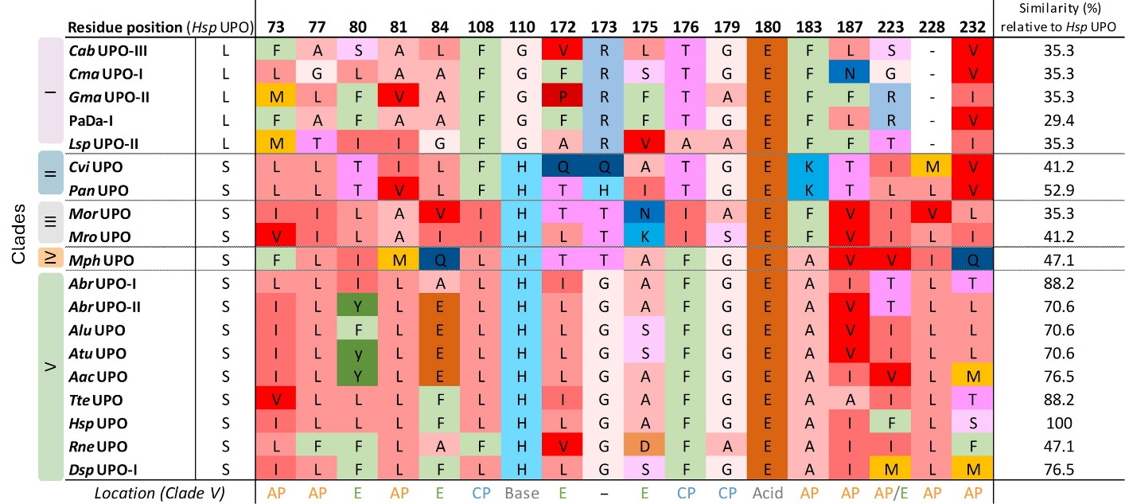
Figure S2. Structure-based sequence alignment for active site residues retrieved from 3DM. Residues were selected based on the catalytic center of HspUPO. Residue numbering corresponds to HspUPO, and residues are colored based on their chemical properties. The overall similarity (%) of these active site residues relative to HspUPO is indicated in the right column. UPOs are grouped according to their phylogenetic clades, as indicated on the left. At the bottom, the structural location of each residue for clade V is described, with labels corresponding the aliphatic pocket (AP), the entrance (E), the catalytic pocket (CP), and the acid-base pair: Glu180 for all UPOs, and His110 in short UPOs and Arg173 in long UPOs (Clade I).

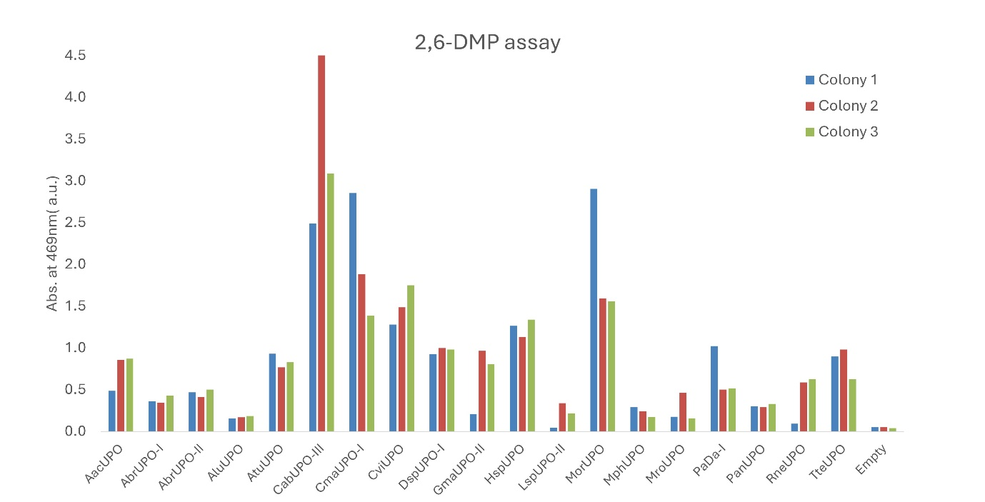
Figure S3. Initial assessment of activity using the 2,6-DMP Assay. The assay was performed using the supernatants of small-scale cultures of three transformants per UPO, to evaluate protein expression yields. The reaction conditions were as follows: 1 mM 2,6-DMP, 2 mM H₂O₂, 100 mM potassium phosphate buffer (pH 7.0), and 96 µL supernatant in a total reaction volume of 200 µL. The graph shows the absorbance at 469 nm recorded 160 seconds after starting the reaction. “Empty” represents the negative control.

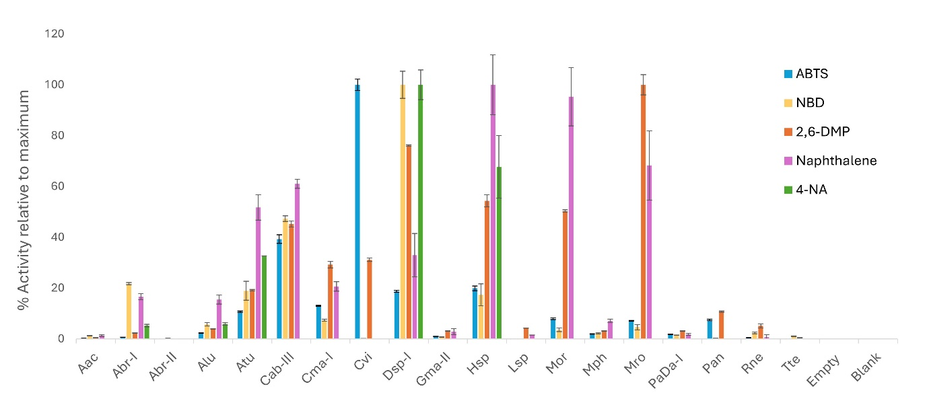Figure S4. Colorimetric assays for the 19 selected UPOs after partial purification. Values correspond to the slope of color formation over time relative to the maximum slope observed for that assay. Three independent reactions were performed, and standard deviations are shown. The concentrated and buffer-exchanged supernatant from the K.phaffii culture transformed with the plasmid lacking the UPO gene was used as a background control (referred to as 'Empty'). The blank corresponds to the reaction mix with MilliQ water instead of UPO. Note that the UPOs were only partially purified, thus, this graph primarily illustrates differences in substrate specificity. The UPO concentration was 0.05 µM UPO for ABTS, NBD and 4-NA assays, and 0.1 µM UPO for the 2,6-DMP and naphthalene assays. The NBD, 2,6-DMP and 4-NA assays were conducted at pH 7.0, whereas the ABTS and naphthalene assays were performed at pH 4.5. Abbreviations: ABTS, 2,2′-azino-bis(3-ethylbenzothiazoline-6-sulfonic acid) diammonium salt; NBD, 5-nitro-1,3-benzodioxole; 2,6-DMP, 2,6-dimethoxyphenol; 4-NA, 4-nitroanisole.

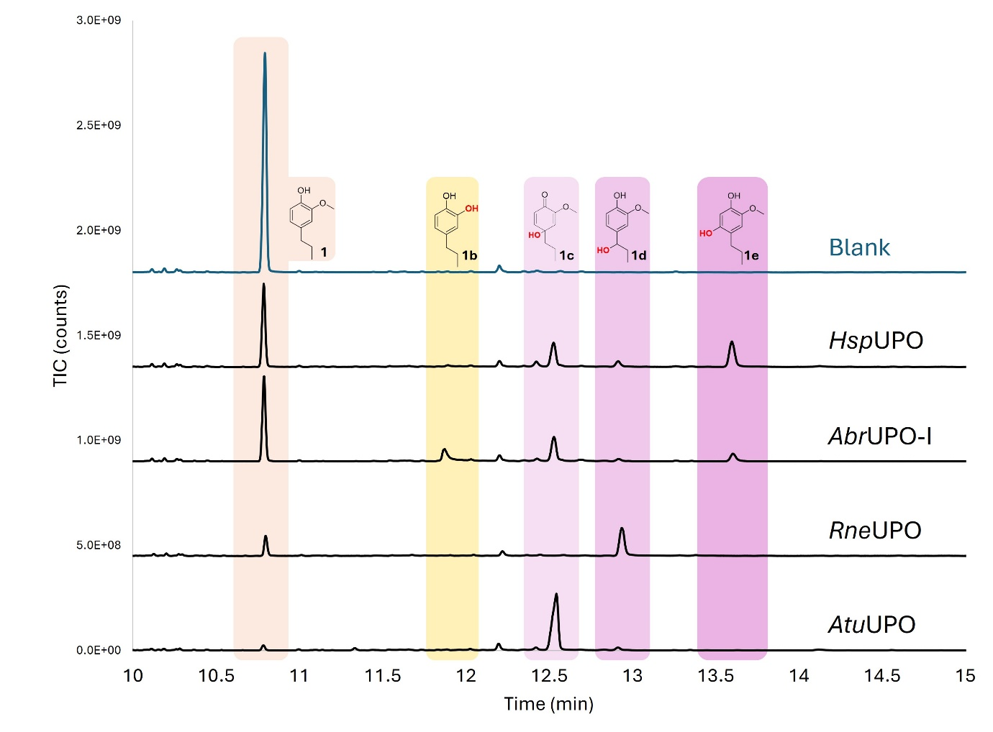
Figure S5. GC–MS chromatograms for various reactions. The blue trace represents the blank (reaction mixture without UPO) at pH 8.0. Reactions with HspUPO, AtuUPO, and AbrUPO-I were performed at pH 8.0 in the presence of ascorbic acid, whereas the RneUPO reaction was conducted at pH 3.5 without ascorbic acid. The substrate (1) eluted at 10.80 min; compound 1a (not shown) at 11.66 min; compound 1b at 11.88 min; compound 1c at 12.52 min; compound 1d at 12.92 min; and compound 1e at 13.62 min.

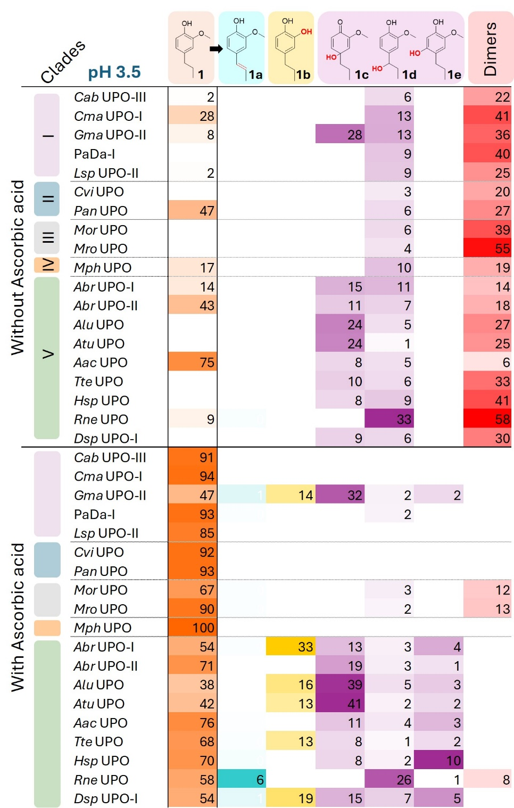

Figure S6. Heatmap for the catalytic activity of 19 UPOs on 4-propylguaiacol at pH 3.5, in the absence or presence of ascorbic acid. Values represent the percentages of products and remaining substrate (orange) relative to the total amount of substrate added. Color intensities are proportional to the values, with darker tones corresponding to higher values. Each column represents a different compound, as indicated at the top of the Figure. Compound concentrations were determined by external calibration curves using commercial standards and analyzed via GC-MS. A standard for compound 1c (m/z 182) was not available; this compound was quantified using the calibration curve established for compound 1d. Some of the products appeared as dimers identified by the m/z 330 in GC-MS. The values for the dimers do not represent actual product levels but represent the peak area of dimer peaks relative to the peak area of the total amount of substrate added. Thus, these are rather arbitrary numbers that should only be used for comparing UPOs, and not for absolute product quantification or calculating mass balances. Also note that other, non-detected products will be generated in some of the reactions even in reactions with ascorbic acid. The UPOs are grouped according to their respective phylogenetic clades (Fig. 1), as indicated by the color code to the left of the Figure. Reaction conditions: Final volume of 210 µL; 1 µM UPO; 50 mM ammonium bicarbonate buffer (pH 3.5); 2 mM 4-PG; 2 mM hydrogen peroxide, 16 mM ascorbic acid, where indicated; the reactions were incubated at 25°C with shaking at 700 rpm for 1 hour.
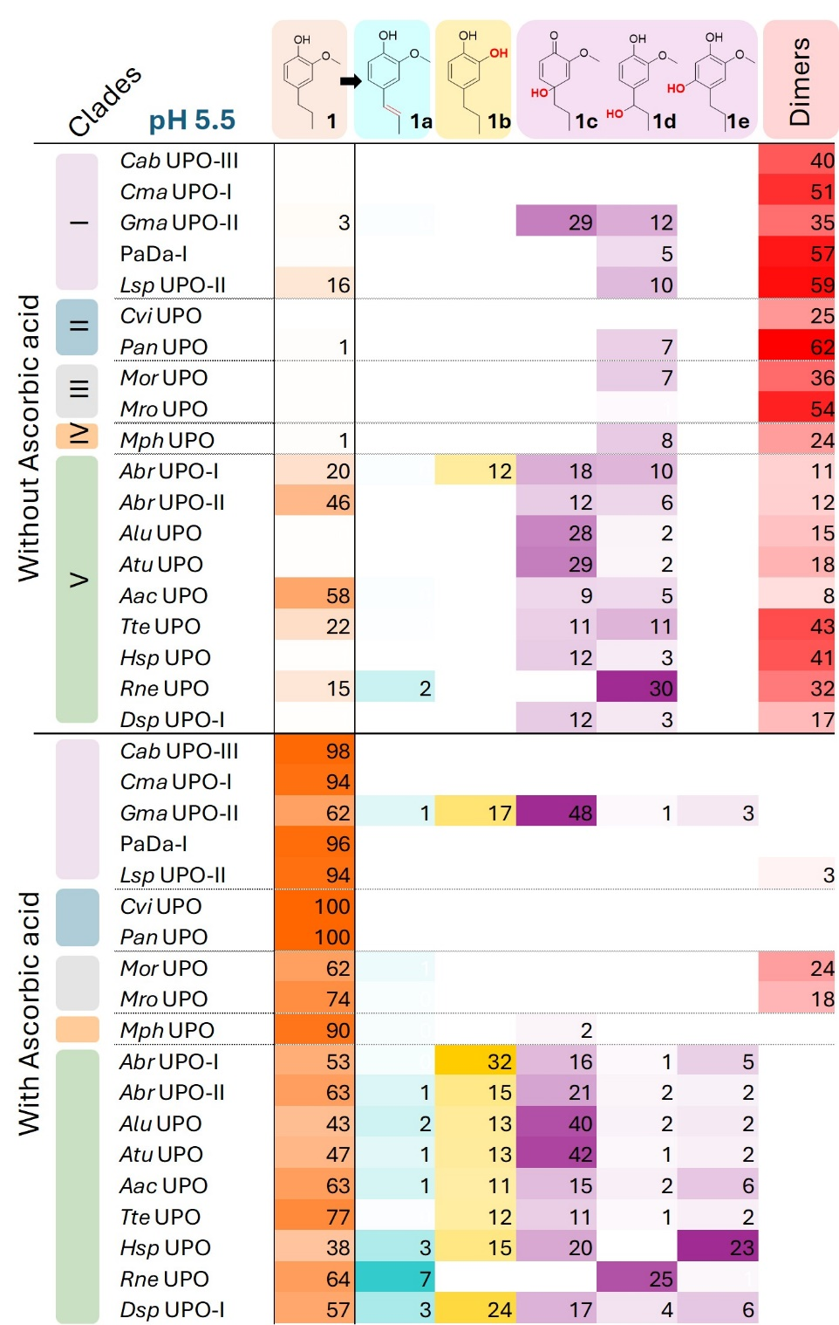

Figure S7. Heatmap for the catalytic activity of 19 UPOs on 4-propylguaiacol at pH 5.5, in the absence or presence of ascorbic acid. Values represent the percentages of products and remaining substrate (orange) relative to the total amount of substrate added. Color intensities are proportional to the values, with darker tones corresponding to higher values. Each column represents a different compound, as indicated at the top of the Figure. Compound concentrations were determined by external calibration curves using commercial standards and analyzed via GC-MS. A standard for compound 1c (m/z 182) was not available; this compound was quantified using the calibration curve established for compound 1d. Some of the products appeared as dimers identified by the m/z 330 in GC-MS. The values for the dimers do not represent actual product levels but represent the peak area of dimer peaks relative to the peak area of the total amount of substrate added. Thus, these are rather arbitrary numbers that should only be used for comparing UPOs, and not for absolute product quantification or calculating mass balances. Also note that other, non-detected products will be generated in some of the reactions even in reactions with ascorbic acid. The UPOs are grouped according to their respective phylogenetic clades (Fig. 1), as indicated by the color code to the left of the Figure. Reaction conditions: Final volume of 210 µL; 1 µM UPO; 50 mM ammonium bicarbonate buffer (pH 5.5); 2 mM 4-PG; 2 mM hydrogen peroxide, 16 mM ascorbic acid, where indicated; the reactions were incubated at 25°C with shaking at 700 rpm for 1 hour.

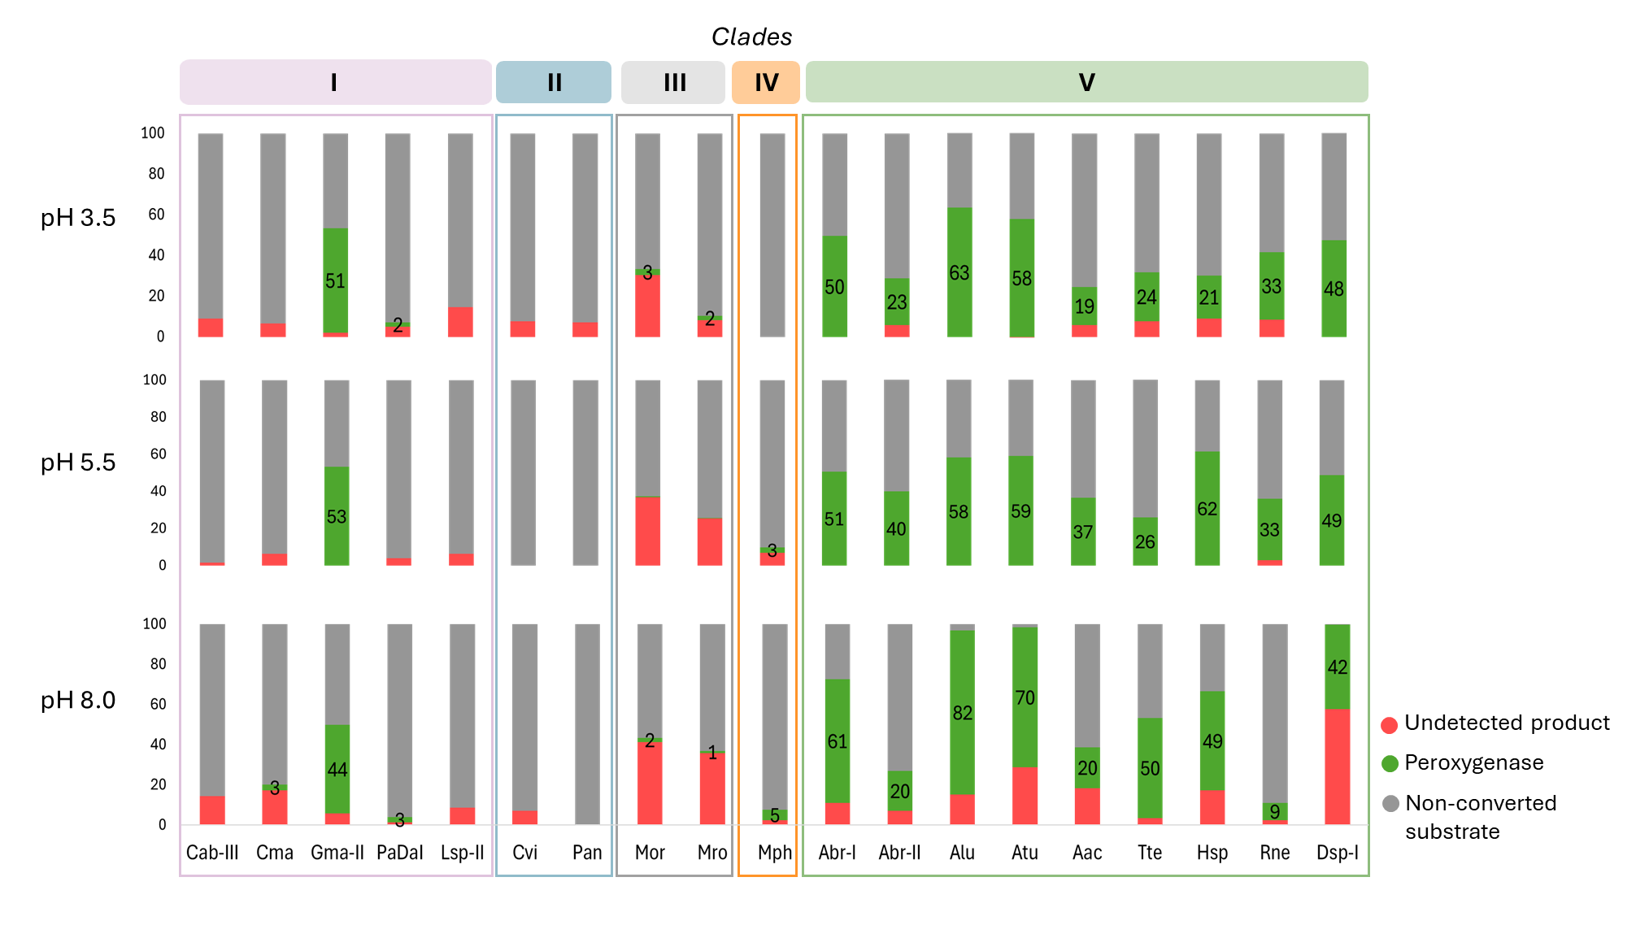Figure S8. Fractions of peroxygenase conversion and non-converted substrate in reactions with ascorbic acid for 19 different UPOs at three different pH values. The y-axis represents the percentage relative to the total amount of substrate added. Compound concentrations were determined using external calibration curves made with commercial standards and compounds were analyzed using GC-MS. The peroxygenase activity (green) represents the sum of all detected monomeric products. The undetected product (red) represents the fraction of the consumed substrate that was not accounted for by the quantified peroxygenase products. This fraction may correspond to peroxidase-derived products that were not scavenged by ascorbic acid (e.g., dimers observed in reactions with MorUPO, MroUPO, AtuUPO and HspUPO) or to compounds that remained undetectable by GC-MS. See Fig. 3 and Figs. S6 & S7 for the underlying data and more details on quantification. The various phylogenetic clades (Fig. 1) are indicated in the top row of the Figure.

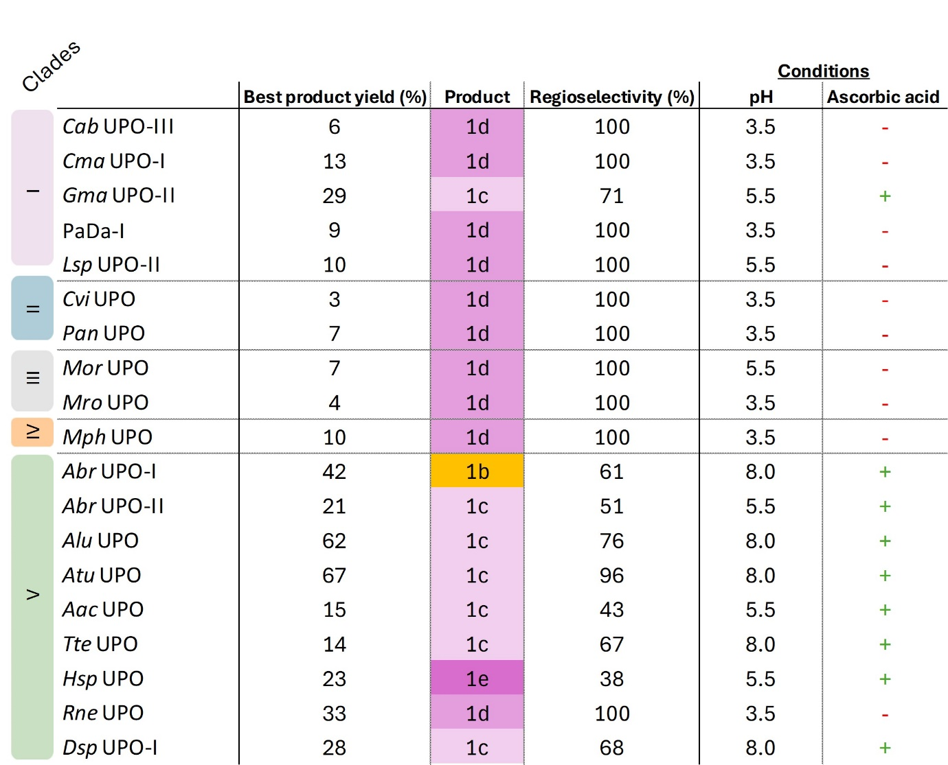
Figure S9. Overview of reactions with the highest yield of a peroxygenase product for each UPO. Yields (in percentage) represent the amount of product relative to the total amount of substrate added. Different products are represented in distinct colors: hydroxylation products are shown in shades of purple, while demethylation products are shown in orange. Regioselectivity (in percentage) is expressed as the amount of a product relative to the total amount of peroxygenase products.

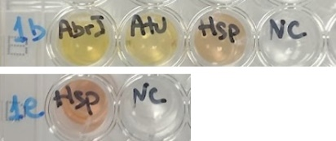
Figure S10. Polymerization of compounds 1b and 1e, indicated by appearance of red-brownish color. Reactions were performed without ascorbic acid using compounds 1b and 1e as substrates with different UPOs. Reactions were performed in ammonium acetate buffer (50 mM, pH 5.5), with 2 mM substrate and 2 mM hydrogen peroxide, and were incubated at 25 °C, shaking at 700 rpm for 1 hour. Nc, negative control (MQ water instead of UPO).

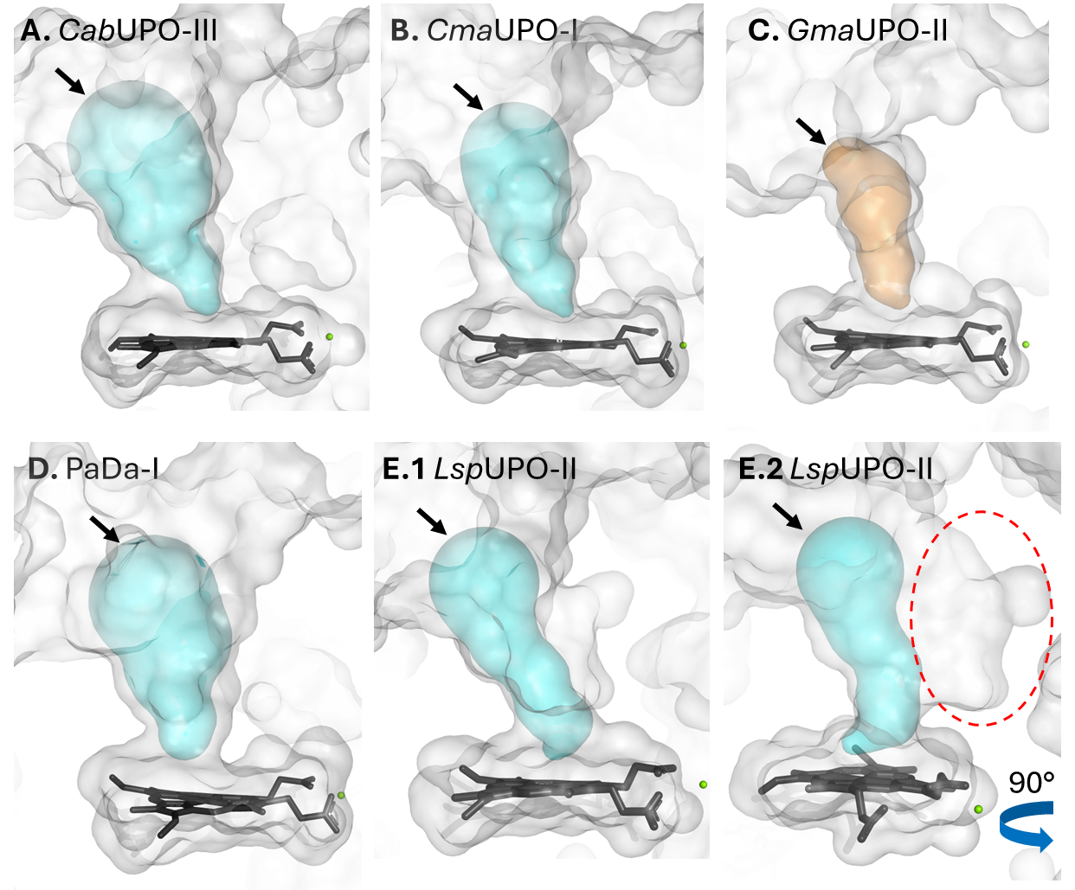
Figure S11. Access channel of UPOs from Clade I. Access channels (cyan and orange surface) were computed using Caver. UPO surfaces represented on gray. The access channel for GmaUPO-II (C) is highlighted in orange to emphasize its narrower nature. Although LspUPO-II (E1) may initially appear to possess a narrow access channel based on the Caver surface analysis, the red dashed circle indicates a broader cavity that was not captured by Caver (E2). Approximate access points for the substrates are indicated by a black arrow. All structures were modeled using AlphaFold3, except for PaDa-I (PDB ID: 6EKZ).

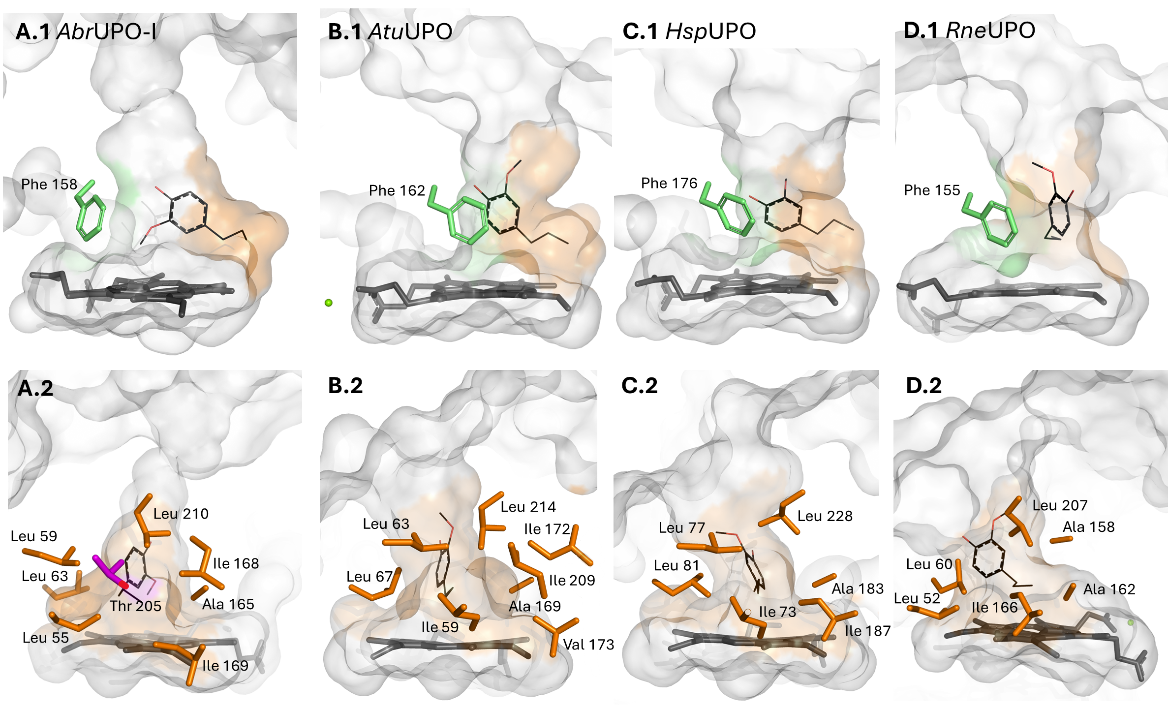
Figure S12. Key features of the catalytic center of UPOs from Clade V: a phenylalanine and the aliphatic pocket. The conserved phenylalanine is highlighted in green (panels 1), while the aliphatic pocket is shown in orange (panels 2). 4-PG (black) was docked using the Vina algorithm in YASARA. The docking solutions were selected among energetically favorable poses primarily for illustrative purposes, based on observed product profile, where the oxidized carbon was positioned close to the heme. All structures were modeled by AlphaFold3, except for HspUPO (PDB ID: 7O1R).

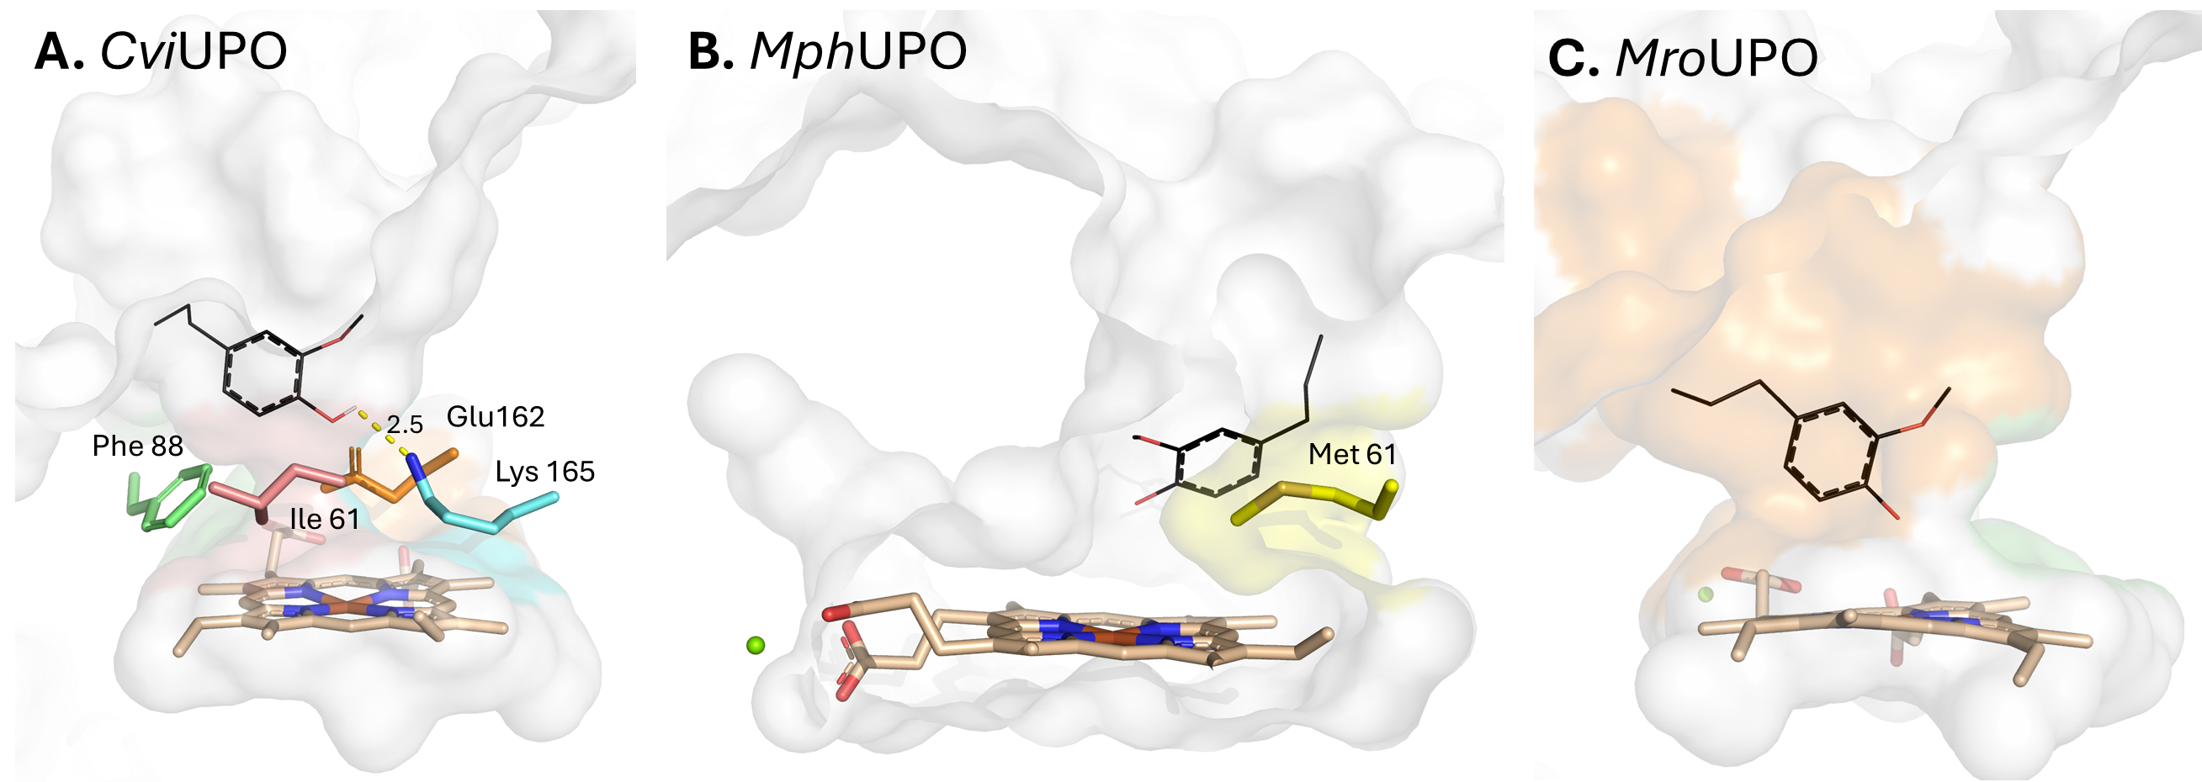
Figure S13. Key features of the catalytic pocket of UPOs with low peroxygenase activity for 4-PG. The aliphatic pocket is absent in the three representative UPOs from Clades II–IV. CviUPO (A) (Clade II) features four bulky residues (Ile61, Phe88, Glu162, and Lys165) in close proximity to the heme, potentially hindering close interaction between 4-PG and the heme. MphUPO (B) (Clade IV) contains Met61, which introduces steric hindrance, which may prevent 4-PG from establishing close contact with the heme. The access channel of MroUPO (C) (Clade III), despite being primarily composed of aliphatic residues, features a funnel-shaped cavity that lacks a constrained aliphatic pocket, which could otherwise retain 4-PG in close proximity to the heme. The docked substrate, 4-PG, is shown in black. The docking solutions were selected primarily for illustrative purposes, based on observed product profile, where the oxidized carbon was positioned close to the heme. The structures used include CviUPO (PDB ID: 7ZCL), MphUPO (AlphaFold model) and MroUPO (PDB ID: 7ZBP).

References
1. Linde D, Olmedo A, González-Benjumea A, Estévez M, Renau-Mínguez C, Carro J, et al. Two new unspecific peroxygenases from heterologous expression of fungal genes in Escherichia coli. Applied and Environmental Microbiology. 2020;86:e02899-19. https://journals.asm.org/doi/full/10.1128/aem.02899-19
2. Rotilio L, Swoboda A, Ebner K, Rinnofner C, Glieder A, Kroutil W, et al. Structural and biochemical studies enlighten the unspecific peroxygenase from Hypoxylon sp. EC38 as an efficient oxidative biocatalyst. ACS Catal. 2021;11:11511–25. https://doi.org/10.1021/acscatal.1c03065
3. Molina-Espeja P, Ma S, Mate DM, Ludwig R, Alcalde M. Tandem-yeast expression system for engineering and producing unspecific peroxygenase. Enzyme and Microbial Technology. 2015;73–74:29–33. https://www.sciencedirect.com/science/article/pii/S0141022915000484
4. Gröbe G, Ullrich R, Pecyna MJ, Kapturska D, Friedrich S, Hofrichter M, et al. High-yield production of aromatic peroxygenase by the agaric fungus Marasmius rotula. AMB Expr. 2011;1:31. https://doi.org/10.1186/2191-0855-1-31
5. Swoboda A, Pfeifenberger LJ, Duhović Z, Bürgler M, Oroz-Guinea I, Bangert K, et al. Enantioselective high-throughput assay showcased for the identification of (R)- as well as (S)-selective unspecific peroxygenases for C−H oxidation. Angewandte Chemie International Edition. 2023;62:e202312721. https://onlinelibrary.wiley.com/doi/abs/10.1002/anie.202312721
6. Ebner K, Pfeifenberger LJ, Rinnofner C, Schusterbauer V, Glieder A, Winkler M. Discovery and Heterologous Expression of Unspecific Peroxygenases. Catalysts. 2023;13:206. https://www.mdpi.com/2073-4344/13/1/206
7. Schmitz F, Koschorreck K, Hollmann F, B. Urlacher V. Aromatic hydroxylation of substituted benzenes by an unspecific peroxygenase from Aspergillus brasiliensis. Reaction Chemistry & Engineering. 2023;8:2177–86. https://pubs.rsc.org/en/content/articlelanding/2023/re/d3re00209h
8. Ma Y, Liang H, Zhao Z, Wu B, Lan D, Hollmann F, et al. A Novel Unspecific peroxygenase from Galatian marginata for biocatalytic oxyfunctionalization reactions. Molecular Catalysis. 2022;531:112707. https://www.sciencedirect.com/science/article/pii/S2468823122005934
9. Püllmann P, Knorrscheidt A, Münch J, Palme PR, Hoehenwarter W, Marillonnet S, et al. A modular two yeast species secretion system for the production and preparative application of unspecific peroxygenases. Commun Biol. 2021;4:1–20. https://www.nature.com/articles/s42003-021-02076-3

