Directed evolution of α-ketoisovalerate decarboxylase for improved isobutanol and 3-methyl-1-butanol production in cyanobacteria

Hao Xie^{1,2}, Afshan Begum³, Laura H. Gunn^{3,4} and Peter Lindblad¹*

¹Microbial Chemistry, Department of Chemistry-Ångström Laboratory, Uppsala University, Uppsala, Sweden
²College of Bioengineering, Sichuan University of Science & Engineering, Yibin, Sichuan, China
³Department of Cell and Molecular Biology, Uppsala University, Uppsala, Sweden
⁴Plant Biology Section, Cornell University, Ithaca, New York, USA

*Corresponding author: Peter Lindblad, peter.lindblad@kemi.uu.se

Additional file 1

Figures S1 - S4
Tables S1 - S2

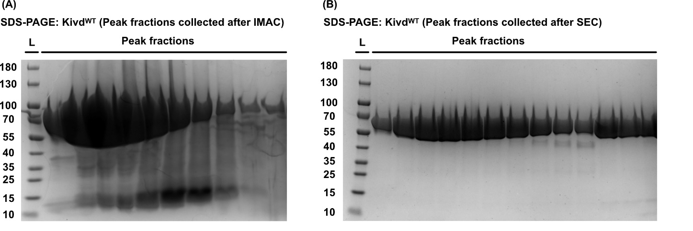
Fig. S1: SDS-PAGE analysis of protein Kivd^{WT} in different steps during purification. (A) SDS-PAGE analysis of Kivd^{WT} with a H₆-Ub tag after IMAC (immobilized metal affinity chromatography) step (B) SDS-PAGE analysis of Kivd^{WT} without a H₆-Ub tag after SEC (size-exclusion chromatography) step. Five microliter from each fraction were loaded for analysis. L, ladder (in kDa). Protein size: Kivd^{WT} with H₆-Ub tag, 72 kDa; Kivd^{WT} without H₆-Ub tag, 61 kDa.

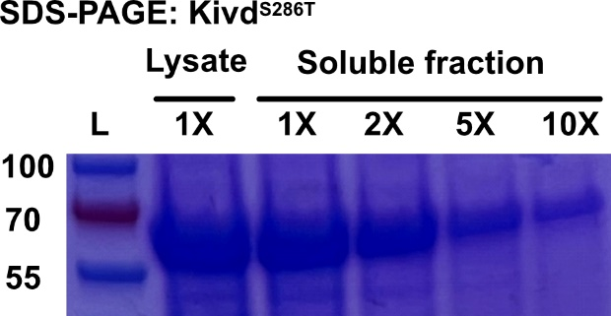
Fig. S2: SDS-PAGE analysis of the recombinant protein Kivd^{S286T} extracted from E. coli BL21(DE3) cells. Cell pellet from 1 mL of cell culture was lysed with 100 μL B-PER complete reagent. The resulting lysate and the soluble fraction after centrifugation were loaded for analysis. For soluble fraction, four different dilutions were applied. 1X, no dilution; 2X, two-time dilution; 5X, five-time dilution; 10X, ten-time dilution. L, ladder (in kDa). Protein size: Kivd^{S286T}, 61 kDa.

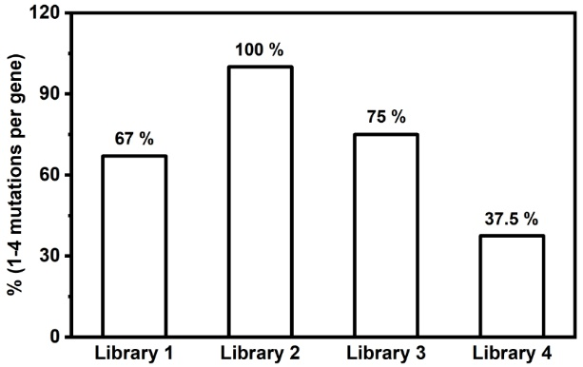
Fig. S3: Four individual random mutagenesis libraries constructed for high-throughput screening. The percentage of kivd^{S286T} variants with 1 - 4 point substitutions are presented for individual libraries.
Fig. S4: Isobutanol (IB) and 3-methyl-1-butanol (3M1B) production per OD₅₉₅ of engineered E. coli strains after 24 h cultivation. Results represent the mean of three biological replicates. Error bars represent standard deviation.

Table S1. Plasmid used in this study. Expressed genes in bold.
Plasmid | Relevant characteristicsª | Reference
pHUE | pHUE_T7_RBS_H6-Ub_T_AmpR | [1]
pUC57_kivd | pUC57_RBS_H6-Ub_kivd_AmpR | This study
pUC57_ST | pUC57_RBS_H6-Ub_kivd^{S286T}_AmpR | This study
pHX_EVC | pHX_T7_RBS_T_AmpR | This study
pHX_ST | pHX_T7_RBS_ kivd^{S286T}_T_AmpR | This study
pHX_1B12 | pHX_T7_RBS_1B12_T_AmpR | This study
pHX_1C9 | pHX_T7_RBS_1C9_T_AmpR | This study
pHX_2A11 | pHX_T7_RBS_2A11_T_AmpR | This study
pHX_3C4 | pHX_T7_RBS_3C4_T_AmpR | This study
pHX_4B7 | pHX_T7_RBS_4B7_T_AmpR | This study
pHX_4H5 | pHX_T7_RBS_4H5_T_AmpR | This study
pHX_5F1 | pHX_T7_RBS_5F1_T_AmpR | This study
pHX_14G8 | pHX_T7_RBS_14G8_T_AmpR | This study
pEEK* | pEEK_Ptrc_RBS_T_KanR | Englund, E., unpublished
pEEK2_ST | pEEK2_PtrcBCD_Strep-ST_T_KanR | This study
pEEK2_1B12 | pEEK2_PtrcBCD_Strep-1B12_T_KanR | This study
pEEK2_1C9 | pEEK2_PtrcBCD_Strep-1C9_T_KanR | This study
pEEK2_2A11 | pEEK2_PtrcBCD_Strep-2A11_T_KanR | This study
pEEK2_3C4 | pEEK2_PtrcBCD_Strep-3C4_T_KanR | This study
pEEK2_4B7 | pEEK2_PtrcBCD_Strep-4B7_T_KanR | This study
pEEK2_4H5 | pEEK2_PtrcBCD_Strep-4H5_T_KanR | This study
pEEK2_5F1 | pEEK2_PtrcBCD_Strep-5F1_T_KanR | This study
pEEK2_14G8 | pEEK2_PtrcBCD_Strep-14G8_T_KanR | This study
pEEK2_T186S | pEEK2_PtrcBCD_Strep-T186S_T_KanR | This study
pEEK2_K419E | pEEK2_PtrcBCD_Strep-K419E_T_KanR | This study
pHUE_kivd | pHUE_T7_RBS_H6-Ub_kivd_T_AmpR | This study
PHUE_ST | pHUE_T7_RBS_H6-Ub_kivd^{S286T}_T_AmpR | This study
a KmR, kanamycin resistance cassette; AmpR, ampicillin resistance cassette; T, Terminator BBa_B0015

Table S2. Oligonucleotides used in this study.
Primer name | Oligonucleotide sequence
A. Primers for fragment amplification
pHX_F | Pho-CTAGCATAACCCCTTGGGG
pHX_R | Pho-TCTCCTTCTTAAAGTTAAACAAAATT
pHUE_F | CGGAGCAAAATAAAAGCTAAGAATTCGAGCTCGGTACCGTC
pHUE_R | GTAGTCGCCAACGGTGTACATGGTATATCTCCTTCTTAAAG
kivd_F | ATGTACACCGTTGGCGACTAC
kivd_R | TTAGCTTTTATTTTGCTCCG
kivd_BglII_F | TATAAGATCTATGTACACCGTTGGCGACTAC
kivd_SpeI_R | TATAACTAGTTTAGCTTTTATTTTGCTCCGCGAAC
B. Primers for E. coli colony PCR and Synechocystis colony PCR
T7_SF | GCGAAATTAATACGACTCACTATAG
VF2 | TGCCACCTGACGTCTAAGAA
VR | ATTACCGCCTTTGAGTGAGC
kivd_SR | CGTTGCCAACCCATTTCATATC

Reference:
1. Catanzariti AM, Soboleva TA, Jans DA, Board PG, Baker RT. An efficient system for high-level expression and easy purification of authentic recombinant proteins. Protein Sci. 2004;13(5):1331-9.

