Biswal et al. - Supplementary material

- Rhamnogalacturonan I is a recalcitrant pectin domain during Clostridium thermocellum-mediated deconstruction of switchgrass biomass

Ajaya K. Biswal^{1,2,5*}, Neal N. Hengge^{4,5}, Melani A. Atmodjo^{1,2,5}, Paul E. Abraham^{3,5}, Nancy L. Engle^{3,5}, Sushree S. Mohanty^{2,5}, Ian M. Black², Xiaochun Cheng^{2#}, David Ryno^{2,5}, Parastoo Azadi², Timothy J. Tschaplinski^{3,5}, Yannick J. Bomble^{4,5}, and Debra Mohnen^{1,2,5*}

¹Department of Biochemistry and Molecular Biology, University of Georgia, Athens, GA-30602, USA; ²Complex Carbohydrate Research Center, University of Georgia, Athens, GA-30602, USA; ³Biosciences Division, Oak Ridge National Laboratory, Oak Ridge, Tennessee 37830, USA ⁴Biosciences Center, National Renewable Energy Laboratory, Golden, CO 80401, USA; ⁵Center for Bioenergy Innovation, Oak Ridge National Laboratory, Oak Ridge, Tennessee 37830.
- Supplementary material:

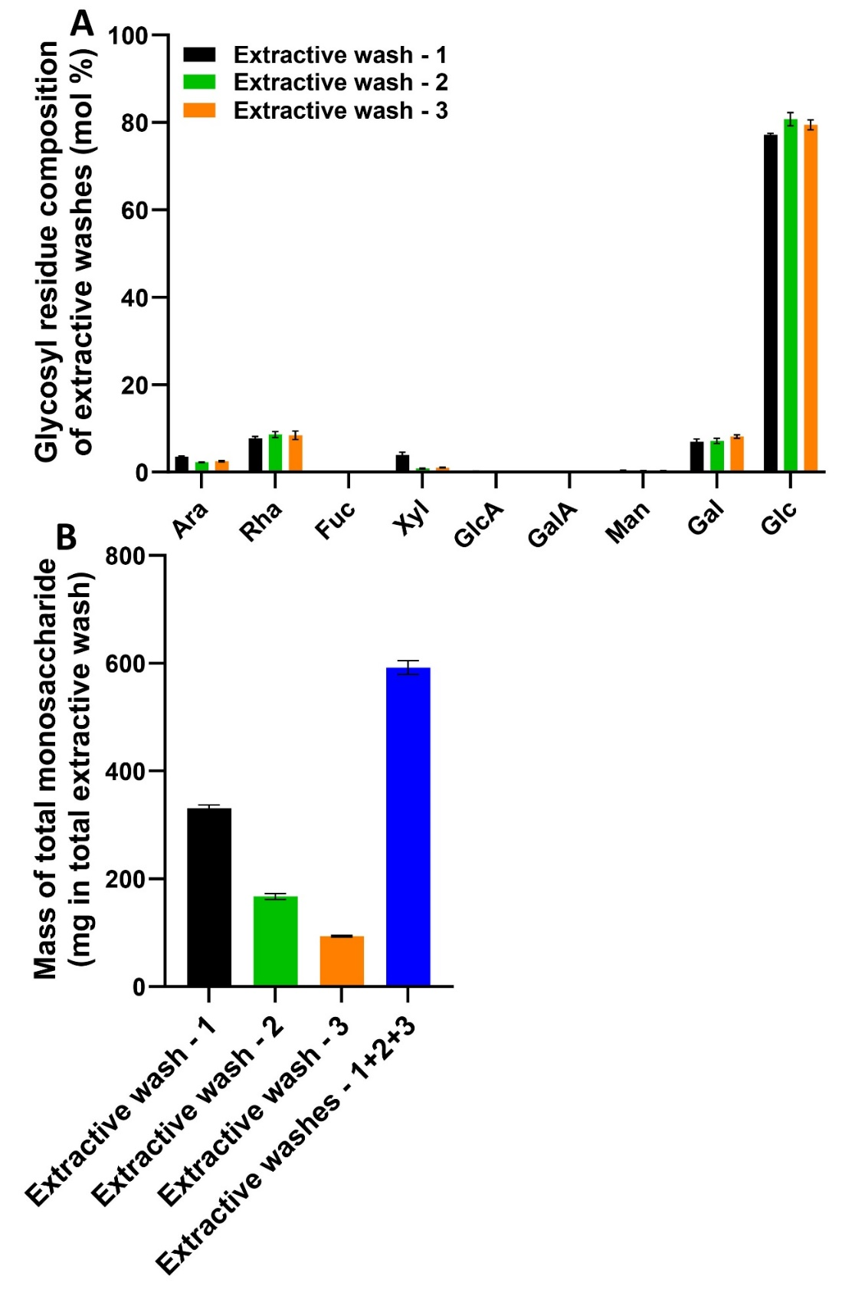
- Additional File 2: Fig. S2. Soluble sugars released during sequential extractive washes of switchgrass biomass prior to CBP. (A) Sugar composition expressed as average mol% of individual glycosyl residues and (B) total mass of monosaccharides quantified in the extractives washes. Glycosyl residue composition was determined by GC-MS following TMS derivatization from extractives washes 1, 2, and 3, as described in Fig. 1. Data are mean ± standard deviation of two biological replicates and two technical replicates (n = 4).

