Biswal et al. - Supplementary material

- Rhamnogalacturonan I is a recalcitrant pectin domain during Clostridium thermocellum-mediated deconstruction of switchgrass biomass

Ajaya K. Biswal^{1,2,5*}, Neal N. Hengge^{4,5}, Melani A. Atmodjo^{1,2,5}, Paul E. Abraham^{3,5}, Nancy L. Engle^{3,5}, Sushree S. Mohanty^{2,5}, Ian M. Black², Xiaochun Cheng^{2#}, David Ryno^{2,5}, Parastoo Azadi², Timothy J. Tschaplinski^{3,5}, Yannick J. Bomble^{4,5}, and Debra Mohnen^{1,2,5*}

¹Department of Biochemistry and Molecular Biology, University of Georgia, Athens, GA-30602, USA; ²Complex Carbohydrate Research Center, University of Georgia, Athens, GA-30602, USA; ³Biosciences Division, Oak Ridge National Laboratory, Oak Ridge, Tennessee 37830, USA ⁴Biosciences Center, National Renewable Energy Laboratory, Golden, CO 80401, USA; ⁵Center for Bioenergy Innovation, Oak Ridge National Laboratory, Oak Ridge, Tennessee 37830.

- Supplementary material:

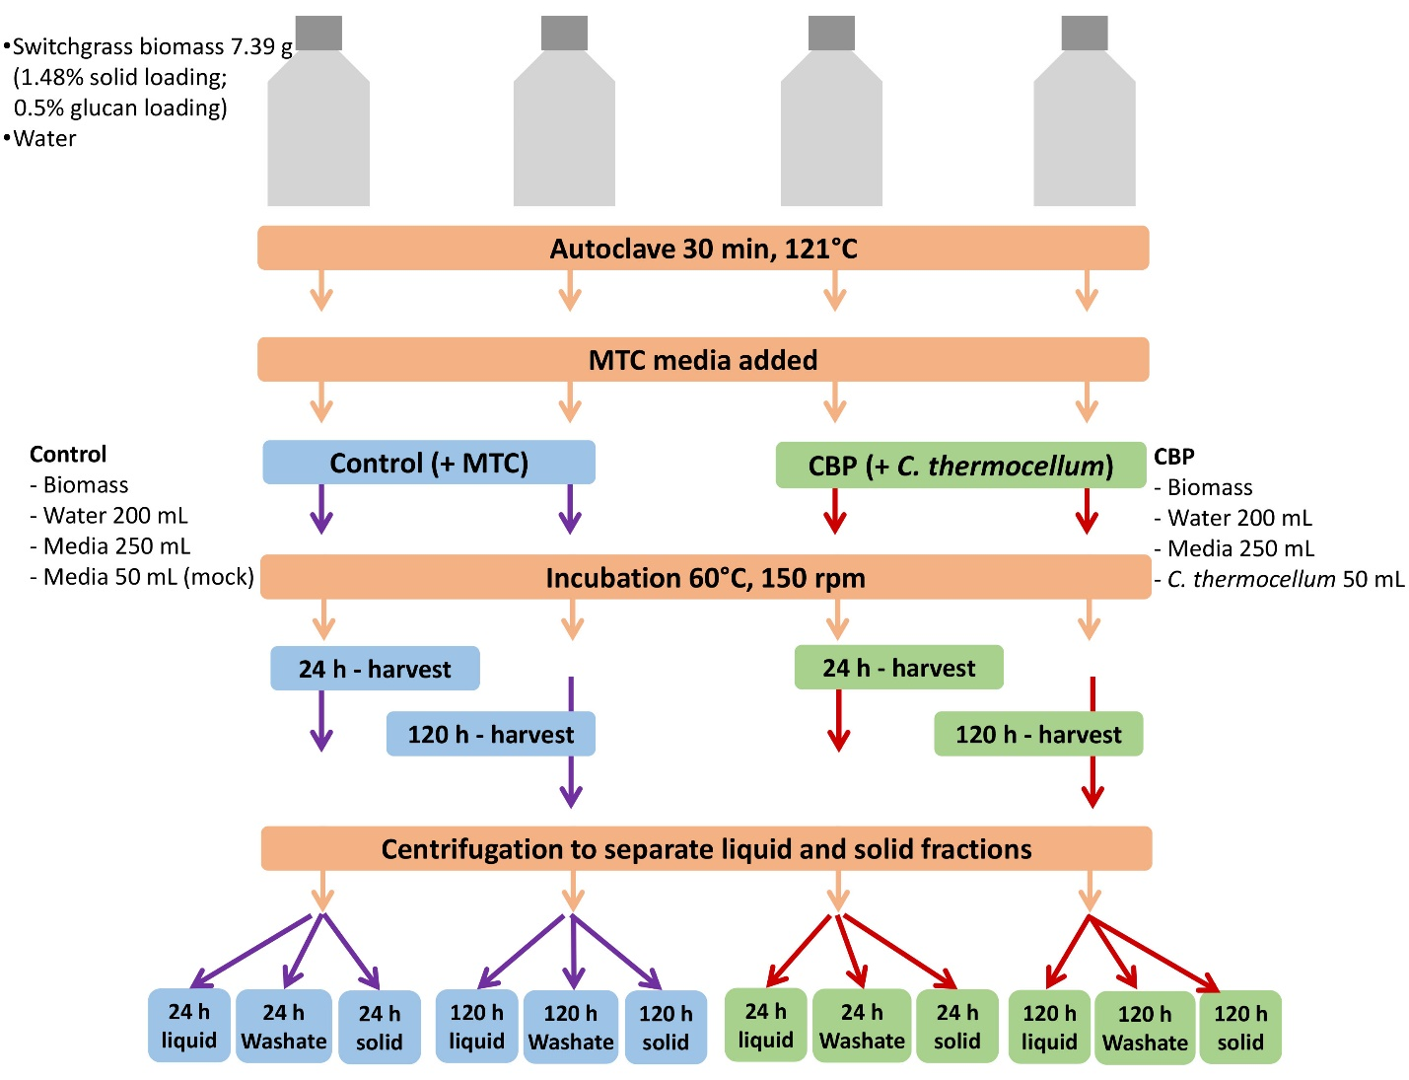
Additional File 3: Fig. S3. Schematic workflow for consolidated bioprocessing (CBP) of milled, extractives-washed BESC standard switchgrass biomass. Fermentation vessels containing 7.39 g of switchgrass biomass and 200 mL of water were autoclaved before adding 250 mL of sterilized 2× MTC medium stock. CBP reactors were inoculated with 50 mL of C. thermocellum culture, and fermentations were conducted following the protocol described by Biswal et al. (2022). Control and fermented samples were harvested in duplicates at 24 and 120 hours. Residual solids from post-CBP processing were separated from the fermentation liquor by centrifugation and dried at 60°C for five days.

