Biswal et al. - Supplementary material

- Rhamnogalacturonan I is a recalcitrant pectin domain during Clostridium thermocellum-mediated deconstruction of switchgrass biomass

Ajaya K. Biswal^{1,2,5*}, Neal N. Hengge^{4,5}, Melani A. Atmodjo^{1,2,5}, Paul E. Abraham^{3,5}, Nancy L. Engle^{3,5}, Sushree S. Mohanty^{2,5}, Ian M. Black², Xiaochun Cheng^{2#}, David Ryno^{2,5}, Parastoo Azadi², Timothy J. Tschaplinski^{3,5}, Yannick J. Bomble^{4,5}, and Debra Mohnen^{1,2,5*}

¹Department of Biochemistry and Molecular Biology, University of Georgia, Athens, GA-30602, USA; ²Complex Carbohydrate Research Center, University of Georgia, Athens, GA-30602, USA; ³Biosciences Division, Oak Ridge National Laboratory, Oak Ridge, Tennessee 37830, USA ⁴Biosciences Center, National Renewable Energy Laboratory, Golden, CO 80401, USA; ⁵Center for Bioenergy Innovation, Oak Ridge National Laboratory, Oak Ridge, Tennessee 37830.

- Supplementary material:

- 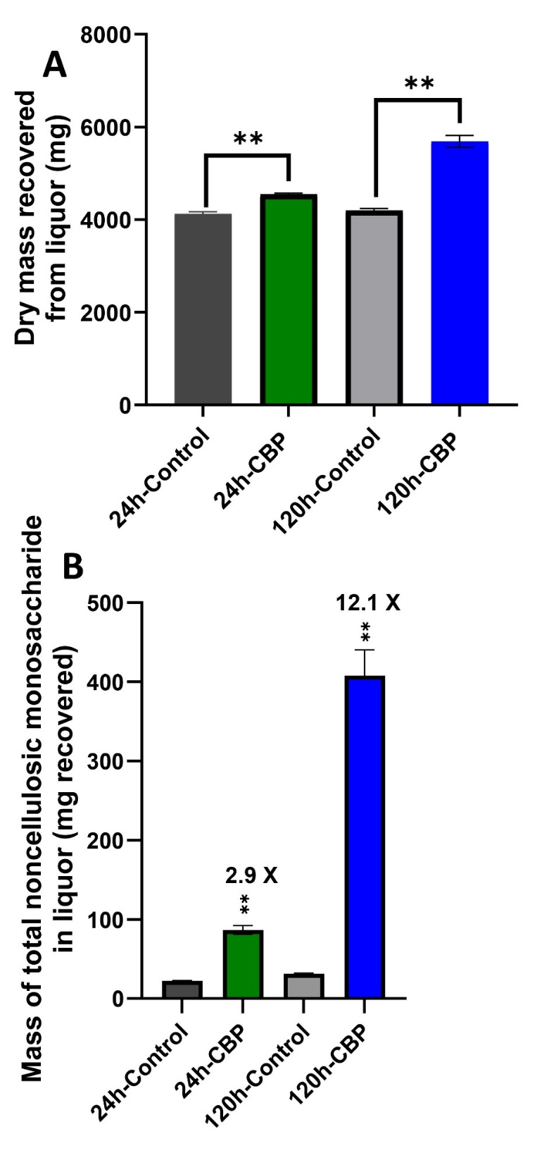
Additional File 5: Fig. S5. Total dry mass and monosaccharide content of 24-hr and 120-hr fermentation liquor produced during CBP of milled, non-pretreated BESC switchgrass by C. thermocellum DSM1313 over five days at 60°C. (A) Dry mass recovery from fermentation liquor as described in Additional File 3: Fig. S3. (B) Total noncellulosic sugar content in the soluble liquor was measured from 7.39 g of starting biomass (Fig. 3) by GC-MS analysis of TMS-derivatized methyl glycosides, following acid methanolysis of the dried liquor samples, as described in the Materials and Methods section. Statistical significance was analyzed using one-way ANOVA followed by Fisher’s LSD method; **P < 0.001.

