Biswal et al. - Supplementary material

- Rhamnogalacturonan I is a recalcitrant pectin domain during Clostridium thermocellum-mediated deconstruction of switchgrass biomass

Ajaya K. Biswal^{1,2,5*}, Neal N. Hengge^{4,5}, Melani A. Atmodjo^{1,2,5}, Paul E. Abraham^{3,5}, Nancy L. Engle^{3,5}, Sushree S. Mohanty^{2,5}, Ian M. Black², Xiaochun Cheng^{2#}, David Ryno^{2,5}, Parastoo Azadi², Timothy J. Tschaplinski^{3,5}, Yannick J. Bomble^{4,5}, and Debra Mohnen^{1,2,5*}

¹Department of Biochemistry and Molecular Biology, University of Georgia, Athens, GA-30602, USA; ²Complex Carbohydrate Research Center, University of Georgia, Athens, GA-30602, USA; ³Biosciences Division, Oak Ridge National Laboratory, Oak Ridge, Tennessee 37830, USA ⁴Biosciences Center, National Renewable Energy Laboratory, Golden, CO 80401, USA; ⁵Center for Bioenergy Innovation, Oak Ridge National Laboratory, Oak Ridge, Tennessee 37830.

- Supplementary material:
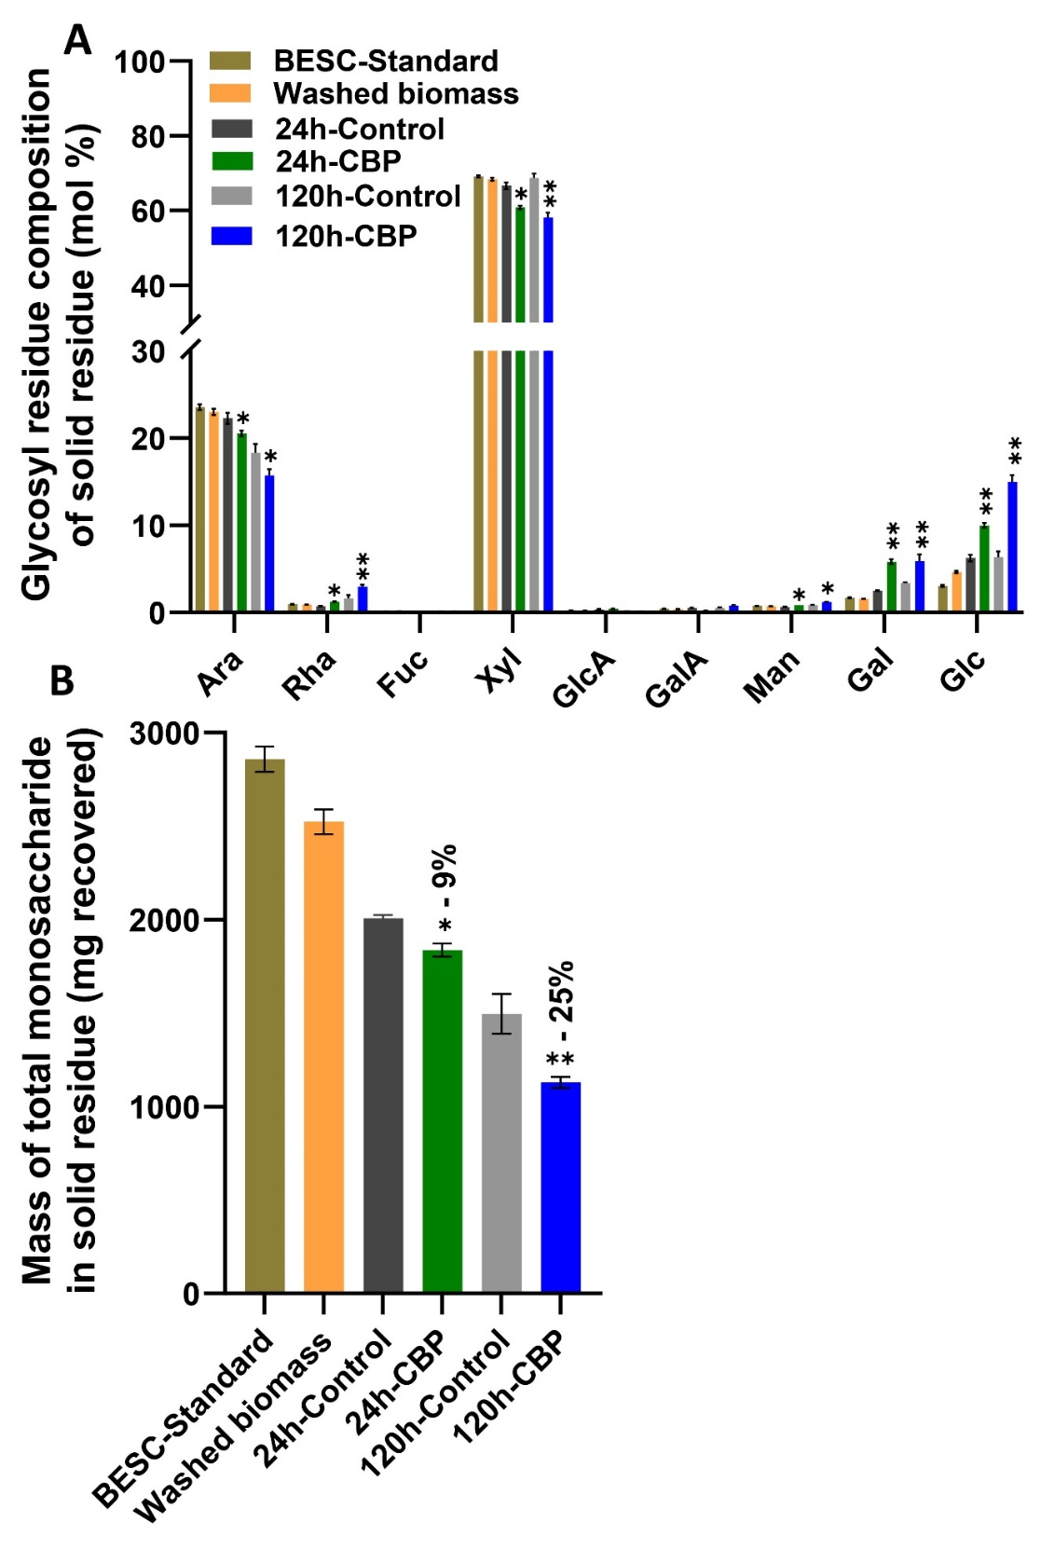
Additional File 9: Fig. S9. Changes in monosaccharide composition of solid residues following C. thermocellum CBP fermentation. The sugar amounts are represented as (A) average mol% and (B) total monosaccharide mass recovered in the solid residue. Glycosyl residue composition was analyzed by GC-MS following TMS derivatization. Values are presented as mean ± SD (n = 4). Asterisks indicate significant differences between 24 h and 120 h CBP fermentation samples and their respective controls. Significance levels: *P ≤ 0.05, **P ≤ 0.001.

