Supplemental Materials

Reliable Renewable Electricity Generation System on Small Animal Farms for Rural Electric Vehicle Charging
Meicai Xu ª, Carter Monson ª, Jacob Willsea ª, Sibel Uludag-Demirer ª,
April Leytem ^{b}, Barry Bradford ^{c}, Wei Liao ª*

a. Anaerobic Digestion Research and Education Center, Department of Biosystems and Agricultural Engineering, Michigan State University, East Lansing, MI 48824, USA
b. Washington State University, Pullman, WA 99164, USA
c. Department of Animal Sciences, Michigan State University, East Lansing, MI 48824, USA

*Corresponding Author:
Wei Liao, Ph.D., P.E.
Department of Biosystems and Agricultural Engineering
Michigan State University
524 S. Shaw Ln, Room 202
East Lansing, MI 48864
Tel: 517-432-7205
Email: liaow@msu.edu
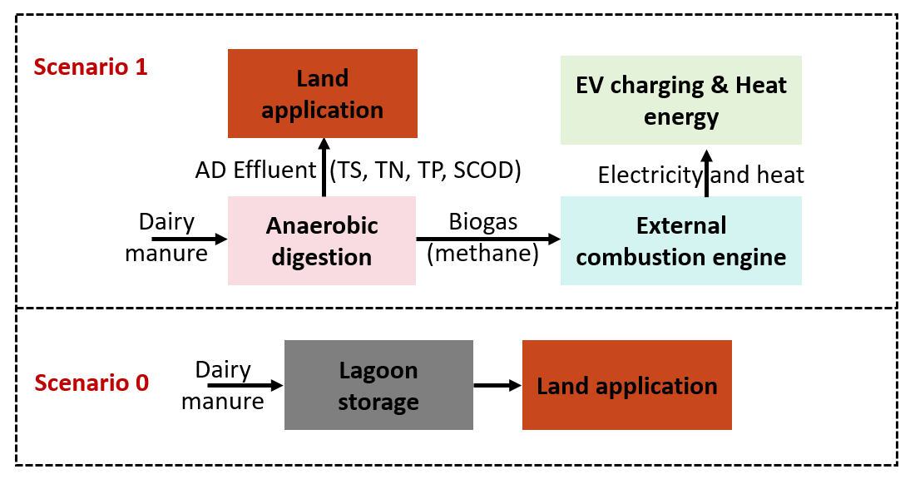
Fig. S1. Two scenarios and the boundary in the LCA study
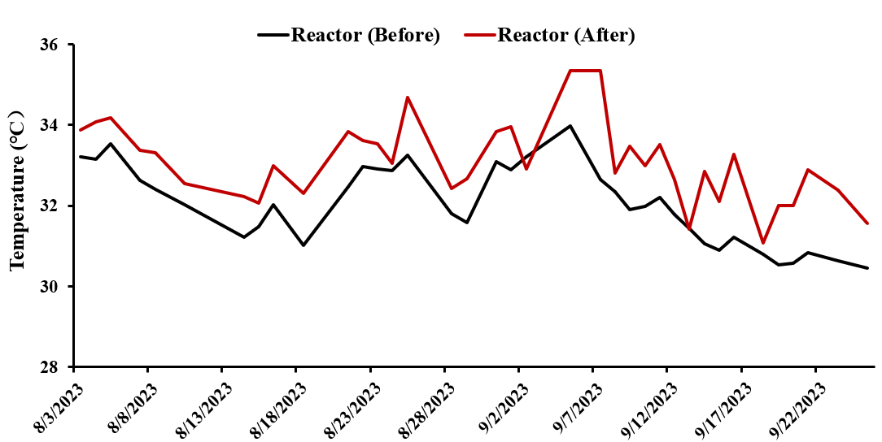

Fig. S2. Daily temperature variations of the anaerobic digester before and after electric heating
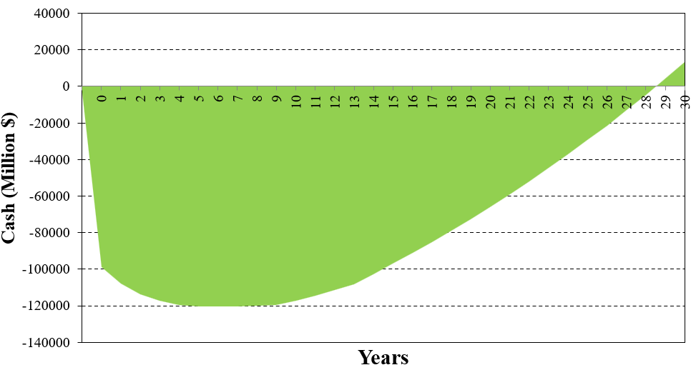
Fig. S3. Cash flow of the EV solution for a 30-cow dairy farm

Table S1. Temperature recordings of the anaerobic digestion (AD) reactor before and after electric heating
Date | Heating time (h) | T0 (℃) | T1 (℃) | ΔT (℃)
8/3/2023 | 1.50 | 33.22 | 33.87 | 0.65
8/4/2023 | 1.58 | 33.16 | 34.08 | 0.92
8/5/2023 | 1.87 | 33.53 | 34.18 | 0.65
8/7/2023 | 1.62 | 32.62 | 33.38 | 0.76
8/8/2023 | 1.45 | 32.40 | 33.31 | 0.91
8/10/2023 | 3.45 | 32.02 | 32.55 | 0.53
8/14/2023 | 2.12 | 31.23 | 32.23 | 1.00
8/15/2023 | 2.33 | 31.48 | 32.07 | 0.59
8/16/2023 | 1.67 | 32.02 | 32.99 | 0.97
8/18/2023 | 2.42 | 31.01 | 32.31 | 1.30
8/21/2023 | 1.92 | 32.47 | 33.83 | 1.36
8/22/2023 | 2.17 | 32.97 | 33.61 | 0.64
8/23/2023 | 2.25 | 32.92 | 33.54 | 0.62
8/24/2023 | 1.83 | 32.87 | 33.05 | 0.18
8/25/2023 | 1.33 | 33.26 | 34.69 | 1.43
8/28/2023 | 2.00 | 31.80 | 32.43 | 0.63
8/29/2023 | 2.50 | 31.59 | 32.66 | 1.07
8/31/2023 | 2.08 | 33.10 | 33.83 | 0.73
9/1/2023 | 2.25 | 32.89 | 33.96 | 1.07
9/2/2023 | 1.92 | 33.21 | 32.91 | -0.30
9/5/2023 | 1.00 | 33.97 | 35.35 | 1.38
9/7/2023 | 1.75 | 32.65 | 35.35 | 2.70
9/8/2023 | 2.08 | 32.35 | 32.82 | 0.47
9/9/2023 | 1.83 | 31.90 | 33.47 | 1.57
9/10/2023 | 1.92 | 31.98 | 33.00 | 1.02
9/11/2023 | 2.67 | 32.20 | 33.52 | 1.32
9/12/2023 | 2.25 | 31.78 | 32.65 | 0.87
9/13/2023 | 1.25 | 31.45 | 31.42 | -0.03
9/14/2023 | 1.83 | 31.06 | 32.86 | 1.80
9/15/2023 | 2.00 | 30.89 | 32.11 | 1.22
9/16/2023 | 2.50 | 31.23 | 33.27 | 2.04
9/18/2023 | 2.00 | 30.80 | 31.07 | 0.27
9/19/2023 | 2.00 | 30.54 | 32.01 | 1.47
9/20/2023 | 2.00 | 30.58 | 32.00 | 1.42
9/21/2023 | 1.00 | 30.84 | 32.90 | 2.06
9/23/2023 | 2.00 | 30.64 | 32.38 | 1.74
9/25/2023 | 2.25 | 30.46 | 31.57 | 1.11
Note: T0 represents the temperature before feedstock feeding and heating, while T1 refers to the temperature recorded when the feedstock was pumped back into the AD reactor.
Table S2. The key data for the five engine tests
Parameters | Test 1 | Test 2 | Test 3 | Test 4 | Test 5 | Average
Engine running time (h) | 0.5 | 0.5 | 0.5 | 0.5 | 0.5 | 0.5
Air-to-fuel ratio | 1.05 | 1.05 | 1.05 | 1.05 | 1.05 | 1.05
Biogas combusted (L) | 1,120 | 1,340 | 1,164 | 1,216 | 1,209 | 1,209
VDF (%) | 65 | 75 | 60 | 70 | 80 | NM
Biogas consumption rate (m³/h) | 2.240 | 2.680 | 2.328 | 2.432 | 2.418 | 2.420
Methane consumption rate (m³/h) | 1.344 | 1.608 | 1.397 | 1.459 | 1.451 | 1.452
Power (kW) | 2.054 | 2.041 | 2.030 | 2.010 | 1.939 | 2.015
Electricity generated (kWh) | 1.027 | 1.021 | 1.015 | 1.005 | 0.970 | 1.007
Electricity generation rate (Wh/L biogas) | 0.917 | 0.762 | 0.872 | 0.826 | 0.802 | 0.836
Generated electricity energy (MJ) | 3.697 | 3.674 | 3.654 | 3.618 | 3.490 | 3.627
Biogas energy (kWh-e/h) | 12.443 | 14.887 | 12.932 | 13.510 | 13.432 | 13.441
GHT time (h) | 0.5 | 0.5 | 0.5 | 0.5 | 0.5 | 0.5
Temperature increases for feeding tank (℃) | 13.62 | 16.73 | 14.56 | 15.64 | 14.29 | 14.97
Heat input for that temperature change (MJ/h) | 16.344 | 20.076 | 17.472 | 18.768 | 17.148 | 17.962
Heat utilized (kWh-e) | 2.270 | 2.788 | 2.427 | 2.607 | 2.382 | 2.495
Heat generation rate (Wh-e/L biogas) | 2.027 | 2.081 | 2.085 | 2.144 | 1.970 | 2.061
Electricity efficiency (%) | 16.51 | 13.71 | 15.70 | 14.88 | 14.44 | 15.05
GHT efficiency (%) | 36.49 | 37.46 | 37.53 | 38.59 | 35.46 | 37.11
Total energy utilization efficiency (%) | 52.99 | 51.17 | 53.23 | 53.47 | 49.90 | 52.15

Table S3. Details of LCIA-GWP calculation
 | Unit | Value | Notes
Biogas electricity as the electric vehicle fuel
Total electricity generation | kWh-e/year | 16,958 | Net electricity: 46.46 kWh/day, with 365 days a year
EV electricity consumption | kWh-e/100 miles | 33.33 | 3 miles/kWh for moderate EV
Gas-powered vehicle fuel consumption | gallon gasoline/100 miles | 3.33 | 30 mpg for moderately gas-powered vehicle
GWP of gasoline | g CO₂-e/gallon | 8,887 | Data from EPA website
GWP Reduction | Mg CO₂/year | -15.07 | 16,958/33.33×3.33×8,887×10^(-1)
Land application of AD effluent
N₂O emission from the effluent
Effluent | Mg/year | 748.25 | Effluent: 2,050 kg/day×365 days /1000
Total nitrogen of the effluent | g/Mg | 2581 | TN in effluent: 2.58 g/kg (effluent test data)
N₂O emission factor | g N emitted as N₂O/ g TKN in wastes | 0.005 | EPA data, see Table 2 in manuscript
Mol weight conversion of N₂O per N₂ | - | 1.57 | 44/28
unit conversion factor (metric ton/g) | - | 0.000001 | 1 metric ton = 1,000,000 g
N₂O emission | Mg N₂O/year | 0.015173976 | 748.25×2,580×0.005×1.57×10^(-6)
GWP factor for N₂O | kg CO₂ eq/kg N₂O | 298 | EPA data, see Table 2 in manuscript
GWP | Mg CO₂/year | 4.52 | Mg N₂O/year× kg CO₂-eq/kg N₂O
CH₄ emission from the effluent
Effluent | Mg/year | 748.25 | Effluent: 2,050 kg/day×365 days /1000
Total solids of the effluent | kg/Mg | 41.56 | Test data, 41.56 g/kg TS of effluent
CO₂-e emission factor for the CH₄ emission | kg CO₂/kg TS | 0.000308 | See Table 2 in manuscript
CH₄ emission | Mg CO₂-e/year | 0.009577959 | 748.25×41.56×0.000308 /1000
GWP | Mg CO₂/year | 0.009577959
Total GWP from the effluent | Mg CO₂/year | 4.53 | Sum of N₂O and CH₄ GWP
Manure land application with lagoon storage
N₂O emission from the manure
Manure | Mg/year | 657 | 1,800kg manure/day ×365days/1,000
Total nitrogen of the manure (waste) | g/Mg | 3,530 | Test data, TN in manure: 3.53 g/kg
N₂O emission factor | g N emitted as N₂O /g TKN in the waste | 0.005 | EPA data, see Table 2 in manuscript
Mol weight conversion of N₂O per N₂ | - | 1.57 | 44/28
unit conversion factor (metric ton/g) | - | 0.000001 | 1 metric ton = 1,000,000 g
N₂O emission | Mg N₂O/year | 0.018 | 657×3,530×0.005×1.57×10^(-6)
GWP factor for N₂O | kg CO₂ eq /kg N₂O | 298 | EPA data, see Table 2 in manuscript
GWP | Mg CO₂/year | 5.43 | Mg N₂O/year × kg CO₂-eq/kg N₂O
CH₄ emission from the manure
Manure | Mg/year | 657 | 1,800kg manure/day ×365days/1,000
Volatile solids of the manure | kg/Mg | 121.42 | Test data: 121.42 g/kg VS of manure
CH₄ emission factor | kg CH₄/kg VS | 0.127 | See Table 2 in manuscript
CH₄ -eq emission | Mg CH₄ eq/year | 10.13116338 | 657×121.42×0.127/1000
GWP factor for CH₄ | kg CO₂-eq/kg CH₄ | 30 | GWP of CH₄ is 28~34, over a 100-year time horizon
GWP | Mg CO₂/year | 303.93 | Mg CH₄ eq/year ×kg CO₂-eq/kg CH₄
Total GWP from the manure | Mg CO₂/year | 309.37 | sum of N₂O and CH₄ GWP
Note: Fig. 3a in the manuscript was obtained from the data in this table.

Table S4. Details of LCIA-SMOG calculation
 | Unit | Value | Notes
Biogas electricity as the electric vehicle fuel
Total electricity generation | kWh-e/year | 16,958 | Net electricity: 46.46 kWh/day, with 365 days a year
Smog factor for RNG electricity | kg O₃ eq/kWh-e | 0.035 | EPA data
EV electricity consumption | kWh-e/100 miles | 33.33 | 3 miles/kWh for moderate EV
Gas-powered vehicle fuel consumption | gallon gasoline/100 miles | 3.33 | 30 mpg for moderately gas-powered vehicle
Smog of gasoline | g O₃-e/gallon | 4456.84 | EPA data: 1.5 kg O₃/kg gasoline
SMOG Reduction | Mg O₃/year | -6.96
Land application of AD effluent
N₂O emission from the effluent
Effluent | Mg/year | 748.25 | Effluent: 2,050 kg/day×365 days /1000
Total nitrogen of the effluent | g/Mg | 2581 | TN in effluent: 2.58 g/kg (effluent test data)
N₂O emission factor | g N emitted as N₂O/ g TKN in wastes | 0.005 | EPA data, see Table 2 in manuscript
Mol weight conversion of N₂O per N₂ | - | 1.57 | 44/28
unit conversion factor (metric ton/g) | - | 0.000001 | 1 metric ton = 1,000,000 g
N₂O emission | Mg N₂O/year | 0.015173976 | 748.25×2,580×0.005×1.57×10^(-6)
Smog factor for N₂O | kg O₃ eq/kg N₂O | 24.8 | EPA data, see Table 2 in manuscript
SMOG | Mg O₃/year | 0.38 | Mg N₂O/year× kg O₃-eq/kg N₂O
CH₄ emission from the effluent
Effluent | Mg/year | 748.25 | Effluent: 2,050 kg/day×365 days /1000
Total solids of the effluent | kg/Mg | 41.56 | Test data, 41.56 g/kg TS of effluent
CO₂-e emission factor for the CH₄ emission | kg CO₂/kg TS | 0.000308 | See Table 2 in manuscript
CH₄ emission | Kg CH₄/kg TS | 0.00001232 | NA
SMOG | Mg O₃/year | 0.00 | Mg CH₄/year× kg O₃-eq/kg CH₄
Total SMOG from the effluent | Mg O₃/year | 0.38 | Sum of N₂O and CH₄ SMOG
Manure land application with lagoon storage
N₂O emission from the manure
Manure | Mg/year | 657 | 1,800kg manure/day ×365days/1,000
Total nitrogen of the manure (waste) | g/Mg | 3,530 | Test data, TN in manure: 3.53 g/kg
N₂O emission factor | g N emitted as N₂O /g TKN in the waste | 0.005 | EPA data, see Table 2 in manuscript
Mol weight conversion of N₂O per N₂ | - | 1.57 | 44/28
unit conversion factor (metric ton/g) | - | 0.000001 | 1 metric ton = 1,000,000 g
N₂O emission | Mg N₂O/year | 0.018 | 657×3,530×0.005×1.57×10^(-6)
SMOG factor for N₂O | kg O₃ eq /kg N₂O | 24.8 | EPA data, see Table 2 in manuscript
SMOG | Mg O₃/year | 0.45 | Mg N₂O/year × kg O₃-eq/kg N₂O
CH₄ emission from the manure
Manure | Mg/year | 657 | 1,800kg manure/day ×365days/1,000
Volatile solids of the manure | kg/Mg | 121.42 | Test data: 121.42 g/kg VS of manure
CH₄ emission factor | kg CH₄/kg VS | 0.127 | See Table 2 in manuscript
CH₄ -eq emission | Mg CH₄ eq/year | 10.13116338 | 657×121.42×0.127/1000
SMOG factor for CH₄ | kg O₃-eq/kg CH₄ | 0.014 | NA
SMOG | Mg O₃/year | 0.146 | Mg CH₄ eq/year ×kg O₃-eq/kg CH₄
Total SMOG from the manure | Mg O₃/year | 0.60 | sum of N₂O and CH₄ SMOG
Note: Fig. 3b in the manuscript was obtained from the data in this table.

Table S5. Details of LCIA-WEP calculation
 | Unit | Value | Notes
AD effluent
TN
Effluent | Mg/year | 748.25 | Effluent: 2050 kg/day×365 days/10^3
TN concentration | g/Mg | 2,581 | Test data: TN in effluent: 2.58 g/kg
Total TN | Mg N/year | 1.9312 | 748.25×2,580×10^(-6)
WEP conversion factor | kg N eq/Mg TN | 0.9864 | EPA data, see Table 2 in manuscript
WEP | kg N eq/year | 1.905
TP
Effluent | Mg/year | 748.25 | Effluent: 2050 kg/day×365 days/10^3
TP concentration | g/Mg | 1,320 | Test data: TP in effluent: 1.32 g/kg
Total TP | Mg P/year | 0.98769 | 748.25×1,320×10^(-6)
WEP conversion factor | g N eq/kg TP | 7.29 | EPA data, see Table 2 in manuscript
WEP | kg N eq/year | 7.200
COD
Effluent | Mg/year | 748.25 | Effluent: 2050 kg/day×365 days/10^3
COD concentration | g/Mg | 7,803 | Test data: COD in effluent: 7,803 mg/kg
Total COD | Mg COD/year | 5.83859475 | 748.25×7,803×10^(-6)
WEP conversion factor | g N eq/kg COD | 0.05 | EPA data, see Table 2 in manuscript
WEP | kg N eq/year | 0.292
Manure land application with lagoon storage
TN
Manure | Mg/year | 657 | 1,800kg/day ×365days/1,000
TN concentration | g/Mg | 3,530 | Test data: TN in manure: 3.53 g/kg
Total TN | Mg N/year | 2.319 | 657×3,530×10^(-6)
WEP conversion factor | kg N eq/Mg TN | 0.9864 | EPA data, see Table 2 in manuscript
WEP | kg N eq/year | 2.288
TP
Manure | Mg/year | 657 | 1,800kg/day ×365days/1,000
TP concentration | g/Mg | 3,463 | Test data: TP in manure 3.463 g/kg
Total TP | Mg P/year | 2.275191
WEP conversion factor | g N eq/kg TP | 7.29 | EPA data, see Table 2 in manuscript
WEP | kg N eq/year | 16.586
COD
Manure | Mg/year | 657 | 1,800kg/day ×365days/1,000
COD concentration | g/Mg | 114,980 | Test data: COD in manure: 114.98 g/kg
Total COD | Mg COD/year | 75.54186 | 657×114,980×10^(-6)
WEP conversion factor | g N eq/kg COD | 0.05 | EPA data, see Table 2 in manuscript
WEP | kg N eq/year | 3.777
Note: Fig. 3c in the manuscript was obtained from the data in this table.

Supplemental-TEA: Supplemental techno-economic analysis of a stand-alone photovoltaic (PV) battery system for EV charging

S-TEA 1. Methods
To design a stand-alone photovoltaic (PV) system capable of delivering a continuous 46 kWh day⁻¹ of electricity in East Lansing, Michigan, the PV array was sized according to the worst-month solar resource, which governs year-round reliability. Following the standard methodology used in NREL’s PVWatts model and related PV system design practice [1–4], monthly average peak sun hours (PSH) and a system performance ratio (PR) were used to estimate the minimum required PV array size.

The daily energy generated by a PV array is estimated as:

$E_{PV, day}=P_{PV}×{PSH}_{m}×PR$ (1)

Where E_{PV,day} is the daily AC energy production (kWh day⁻¹); P_{PV} is the installed PV capacity (kW); PSH_{m} is the monthly average peak sun hours for month mmm (hours day⁻¹); and PR is the performance ratio (unitless), accounting for inverter losses, temperature derating, wiring, and soiling.
For the Lansing region, December is the lowest insolation month with PSH_{Dec} ≈ 2.5 h day⁻¹ [3,4]. A performance ratio of PR = 0.75 is applied, consistent with common design assumptions for small ground-mount PV systems in northern U.S. climates. To ensure the system meets the required daily demand of 46 kWh day⁻¹ in December, the minimum PV capacity is:

$P_{PV, min}=\frac{E_{load}}{{PSH}_{Dec}×PR}=\frac{46}{2.5×0.75}≈24.6 kW$ (2)

The PV array was rounded up to 30 kW to account for additional winter derating from snow coverage, low solar elevation, and consecutive overcast days conditions that are well documented to reduce practical winter PV output in the U.S. Midwest [1,5]. Assuming individual PV panel rated at 600 W, the number of panels required for a 30 kW PV array is:

$N_{panels}=\frac{P_{PV}}{0.6 kW/panel}=\frac{30}{0.6}=50 panels$ (3)

To guarantee uninterrupted electricity supply during periods of minimal or zero solar generation, the battery energy storage unit was sized using the days-of-autonomy method widely adopted in stand-alone PV system design [5,6]. The required nameplate battery capacity is computed as:

$E_{battery}=\frac{E_{load}×N_{autonomy}}{DoD}$ (4)

Where E_{battery} is the battery nameplate energy capacity (kWh); E_{load} is 46 kWh day-1 (continuous load requirement); N_{automony} is the desired autonomy period of 5 days; and DoD is the allowable depth of discharge of the batteries (unitless). Lithium iron phosphate (LiFePO₄) batteries were assumed with a DoD of 0.8, consistent with commercial off-grid energy storage products.

$E_{battery}=\frac{46×5}{0.8}=287.5 kWh$ (5)

Thus, a 290 kWh nominal battery bank is required to meet 5-day autonomy with no auxiliary generator support.
S-TEA 2. Results and Discussion
S-TEA 2.1. PV array performance and year-round reliability
Using the worst-month design approach, the minimum PV capacity required to deliver a continuous 46 kWh day⁻¹ in Michigan was calculated as ~25 kW. However, due to the substantial seasonal decline in solar resource between summer and winter, Michigan receives only 10–15% of its annual solar yield between November and February. Therefore, the PV array was intentionally oversized to 30 kW to improve winter reliability. The larger array ensures that even during prolonged cloudy periods, daily energy production remains adequate to recharge the battery system and sustain the continuous load. Oversizing the array is a cost-effective strategy because added PV capacity is significantly cheaper per kWh-delivered than added long-duration battery storage. This is consistent with IEA PVPS findings that PV oversizing is a primary resilience strategy in northern latitudes [5]. For the selected 30 kW PV system using 600 W modules, the system requires 50 PV panels. The 30 kW size also increases tolerance to snow coverage and soiling. Even if output is temporarily reduced by 20–30%, the array can still maintain adequate daily energy delivery when combined with stored energy.
The calculated battery capacity of 290 kWh enables 5 days of operation with zero solar input, equivalent to full load coverage during extended winter storms or other weather events. Multi-day low-insolation events of 3–7 days are common in the Midwest during winter, making 5-day autonomy an appropriate reliability target. During normal operation daily cycling uses only ~15% of battery capacity. The large storage bank provides substantial buffering against both short-term and multi-day intermittency. The relationship between PV oversizing and battery depth-of-discharge is synergistic: the larger 30 kW array reduces the number of days the system must rely solely on battery storage, thereby extending battery lifetime and improving the system performance.
For small animal farms or rural EV charging stations, the combined 30 kW PV + 290 kWh storage configuration provides several advantages of i) continuous, stable, non-interrupted power year-round; 2) full off-grid capability without reliance on diesel or biogas generators; and 3) high resilience to Michigan’s harsh seasonal conditions.

S-TEA 2.2. Economic analysis
The capital investment required to install a PV-powered EV charging system capable of supplying 46 kWh day⁻¹ for a 30-cow dairy farm is summarized in Table S6. The total capital expenditure (CapEx) is $162,000, consisting primarily of the PV array and the battery storage system. The 30 kW PV array accounts for $60,000, based on an installed cost of $2/W, while the 290 kWh LiFePO₄ battery bank contributes $87,000 to the total. An additional $14,700, equivalent to 10% of the combined PV and battery cost, covers the EV charger, system controls, site civil work, engineering, and commissioning. This distribution of capital cost is consistent with the system architecture, where long-duration battery storage is the main cost driver, and PV oversizing is a comparatively economical strategy to ensure wintertime energy sufficiency.
The annual revenue generated from EV charging is estimated at $5,935/year, representing the value of electricity delivered to vehicles at the farm. This revenue calculation deliberately excludes the additional surplus electricity produced during spring, summer, and fall, which varies seasonally and is not monetized in this scenario. Operational expenditure (OpEx) is modest, with PV maintenance costing approximately $2,000/year, based on $19/kW-year. No additional routine battery maintenance cost is included, as LiFePO₄ systems typically require minimal annual service under farm-scale operating conditions. Combining revenue and OpEx yields an annual net revenue of $3,935/year.
Using the net annual revenue and total CapEx, the simple payback period for the system is approximately 47 years. This long payback reflects the capital-intensive nature of stand-alone PV–battery systems designed for high reliability and multi-day autonomy in northern climates.

Table S6. Economic analysis of the PV EV charging solution to provide the equivalent electricity (46 kWh day⁻¹) from the 30-cow dairy farm

 | The PV battery EV charging system
Capital expenditure (CapEx) ª
PV panels (installed cost) ^{b} | $60,000
Battery bank ^{c} | $87,000
EV charger, controls, site civil work, engineering, and commissioning ^{d} | $15,000
Total CapEx cost | $162,000
Revenue
EV charging ^{e} | $5,935/year
Total revenue | $5,935/year
Operational expenditure (OpEx)
PV maintenance ^{f} | $2,000/year
Net Revenue
Net revenue | $3,935/year
Payback time
Payback time (year) ^{g} | 47
a: The installation cost is included in the capital cost of each unit. All costs are based on projects that the authors have carried out. b: The PV installed coat is $2/W [7]. c: The LiFePO4 batteries are used as energy storage. The battery installed cost is $300/kWh (MSU data). d: 10% of the PV panels and battery bank cost is for EV charger, controls, site civil work, engineering, and commissioning. e: The revenue only counts for the EV charging. The additional electricity during the other seasons (summer, spring, and fall) are not considered into this analysis due to the variations of electricity generation during different seasons. f: The PV maintenance cost is set at $19/kW/year [7]. g: the payback time analysis follows the method described in the TEA section in the main content.

References:

1. Habte A, Sengupta M, Yuan H, Buster G, Tan J. Simulation of PV Variability as a Function of PV Generation and Plant Size: Preprint. 2021 [cited 2025 Dec 5]; www.nrel.gov/publications. Accessed 5 Dec 2025
2. Stein JS, Klise GT. Models used to assess the performance of photovoltaic systems. Albuquerque, NM, and Livermore, CA (United States); 2009 [cited 2025 Dec 6]; https://doi.org/10.2172/974415
3. Sengupta M, Xie Y, Lopez A, Habte A, Maclaurin G, Shelby J. The National Solar Radiation Data Base (NSRDB). Renewable and Sustainable Energy Reviews [Internet]. Elsevier Ltd; 2018 [cited 2025 Dec 5];89:51–60. https://doi.org/10.1016/j.rser.2018.03.003
4. NSRDB [Internet]. [cited 2025 Dec 5]. https://nsrdb.nrel.gov/. Accessed 5 Dec 2025
5. High Penetration of PV in Local Distribution Grids [Internet]. IEA PVPS IEA PVPS; 2014 [cited 2025 Dec 6]. https://iea-pvps.org/key-topics/high-penetration-of-pv-in-local-distribution-grids-iea-pvps-task-1402-2014/. Accessed 6 Dec 2025
6. Hafez O, Bhattacharya K. Optimal planning and design of a renewable energy based supply system for microgrids. Renew Energy [Internet]. Pergamon; 2012 [cited 2025 Dec 6];45:7–15. https://doi.org/10.1016/J.RENENE.2012.01.087
7. Ramasamy V, Zuboy J, Woodhouse M, O’shaughnessy E, Feldman D, Desai J, et al. U.S. Solar Photovoltaic System and Energy Storage Cost Benchmarks, With Minimum Sustainable Price Analysis: Q1 2023. 2050 [cited 2025 Dec 6]; www.nrel.gov/publications. Accessed 6 Dec 2025

