Supplementary material
Fig. S1. A graphic illustration summarizing the effects of the gene modifications on the metabolism of S.7942.
(1) Inactivation of the aas gene, which codes for acyl-ACP synthetase, prevents the recycling of free fatty acids (FFAs).
(2) Expression of a foreign thioesterase leads to generation of FFAs from acyl-ACP.
(3) Deletion of the nrtABCD genes inhibits the active uptake of nitrate into the cell.
(4) Overexpression of the rndA1B1 genes enhances the extrusion of FFAs from the cell.

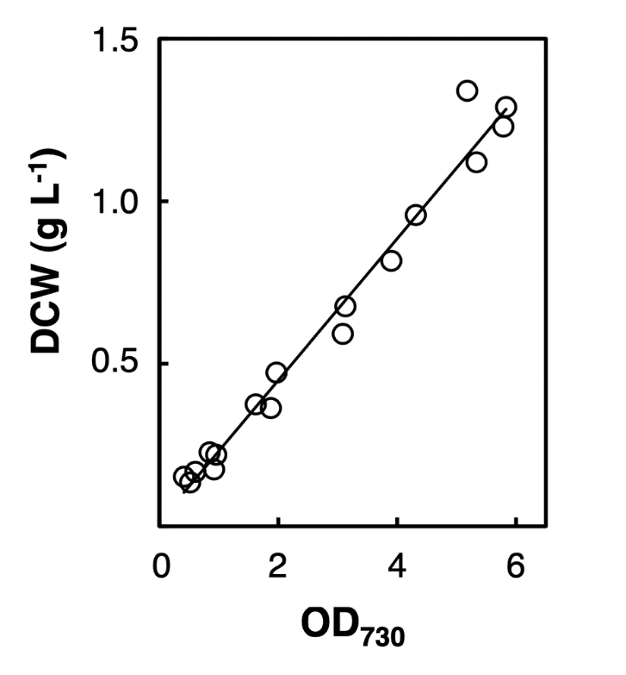

Fig S2. The relationship between OD₇₃₀ and the dry cell matter content of the cyanobacterial cultures.
The dry cell weight (DCW) per L of cyanobacterial cultures (Y-axis) and the optical density at 730 nm (OD₇₃₀) of the cultures (X-axis) were determined as described in Methods section. The data from 17 biological replicates of the dAS2T and dAS2T/pRND1 cultures were fitted to the following linear relationship: y = 0.218x + 0.014 (r² = 0.979).

Fig. S3. Distribution of extracellular FFA between aqueous and organic phases during the two-phase cultivation experiment shown in Fig. 3.
Time-course analysis of extracellular free fatty acid (FFA) production in (a) dAS1T, (b) dAS2T, and (c) dAS2T/pRND1 during 0–240 h cultivation in an aqueous–organic two-phase system overlaid with isopropyl myristate (IM). FFA concentrations recovered from the aqueous phase and the IM layer at 144, 192, and 240 h are shown.

Fig S4. Distribution of extracellular FFA between aqueous and organic phases under different nitrate concentrations.
Time-course analysis of extracellular free fatty acid (FFA) distribution in dAS2T/pRND1 cultivated in an aqueous–organic two-phase system supplemented with (a) 30 mM NO₃⁻, (b) 15 mM NO₃⁻, or (c) 7.5 mM NO₃⁻. FFA amounts detected in the aqueous phase and recovered in the isopropyl myristate (IM) layer at 144, 192, and 240 h are shown.

