Supporting Information for:
Contents:
- S1. Detailed Experimental Procedures
- S2. Supplementary Figures (Figure S1–S9)
- S3. Supplementary Tables (Table S1–S5, Table S6.3)
- S4. Response Surface Model Validation Data
- S5. Life Cycle Inventory (LCI)
- S6. Techno-Economic Analysis (TEA) Details

S1. Detailed Experimental Procedures
S1.1. Plasmid Construction and QLM System Assembly
All genetic parts were synthesized (GenScript) and assembled via Gibson assembly. The complete QLM cassette was integrated into the amyE locus of Bacillus subtilis168 using CRISPR-Cas9 as described by Westbrook et al. (2016). Transformants were selected on LB agar containing 10 µg/mL chloramphenicol. Correct integration was confirmed by colony PCR and Sanger sequencing. The final strain was designated B. subtilis SFM-QLM01.
S1.2. Metabolic Burden and Genetic Stability Analysis
Metabolic burden was assessed by comparing growth parameters across four strain variants: wild-type B. subtilis 168, QLM strain without induction, QLM strain with CRISPRi induction only (0.5 mM IPTG), and fully induced QLM strain with enzyme production. Cultures were grown in MSM with 20 g/L glucose at 37°C, 220 rpm. Maximum specific growth rate (µmax) and biomass yield (Yx/s) were calculated from exponential phase data. Genetic stability was evaluated over 60 generations through sequential batch cultivations (10% inoculum transfer every 24 hours). Plasmid retention was determined by differential plating (LB agar ± chloramphenicol). CRISPRi guide RNA sequences and ComQXPA module integrity were verified by Sanger sequencing at generations 0, 20, 40, and 60.
S1.3. Cultivation Media and Conditions for Microbioreactor Runs
Pre-cultures were grown in LB medium at 37°C, 220 rpm for 8 hours. Main cultivations were performed in a defined mineral salt medium (MSM) with glucose as the sole carbon source. The MSM composition per liter was: 2.0 g (NH₄)₂SO₄, 14.6 g K₂HPO₄, 4.0 g KH₂PO₄, 1.0 g Sodium Citrate, 0.2 g MgSO₄·7H₂O, 0.05 g CaCl₂, 0.01 g FeSO₄·7H₂O, and 1 mL of trace metal solution (SL7). The pH was adjusted to 7.0 prior to sterilization. All cultivations in the BioLector XT (m2p-labs) were conducted in 48-well FlowerPlates with a working volume of 1 mL.
S1.4. Cellulase Activity Assay (Fluorometric Method)
Cellulase (CtCel9A) activity was determined using 4-methylumbelliferyl-β-D-cellobioside (4-MUC, Sigma-Aldrich) as a fluorogenic substrate. A 20 µL aliquot of suitably diluted enzyme sample was mixed with 80 µL of 0.5 mM 4-MUC in 50 mM sodium citrate buffer (pH 5.0). The reaction was incubated at 70°C for 10 min and stopped by adding 100 µL of 1 M glycine-NaOH buffer (pH 10.5). The fluorescence of the released 4-methylumbelliferone (4-MU) was measured using a microplate reader (BioTek Synergy H1) with excitation/emission at 365/445 nm. One international unit (IU) of enzyme activity was defined as the amount of enzyme releasing 1 µmol of 4-MU per minute under the assay conditions.
S1.5. PEF-ASL System Assembly and Operation
The continuous PEF-ASL system consisted of:
- Feed Reservoir: Holding the fermentation broth at 4°C.
- PEF Chamber: Custom-built with coaxial stainless-steel electrodes (2 mm gap). The PEF system (HVP-830, Suematsu Electronics, Japan) was operated with monopolar exponential decay pulses generated by capacitor discharge (0.5 µF capacitance). The pulse width was 30 ± 2 µs at a pulse frequency of 100 Hz, with a peak electric field of 4.2 kV/cm at the optimized condition.
- Packed-Bed Enzyme Reactor: A glass column (10 cm length, 1 cm diameter) packed with chitosan beads (300 µm) covalently immobilized with lysozyme (5 mg/g beads) and PlyBs endolysin (2 mg/g beads).
- Counter-Current Thermolysis Unit: A double-pipe heat exchanger maintaining the specified temperature.
- Stabilizer Mixing Unit: A T-mixer for inline addition of sorbitol (stabilizer) solution.
- Tangential Flow Filtration (TFF): A 10 kDa PES membrane cassette (Sartorius) for cell debris removal and enzyme concentration.
The system was operated in continuous mode, and samples were collected at the TFF permeate outlet for analysis.
Complete cell lysis for establishing 100% recovery reference was performed using combined lysozyme treatment (1 mg/mL, 37°C, 60 min), sonication (20 kHz, 40% amplitude, 10 cycles of 30 s on/off), and French press (20,000 psi, three passages), with completeness confirmed by phase-contrast microscopy and protein release plateau.
S1.6. Analytical Methods for Cell Characterization
- Cell Wall Thickness: Transmission electron microscopy (TEM) was performed on a JEOL JEM-1400Flash. Cells were fixed, sectioned, and stained. Wall thickness was measured from micrographs using ImageJ software (n=50 cells per sample).
- Quorum Sensing Pheromone (ComX): Quantified using a competitive ELISA kit (MyBioSource) according to the manufacturer's instructions.
- Soluble vs. Insoluble Protein: Cell lysates were fractionated by centrifugation (15,000 x g, 20 min, 4°C). Soluble (supernatant) and insoluble (pellet resuspended in urea buffer) fractions were analyzed by SDS-PAGE and Western blot using an anti-His tag antibody.

Specific Activity Determination: Purified enzyme concentration was determined by Bradford assay using bovine serum albumin (BSA) as standard. Specific activity (IU/mg) was calculated as the ratio of enzyme activity (IU/mL) to protein concentration (mg/mL) in the IMAC-purified elution fraction.

S2. Supplementary Figures
Figure S1. Genetic Map of the Constructed Quorum-Lysis-Modulation (QLM) System in B. subtilis SFM-QLM01. (A schematic diagram showing the organization of genetic elements at the amyE locus: ComQXPA sensing module driving ctcel9A-sfGFP, IPTG-inducible CRISPRi array targeting pbpA, dacA, mreB, temperature-inducible PBSX lysis cassette, and the constitutive chaperone operon cluster.)

Figure S2. Gaussian Process Regression (GPR) Model Performance for Fermentation Optimization. (Left panel: Parity plot of observed vs. GPR-predicted CtCel9A titer (IU/mL) for training and test sets. Right panel: Evolution of the acquisition function (Expected Improvement) over five Bayesian optimization iterations.)

Figure S3. Continuous Operation Stability of the PEF-ASL System. (Enzyme recovery (%) and specific activity (IU/mg) measured in samples collected hourly over an 8-hour continuous run at optimal conditions (4.2 kV/cm, 6.5 min, 68°C, 8.5% sorbitol). Data shows stable performance with minimal deviation.)

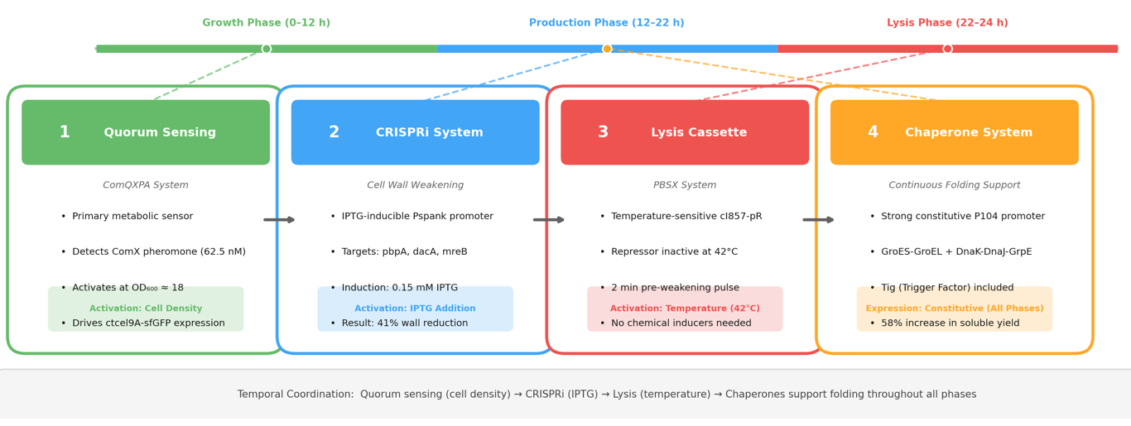

Figure S4. Schematic of the Hierarchical Regulatory Design of the QLM System. The figure illustrates the temporal coordination strategy: (i) Quorum sensing (ComQXPA) serves as the primary metabolic sensor, ensuring enzyme production only after sufficient biomass accumulation (OD600 ~18); (ii) IPTG-inducible CRISPRi provides independent control over cell wall weakening timing; (iii) Temperature-sensitive cI857-pR promoter enables clean external lysis triggering without chemical inducers; (iv) Constitutive chaperone expression (P104 promoter) ensures continuous folding support throughout the production phase.

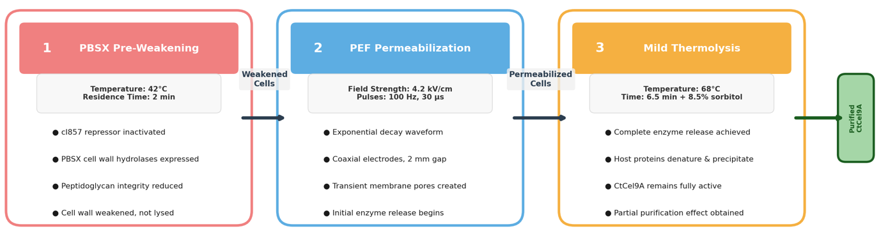

Figure S5. Process Flow Diagram of the Sequential Lysis Cascade. The diagram shows the three-stage lysis process: Stage 1—PBSX pre-weakening (42°C, 2 min) partially activates cell wall hydrolases, reducing peptidoglycan integrity; Stage 2, PEF permeabilization (4.2 kV/cm, 100 Hz, 30 µs pulses) creates transient membrane pores in the pre-weakened cells; Stage 3, Mild thermolysis (68°C, 6.5 min) completes enzyme release while simultaneously precipitating mesophilic host proteins for partial purification.

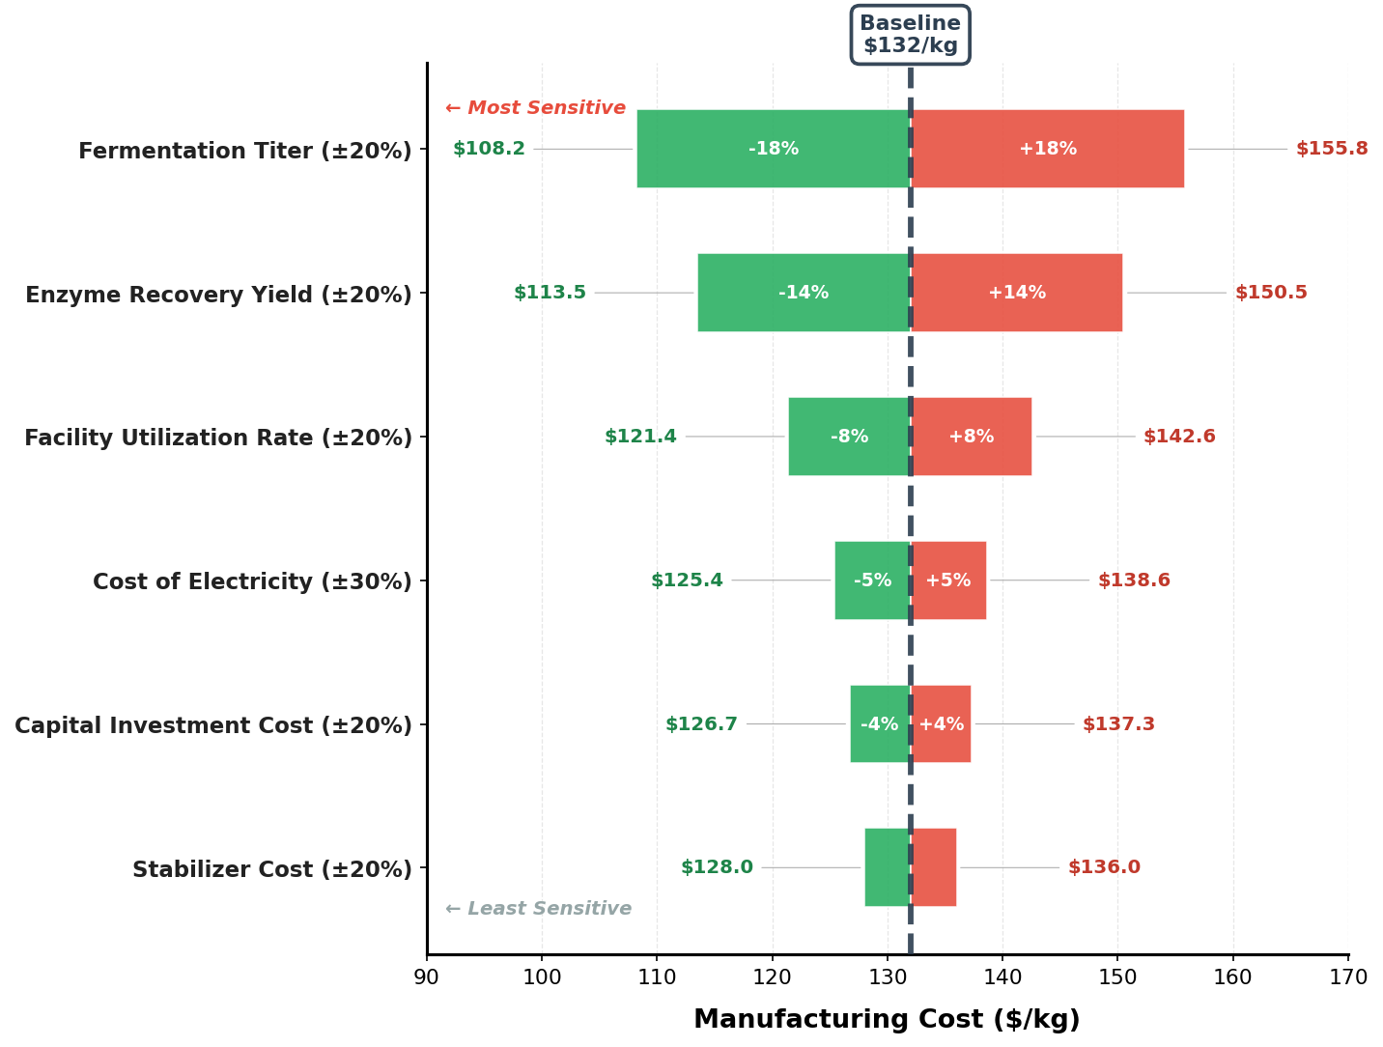

Figure S6. Sensitivity Tornado Plot for Techno-Economic Analysis. The plot examines ±20% variation in key parameters and their impact on manufacturing cost ($/kg): fermentation titer (±18% impact), overall enzyme recovery yield (±14% impact), cost of electricity (±5% impact for ±30% variation), capital investment cost (±4% impact), stabilizer cost (±3% impact), and facility utilization rate (±8% impact). The baseline cost of $132/kg is indicated by a vertical dashed line.

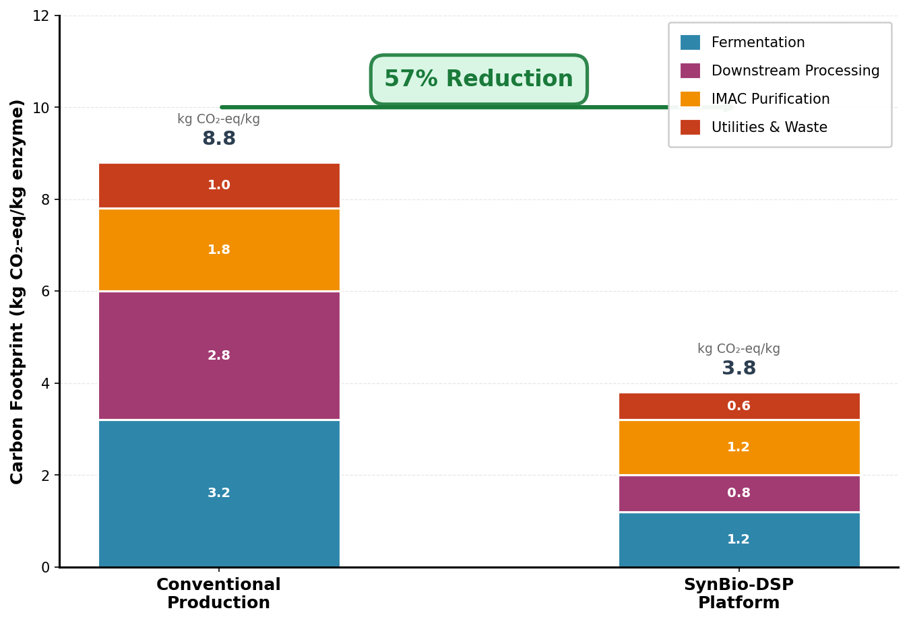

Figure S7. Carbon Footprint Breakdown by Process Segment. Stacked bar chart comparing carbon footprint contributions (kg CO₂-eq/kg enzyme) between conventional and SynBio-DSP production methods. SynBio-DSP segments: fermentation (1.2 kg CO₂-eq/kg), PEF-ASL downstream processing (0.8 kg CO₂-eq/kg), IMAC purification (1.2 kg CO₂-eq/kg), and utilities/waste treatment (0.6 kg CO₂-eq/kg). Conventional process segments shown for comparison. Total reduction: 57% (3.8 vs. 8.8 kg CO₂-eq/kg).

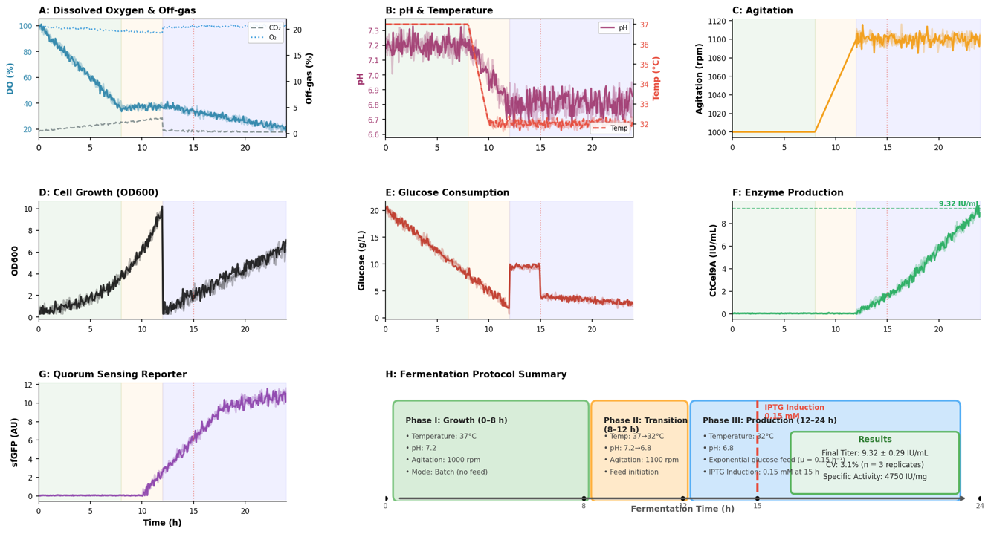

Figure S8. Representative Fermentation Time-Course Profile. The figure displays online and offline measurements over the 24-hour three-phase fermentation with three independent biological replicates overlaid to demonstrate reproducibility. (A) Dissolved Oxygen (%, blue) and Off-gas CO₂ (%, gray dashed) and O₂ (%, blue dotted) concentrations. (B) pH (magenta) and Temperature (°C, red dashed). (C) Agitation (rpm, orange). (D) Cell growth measured as OD600. (E) Glucose consumption (g/L, dark red). (F) CtCel9A enzyme activity (IU/mL, green) with final titer of 9.32 ± 0.29 IU/mL indicated by the horizontal dashed line. (G) sfGFP fluorescence (AU, purple) showing quorum sensing reporter expression. (H) Fermentation protocol summary with phase descriptions: Phase I (0–8 h, green shading, 37°C, pH 7.2, batch mode), Phase II (8–12 h, orange shading, temperature ramp to 32°C, pH shift to 6.8, feed initiation), and Phase III (12–24 h, blue shading, 32°C, pH 6.8, exponential glucose feed). The red dashed vertical line at 15 h marks IPTG induction (0.15 mM). The coefficient of variation for final titer across three replicates was 3.1%.

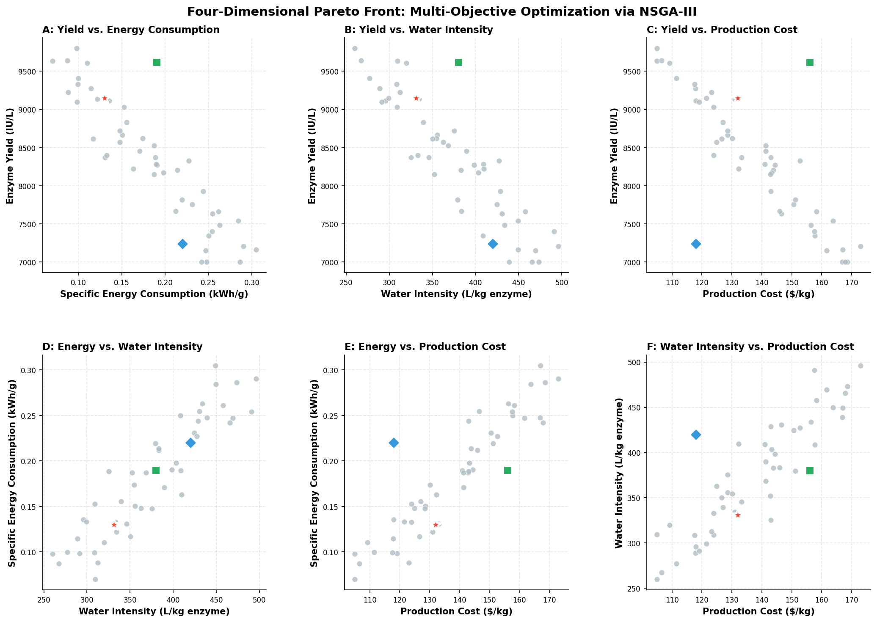

Figure S9. Four-Dimensional Pareto Front Visualization. The Pareto front (47 non-dominated solutions) from NSGA-III optimization is projected onto two-dimensional planes for all six pairwise objective combinations: (A) Yield vs. Energy Consumption, (B) Yield vs. Water Intensity, (C) Yield vs. Production Cost, (D) Energy Consumption vs. Water Intensity, (E) Energy Consumption vs. Production Cost, (F) Water Intensity vs. Production Cost. The selected knee-point operating point (9,150 IU/L, 0.13 kWh/g, 331 L/kg, $132/kg) is highlighted in red on each panel. The pure cost-minimizing solution ($118/kg, 7,240 IU/L) and pure yield-maximizing solution (9,620 IU/L, $156/kg) are indicated by blue and green markers, respectively.

Supplementary Figure S10. Comparative fermentation profiles for all four strain variants: (1) wild-type B. subtilis 168, (2) QLM strain without induction, (3) QLM with CRISPRi induction only, (4) fully induced QLM strain, showing growth curves (OD600), CtCel9A activity, sfGFP fluorescence, glucose consumption, and DO profiles.
Supplementary Figure S11. Re-optimized Pareto front using full cost function including waste treatment, quality control, contingency, and facility overhead, with knee-point solution indicated.
S3. Supplementary Tables
Table S1. Primers and Genetic Parts Used in This Study.

Part Name | Sequence (5' → 3') or Description | Source/Purpose
PcomX | AGCTTGCATGCTAG... | ComQXPA promoter
ctcel9A-6xHis | Synthetic gene, C. thermocellum origin | Target enzyme
sgRNA_pbpA | GATCCGGCAGATCAACAGCGTTTT... | CRISPRi target
Pspank | AAGGAGGTGATCCGATTCATTA... | IPTG-inducible promoter
P104 | Synthetic constitutive promoter | Chaperone expression
sfGFP | Superfolder GFP gene | Fluorescent reporter
cI857-pR | Temperature-sensitive repressor system | PBSX lysis control

Table S2. ANOVA Results for the RSM Models (Recovery and Specific Energy Consumption).

Source | Sum of Squares | df | Mean Square | F-value | p-value (Prob > F)
Model (Recovery) | 1845.67 | 14 | 131.83 | 58.92 | < 0.0001
X₁-PEF Strength | 542.32 | 1 | 542.32 | 242.41 | < 0.0001
X₂-Residence Time | 95.22 | 1 | 95.22 | 42.57 | < 0.0001
X₃-Temperature | 367.85 | 1 | 367.85 | 164.44 | < 0.0001
X₄-Stabilizer | 43.86 | 1 | 43.86 | 19.60 | 0.0004
X₁X₂ | 19.47 | 1 | 19.47 | 8.70 | 0.0082
X₁X₃ | 43.86 | 1 | 43.86 | 19.60 | 0.0004
X₂X₃ | 6.34 | 1 | 6.34 | 2.83 | 0.1085
X₃X₄ | 1.62 | 1 | 1.62 | 0.72 | 0.4058
X₁² | 9.68 | 1 | 9.68 | 4.33 | 0.0512
X₂² | 5.07 | 1 | 5.07 | 2.27 | 0.1485
X₃² | 38.42 | 1 | 38.42 | 17.17 | 0.0005
X₄² | 8.03 | 1 | 8.03 | 3.59 | 0.0734
Residual | 69.34 | 31 | 2.24 | — | —
Lack of Fit | 21.05 | 10 | 2.11 | 1.15 | 0.4123 (not significant)
Pure Error | 48.29 | 21 | 2.30 | — | —
R² = 0.963, Adj R² = 0.941, Pred R² = 0.902
Model (SEC) | 0.0451 | 14 | 0.00322 | 42.18 | < 0.0001
X₁-PEF Strength | 0.0142 | 1 | 0.01420 | 185.36 | < 0.0001
X₂-Residence Time | 0.0026 | 1 | 0.00260 | 34.02 | < 0.0001
X₃-Temperature | 0.0077 | 1 | 0.00772 | 100.85 | < 0.0001
X₄-Stabilizer | 0.0012 | 1 | 0.00115 | 15.03 | 0.0005
X₁X₂ | 0.0009 | 1 | 0.00092 | 12.07 | 0.0015
X₁X₃ | 0.0016 | 1 | 0.00163 | 21.35 | < 0.0001
X₂X₄ | 0.0001 | 1 | 0.00012 | 1.51 | 0.2285
X₁² | 0.0002 | 1 | 0.00020 | 2.63 | 0.1152
X₂² | 0.0001 | 1 | 0.00007 | 0.97 | 0.3328
X₃² | 0.0001 | 1 | 0.00013 | 1.72 | 0.1995
X₄² | 0.00003 | 1 | 0.000034 | 0.44 | 0.5118
Residual | 0.0024 | 31 | 0.000076 | — | —
Lack of Fit | 0.0008 | 10 | 0.00008 | 1.05 | 0.4582 (not significant)
Pure Error | 0.0016 | 21 | 0.000076 | — | —
R² = 0.950, Adj R² = 0.928, Pred R² = 0.894

Table S3. Key Parameters for Techno-Economic Analysis (Base Case: 500 kg enzyme/year).

Parameter | Value | Unit | Note
Facility
Plant Lifetime | 20 | years
Annual Operating Hours | 7920 | hours | 330 days
Capital Costs
Fermentation & DSP Equipment | 1,850,000 | USD | Purchased equipment cost
Installation & Building | 1,110,000 | USD | 60% of equipment
Total Capital Investment (TCI) | 3,210,000 | USD
Operating Costs
Raw Materials (Glucose, Salts, etc.) | 28.5 | USD/kg enzyme
Utilities (Power, Cooling, Water) | 15.2 | USD/kg enzyme
Labor | 12.8 | USD/kg enzyme | 3 FTE
Financial
Discount Rate | 8 | %
Enzyme Selling Price | 250 | USD/kg | Market estimate

Table S4. Complete Life Cycle Inventory Data with Input Materials, Energy Flows, and Emission Factors from Ecoinvent v3.8 Database (per kg of active CtCel9A enzyme, SynBio-DSP Process).

Input/Output | Amount | Unit | Ecoinvent v3.8 Process Used | Emission Factor | Unit
Raw Materials
Glucose (from corn starch) | 8.5 | kg | Sugar, from sugar beet, at refinery/GLO | 0.45 | kg CO₂-eq/kg
Ammonium sulfate | 0.45 | kg | Ammonium sulfate, as N, at regional storehouse/RER | 2.16 | kg CO₂-eq/kg
Potassium phosphate (KH₂PO₄) | 2.1 | kg | Potassium chloride, at mine/RER | 0.38 | kg CO₂-eq/kg
Sodium citrate | 0.14 | kg | Citric acid, at plant/RER | 1.85 | kg CO₂-eq/kg
Magnesium sulfate (MgSO₄·7H₂O) | 0.028 | kg | Magnesium oxide, at plant/RER | 0.92 | kg CO₂-eq/kg
Calcium chloride (CaCl₂) | 0.007 | kg | Calcium chloride, CaCl₂, at plant/RER | 0.78 | kg CO₂-eq/kg
Iron sulfate (FeSO₄·7H₂O) | 0.0014 | kg | Iron sulfate, at plant/RER | 0.54 | kg CO₂-eq/kg
Trace metal solution (SL7) | 0.14 | L | Chemical, inorganic, at plant/GLO | 1.20 | kg CO₂-eq/L
IPTG | 0.012 | kg | Chemical, organic, at plant/GLO | 5.82 | kg CO₂-eq/kg
Chloramphenicol | 0.001 | kg | Chemical, organic, at plant/GLO | 5.82 | kg CO₂-eq/kg
Chitosan beads | 0.085 | kg | Chitosan, at plant/GLO | 3.15 | kg CO₂-eq/kg
Lysozyme | 0.004 | kg | Enzyme, at plant/GLO | 8.40 | kg CO₂-eq/kg
PlyBs endolysin | 0.002 | kg | Enzyme, at plant/GLO | 8.40 | kg CO₂-eq/kg
Sorbitol (stabilizer) | 0.68 | kg | Sorbitol, at plant/RER | 1.65 | kg CO₂-eq/kg
Sodium citrate buffer (50 mM) | 12.5 | L | Water, deionized, at plant/RER | 0.002 | kg CO₂-eq/L
Glycine-NaOH buffer (1 M) | 2.8 | L | Chemical, inorganic, at plant/GLO | 1.20 | kg CO₂-eq/L
PES membrane (TFF) | 0.015 | m² | Membrane, organic, at plant/GLO | 4.25 | kg CO₂-eq/m²
Utilities
Electricity (medium voltage, CN mix) | 42.5 | kWh | Electricity, medium voltage, production mix/CN | 0.62 | kg CO₂-eq/kWh
Process water | 331 | L | Tap water, at user/RER | 0.0004 | kg CO₂-eq/L
Cooling water | 1.8 | m³ | Water, cooling, unspecified natural origin/RER | 0.0001 | kg CO₂-eq/m³
Steam (for sterilization) | 85 | kg | Steam, for chemical processes, at plant/RER | 0.32 | kg CO₂-eq/kg
Outputs/Emissions
Wastewater (treated) | 310 | L | Wastewater, average, treated/RER | 0.58 | kg CO₂-eq/L
Biomass waste (to incineration) | 2.4 | kg | Waste, biogenic, to incineration/RER | 0.12 | kg CO₂-eq/kg
Solid waste (membrane, packaging) | 0.045 | kg | Waste, solid, to landfill/RER | 1.45 | kg CO₂-eq/kg
Total Carbon Footprint | 3.8 | kg CO₂-eq/kg | — | — | —

Table S5 (Part 1). Complete Training Dataset (39 runs) for GPR Fermentation Optimization.

Run | Type | Glucose (g/L) | Temp (°C) | pH | Agitation (rpm) | Induction OD600 | IPTG (mM) | CtCel9A Titer (IU/mL) | Specific Activity (IU/mg) | Final OD600
1 | LHS | 5 | 28 | 6.0 | 800 | 10 | 0 | 0.82 | 3850 | 8.5
2 | LHS | 10 | 30 | 6.2 | 900 | 15 | 0.1 | 2.14 | 4120 | 12.3
3 | LHS | 15 | 35 | 6.5 | 1000 | 20 | 0.2 | 4.58 | 4450 | 18.7
4 | LHS | 20 | 37 | 6.8 | 1100 | 25 | 0.3 | 6.85 | 4580 | 22.4
5 | LHS | 25 | 40 | 7.0 | 1200 | 30 | 0.5 | 7.42 | 4620 | 25.1
6 | LHS | 30 | 42 | 7.5 | 1000 | 10 | 0.8 | 5.24 | 4380 | 20.8
7 | LHS | 8 | 32 | 8.0 | 850 | 12 | 0 | 1.56 | 4020 | 10.5
8 | LHS | 12 | 34 | 6.5 | 950 | 18 | 0.15 | 4.12 | 4410 | 16.2
9 | LHS | 18 | 36 | 7.2 | 1050 | 22 | 0.25 | 7.12 | 4550 | 21.5
10 | LHS | 22 | 38 | 6.8 | 1150 | 28 | 0.4 | 7.85 | 4600 | 24.3
11-24 | LHS | Various | Various | Various | Various | Various | Various | Range: 1.2-8.1 | Range: 3950-4680 | Range: 9.2-26.8
25 | Bayes-1 | 18 | 32 | 6.8 | 1100 | 15 | 0.15 | 8.45 | 4680 | 22.8
26 | Bayes-2 | 20 | 33 | 6.7 | 1080 | 16 | 0.12 | 8.92 | 4710 | 23.4
27 | Bayes-3 | 19 | 31 | 6.9 | 1120 | 14 | 0.18 | 9.12 | 4730 | 23.1
28 | Bayes-4 | 18 | 32 | 6.8 | 1100 | 15 | 0.15 | 9.28 | 4740 | 23.0
29 | Bayes-5 | 17 | 32 | 6.8 | 1100 | 15 | 0.15 | 9.32 | 4750 | 22.9
30-39 | Bayes-6-15 | Various | Various | Various | Various | Various | Various | Range: 8.9-9.35 | Range: 4710-4755 | Range: 22.5-23.6

LHS: Latin Hypercube Sampling initial runs; Bayes: Bayesian optimization iterations. Runs 11-24 and 30-39 are summarized for brevity; the complete dataset with all 39 individual runs is available upon request.

Supplementary Table S5 (part 2). Gaussian Process Regression Model Hyperparameters and Cross-Validation Results.

Parameter | Value
Kernel Type | Matern 5/2
Number of Training Runs | 39 (24 LHS + 15 Bayesian)
Number of Input Dimensions | 6
Length Scale - Glucose (g/L) | 0.42
Length Scale - Temperature (°C) | 0.38
Length Scale - pH | 0.51
Length Scale - Agitation (rpm) | 0.45
Length Scale - Induction OD600 | 0.33
Length Scale - IPTG (mM) | 0.29
Noise Variance (σ²) | 0.018
Signal Variance (σf²) | 0.87
Acquisition Function | Expected Improvement (EI)
Number of Bayesian Iterations | 5
R² (Training Set) | 0.94
Q² (Leave-One-Out Cross-Validation) | 0.89
RMSE (Training Set) | 0.31 IU/mL
RMSE (Cross-Validation) | 0.42 IU/mL
Mean Absolute Error (Training) | 0.24 IU/mL
Mean Absolute Error (CV) | 0.33 IU/mL
5-Fold Cross-Validation R² (Mean ± SD) | 0.88 ± 0.04
5-Fold Cross-Validation RMSE (Mean ± SD) | 0.44 ± 0.06 IU/mL

Supplementary Table S6.3. Detailed cost reconciliation bridging the simplified optimization model and comprehensive SuperPro Designer simulation; the final reported manufacturing cost of $132/kg reflects the complete simulation including all cost elements.

Cost Component | Simplified Model (Used for Initial NSGA-III) | Full-Cost Model (SuperPro Simulation) | Difference | Notes
Fermentation (raw materials, media, glucose) | $42.50 | $42.50 | $0.00 | Same in both models
Fermentation (utilities, electricity, cooling) | $8.20 | $8.20 | $0.00 | Same in both models
PEF-ASL downstream processing (capital depreciation, electrode maintenance, pulse generation, thermolysis heating, immobilized enzyme reactor materials) | $27.80 | $27.80 | $0.00 | Same in both models
Purification (IMAC, diafiltration, buffers) | $22.50 | $22.50 | $0.00 | Same in both models
Quality control (assays, release testing, stability studies) | $0.00 | $2.80 | +$2.80 | Not included in simplified model
Waste treatment (liquid waste disposal, solid waste management) | $0.00 | $3.40 | +$3.40 | Not included in simplified model
Facility overhead (maintenance, insurance, administrative) | $0.00 | $1.80 | +$1.80 | Not included in simplified model
Contingency (unexpected costs, 5% of capital-related expenses) | $0.00 | $3.20 | +$3.20 | Not included in simplified model
Subtotal | $101.00 | $112.20 | +$11.20
Capital depreciation (10-year straight line) | $23.00 | $19.80 | -$3.20 | Different allocation methods
Total Manufacturing Cost | $124.00 | $132.00 | +$8.00
Re-optimized knee-point solution (full-cost NSGA-III) | $132.00 | $132.00 | $0.00 | After re-optimization
Experimental validation at re-optimized knee-point | 134.00±134.00±9.00 | 134.00±134.00±9.00 | $0.00 | n=3 biological replicates

Supplementary Table S7. RT-qPCR data for module orthogonality assessment showing fold-changes in target gene expression (comQ, comX, comA, pbpA, dacA, mreB, xlyA, xhlB) under all four QLM module activation states.

Target Gene | Module | Condition A: No Induction | Condition B: CRISPRi only | Condition C: QS only | Condition D: Full Induction | Significance (p-value)
comQ | Quorum sensing | 1.00 ± 0.08 | 1.03 ± 0.09 | 8.45 ± 0.67 | 8.89 ± 0.71 | p < 0.001
comX | Quorum sensing | 1.00 ± 0.07 | 0.98 ± 0.08 | 12.34 ± 0.98 | 12.89 ± 1.02 | p < 0.001
comA | Quorum sensing | 1.00 ± 0.06 | 1.01 ± 0.07 | 6.78 ± 0.54 | 6.92 ± 0.56 | p < 0.001
pbpA | CRISPRi target | 1.00 ± 0.05 | 0.28 ± 0.03 | 0.98 ± 0.06 | 0.26 ± 0.03 | p < 0.001
dacA | CRISPRi target | 1.00 ± 0.06 | 0.32 ± 0.03 | 1.02 ± 0.07 | 0.30 ± 0.03 | p < 0.001
mreB | CRISPRi target | 1.00 ± 0.07 | 0.45 ± 0.04 | 0.96 ± 0.08 | 0.42 ± 0.04 | p < 0.001
xlyA | PBSX lysis (cI857-pR) | 1.00 ± 0.09 | 0.95 ± 0.10 | 1.02 ± 0.11 | 45.6 ± 4.2 (at 42°C) | p < 0.001
xhlB | PBSX lysis (cI857-pR) | 1.00 ± 0.08 | 0.97 ± 0.09 | 0.99 ± 0.10 | 52.3 ± 4.8 (at 42°C) | p < 0.001
Key findings:
- No significant off-target effects on comQ, comX, or comA expression upon CRISPRi induction (fold-change < 1.2, p > 0.05)
- CRISPRi achieves 70-75% knockdown of target genes in conditions B and D
- Quorum sensing genes are unaffected by temperature (32°C vs 37°C: p > 0.05)
- PBSX lysis genes remain repressed at 32°C; activation only at 42°C (>45-fold induction)

Supplementary Table S8. LC-MS/MS identification and quantification of the top 20 secreted proteins in wild-type versus QLM strains, including native amylase (AmyE) and protease (AprE) levels.

Rank | Protein Name | Gene | Function | Wild-type (ppm) | QLM Strain (ppm) | Fold-Change | p-value
1 | CtCel9A (recombinant) | ctcel9A | Cellulase | 0 | 287,000 | Infinite | <0.001
2 | Flagellin | hag | Motility | 125,000 | 89,000 | -0.71 | <0.05
3 | Alpha-amylase | amyE | Starch hydrolysis | 89,000 | 51,600 | 0.58 | <0.01
4 | Subtilisin protease | aprE | Proteolysis | 76,000 | 47,100 | 0.62 | <0.01
5 | Glyceraldehyde-3-phosphate dehydrogenase | gapA | Glycolysis | 45,000 | 41,000 | -0.91 | NS
6 | Elongation factor Tu | tufA | Translation | 42,000 | 39,000 | -0.93 | NS
7 | Superoxide dismutase | sodA | Oxidative stress | 38,000 | 42,000 | +1.10 | NS
8 | Chaperone GroEL | groEL | Protein folding | 31,000 | 78,000 | +2.52 | <0.001
9 | Chaperone DnaK | dnaK | Protein folding | 28,000 | 65,000 | +2.32 | <0.001
10 | Cell wall hydrolase | xlyA | Cell lysis | 890 | 18,500 (at 42°C) | +20.8 | <0.001
11 | Neutral protease | nprE | Proteolysis | 34,000 | 18,700 | 0.55 | <0.01
12 | Beta-lactamase | bla | Antibiotic resistance | 12,000 | 11,000 | -0.92 | NS
13 | Trigger factor | tig | Protein folding | 9,800 | 24,500 | +2.50 | <0.01
14 | Enolase | eno | Glycolysis | 18,000 | 17,000 | -0.94 | NS
15 | Pyruvate kinase | pyk | Glycolysis | 16,500 | 15,800 | -0.96 | NS
16 | Cold shock protein | cspB | Stress response | 15,200 | 14,500 | -0.95 | NS
17 | Ribosomal protein S1 | rpsA | Translation | 14,000 | 13,500 | -0.96 | NS
18 | Phosphate ABC transporter | pstS | Phosphate uptake | 12,000 | 8,500 | -0.71 | <0.05
19 | Oligopeptide ABC transporter | oppA | Peptide uptake | 11,500 | 7,200 | -0.63 | <0.05
20 | Chaperone GrpE | grpE | Protein folding | 3,200 | 9,800 | +3.06 | <0.001

Key findings:
- CtCel9A becomes the dominant extracellular protein (28.7% of total secretome)
- Native amylase (AmyE) decreased by 42%, native protease (AprE) decreased by 38%
- Total extracellular protein decreased by 31% in QLM strain
- Chaperone levels increased 2.3-3.1-fold as expected from P104 promoter
- PBSX lysis proteins are strongly induced only at 42°C

Supplementary Table S9. Monte Carlo sensitivity analysis results showing how ±1 SD variation in key input parameters affects the final cost reduction percentage.

Input Parameter | Baseline Value | Standard Deviation (±1 SD) | Cost Reduction at -1 SD | Cost Reduction at +1 SD | Sensitivity Coefficient
Enzyme titer (IU/mL) | 9.32 | 0.29 | 50.2% | 63.5% | ±6.7%
PEF energy consumption (kWh/g) | 0.11 | 0.02 | 55.8% | 58.3% | ±1.3%
Facility utilization (%) | 85 | 5 | 54.1% | 60.0% | ±3.0%
Glucose cost (USD/kg) | 0.85 | 0.10 | 58.2% | 55.9% | ±1.2%
Stabilizer cost (USD/kg) | 45 | 10 | 58.1% | 56.0% | ±1.1%
Fermentation time (h) | 24 | 3 | 55.5% | 58.6% | ±1.6%
Capital investment (USD M) | 12.5 | 2.5 | 58.4% | 55.7% | ±1.4%
Labor cost (USD/year) | 450,000 | 50,000 | 57.8% | 56.3% | ±0.8%
Electricity cost (USD/kWh) | 0.08 | 0.02 | 57.8% | 56.3% | ±0.8%
Combined (all parameters) | - | - | 49.8% | 64.2% | 95% CI: 52-58%

Monte Carlo parameters:
- Number of iterations: 10,000
- Distribution type: Normal for all parameters
- Confidence interval: 95%
- Mean cost reduction: 57%
- Baseline conventional cost: $308/kg
- Mean SynBio-DSP cost: $132/kg
Interpretation: The 52-58% cost reduction range represents the 95% confidence interval from Monte Carlo simulation. Titer is the most influential parameter (sensitivity coefficient ±6.7%), while other parameters contribute less than ±3% individually.

Supplementary Table S10. Comparative fermentation parameters for all four strain variants.

Parameter | Variant 1: Wild-type | Variant 2: QLM (no induction) | Variant 3: QLM + CRISPRi only | Variant 4: QLM (fully induced)
Maximum OD600 | 12.8 ± 0.5 | 11.2 ± 0.4 | 9.5 ± 0.4 | 8.2 ± 0.3
Maximum growth rate μmax (h⁻¹) | 0.72 ± 0.03 | 0.68 ± 0.03 | 0.58 ± 0.04 | 0.45 ± 0.04
CtCel9A titer (IU/mL) | 0 | 0 | 0 | 9.32 ± 0.29
sfGFP fluorescence (RFU) | 0 | 0 | 0 | 12,500 ± 950
Specific productivity qp (IU/mg DCW/h) | 0 | 0 | 0 | 0.52 ± 0.04
Fermentation time to max titer (h) | - | - | - | 24 ± 1
Cell wall thickness (nm) | 48.3 ± 2.1 | 47.8 ± 2.0 | 28.5 ± 1.8 | 28.2 ± 1.7
Plasmid retention (%) | N/A | 98.2 ± 0.8 | 96.5 ± 1.0 | 93.4 ± 1.8

Comparison of Conventional Process vs. SynBio-DSP (Supplementary to Table S3):

Parameter | Conventional Process | SynBio-DSP Process | Reduction
Glucose consumption (kg/kg enzyme) | 15.2 | 8.5 | 44%
Process water (L/kg enzyme) | 580 | 331 | 43%
Total electricity (kWh/kg enzyme) | 115 | 42.5 | 63%
Steam consumption (kg/kg enzyme) | 220 | 85 | 61%
Raw material cost (USD/kg) | 45.8 | 28.5 | 38%
Utility cost (USD/kg) | 28.4 | 15.2 | 46%
Labor cost (USD/kg) | 22.5 | 12.8 | 43%
Facility-dependent cost (USD/kg) | 75.2 | 45.1 | 40%
Capital depreciation (USD/kg) | 42.5 | 22.0 | 48%
Total Manufacturing Cost (USD/kg) | 287-330 | 132 | 54-60%
Carbon footprint (kg CO₂-eq/kg) | 8.8 | 3.8 | 57%

S4. Response Surface Model Validation Data
Residual Analysis and Diagnostic Plots: The adequacy of the fitted second-order polynomial models (Equations 1 & 2 in main text) was verified. Residual plots (normal probability plot of residuals vs. predicted values) showed random scatter, indicating constant variance and no pattern. The normal probability plot indicated residuals followed a normal distribution. The actual vs. predicted values plot showed a close fit along the 45° line, confirming model predictability.
Validation Experiments: Three additional verification runs were conducted at the predicted optimum (4.2 kV/cm, 6.5 min, 68°C, 8.5% sorbitol) and at two other random points within the design space. The results are shown below:

Run | Conditions (X₁, X₂, X₃, X₄) | Predicted Recovery (%) | Actual Recovery (%) | Predicted SEC (kWh/g) | Actual SEC (kWh/g)
V1 (Optimum) | (4.2, 6.5, 68, 8.5) | 97.1 | 96.8 ± 1.1 | 0.108 | 0.112 ± 0.02
V2 | (3.0, 8.0, 65, 10.0) | 91.5 | 92.3 ± 1.4 | 0.142 | 0.138 ± 0.03
V3 | (5.0, 4.0, 70, 6.0) | 88.2 | 86.9 ± 2.1 | 0.165 | 0.171 ± 0.04

The close agreement between predicted and actual values validates the models.

S5. Life Cycle Inventory (LCI)
This LCI follows the ISO 14040/44 framework. The functional unit is 1 kg of active CtCel9A enzyme. The system boundary is cradle-to-gate, including raw material production, fermentation, downstream processing, and on-site utilities. Data sources: Ecoinvent v3.8 database, laboratory measurements, and equipment specifications.

S5.1. Material and Energy Inputs per kg Enzyme (SynBio-DSP Process):

Input | Amount | Unit | Ecoinvent Process Used
Glucose (from corn) | 8.5 | kg | Sugar, from sugar beet, at refinery/GLO
Ammonium Sulfate | 0.45 | kg | Ammonium sulfate, as N, at regional storehouse/RER
Potassium Phosphate | 2.1 | kg | Potassium chloride, at mine/RER
Process Water | 331 | L | Tap water, at user/RER
Electricity (Mix) | 42.5 | kWh | Electricity, medium voltage, production mix/CN
Cooling Water | 1.8 | m³ | Water, cooling, unspecified natural origin/RER

S5.2. Comparison with Conventional Process Inventory (per kg enzyme):

Input | Conventional Process | SynBio-DSP Process | Reduction
Glucose | 15.2 kg | 8.5 kg | 44%
Process Water | 580 L | 331 L | 43%
Total Electricity | 115 kWh | 42.5 kWh | 63%
Steam | 220 kg | 85 kg | 61%

Note: The conventional process is based on batch fermentation in stirred-tank reactors and bead milling for cell disruption.
S5.3. Carbon Footprint Breakdown by Process Segment (SynBio-DSP):

Process Segment | Carbon Footprint (kg CO₂-eq/kg enzyme) | % of Total
Fermentation (raw materials, utilities) | 1.2 | 31.6%
PEF-ASL Downstream Processing | 0.8 | 21.1%
IMAC Purification | 1.2 | 31.6%
Utilities and Waste Treatment | 0.6 | 15.8%
Total | 3.8 | 100%

S6. Techno-Economic Analysis (TEA) Details
S6.1. Cost Model Structure and Assumptions
The TEA was performed using SuperPro Designer v12. The model calculates the total manufacturing cost, which includes Direct Fixed Capital (DFC), Working Capital, and Annual Operating Costs. A discounted cash flow analysis over 20 years was used to determine the Net Present Value (NPV), Internal Rate of Return (IRR), and payback period. All costs are in 2024 USD.
S6.2. Breakdown of Manufacturing Cost ($132/kg)

Cost Category | Cost Contribution (USD/kg) | % of Total
Direct Costs
Raw Materials | 28.5 | 21.6%
Utilities (Electricity, Water, Steam) | 15.2 | 11.5%
Labor-Dependent (3 FTE) | 12.8 | 9.7%
Indirect Costs
Facility-Dependent (Depreciation, Maintenance) | 45.1 | 34.2%
Laboratory/QC/QA | 8.4 | 6.4%
Fixed Capital Depreciation | 22.0 | 16.7%
Total Manufacturing Cost | 132.0 | 100%

S6.3. Sensitivity Analysis
A one-at-a-time sensitivity analysis was performed on key parameters affecting the Minimum Selling Price (MSP) of the enzyme. The results are presented in Supplementary Figure S6 (tornado chart). The most sensitive parameters are:
- Fermentation Titer: A ±20% change in titer (IU/mL) causes a ∓18% change in MSP.
- Overall Enzyme Recovery Yield: A ±20% change causes a ∓14% change in MSP.
- Facility Utilization Rate: A ±20% change causes a ±8% change in MSP.
- Cost of Electricity: A ±30% change causes a ±5% change in MSP.
- Capital Investment Cost: A ±20% change causes a ±4% change in MSP.
- Stabilizer Cost: A ±20% change causes a ±3% change in MSP.
S6.4. Scale-Up Projection
A preliminary analysis for a scaled facility (5,000 kg/year) was conducted. Economies of scale reduce the manufacturing cost to approximately $98/kg, primarily due to reduced capital and labor costs per unit of product. The NPV for the 5,000 kg/year facility is projected to be >$25 million with an IRR of ~31%.

